**Microprocessor Lab**

Laboratory Activity No. 2

**Arduino and Tinkercad Interface**

|  |
| --- |
|  |

Score

*Submitted by:*

**Gutierrez, Kevin Jay Vincent R.**

**Saturday 1:00pm-4:00pm/ BSCpE 412-2**

*Date Submitted*

**16-09-2023**

*Submitted to:*

**Engr. Maria Rizette H. Sayo**

I. Objectives

This laboratory activity aims to implement the principles and techniques of hardware programming using Arduino through:

- creating an Arduino programming and circuit diagram.

II. Method/s

- Perform a task problem given in the presentation.

- Write a code and perform an Arduino circuit diagram of a ring counter that display eight (8)LEDs starting from left.

III. Results

**TinkerCad**

**Exercise 1: Write a code that does a ring counter display for eight (8) LEDs starting from left.**

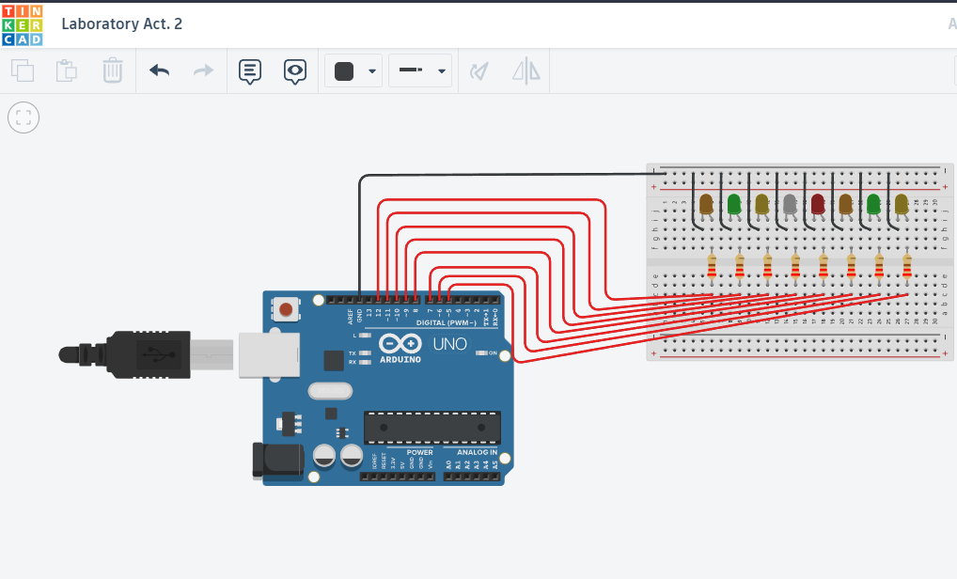Figure No.1 Ring Counter Display Circuit Diagram

**Components Used**

1. 8 LEDs
2. Resistor
3. Breadboard

**CODE:**

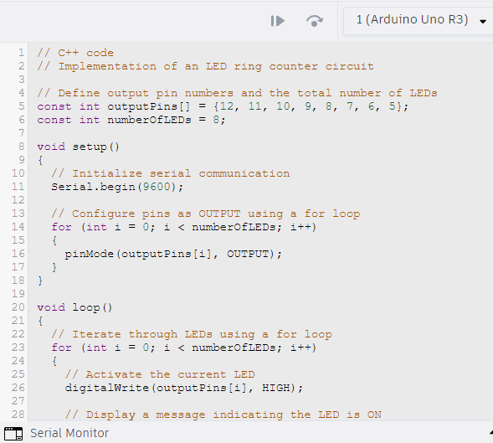

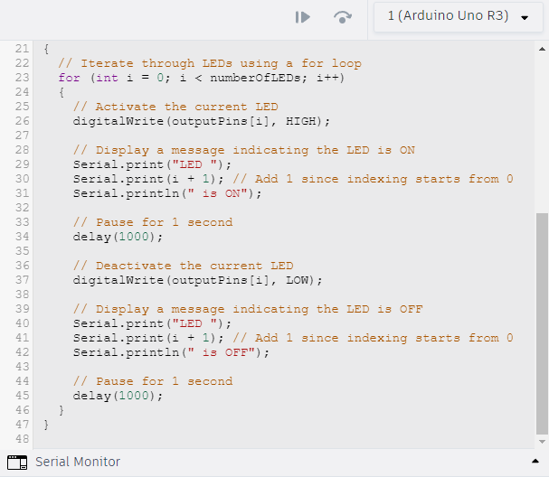

IV. Conclusion

In conclusion, the Arduino ring counter activity not only highlighted the fundamental principles of hardware programming, sequential logic, and digital output control, but it also provided a hands-on exploration, emphasizing the symbiotic relationship between meticulous circuit design and the nuanced intricacies of programming logic. This hands-on learning method increased understanding of the effective interaction of software and hardware, laying the framework for more complex projects in the domain of embedded systems and electronics.

**References**

[1] D.J.D. Sayo. “University of the City of Manila Computer Engineering Department Honor Code,” PLM-CpE Departmental Policies, 2020.

*<This is in a separate page>*