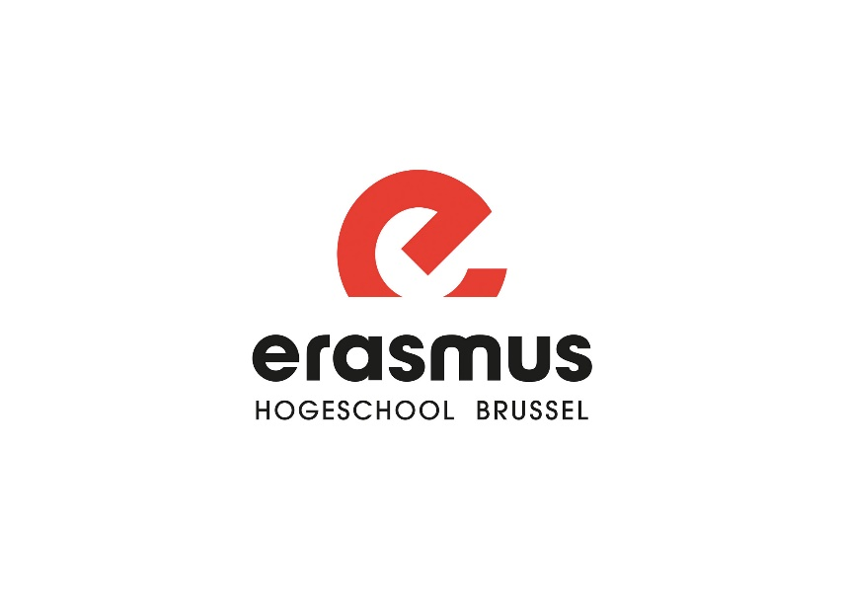

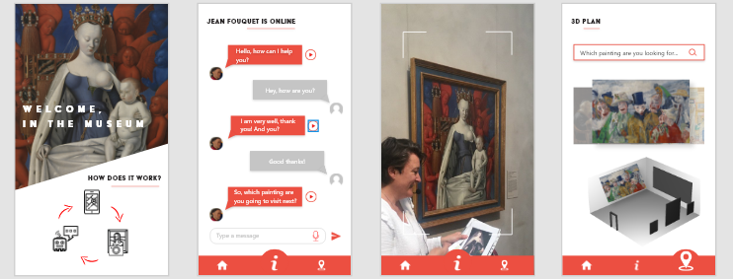

Course: Full Project

Commisioner: Kobe Vermeire, Johan van Den Broek, Joni De Borger

By Shi Yuan Kevin Ji, Kelly Peeters, Cyril Passeleur, Adam Weir

17 January 2020

# Summary

This document is the used documentation for creating a chatbot used in a museum. We used a chatbot to talk about anything the user wants. The chatbot can also ask questions to the customer to tell him interesting things about a certain painting. On top of that our app can scan a certain painting and recognize it which will lead to starting interacting with a chatbot.

In this repository you can find a few files:

* Chatbot in unity
* Json file is a list of all the possible answers and questions for the chatbot

Table of contents

Summary 2

1. REQUIREMENTS 4

2. DESIGN 4

3. CHATBOT 4

3.1. CREATE YOUR OWN CHATBOT 4

3.2. USE OUR CHATBOT 6

4. RECOGNITION OF PAINTING 6

## REQUIREMENTS

* Foreknowledge of coding
* Foreknowledge designing
* Unity 2020.1.0 Alpha 19
* IBM CLOUD V2

## DESIGN

Of course you decide to create an app, you need a design. We used Adobe XD to create our own design. You have to think about all the User Interface to make it more useful for the client. To make it easier for him to use it.

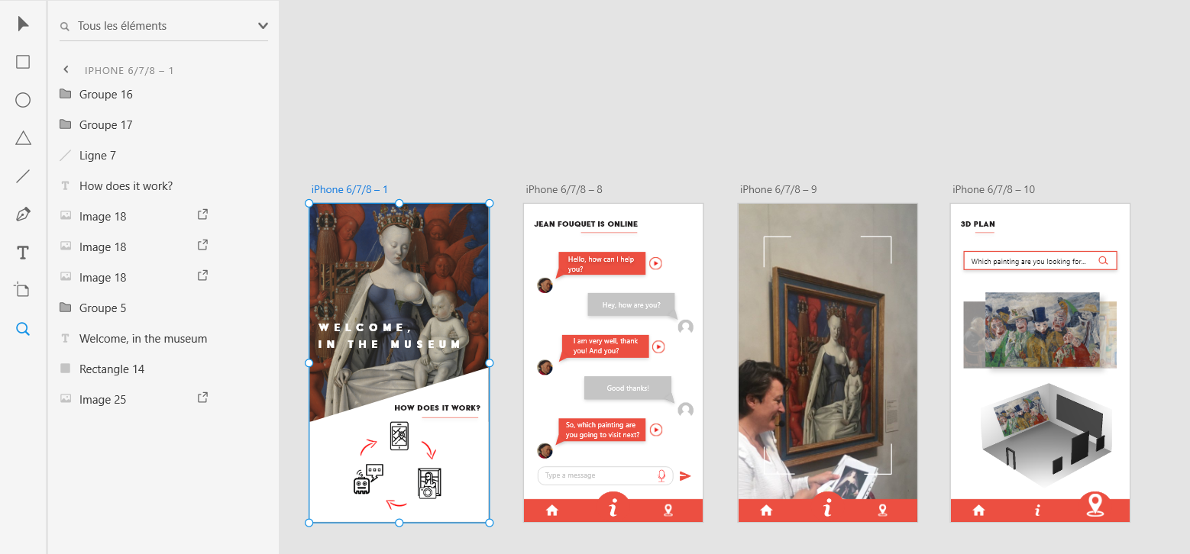

## CHATBOT

To create a chatbot you can use IBM Watson  
IBM WATSON ASSISTANT: [https://assistant-eu-gb.watsonplatform.net/eu-gb/crn:v1:bluemix:public:conversation:eu-gb:a~2Ff2152eb2f99940578b9184ae78405af0:5008e9b3-b1ef-4ad2-9c41-45f3c67b971b::/skills/9684bd3a-817e-4e98-9956-e2aefe9541b4/build/intentsx](https://assistant-eu-gb.watsonplatform.net/eu-gb/crn:v1:bluemix:public:conversation:eu-gb:a~2Ff2152eb2f99940578b9184ae78405af0:5008e9b3-b1ef-4ad2-9c41-45f3c67b971b::/skills/9684bd3a-817e-4e98-9956-e2aefe9541b4/build/intentsx?fbclid=IwAR0eIzAagIsjjo5Th0sZ9Abp62P9Va63TqRWVlY7oOEXSzHDDBUC4dskZOc).   
When we used this to create our own chatbot we used the version: IBM Watson V2

### CREATE YOUR OWN CHATBOT

After creating an account you get to choose between different services. To create a chatbot you can use IBM Watson Assistant, you can find this in the catalog after you logged into IBM Cloud. Once you are on IBM Watson Assistant you can click on “Create assistant”

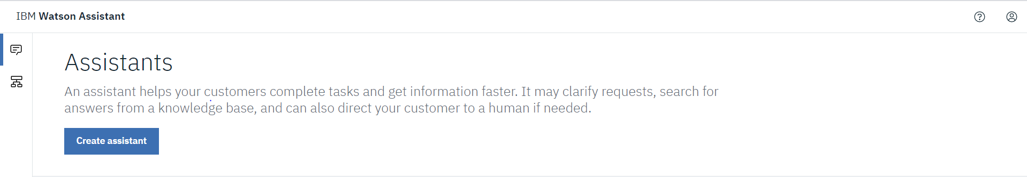

By doing this you give a name to the project/chatbot. Once you have your assistant you can give that assistant skills. Of course since it is a chatbot you give it a dialog skill. Once the assistant has a dialog skill you can create intents. Intents are the questions that the user can ask to the chatbot. Here you write all the questions that are possible that the user might ask.

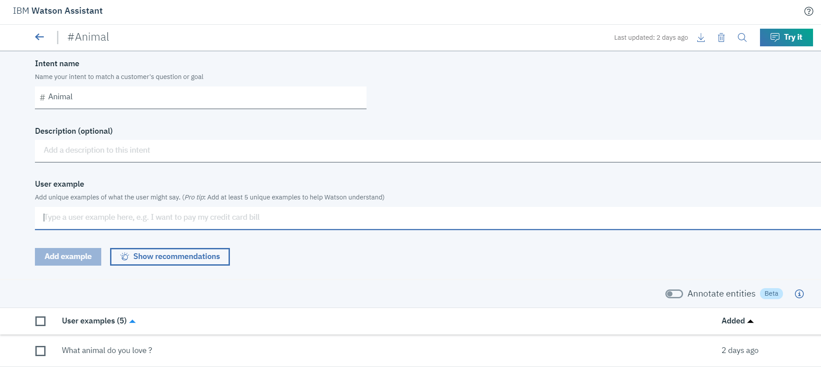

If the chatbot recognizes the question of the user, he has to find a suited answer. To get these answers you need to add them into the database of the chatbot. You can do this by pressing on the “Dialog” button and you have to press “add node”.

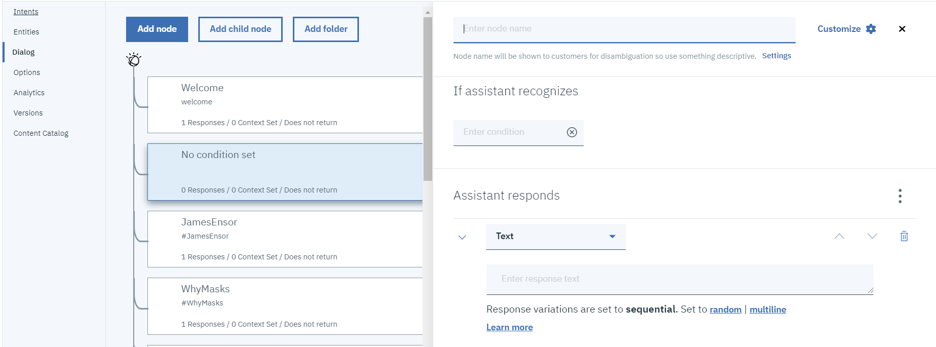

Here you give a name to that particular answer. With the text/answer that the chatbot is going to answer if he recognizes the question.

Once you have all your answers and questions you can download an api key and url which you can use on unity. You link unity with that url to get the data of your list.

To use that chatbot you can use the documentation of:

<https://github.com/ZeeNastalski/unity-watson-chat?fbclid=IwAR0QOlu0xGdKlCl5nM2Ii0aYOk7n4pR39lrKDrdkfnPJ8-DBqf7MF1NhSOw>

Here it is explained how to make your chatbot in unity. There our three services explained: Speech to Text, conversation and Text to speech. Don’t forget to get the right api key and url since they are different in the documentation.

Once you have done that, your chatbot can now talk, answer and understand what the user said.

### USE OUR CHATBOT

We attached our json file in the zip where you found the pdf/documentation. Feel free to use it in unity.

To use that chatbot you can use the documentation of:

<https://github.com/ZeeNastalski/unity-watson-chat?fbclid=IwAR0QOlu0xGdKlCl5nM2Ii0aYOk7n4pR39lrKDrdkfnPJ8-DBqf7MF1NhSOw>

Here it is explained how to make your chatbot in unity. There our three services explained: Speech to Text, conversation and Text to speech. Don’t forget to get the right api key and url since they are different in the documentation.

Once you have done that, your chatbot can now talk, answer and understand what the user said.

## RECOGNITION OF PAINTING

To recognize a painting we used unity and followed a tutorial.

<https://www.youtube.com/watch?v=MtiUx_szKbI&t=0s&fbclid=IwAR3BKLFL7KLBcbhr3UD2XSz1qg8CJ9WB1KADCu4XpN6mi-YWsTBhGKl2RMs>

In the video he uses cards but instead of cards we want paintings. And you also have to change what has to appear once the painting has been recognized. In our case, once it recognized the painting we want to have a button which you can click on to get started interacting with a chatbot.