ENGG 6150 Term Project Component Design 4  
Student: Jian Bin(Kevin), Lin"  
Email: [jlin17@uoguelph.ca](mailto:jlin17@uoguelph.ca)  
Instructor: Dr.Maher Bakri-Kassem  
Date: Apr/01/2020

Component Design 4:

Turbidity sensor has connected it analogous controller to obtain sensor reading. This signal needs to be furhter manipulated conditioned into human readable data. In this case, Analougue controller is connected to Arduino. Arduino is connected to a laptop using a cable. Software Arduino is downloaded. The reading is voltage and needs to change to NTU. The formula to convert voltage to NTU is:

NTU = -1120.4 *+ 5742.3*voltage - 4353.8

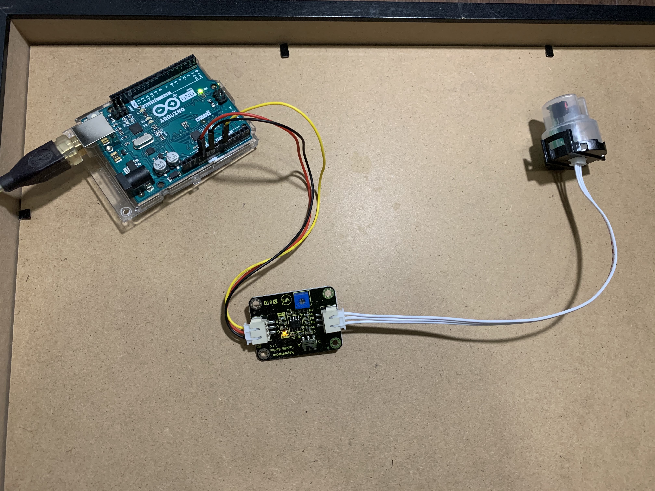

Figure 1: complete final tubidity meter setup