Estimating the Probability of a Voting Cycle

Chang Geun Song

(Last update, October 13, 2021)

Abstract

Voting cycles do exist, but much less frequently in practice than is predicted. This paper develops an estimate of the probability of a cycle that closer to what the data reveal. In the absence of an abundance of actual voting data in which voters rank candidates, survey data is the best alternative. We use German Politbarometer data, which offers two benefits for empirical analysis of voting systems; the fact that participants score the candidates and the large number of observations. We develop hypotheses and models based on cardinality. Specifically, we consider a 'median' of collected evaluations as a significant factor in predicting the winner of head-to-head comparisons, estimating the probability of a cycle from the probability of two sets of three events occurring. The model predicts a significantly lower voting cycle frequency than models based on the IC and IAC assumptions. Our approach involves 1) assigning three candidates presumed positions of first, second and third 2) noting the gaps between pairs of candidates in apparent estimated merit, and then 3) computing the probability that the three pairwise comparisons will have a combination of outcomes that results in a cycle.

**1. Introduction**

The decision-making process of a group is not like that of an individual. When people have different views and preferences, a natural and acceptable way to aggregate the opinions of the members of the group is voting. The most common electoral system, plurality rule, is used worldwide and continuously. The ease of understanding and implementing plurality are advantages, but it also has flaws. Thus, researchers have suggested many alternatives to better aggregate individuals’ preferences and reach better outcomes. Almost all of them are demonstrably better than the plurality rule in many respects.

Nevertheless, no voting rule is “ideal.” In particular, no ranking-based voting rule for three or more options is free from the Condorcet paradox, the possibility that aggregated majority preferences are cyclic or, in other words, transitivity does not hold: Suppose there are three available options for a group, A, B, and C. Different majorities of the group prefers A to B, B to C, and C to A. If the group decides to use pairwise comparisons sequentially to find the best option for the group, the winner depends on the order of the comparisons, and the agenda setter can manipulate the result. The more severe problem is that if a voting cycle exists, for any option that wins under ANY voting rule, there will always be another option with a majority over the chosen one. Thus, voting provides necessarily imperfect estimates of the socially best option, and the impact of the Condorcet paradox has been regarded as a serious potential peril to the coherence of democratic decision-making. More worrisome is the fact that some theories and probabilistic models predict the frequent occurrence of the Condorcet paradox.

Researchers have also tried to find empirical evidence. However, the Condorcet paradox has not been detected in practice as often as previous studies. Rather, voting cycles have very rarely been observed. Nevertheless, one supposes that the gap between the theories and the real world arises only because the number of empirical studies is limited. According to **Van Deemen (2014) [16]**, there have been only 47 empirical studies related to the Condorcet paradox, involving 265 elections in total, from 1955 to 2010. Moreover, almost all of these studies dealt with a few elections.

The main reason for a limited number of studied elections is that available data are scarce. There have been countless elections in human history, and, for many of them, the data exist. However, most elections are held under the plurality rule, which can only reveal how many first-choice votes each candidate had. This information is insufficient for constructing each voter’s ranking of the candidates and so the aggregated ranking. Thus, there is no way of determining the existence of Condorcet paradoxes or of opportunities for strategic voting.

In the present paper, we use a part of German Politbarometer survey data. The data include respondents’ scoring data of politicians. Using the data, we construct individuals’ reported preference orderings and check the frequency of voting cycles in synthetic elections. One might be concerned that people who participate in a poll or survey may have significantly different preferences than people who do not, so that an analysis based on the survey data will not be a good way to approximate the preference orderings of voters. However, it is impossible to know voters’ rankings unless voters report their rankings of candidates in elections, so survey data is generally the best available actual data except for actual election data.

Additionally, the lack of data from actual elections makes it interesting to use survey data. A huge benefit of using Politbarometer data is its vast number of observations: We analyze 1,022 synthetic elections. Another advantage of using poll or survey data is that respondents have no incentive to report false preferences intentionally, and so there is reason to expect less distortion in aggregated preferences. Since participants are merely answering a survey, nothing changes with regards to one’s welfare. However, that also causes some meaningless or careless responses, and we screen out the obviously meaningless ones.

Our goal is to report the empirical result and then suggest a way to explain the observed frequency of the Condorcet paradox and the reason for the departure of the result from the predictions of previous models. The modeling process is based on actual data, unlike previous probabilistic models. What makes our work different from the others more than anything else is that we directly connect the cardinal information to the probability of winning in the pairwise election and establish a model based on that to estimate the frequency of voting cycles. Specifically, we introduce the concept of a fraction-valued median, which is based on a combination of the standard median and the distributions of observations. Then, we check the usefulness of the gap in the fraction-valued medians of scores of two candidates for predicting which candidate wins in pairwise comparisons. Finally, we consider a cycle as a result of three consecutive head-to-head election and calculate the probability by multiplications of three estimated probabilities.

**Contents**

The remaining parts of this paper are as follows: In section 2, a literature review, we discuss some well-known probabilistic models and describe the departures of the predictions of these models from the occurrence of the Condorcet paradox in empirical work. Section 3 describes the data that are used, the methods of analysis, and the results. Finally, section 4 summarizes and proposes future research.

**2. Literature Review**

The Condorcet paradox was initially discussed in the late 18th century by Condorcet. Since then, there have been fewer results from empirical work than from theoretical approaches. Researchers have mainly analyzed elections generated from hypothetical, probabilistic models because of the scarcity of large data sets of the relevant sort.

First, we will outline widely used probabilistic models and then discuss empirical work on the Condorcet paradox.

**Probabilistic models**

Individuals’ preference orderings determine the aggregate preference ordering through the application of a voting rule, and the choice of the voting rule affects who will win.

When we have *n* alternatives, we have *n*! possible strict orderings. Furthermore, the frequency distribution over the strict orderings would be expressed by a vector with *n*! components, such that the sum of components is 1.

**Impartial Culture (IC) model**

**Guilbaud (1952) [8]** proposed the impartial culture (IC) model, which, for every voter, assigns equal probability to every possible preference ordering. For example, suppose there are six (strict) rankings ABC, ACB, BAC, BCA, CBA, and CAB for three options A, B and C. Hence, the IC model assumes that every individual would have each preference ranking with 1/6 probability.

**Impartial Anonymous Culture (IAC) model**

The impartial anonymous culture (IAC) model was developed by **Kuga and Nagatani (1974) [9]** and **Gehrlein and Fishburn (1976**) **[3]**.

Define a preference profile as a sequence of preference orderings. For the case of two alternatives A and B with three voters, there are 2 possible preference orderings, AB and BA, and possible preference profiles. Then, we can categorize the profiles into four “anonymous equivalence classes” (AECs) by their composition without considering the order of voters.

|  |
| --- |
| AEC1: AB x3 - (AB, AB, AB) |
| AEC2: AB x2, BA x1 – (AB, AB, BA), (AB, BA, AB), (BA, AB, AB) |
| AEC3: AB x1, BA x2 – (AB, BA, BA), (BA, AB, BA), (BA, BA, AB) |
| AEC4: BA x3 - (BA, BA, BA) |

The IAC model assumes that each class of preference profiles has an equal probability of realization, 1/4 for the given example.

**Normal spatial model**

The normal spatial model was developed by **Good and Tideman (1976) [7].** This model assumes an attribute space, and an individual’s preference ordering is determined by the distances from the options to his or her most desired option, with closer options ranked higher. The Normal spatial model assumes that the voters’ most desired options are drawn from a (multivariate) normal distribution. The hyperplanes that bisect line segments connecting all pairs of candidates divide the space into sectors corresponding to different strict preference orderings. The integration of the voters’ probability density over all such sectors specifies the probabilities. For three candidates, one needs at least two dimensions to represent all six possible, strict rankings.

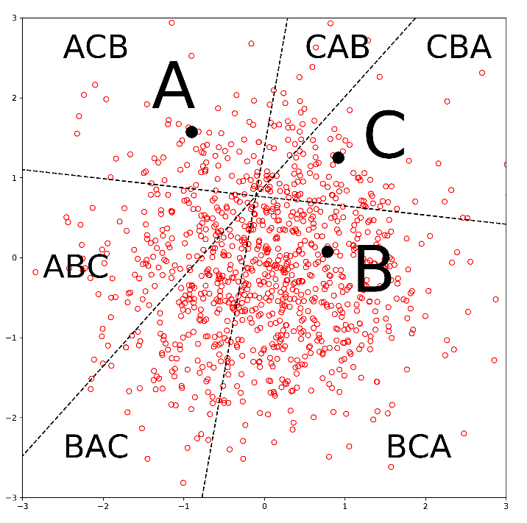

**<figure 1, normal spatial model, 3 candidates, 2-dimensional>**

**The probabilities implied by the models**

The normal spatial model implies that as the number of voters approaches infinity, the probability of a voting cycle approaches 0, since a candidate closer to the mode of the voters’ locations will always have more votes than a candidate who is farther from the mode. **Gehrlein (2002, 2006) [4][5]** provides calculations for the probabilities of the existence of the Condorcet winner under different assumptions on culture. In the three-candidate case, it is equivalent to the probability of non-existence of the Condorcet paradox. When the number of voters goes large enough, the IC model and the IAC model yield probabilities of Condorcet paradox decreases and converges to 8.77% and 6.25%, respectively. On the other hand, the estimated frequency of a voting cycle under the normal spatial model, varies depending on the data, is much lower than those of the IC and IAC models, and converges to 0 as the number of voter goes infinity.

**Empirical works**

We will briefly summarize the framework and results of empirical works that provides estimates of the frequency of the Condorcet paradox. We purposely omit relevant ones published before 2010 (cf. **Gehrlein and Lepelley (2011: 13)** [6]and **Van Deemen (2014, Sect. 5) [16]**).

**Voting cycles in simulations based on real data**

**Popov et al. (2014) [13]** used five-candidate American Psychological Association (APA) presidential election data to compare and evaluate various voting systems, including the Plurality rule, Instant Runoff Voting, and the Borda Rule. The data include voters’ full or partial rankings of candidates. With 12 elections, they generated three thousand bootstrapped ballot profiles for each. The frequency of Condorcet paradox was infrequent, lower than 0.3% of total samples.

**Darmann el al. (2019)** [1] used online survey data collected two weeks before the 2015 parliamentary elections in the Austrian federal state of Styria. Questions asked respondents to assign points ranges in [-20,20]. The authors reported 13 voting cycles out of 1000 bootstrapped profiles but 0 voting cycles of three candidates who won the most votes under plurality rule.

Another notable empirical study is **Tideman and Plassmann (2012) [15].** They used actual election data from Electoral Reform Society, and survey data from the American National Election Studies. They showed that the spatial model fits the data better than other probabilistic models, including the IC and IAC models. The authors estimated the share of preference orderings by spatial model and simulated 1,000,000 elections for each different number of voters. For 1,000 voters, the voting cycle existed 0.53% of simulated elections, and it converged to 0% as the number of voters increased.

**Voting cycles in real election data**

**Mattei (2011) [11]** measured the Condorcet efficiency (the probability of selecting a Condorcet winner) of several voting rules and calculates how often a voting paradox happens in three alternative and four-alternative elections that are constructed from a vast data set consisting of individual ratings of 17,770 movies. The ratings came from 480,189 distinct users of Netflix, who were asked to assign stars from 1-5 (with half stars permitted) for how well they liked the movies they watched[1][2]. The author made three subsets by randomly drawing 2,000 movies from the 17,770 movies. He then generated all possible three-alternative elections and four-alternative elections in each subset. A derived election was included in the analysis only if it had more than 350 voters. The share of three-alternative elections that exhibited Condorcet paradox in the three independent subsets were 0.041%, 0.044%, and 0.056% in each subset. In **Mattei et al. (2012) [12]**, the work was extended. The authors made ten subsets with the same data set with non-overwrapping 1,777 movies for each and checked the voting cycle for all possible triples and quadruples in each subset. The frequency of the cycles in the top three candidates in four alternative elections was lower than 0.11% of the total.

**Kurrild-Klitgaard (2014)** [10] provided possible evidence of a voting cycle in practice based on the result of a Monmouth University Poll in March and April 2015, which asked head-to-head comparison of four potential candidates (Jeb Bush, Chris Christie, Ted Cruz, and Scott Walker) for 2016 Republican party presidential primaries. The result showed a top voting cycle of three candidates. **Feizi et al. (2020) [2]** also analyzed several polls before the actual election. The polls began some weeks before the 2017 Iranian presidential election. The polls included the pairwise comparison of candidates. The authors concluded that there was no voting cycle of three leading candidates in any poll.

**3. Analysis**

**Description of the data**

We use German Politbarometer data, which are freely available to the public at the Politbarometer website. These data come from surveys of German voters, conducted approximately monthly, beginning in 1977 and ending in December 2019. The surveys contain many questions about demographic characteristics, region of residence, and weekly working hours.

We focused on questions related to a *skalometer* (in English, consists of “scale” and “meter”) of politicians. Each participant is asked to assign to each politician one of the 11 integers from -5 to 5; higher integers meaning the participant thinks higher of the politician. Thus, we have cardinality as well as rankings, which is uncommon.

After East Germany and West Germany unite, we treat the data as separate surveys for East and West Germany. We also divide the data when the set of politicians for the questions varies, even in the same region and the same month. After cleaning the data, we have 1,022 usable surveys.

In each survey, at least four and at most 21 politicians are evaluated (10.62 on average), and the number of participants in a survey ranges from 179 to 3,345 (930.05 on average). The politicians in the questionnaire consist of influential politicians at the time of the survey. There is no regular rule for forming the pool; some politicians continue to the following survey, and others do not. Some excluded politicians are re-included in later surveys’ pools. In some surveys, former politicians or famous politicians from countries other than Germany are also on the list[3].

For convenience, we confine our analysis to triples of candidates, the minimum number of alternatives needed for a Condorcet paradox. We construct triples from each survey, for all possible combinations of three politicians in the survey. To be specific, we can make four triples from four politicians, ten triples from five politicians, and triples from politicians.

For every triple, we checked for the existence of a cycle by paired comparisons. We exclude participants who did not provide a score for both politicians. As a result, there are 206 majority cycles (including semi-cycle), out of 181,579 triples, a rate of 0.113%, or about 1 out of 881, showing a significant departure from the predictions of the IC and IAC models.

**Framework for analysis**

1. Decompose a voting cycle into three probabilistic events

To check whether there is a voting cycle, we need to know the majorities in three paired comparisons. Define A**p**B as the voter strictly prefers A to B, n[A**p**B] as the number of voters who prefer A to B., and as the difference between n[A**p**B] and n[B**p**A].

For arbitrarily labeled alternatives **A**, **B**, and **C**, as table 1 shows, there are eight possible combinations of the sign of for {**A**, **B**, **C}**, and they correspond to the six possible strict preference orderings and two cyclical orderings of the three options.

|  |  |  |  |  |
| --- | --- | --- | --- | --- |
|  |  |  |  | preference ordering |
| sign of difference in majority | + | + | + | ABC |
| + | + | - | ABCA (cycle) |
| + | - | + | ACB |
| + | - | - | CAB |
| - | + | + | BAC |
| - | + | - | BCA |
| - | - | + | CBAC (cycle) |
| - | - | - | CBA |

**<table 1, eight possible profiles of signs of and implied preference orderings>**

If we can accurately predict the sign of , , and , then we can also predict whether there exists the voting cycle or not. Furthermore, properties of the distributions of skalometer scores are likely to be good predictors of the signs of majorities and therefore of the existence of voting cycles. Thus, we record the median evaluation of each alternative.

**Why does the median matters?**

Let the voters’ cardinal evaluation of two candidates be distributed on a two-dimensional space as in the left of **<figure 2>**. A voter’s evaluation of **A** is on the x-axis and that of **B** is on the y-axis. and are the median evaluation of candidates **A** and **B**, respectively. If voters cast ballots based on their evaluation, **B** will be selected by the majority rule if and only if more than a half of voters are located above line *D*, which is a 45-degree line. However, due to the half of voters being on the right of , and half voters being below , candidate **A** is more likely to have a majority of the votes.

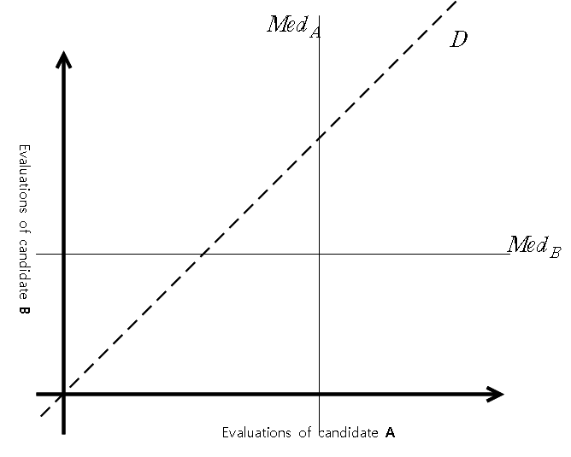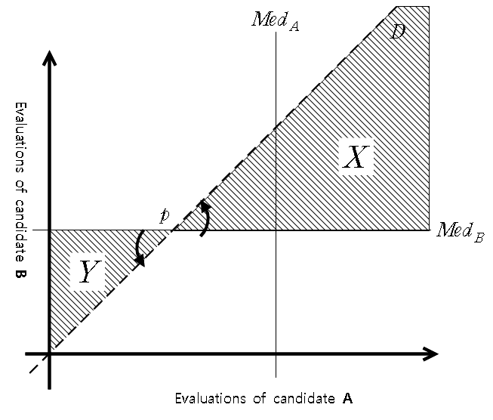

**<figure 2, Median and Majority>**

Another way to think about the possibilities is to rotate the horizontal line about a point , 45 degrees, counterclockwise. It will coincide with the dashed line *D*. The voters who rank **A** ahead of **B** are the ones on the lower right side of the dashed line *D*. Line represents an even split of the voters. Therefore, for there to be a majority in favor of candidate **B**, ruling out voters in area X from above the line , and adding voters in area Y from below the line, add less voters than it subtracts. This seems more and more likely as the intersection of and moves farther below line *D*.

To measure the impact of relative median evaluations on the probability of winning, we check each candidate’s median evaluation and which one would win more votes in all 55,321 pairs of candidates from 1,022 surveys. Among 41,512 pairs with a gap between two candidates’ median evaluations, the candidate with the lower median beats the other in 213 cases. It happens only when the gap is 0.5 and 1, and the proportion is smaller when the gap is 1 then when it is 0.5.

|  |  |  |  |  |  |  |
| --- | --- | --- | --- | --- | --- | --- |
| median gap | pairs | beat by lower candidate |  | median gap | pairs | beat by lower candidate |
| 0 | 13809 | 0 |  | 5.5 | 1 | 0 |
| 0.5 | 297 | 22 |  | 6 | 93 | 0 |
| 1 | 22195 | 191 |  | 6.5 | 2 | 0 |
| 1.5 | 203 | 0 |  | 7 | 31 | 0 |
| 2 | 11864 | 0 |  | 7.5 | 0 | 0 |
| 2.5 | 71 | 0 |  | 8 | 7 | 0 |
| 3 | 4639 | 0 |  | 8.5 | 0 | 0 |
| 3.5 | 28 | 0 |  | 9 | 4 | 0 |
| 4 | 1576 | 0 |  | 9.5 | 0 | 0 |
| 4.5 | 8 | 0 |  | 10 | 0 | 0 |
| 5 | 493 | 0 |  |  |  |  |
|  |  |  |  | total | 55321 | 213 |

**<table2, the number of pairs and beat by lower with respect to median gap>**

Comparing the median evaluations seems to be a reasonable way to predict which candidate will win in paired comparison. A substantial problem with using the median gap in our analysis is that the survey allows only 11 integers for scoring, so there are many ties in pairwise comparisons of medians. Indeed, we have pairs that have the same median evaluation between two candidates in about 1/4 of the total cases. We need to identify a better measure of candidate quality, one that will be a better explanatory factor for the difference between votes that two candidates receive and will be easy to observe and calculate.

**The Fraction-Valued Median (FVM)**

We construct a measure that has the character of a median but generally does not result in ties, despite only a few discrete values that the underlying variable can take. The “fraction-valued median (FVM)” takes non-integer value based on the median and the placement of the median in the set of median-valued observations.

It is derived in the following way.

-Sort the numbers in ascending order

-Let **M** be the integer median of the numbers in the set,

-Let **N** be the number of observations that take the standard median value,

-Let **K** be the number of observations to the left of “the median” that take the standard median value.

Then FVM of the set is M – 1/2 + K/N. If the median occurs precisely in the middle of the observations that have the median value, then the FVM is M. By its definition, FVM can only have the value from M-1/2 to M+1/2, and even two sets have the same standard median, it will generally be true that one will have a higher FVM than the other. Note that if the standard median is not an integer, then define FVM as the median.

As an example of a calculation of an FVM, the set {2, 2, 3, 3, 4, 5, 7} has an FVM of 3 – 0.5 + 0.75 = 3.25 **(figure 3a).** The value 3.25 indicates that the median is 3 and, being greater than the median, indicates that the number of observations in the given set that take a value higher than 3 is greater than the number that takes a value less than 3.

Graphically, FVM is described as follows.

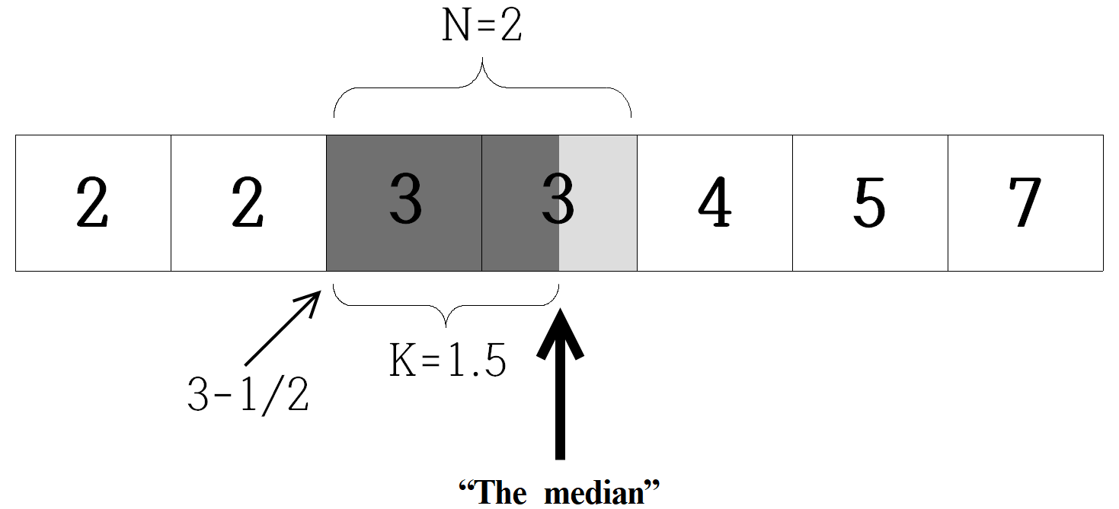

**<figure 3a, Idea of Fraction-Valued Median>**

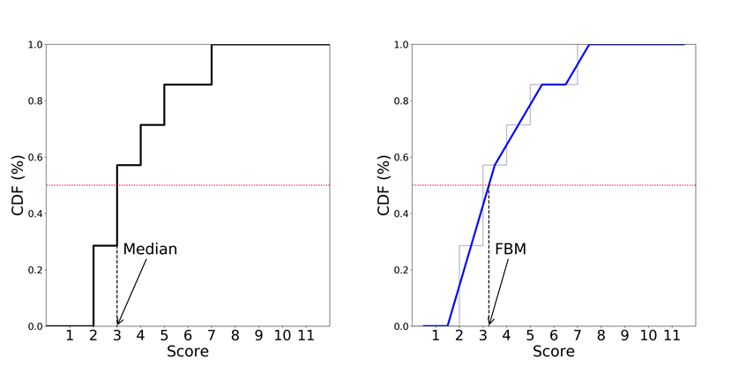

**<figure 3b, Median and Fraction-Valued Median by CDF>**

The cumulative density function (CDF) of a set of discrete random variables is a step function. The standard median is the score where the CDF intersects a horizontal line at the height 0.5. Suppose a series of line segments, passing through the midpoints of all of the horizontal segments of the CDF **(the second graph on figure 3b)**. The FVM will be at the fractional score where that series of line segments intersects the horizontal line at the height of 0.5.

**Upset rate**

Now we restrict our interest to the top triple of each survey, the three politicians with the highest FVMs. The main reason for this restriction is that the frequency of voting cycles being created by a fourth or other politician and resulting in no Condorcet winner can be expected to be much lower than the frequency for cycles among the top three.

We assign labels **1**, **2**, and **3** according to FVMs. That is, **1** is the politician who has the highest FVM among all candidates in a survey, **2** is the second highest and **3** is the third highest.

If scores assigned by participants are not correlated, then in any paired comparison, the candidate with the higher FVM score is more likely to win the paired comparison. While the candidate with the lower FVM might beat the candidate with the higher FVM, we will call such an event an “***upset***” and the usual result a “***straight***.” We checked how often upsets happen in all possible pairwise comparisons to the difference in fraction-valued medians. We have 3,066 pairs from the top three candidates of 1,022 surveys. We fit the data for the upset rate, U, by the arc of an ellipse. The data shows a clear downward trend for the frequency of upsets as a function of the FVM difference between two candidates, as shown in the **<figure 4>**. [4]

**<figure 4, upset rate>**

Where is the difference in FVMs, and the number 0.4081 matches the integral under the ellipse to the integral of the line segments from the data.

For a given FVM difference, D, U( . ) generates the probability estimation of an upset, and 1-U(.) estimates the probability of a straight. A voting cycle requires either (straight, straight, upset) or (upset, upset, straight) in pairwise comparisons, and the probability of a voting cycle can be calculated as follows

where is FVM difference between th and th candidates.

We extract s (FVM differences in th survey) from 1,022 surveys, and calculate as a simple estimation of voting cycles, and we have 9.1837.

**Frequency of , ,**

Besides the function for estimating upset rate by given *D*, question of interest is the distribution of *D*. The empirical frequency distribution of FVM differences between candidates 1 and 3 is shown in **<figure 5>**. By its shape, we fit a generalized gamma distribution (three-parameter gamma distribution) in the data. Specifically, for the distribution function to emerge from the origin with a finite, positive slope and no curvature, as seems to be true of the data, the second parameter of the generalized gamma distribution, d, must be 2.

The probability density function of generalized gamma distribution is as follows.

The likelihood maximized when (a,d,p) = (1.1531, 1.7766, 2.0646), **<figure 5>** shows that the estimated with the real frequency of the data.

**<figure 5. real distribution of D and estimation with three-parameter gamma distribution when (a,d,p) = (1.1531, 1.7766, 2.0646), >**

We also need to be concerned about the FVM difference between candidates 1 and 2, and 2 and 3. Those FVM differences depend on the FVM difference between candidates 1 and 3. Hence, we do not assume each FVM difference is drawn independently; we assume a FVM difference between candidates 1 and 3 is drawn and examine the proportions in which this difference is divided between a 1-2 difference and a 2-3 difference. Thus, if we define the share of FVM difference between 1 and 2 in the FVM difference between 1 and 3 as , we can examine the empirical distribution of this share. **<figure 6>** shows that it seems to have a relatively steep upward trend until a certain point, and then the degree gets mild. For simplicity, we fit two line segments. The empirical distribution shows that the FVM difference between 1 and 2 is likely to be greater than that of 2 and 3.

**<figure 6, distribution of the ratio z>**

**<equation 1>**

The joint distribution of the FVM difference between 1 and 2, 2 and 3, and 1 and 3 can be represented by a draw of *D* from a generalized gamma distribution with parameters a = 1.1531, d = 1.7766, p = 2.0646. followed by a draw from the normalized version of the distribution specified by **<equation 1>**, divide the difference between the FVMs of 1 and 3 into a difference between the FVMs of 1 and 2 and between those of 2 and 3.

The probability estimation is an integration of the probability of two “types” of cycle given 1-3 FVM difference and proportions of 1-2 FVM difference and 2-3 FVM difference. The expectation of the probability of a cycle can be calculated as

**<equation 2>**

The estimation is 0.0088 (0.88%) or one cycle every 113.6 elections. The estimation is a bit off from what data shows; in 1,022 triples of top candidates from all surveys, there are 0 cycles.

**An extended model**

For our research, we choose only the top three candidates among the candidate pool in each survey, and the number of politicians in the pool varies in each survey from 4 to 21. It is reasonable to expect that the average values of differences in FVMs within the top triple will shrink when the top triple is chosen from a survey that has more politicians. Intuitively, when all politicians have FVMs in the fixed interval [-5,5], more politicians can be expected, on average, to lead to a reduction in every gap between a candidate to a candidate, and the gap will be 0 in the limit as the number of candidates increases.[5]

The data display a weak negative correlation between the number of candidates in a survey and the FVM difference between candidates 1 and 3, or D. The standard deviation somewhat gets smaller (**<table 3>**, **<figure 7>**, and **<figure 8>)**.

|  |  |  |  |  |  |
| --- | --- | --- | --- | --- | --- |
| Number of candidates | Number of instances | Mean difference  in 1-3 FVM | Standard deviation | Coefficient  of variation | Standard error of estimate |
| 4 | 18 | 1.7825 | 0.7558 | 0.4240 | 0.1781 |
| 5 | 22 | 1.5989 | 0.4449 | 0.2782 | 0.0949 |
| 6 | 23 | 1.5207 | 0.5936 | 0.3904 | 0.1238 |
| 7 | 15 | 1.2041 | 0.6812 | 0.5658 | 0.1759 |
| 8 | 19 | 1.2831 | 0.6405 | 0.4992 | 0.1469 |
| 9 | 11 | 0.9426 | 0.5228 | 0.5546 | 0.1576 |
| 10 | 483 | 0.7876 | 0.4345 | 0.5516 | 0.0198 |
| 11 | 250 | 0.9515 | 0.4705 | 0.4944 | 0.0298 |
| 12 | 48 | 0.8593 | 0.4704 | 0.5474 | 0.0679 |
| 13 | 44 | 0.7759 | 0.4139 | 0.5335 | 0.0624 |
| 14 | 16 | 0.9608 | 0.4127 | 0.4296 | 0.1032 |
| 15 | 26 | 1.1314 | 0.4957 | 0.4382 | 0.0972 |
| 16 | 11 | 1.2559 | 0.4868 | 0.3876 | 0.1468 |
| 17 | 5 | 1.0412 | 0.3490 | 0.3352 | 0.1561 |
| 18 | 20 | 1.2805 | 0.4340 | 0.3389 | 0.0970 |
| 19 | 4 | 1.5021 | 0.5549 | 0.3694 | 0.2774 |
| 20 | 4 | 1.1556 | 0.2175 | 0.1882 | 0.1088 |
| 21 | 3 | 1.1758 | 0.1008 | 0.0857 | 0.0582 |

**<table 3, relative statistics of the data>**

**<figure 7, 1-3 FVM difference and the number of candidates>**

**<figure 8, 1-3 standard deviation and the number of candidates >**

**<figure 9, The coefficient of variation , data and estimated>**

For convenience, we keep our assumption that the data follow a generalized gamma distribution with d = 1.7766 that we have found earlier. Only the other two parameters, a and p, for the distribution differ by the number of the candidates. We use the method of moments.

To specify two parameters, mean and standard deviation are required, we use an exponential function capture the trend, and least square method for the parameters **(<figure 7> and <figure 8>).**

where and are the mean and the standard deviation of FVM difference between 1 and 3. C is the number of candidates in the survey.

The coefficient of variation, the ratio of the standard deviation to the mean, of the generalized gamma distribution is

**<equation 3>**

The mean of the distribution can be found by

**<equation 4>**

We have with , , and d, and solving **<equation 3 and 4>** to p and c, one could get p and then a that corresponds to each C.

Let is a generalized gamma distribution with a(C), d = 1.7766, p(C). The shape is of the same general form as in **<figure 9>**, but with a squeezing of the distribution toward the vertical axis as the number of candidates increases. This is applying our assumption that differences in FVMs within the top triple tend to shrink when a survey has many candidates.

**<figure 9, estimated distribution of 1-3 FVM differences for the number of candidates>**

Maintaining all other assumptions, the probability of a cycle can be calculated as

The only difference of the new equation from the **<equation 2>** is that the number of the candidates varies the distribution of D. The probability calculation results for each number of candidates are shown in **<table 4>** and **<figure 10>.**

|  |  |  |  |  |
| --- | --- | --- | --- | --- |
| Number  of  candidates | Estimated  probability of  a voting cycle |  | Number  of  candidates | Estimated  probability of  a voting cycle |
| 4 | 0.005581 |  | 13 | 0.010064 |
| 5 | 0.005959 |  | 14 | 0.010744 |
| 6 | 0.006363 |  | 15 | 0.011469 |
| 7 | 0.006794 |  | 16 | 0.012243 |
| 8 | 0.007254 |  | 17 | 0.013068 |
| 9 | 0.007745 |  | 18 | 0.013947 |
| 10 | 0.008269 |  | 19 | 0.014884 |
| 11 | 0.008829 |  | 20 | 0.015883 |
| 12 | 0.009426 |  | 21 | 0.016947 |

**<table 4, estimated probability of cycle>**

**<figure 10, estimated probability of cycle >**

As the number of the candidates increases, FVM difference between the first and the third candidates decreases, and a voting cycle is more likely to exist.

**4. Discussion and future work**

Theories and models have warned of the risk of the Condorcet paradox and have sought to estimate the frequency of cycles in actual elections. However, voting cycles rarely happen in real surveys and elections, and finding a better method for bridging the gap between theoretical models and reality is our primary objective.

We propose an approach based on the distribution of cardinal evaluation data. Using basic techniques and a unique data-set with cardinality in preferences distinguishes our model from others. This, however, is a two-edged sword, because it is difficult to find additional data with voters’ scoring information.

The data shows 0 cycles in 1,022 top triples, and 206 cycles in all 181,579 possible triples. On the other hand, in the base model, the estimated probability of a voting cycle among the top three candidates in a survey is 0.0088, or 0.88%. In the modified model with the additional assumption of variation dependent on the number of candidates, the estimation ranges from 0.0056 to 0.0169 as the number of candidates increases. For a binomial distribution with p = 0.0088 with 1,022 trials. The expected value of the number of successes is 8.9836, and the standard deviation is 2.653.

While critics might not accept our approach, we are at least one step closer to an accurate model since our results suggest a much lower probability of a Condorcet paradox than the 8.77% and 6.25% that the IC and IAC models offer. Moreover, there are several aspects of the modeling process that we have ignored, which can be examined in future work.

First, we ignored some statistics. We did not count the number of voters for each survey and the representativeness of each observation, the weighting factor. Regarding the weighting factor, since we split the observations by region and by the questionnaire, it is tricky to adjust the factor correctly.

Second, for all separated surveys, we assumed that they were independent of each other. Sometimes the candidate pool changes insignificantly from a month to the following month, and aggregated evaluation of a candidate is correlated from one month to the next, reducing the effective number of independent trials and increasing the standard error of the number of cycles.

In some surveys, participants need to assess and judge many candidates. For instance, when the participant had 20 or 21 candidates to evaluate, he could feel fatigued and move over some “unpopular” candidates without serious consideration and evaluation. If this is the case, it will provide better results when we set aside or independently analyze surveys with more than a reasonable number of candidates.

Fourth, we did not handle blanks. In pairwise comparison, we only counted the participants who evaluated both candidates and got rid of those who did not. This might be problematic. However, we do not expect the distortion from this process to be severe since this research focused on “strong” candidates, those who are highly evaluated by most of the participants. One possibility is to consider a blank as a choice under uncertainty or ambiguity. It would not be tough to make an estimated preference order. Still, it is challenging to fill the blanks with numbers that will produce convincing result.

**References**

[1] Darmann, A., Grundner, J., & Klamler, C. (2019). Evaluative voting or classical voting rules: Does it make a difference? Empirical evidence for consensus among voting rules. European Journal of Political Economy, 59, 345-353.

[2] Feizi, M., Ramezanian, R., & Malek Sadati, S. (2020). Borda paradox in the 2017 Iranian presidential election: empirical evidence from opinion polls. Economics of Governance, 21(2), 101-113.

[3] Gehrlein, W. V., & Fishburn, P. C. (1976). The probability of the paradox of voting: A computable solution. Journal of Economic Theory, 13(1), 14-25.

[4] Gehrlein, W. V. (2002). Condorcet's paradox and the likelihood of its occurrence: different perspectives on balanced preferences. Theory and decision, 52(2), 171-199.

[5] Gehrlein, W. V. (2006). Condorcet’s paradox (pp. 31-58). Springer Berlin Heidelberg.

[6] Gehrlein, W. V., & Lepelley, D. (2011). Condorcet efficiency and social homogeneity. In Voting Paradoxes and Group Coherence (pp. 157-198). Springer, Berlin, Heidelberg.

[7] Good, I. J., & Tideman, T. N. (1976). From individual to collective ordering through multidimensional attribute space. Proceedings of the Royal Society of London. A. Mathematical and Physical Sciences, 347(1650), 371-385.

[8] Guilbaud, G. T. (1952). Les theories de Pinteret general et le probleme logique de Fagregation. Economic appliquee, 5, 501-584.

[9] Kuga, K., & Nagatani, H. (1974). Voter antagonism and the paradox of voting. Econometrica: Journal of the Econometric Society, 1045-1067.

[10] Kurrild-Klitgaard, P. (2018). Trump, Condorcet and Borda: Voting paradoxes in the 2016 Republican presidential primaries. European Journal of Political Economy, 55, 29-35.

[11] Mattei, N. (2011, October). Empirical evaluation of voting rules with strictly ordered preference data. In International Conference on Algorithmic Decision Theory (pp. 165-177). Springer, Berlin, Heidelberg.

[12] Mattei, N., Forshee, J., & Goldsmith, J. (2012). An empirical study of voting rules and manipulation with large datasets. Proceedings of COMSOC, 59.

[13] Popov, S. V., Popova, A., & Regenwetter, M. (2014). Consensus in organizations: Hunting for the social choice conundrum in APA elections. Decision, 1(2), 123–146. <https://doi.org/10.1037/dec0000010>

[14] Regenwetter, M., Kim, A., Kantor, A., & Ho, M. H. R. (2007). The unexpected empirical consensus among consensus methods. Psychological Science, 18(7), 629-635.

[15] Tideman, T. N., & Plassmann, F. (2012). Modeling the outcomes of vote-casting in actual elections. In Electoral Systems (pp. 217-251). Springer, Berlin, Heidelberg.

[16] Van Deemen, A. (2014). On the empirical relevance of Condorcet’s paradox. Public Choice, 158(3), 311-330.

**Appendix. A**

A. Upset rate and mean difference / FVM difference in 55,321 pairwise comparisons (all possible pairs).

B.Upset rate and mean difference / FVM difference in 3,066 pairwise comparisons (top 3 candidates).

From top 3 candidates by FVM From top 3 candidates by MEAN

**Why do we NOT use the mean of the evaluations to predict upset?**

One of the essentials in our modeling is estimating the probability of the upset, and we construct a statistics, FVM, for prediction. We suggest a reason that we stick to the median in section 2. It is, by definition, the median is directly linked to the distribution of the majority. In addition, it is well-known that the mean is vulnerable to extreme values. We attach what our data tell for another reason.

There is no difference in “all pairs.” However, when it comes to pairs generated from the 1,022 top triples, with the same numeric difference between two candidates in different statistics, upset is less likely to happen in FVM, which indicates that FVM works better than the mean to predict the upset in pairwise comparisons.

**Appendix. B**

To support our intuition, “the average values of differences in FVMs within the top triple will shrink when the top triple is chosen from a survey that has more politicians,” we do simulation with different distribution setting.

Suppose that a candidate’s evaluation follows 1) standard normal distribution, 2) uniform distribution [0,1]. Then for various number of samples from 3, we calculate the 95% confidence interval of , where is ’th biggest number among the samples. For each number of samples, we simulated 10,000 times. The result shows the gap between two order statistics tend to decrease as the number of samples increases, and this would be qualitatively not very different with different support setup, [-5,5].

|  |  |  |  |  |  |
| --- | --- | --- | --- | --- | --- |
| Number  of  candidates | confidence interval (uniform) | |  | confidence interval (normal) | |
| 3 | 0.49986 | 0.50183 |  | 1.67772 | 1.70851 |
| 4 | 0.39874 | 0.40032 |  | 1.32073 | 1.34153 |
| 5 | 0.33192 | 0.33316 |  | 1.15662 | 1.17343 |
| 6 | 0.28447 | 0.28546 |  | 1.05651 | 1.07190 |
| 7 | 0.24832 | 0.24913 |  | 0.98725 | 1.0002 |
| 8 | 0.22197 | 0.22265 |  | 0.95017 | 0.96291 |
| 9 | 0.19901 | 0.19958 |  | 0.91365 | 0.92590 |
| 10 | 0.18115 | 0.18164 |  | 0.88363 | 0.89491 |
| 20 | 0.09497 | 0.09512 |  | 0.73558 | 0.74427 |
| 50 | 0.03956 | 0.03959 |  | 0.62221 | 0.62857 |
| 100 | 0.01997 | 0.01997 |  | 0.55911 | 0.56455 |
| 1000 | 0.00202 | 0.00202 |  | 0.44226 | 0.44597 |

1. One can find detailed information at https://www.netflixprize.com/.
2. The rating by stars has been abolished and replaced by ratings of “like” or “dislike.”
3. Ronald Reagan, Margaret Thatcher, George W. Bush, Michail Gorbachev, Tony Blair Jacques Chirac, and Vladimir Putin are on the list on some surveys.
4. We attach graphs and notes about the upset rates and mean evaluation in Appendix.
5. We attach the table of 95% confidence interval of the gap between the first and the third order statistics, , in Appendix.