Flux, streak and placement fidelity of DIRSIG5 renders of orbital targets against a dark background
Kevin Kearney
Abstract
We compare 131 DIRSIG5 renders of flat Lambertian plates and Lambertian spheres seen from an orbiting sensor with closed-form expectations for integrated flux, footprint, streak length and solar-phase dependence, and 9 renders of the same geometries by SatSim, a renderer without per-pixel ray sampling, as a control. Targets span 0.019 to 49.0 pixels across. A still or singly moving target of 2 pixels or more keeps its integrated flux within 2.7 % (61 renders). The fitted streak length of a resolved or hyperresolved plate under platform or target motion is 2.0 to 2.6 % short of the closed form at DIRSIG’s default sampling and 0.12 to 0.17 % short at a fixed path count per pixel; SatSim’s renders of the same streaks read 0.9942 to 0.9983 of it. A labelled sub-pixel plate centred on a pixel corner and seen 45 to 65 degrees off its normal reads 7.5 to 12.5 % below the closed form, and holds it when moved off the corner. A labelled sub-pixel plate moving across the field loses 12.7 % (1.22 px) and 22.2 % (0.61 px) of its flux; SatSim keeps a moving point’s flux to 6.3e-6. Under combined platform and target motion the flux deficit grows as the target shrinks (0.0, 1.3, 3.7 % at 24.48, 6.12, 3.06 px). The deficits that SatSim does not show go with DIRSIG’s adaptive per-pixel sampling. With one rendering thread a DIRSIG render repeats bit for bit; at the default thread count 4 to 13 of 2,923 lit pixels of a test frame draw other samples and differ by up to 3.3 % of a value.

Introduction
A sensor in orbit imaging an orbital target sees it against space or against the Earth, at a range and relative velocity set by the two orbits, with the Sun at a phase angle set by the three positions. The image of the target depends on its angular size against the pixel footprint. An unresolved target, under one pixel across, is a point whose flux the optics spread and the pixel grid divides according to its sub-pixel position. A resolved target, 1 to 10 pixels across, is mostly edge pixels. A hyperresolved target, over 10 pixels across, is mostly interior pixels. Relative motion during the exposure draws the target into a streak whose length is the relative angular speed times the exposure: platform motion streaks the target and the background together, and target motion streaks the target alone. The look angle off a flat target’s normal foreshortens it, and the solar phase angle sets the brightness of a curved one.
A rendered image of such a scene serves algorithm development and sensor trade studies to the extent that its integrated flux, footprint, streak length and phase dependence are those of the geometry. We measure them for DIRSIG5, a Monte Carlo path tracer with adaptive per-pixel sampling (DIRSIG5 documentation, release 2026.38.0.a020954), against closed forms, in scenes built so that each observable has one. SatSim 0.26.1 renders the same geometries by depositing a point or a sprite of stated flux, with no per-pixel ray sampling; a deficit that DIRSIG shows and SatSim does not is a property of DIRSIG’s sampling rather than of the geometry or the closed form.
The axes exercised are the target’s size in pixels, platform motion, target motion and both together, the shutter time, the look angle off nadir, the solar zenith and phase angle, the target’s sub-pixel position, and DIRSIG’s ::IMPORTANT:: label, which raises the path count of the pixels holding the labelled object. Every target has a black backstop behind it: a surface of zero reflectance which, in a band where no emission is evaluated, renders exactly as empty space would. An Earth background is not exercised.

Method

Run specifications and scenes
Each case is a run-spec/1 document generated from stated numbers by scripts/s2s_scenarios.py: 153 DIRSIG specifications in three families, of which 131 are rendered and recorded, and 9 SatSim control configurations. Appendix A lists them by family and group with the values of each axis.
Family I places square Lambertian plates of reflectance 0.5 in an otherwise empty scene: a plate 20 m on a side, and plates 0.5 m on a side with and without the label, two of them moving at 1000 and 7500 m/s. The platform is static at a stated range, look angle and sub-pixel offset. Family II moves the scene rather than the platform. The 20 m plate stands in front of a black plate carrying bars of reflectance 0.25 with a period of 80 m; platform motion translates target and background together, target motion translates the plates alone, and both translates them in opposite directions, so the three are separately stated. Family II also holds a look sweep against the barred background, and a pair of renders from a platform propagated with SGP4 from a two-line element set whose line of sight stays on the plate. Family III replaces the plates by DIRSIG’s analytic sphere primitive, of radius 10 m and 0.25 m, under a Sun at a stated zenith and azimuth.
The sensor has a single near-infrared channel, an aperture of 85 mm, a focal length of 306 mm ($N=3.6$), an in-band throughput of 0.875 and a pixel pitch of 10 µm. The atmosphere is uniform, with no extinction and no path radiance: all-direct irradiance of 0.1 $W cm^{−2} μm^{−1}$, spectrally constant. The window is the template’s native array of 500 × 500 pixels (89 renders) or a region of interest of 64 × 64 pixels centred on the target (42 renders).

Execution
Every specification states one rendering thread and seed 1. Each render runs alone through the SDK’s layered job (Simulation.run), with a per-run home directory so that DIRSIG’s material caches stay with the run, and is reduced by scripts/s2s_measure.py. The harness writes one record per specification to docs/data/s2s_results.jsonl: the specification and run identifier, the sha256 of each product, the full-pixel signal and the measurements below. A SatSim control runs through the same harness and the SatSim adapter. The products are not kept; the section on determinism states why a record can be regenerated from its specification.

Closed forms
A pixel wholly on a plate of reflectance $ρ$ facing a Sun at zenith angle $θ_{s}$ collects, over an exposure $t$,
$$S=\frac{ρ Ecosθ_{s}}{π} \frac{τ πD^{2}}{4f^{2}} \frac{1}{1+1/(4N^{2})} t∫s(λ) dλ$$
photo-electrons per unit area of focal plane, with $E$ the irradiance, $D$ the aperture diameter, $f$ the focal length, $τ$ the throughput and $s(λ)$ the channel’s relative response times its quantum efficiency. The factor $1/(1+1/(4N^{2}))=0.981075$ is the exact aperture cone; DIRSIG applies it and a paraxial chain does not. The full-pixel signal $S_{full}$ is $S$ for $ρ=0.5$ and $θ_{s}=0$: 2.83e16 $e^{−} m^{−2}$ in 5 ms. Every closed form below is a number of full pixels.
At range $R$ the pixel footprint is $g=R p/f$ for pitch $p$. A plate of area $A$ seen at angle $θ_{v}$ off its normal holds
$$n_{plate}=\frac{Acosθ_{v}cosθ_{s}}{g^{2}}.$$
A Lambertian sphere of radius $r$ at phase angle $a$ holds
$$n_{sphere}=\frac{2πr^{2}}{3g^{2}} Φ(a), Φ(a)=\frac{sina+(π−a)cosa}{π},$$
with $a$ the look angle plus the solar zenith (the Sun opposite the sensor in the look plane). A target moving at relative speed $v$ across the line of sight sweeps
$$b=\frac{v t}{g}$$
pixels during the exposure, starting at the task time; its row profile is a boxcar of length $b$ convolved with the plate’s width and the pixel. The bars of family II and III have the level $(ρ_{bar}/ρ)cosθ_{s}$ and, seen at angle $θ$ from a footprint $g_{b}$ at the background’s slant range, the period $Λcosθ/g_{b}$ pixels for a bar period $Λ$. The signal is linear in the exposure.

Window and native size
The region of interest changes which pixels the adaptive sampler visits and the sequence of random draws each receives, so a small-window image is not a crop of the native one. Its image sum is 0.99987, 0.99629 and 0.98658 of the native record’s for the same 24.48, 6.12 and 0.61 px targets. A small-window measurement of an angle is therefore taken against the small window’s own nadir record of the same target where one exists.

Measurements
Flux closure is the image sum over $S_{full}$, divided by the closed form. The sum is over the whole frame for the still targets of families I and III, whose backstops are black, over a box about the streak for the blur groups of family II, over the target’s rows for the look group, and over a box of 100 × 100 pixels about the sphere in front of the barred background. The half-level count is the number of pixels at or above half of $S_{full}$, divided by the closed form. The streak length is the length $b$ of the swept-plate model fitted by least squares, with start and length free, to the mean of the plate’s interior rows, divided by the closed form; a plate under about six pixels across, which has no interior row, is fitted in its column sums divided by its width. A sweep shorter than 1 px is not compared with its closed form: a still plate fits a sweep of 0.62 px at 24.48 px across and 1.14 px at 3.06 px across from the spread of DIRSIG’s optics alone, which the boxcar model does not contain. The centre offset of a SatSim control is the distance of the target’s mid-exposure centre from its intended position. The deficit of a measurement is one minus the measurement over its closed form; a negative deficit is an excess.
No record carries a tolerance. The regression test of the records (tests/test_s2s_results.py) holds each closed-form case to the largest residual its records show, rounded up in the third significant digit, so that a record moving further from its closed form fails (Table 1). These are measured residuals, not acceptance thresholds.
Regression tolerances of the closed-form cases and the residual each bounds.
Tolerance | Value | Case
TOL_FLUX_PLATE | 0.00816 | 20 m plate, 12.5 to 100 km
TOL_R2 | 0.00721 | equivalent footprint x range^2 against 25 km
TOL_EXPOSURE | 1.34e-15 | 1 and 20 ms against 5 ms
TOL_LOOK | 0.000803 | family I, 30 and 60 degrees
TOL_LOOK_BACKGROUND | 0.000822 | family II look group, 15 to 60 degrees
TOL_SUN | 4.54e-05 | family I, solar zenith 30 and 60 degrees
TOL_PHASE | 0.00982 | family III, 10 m sphere, 0 to 150 degrees
TOL_PERIOD | 0.00362 | family II, bar period 0 to 60 degrees
TOL_BAR | 0.000154 | family III, bar level under the Sun at 0 to 75 degrees
TOL_WINDOW | 0.000134 | 20 m plate, 25 km
TOL_PLATE_LOOK_SUN | 0.000987 | 20 m plate, cos(look) cos(zenith) at 30/30, 45/45, 60/60 and 0/75
TOL_SMALL_SUN | 0.000819 | 0.5 m plate (0.61 px), 25 km
TOL_FLUX_BOTH | 0.00162 | family II’s both group at 0.1, 1 and 5 ms
TOL_FLUX_STREAK_100KM | 0.00893 | 20 m plate at 100 km (6.12 px), 20 ms streak, flux closure (8.928e-3)
TOL_SHORTFALL_WIDTH | 0.00038 | sweep ratio of the 6.12 px plate over the 24.5 px plate’s, same 6.12 px sweep (3.797e-4)
TOL_SMALL_OFFSET_LOOK | 0.0188 | 0.5 m plate, look 60, offsets 0.25 and 0.5 px
TOL_RESOLVED_WINDOW | 0.00371 | 20 m plate, 100 km
TOL_RESOLVED_LOOK_SUN | 0.0095 | 20 m plate, 100 km, cos(look) cos(zenith) at 30/30 (9.499e-3)
TOL_RESOLVED_PHASE | 0.0233 | 10 m sphere, 100 km, phase function at 0, 60 and 120 degrees
TOL_SATSIM_FLUX | 6.31e-06 | nine controls, flux closure
TOL_SATSIM_STREAK | 0.0058 | plate sprite streaks, fitted sweep
TOL_SATSIM_CENTRE | 0.085 | px, mid-exposure centre from the intended one
TOL_RESOLVED_SUN_ALONE | 6.4e-05 | 20 m plate, 100 km, cos(zenith) at zenith 60 against the window’s record (6.392e-5)
TOL_RESOLVED_SPLIT | 0.00439 | 10 m sphere, 100 km, phase 60 all in the look or all in the Sun
TOL_FLUX_BOTH_RESOLVED | 0.0135 | family II’s both group at 100 km, 20 ms (6.12 px plate, 12.24 px sweep) (1.347e-2)
TOL_FLUX_ENVELOPE | 0.0111 | family II, 20 ms, static, platform and target at 3.06 to 12.24 px

Results

Hyperresolved targets
The 20 m plate at nadir, from 48.96 to 6.12 px across, closes to between 0.99992 and 1.00816 (Table 2). Its peak pixel is $S_{full}$ to 8.8e-8. The half-level count is 0.9941 of the closed form at the shortest range and 0.9612 beyond: edge pixels partly on the plate fall below half level, and the count depends on how the edges fall on the pixel grid. The residual of the flux closure grows as the edge pixels become a larger share of the signal. Its sign is not systematic: at 50 and 100 km, seeds 2 and 3 give 0.99694 and 1.00495, and 0.99641 and 1.01350, against 1.00536 and 1.00816 for seed 1 (scratch renders, Appendix B). The images at 1 and 20 ms are the 5 ms image scaled by the exposure to 1.3e-15.
The 20 m plate at nadir, solar zenith zero, 5 ms, native window.
Range (km) | Side (px) | Closed form (px) | Measured (full px) | Flux closure | Pixels at half level | Half-level count / closed form | Peak / full pixel
12.5 | 48.96 | 2397.08 | 2396.89 | 0.99992 | 2383 | 0.9941 | 1.0000
25 | 24.48 | 599.27 | 599.84 | 1.00095 | 576 | 0.9612 | 1.0000
50 | 12.24 | 149.82 | 150.62 | 1.00536 | 144 | 0.9612 | 1.0000
100 | 6.12 | 37.45 | 37.76 | 1.00816 | 36 | 0.9612 | 1.0000
The cosine laws hold to the scatter of the sampling (Table 3). The plate seen off its normal follows $cosθ_{v}$ to 8.0e-4, the Sun off the normal $cosθ_{s}$ to 4.5e-5, and both together, up to a phase angle of 120 degrees, $cosθ_{v}cosθ_{s}$ to 9.9e-4. Against the barred background the plate’s rows follow $cosθ_{v}$ to 8.2e-4 up to 60 degrees, and the bar period follows its closed form to 3.6e-3. At 75 degrees the line of sight through the plate passes beyond the background’s edge, and the plate’s flux falls to 0.9571: a pixel’s sampling ends at its first path that reaches DIRSIG’s earth core, an absorbing surface about 430 m below the scene origin, so a target with nothing behind it is undersampled. The 10 m sphere follows $Φ(a)$ from phase 0 to 150 degrees to between 1.0012 and 1.0098, the residual growing as the lit crescent narrows to a few edge pixels; at a fixed path count the phase-150 render reads 0.9998. At phase 60 degrees the three splits of the angle between the look and the Sun agree to 2.3e-4. The bars follow $cosθ_{s}$ to 1.5e-4 up to a solar zenith of 75 degrees, in the same frames as the sphere.
Angle cases of hyperresolved targets. For a plate the closed form holds the cosine, and the last column divides by the record of the same target at nadir.
Case | Spec | Closed form | Measured / closed form | Over the reference record
plate, look | s2s-hyperresolved-r25km-v0mps-e5ms-l30-z0-d0 | cos 30 | 1.00015 | 0.99920
plate, look | s2s-hyperresolved-r25km-v0mps-e5ms-l60-z0-d0 | cos 60 | 1.00138 | 1.00043
plate, Sun | s2s-hyperresolved-r25km-v0mps-e5ms-l0-z30-d0 | cos 30 | 1.00096 | 1.00001
plate, Sun | s2s-hyperresolved-r25km-v0mps-e5ms-l0-z60-d0 | cos 60 | 1.00100 | 1.00005
plate, look and Sun | s2s-hyperresolved-r25km-v0mps-e5ms-l30-z30-d0-w64 | cos 30 cos 30 | 1.00031 | 0.99950
plate, look and Sun | s2s-hyperresolved-r25km-v0mps-e5ms-l45-z45-d0-w64 | cos 45 cos 45 | 1.00015 | 0.99934
plate, look and Sun | s2s-hyperresolved-r25km-v0mps-e5ms-l60-z60-d0-w64 | cos 60 cos 60 | 1.00180 | 1.00099
plate, Sun | s2s-hyperresolved-r25km-v0mps-e5ms-l0-z75-d0-w64 | cos 75 | 1.00092 | 1.00010
plate against bars, look | s2s2-look-l15 | cos 15 | 1.00062 | 0.99967
plate against bars, look | s2s2-look-l30 | cos 30 | 1.00013 | 0.99918
plate against bars, look | s2s2-look-l45 | cos 45 | 1.00019 | 0.99924
plate against bars, look | s2s2-look-l60 | cos 60 | 1.00135 | 1.00040
plate against bars, look | s2s2-look-l75 | cos 75 | 0.95705 | 0.95615
sphere, phase | s2s3-phase-hyperresolved-a0-l0-z0 | Φ(0) | 1.00116 | -
sphere, phase | s2s3-phase-hyperresolved-a20-l10-z10 | Φ(20) | 1.00121 | -
sphere, phase | s2s3-phase-hyperresolved-a40-l20-z20 | Φ(40) | 1.00185 | -
sphere, phase | s2s3-phase-hyperresolved-a60-l0-z60 | Φ(60) | 1.00176 | -
sphere, phase | s2s3-phase-hyperresolved-a60-l30-z30 | Φ(60) | 1.00163 | -
sphere, phase | s2s3-phase-hyperresolved-a60-l60-z0 | Φ(60) | 1.00153 | -
sphere, phase | s2s3-phase-hyperresolved-a80-l40-z40 | Φ(80) | 1.00163 | -
sphere, phase | s2s3-phase-hyperresolved-a100-l50-z50 | Φ(100) | 1.00311 | -
sphere, phase | s2s3-phase-hyperresolved-a120-l60-z60 | Φ(120) | 1.00217 | -
sphere, phase | s2s3-phase-hyperresolved-a135-l67p5-z67p5 | Φ(135) | 1.00866 | -
sphere, phase | s2s3-phase-hyperresolved-a150-l75-z75 | Φ(150) | 1.00981 | -
bars, Sun | s2s3-background-z0 | 0.5 cos 0 | 1.00000 | -
bars, Sun | s2s3-background-z30 | 0.5 cos 30 | 1.00001 | -
bars, Sun | s2s3-background-z60 | 0.5 cos 60 | 1.00006 | -
bars, Sun | s2s3-background-z75 | 0.5 cos 75 | 1.00015 | -
bar period, look | s2s2-look-l15 | 80 cos θ / g_b (92.66 px) | 1.00362 | -
bar period, look | s2s2-look-l30 | 80 cos θ / g_b (82.89 px) | 1.00136 | -
bar period, look | s2s2-look-l45 | 80 cos θ / g_b (67.34 px) | 1.00245 | -
bar period, look | s2s2-look-l60 | 80 cos θ / g_b (47.08 px) | 0.99837 | -

Resolved targets
At 6.12 px across, the plate and the sphere follow the same closed forms with residuals a few times larger (Table 4). The plate’s image scales exactly with the exposure, and the Sun alone scales it by $cosθ_{s}$ to 6.4e-5. Look and Sun together at 30 degrees each read 0.9905 of the closed form against the window’s nadir record. Seen 60 degrees off its normal with the Sun at the zenith, the plate reads 0.9692 on a pixel corner and 0.9724 off it: deficits of 3.1 and 2.8 % that do not depend on placement and are not isolated. The sphere follows $Φ(a)$ to 4.4e-3 at 60 degrees however the angle is split, and reads 1.0233 at 120 degrees, where the lit crescent is a pixel or two wide. The still 3.06 px plate reads 0.9889. A platform on its orbit with its line of sight on a 3.96 px plate holds it still over the exposure: the 0.1 ms and 20 ms renders both read 1.0058.
Resolved targets, small window. The last column divides a plate’s flux closure by the window’s nadir record of the same plate.
Case | Spec | Size (px) | Flux closure | Over the window’s nadir record
plate, nadir, window control | s2s-hyperresolved-r100km-v0mps-e5ms-l0-z0-d0-w64 | 6.12 | 1.00442 | -
plate, exposure 20 ms | s2s-hyperresolved-r100km-v0mps-e20ms-l0-z0-d0-w64 | 6.12 | 1.00442 | 1.00000
plate, Sun 60 | s2s-hyperresolved-r100km-v0mps-e5ms-l0-z60-d0-w64 | 6.12 | 1.00449 | 1.00006
plate, look 30, Sun 30 | s2s-hyperresolved-r100km-v0mps-e5ms-l30-z30-d0-w64 | 6.12 | 0.99488 | 0.99050
plate, look 60, pixel corner | s2s-hyperresolved-r100km-v0mps-e5ms-l60-z0-d0-w64 | 6.12 | 0.97345 | 0.96917
plate, look 60, offset 0.5 px | s2s-hyperresolved-r100km-v0mps-e5ms-l60-z0-d0p5-w64 | 6.12 | 0.97665 | 0.97236
sphere, phase 0 | s2s3-phase-hyperresolved-a0-r100km-l0-z0-w64 | 6.12 | 0.99496 | -
sphere, phase 60 (look 60) | s2s3-phase-hyperresolved-a60-r100km-l60-z0-w64 | 6.12 | 1.00235 | -
sphere, phase 60 (look 30, Sun 30) | s2s3-phase-hyperresolved-a60-r100km-l30-z30-w64 | 6.12 | 1.00291 | -
sphere, phase 60 (Sun 60) | s2s3-phase-hyperresolved-a60-r100km-l0-z60-w64 | 6.12 | 1.00438 | -
sphere, phase 120 | s2s3-phase-hyperresolved-a120-r100km-l60-z60-w64 | 6.12 | 1.02329 | -
plate, still, 20 ms | s2s2-blur-static-r200km-e20ms-w64 | 3.06 | 0.98894 | -
plate, orbit form (tracked), 0.1 ms | s2s2-orbit-e0p1ms | 3.96 | 1.00576 | -
plate, orbit form (tracked), 20 ms | s2s2-orbit-e20ms | 3.96 | 1.00576 | -

Unresolved targets
Without a surface behind it, a sub-pixel plate is lost: the first path of a pixel that misses it reaches the earth core and ends the pixel’s sampling. With the backstop, the labelled plate’s pixels take 2000 paths each, and its flux closes to 0.9945 at 1.22 px across and 0.9945 at 0.61 px (Table 5). From 0.31 px down the image is a count of a few tens of hits or fewer, and the closure scatters between 0.705 and 0.817. Records of targets under 0.3 px across are excluded from the envelope below for that reason. Without the label a pixel takes at most 100 paths: the unlabelled plate reads 1.068 at 1.22 px and 1.068 at 0.61 px, 0.320 at 0.31 px, and nothing beyond.
The sub-pixel position moves the closure by a few percent where the plate fills a third of a pixel or more: at 0.61 px, offsets of a quarter, a half and three quarters of a pixel from the pixel corner read 1.0205, 0.9667 and 0.9682. Seen off its normal, the 0.61 px plate centred on a pixel corner reads 0.9251 to 0.8750 of the closed form from 45 to 65 degrees, below it in every case, by 1.6 to 2.1 standard deviations of the hit count, and further below as the look grows (Figure 1). At 60 degrees, moved a quarter and a half of a pixel off the corner, it reads 0.9985 and 1.0188. The deficit is therefore a property of a target lying across pixel edges, not of the look angle; the unlabelled plate at the same geometry rests on too few hits (0.534) to separate an effect of the label.
The 0.5 m plate. Range and offset cases are native renders at nadir; look cases use the small window.
Case | Range (km) | Side (px) | Look (deg) | Offset (px) | Labelled: flux closure | Unlabelled: flux closure | Under the envelope’s floor
range | 12.5 | 1.224 | 0 | 0 | 0.9945 | 1.0680 | no
range | 25 | 0.612 | 0 | 0 | 0.9945 | 1.0680 | no
range | 50 | 0.306 | 0 | 0 | 0.8170 | 0.3204 | no
range | 100 | 0.153 | 0 | 0 | 0.7049 | 0.0000 | yes
range | 200 | 0.077 | 0 | 0 | 0.7689 | 0.0000 | yes
range | 400 | 0.038 | 0 | 0 | 0.3417 | 0.0000 | yes
range | 800 | 0.019 | 0 | 0 | 1.3670 | 0.0000 | yes
offset | 12.5 | 1.224 | 0 | 0.25 | 0.9794 | - | no
offset | 12.5 | 1.224 | 0 | 0.5 | 1.0028 | - | no
offset | 12.5 | 1.224 | 0 | 0.75 | 0.9914 | - | no
offset | 25 | 0.612 | 0 | 0.25 | 1.0205 | - | no
offset | 25 | 0.612 | 0 | 0.5 | 0.9667 | - | no
offset | 25 | 0.612 | 0 | 0.75 | 0.9682 | - | no
offset | 50 | 0.306 | 0 | 0.25 | 0.9612 | - | no
offset | 50 | 0.306 | 0 | 0.5 | 0.9767 | - | no
offset | 50 | 0.306 | 0 | 0.75 | 0.7262 | - | no
offset | 200 | 0.077 | 0 | 0.25 | 1.7942 | - | yes
offset | 200 | 0.077 | 0 | 0.5 | 1.0252 | - | yes
offset | 200 | 0.077 | 0 | 0.75 | 1.0252 | - | yes
look, pixel corner | 25 | 0.612 | 0 | 0 | 0.9812 | - | no
look, pixel corner | 25 | 0.612 | 15 | 0 | 0.9951 | - | no
look, pixel corner | 25 | 0.612 | 45 | 0 | 0.9251 | - | no
look, pixel corner | 25 | 0.612 | 50 | 0 | 0.9138 | - | no
look, pixel corner | 25 | 0.612 | 55 | 0 | 0.9054 | - | no
look, pixel corner | 25 | 0.612 | 60 | 0 | 0.9051 | - | no
look, pixel corner | 25 | 0.612 | 65 | 0 | 0.8750 | - | no
look, off the corner | 25 | 0.612 | 60 | 0.25 | 0.9985 | - | no
look, off the corner | 25 | 0.612 | 60 | 0.5 | 1.0188 | - | no
look, unlabelled | 25 | 0.612 | 60 | 0 | - | 0.5340 | no
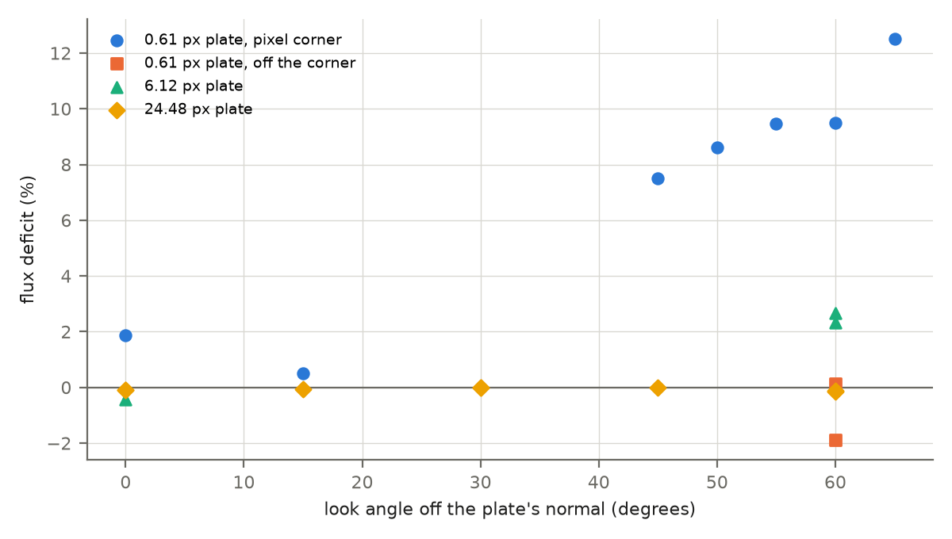
Flux deficit against the look angle off the plate’s normal: the 0.61 px plate centred on a pixel corner and moved off it, the 6.12 px plate, and the 24.48 px plate alone and against the barred background.
The labelled 0.25 m sphere (0.61 px across) follows $Φ(a)$ within its hit count (Table 6): 0.978 to 1.161 of the closed form, with the excess at large phase where the lit part of the disc is a few percent of it. Over seeds at reduced size its closure has a standard deviation of 0.04 at phase 0 and 0.24 at phase 150; with the path count of the focal plane fixed, the phase-150 render reads 0.996.
The 0.25 m sphere at 25 km, native window.
Phase (deg) | Closed form (full px) | Labelled: flux closure | Unlabelled: flux closure
0 | 0.19611 | 0.9810 | 1.0333
20 | 0.18516 | 0.9777 | -
40 | 0.15697 | 0.9807 | -
60 | 0.11943 | 0.9863 | -
80 | 0.08039 | 1.0027 | 1.0317
100 | 0.04634 | 1.0425 | -
120 | 0.02138 | 1.0511 | -
135 | 0.00947 | 1.1607 | -
150 | 0.00291 | 1.1116 | 0.9350

Motion and shutter blur
Platform motion and target motion conserve the hyperresolved plate’s flux to between 0.9980 and 1.0009 over exposures that sweep 0.12 to 24.48 px (Table 7, Figure 2). The two motions give the same ratios to four digits at every size, and the background streaks only under platform motion. The fitted streak reads 0.9743 to 0.9799 of $v t/g$ for sweeps of 6.12 to 24.48 px and plates of 6.12 to 24.48 px, independent of the plate’s width. DIRSIG5 spreads ray times uniformly over the exposure and does not use the platform’s temporal sample count: at 2 samples instead of 10 the image is identical.
Combined motion conserves the flux of the 24.48 px plate (1.0002) but not of smaller ones: 0.9865 at 6.12 px and 0.9633 at 3.06 px, where platform and target motion alone hold it to 0.8 %. The cause is not isolated.
A labelled sub-pixel plate moving across the field loses flux: 0.8727 at 1.22 px sweeping 12.24 px, and 0.7783 at 0.61 px sweeping 6.12 px. The label raises the path count of the pixels holding the object at about the task time only. The other streak pixels start at the adaptive minimum of 20 paths and stop there when no path hits the plate; in a truth render of a longer streak about 15 % of them were hit at all.
Family II streaks and their SatSim controls. The closed-form sweep is $v t/g$; a sweep under 1 px reads long by the optics’ spread.
Spec | Motion | Plate (px) | Exposure (ms) | Closed-form sweep (px) | Fitted sweep / closed form | Flux closure | SatSim control: sweep / closed form
s2s2-blur-static-e5ms | static | 24.48 | 5 | 0.000 | - | 1.0010 | -
s2s2-blur-platform-e0p1ms | platform | 24.48 | 0.1 | 0.122 | 4.9275 | 1.0009 | -
s2s2-blur-platform-e1ms | platform | 24.48 | 1 | 1.224 | 1.0070 | 0.9995 | -
s2s2-blur-platform-e5ms | platform | 24.48 | 5 | 6.120 | 0.9759 | 1.0002 | -
s2s2-blur-platform-e20ms | platform | 24.48 | 20 | 24.480 | 0.9743 | 0.9980 | -
s2s2-blur-target-e0p1ms | target | 24.48 | 0.1 | 0.122 | 4.9275 | 1.0009 | -
s2s2-blur-target-e1ms | target | 24.48 | 1 | 1.224 | 1.0070 | 0.9995 | -
s2s2-blur-target-e5ms | target | 24.48 | 5 | 6.120 | 0.9759 | 1.0002 | 0.9983
s2s2-blur-target-e20ms | target | 24.48 | 20 | 24.480 | 0.9743 | 0.9980 | 0.9965
s2s2-blur-both-e0p1ms-w64 | both | 24.48 | 0.1 | 0.245 | 2.5599 | 1.0016 | -
s2s2-blur-both-e1ms-w64 | both | 24.48 | 1 | 2.448 | 1.0076 | 1.0000 | -
s2s2-blur-both-e5ms-n2-w64 | both | 24.48 | 5 | 12.240 | 0.9809 | 1.0002 | -
s2s2-blur-both-e5ms-w64 | both | 24.48 | 5 | 12.240 | 0.9809 | 1.0002 | -
s2s2-blur-target-r50km-e20ms-w64 | target | 12.24 | 20 | 12.240 | 0.9799 | 0.9904 | -
s2s2-blur-platform-r100km-e20ms-w64 | platform | 6.12 | 20 | 6.120 | 0.9755 | 0.9911 | -
s2s2-blur-target-r100km-e20ms-w64 | target | 6.12 | 20 | 6.120 | 0.9755 | 0.9911 | 0.9942
s2s2-blur-both-r100km-e20ms-w64 | both | 6.12 | 20 | 12.240 | 0.9656 | 0.9865 | -
s2s2-blur-static-r200km-e20ms-w64 | static | 3.06 | 20 | 0.000 | - | 0.9889 | -
s2s2-blur-platform-r200km-e20ms-w64 | platform | 3.06 | 20 | 3.060 | 1.0078 | 1.0082 | -
s2s2-blur-target-r200km-e20ms-w64 | target | 3.06 | 20 | 3.060 | 1.0078 | 1.0082 | -
s2s2-blur-both-r200km-e20ms-w64 | both | 3.06 | 20 | 6.120 | 1.0136 | 0.9633 | -
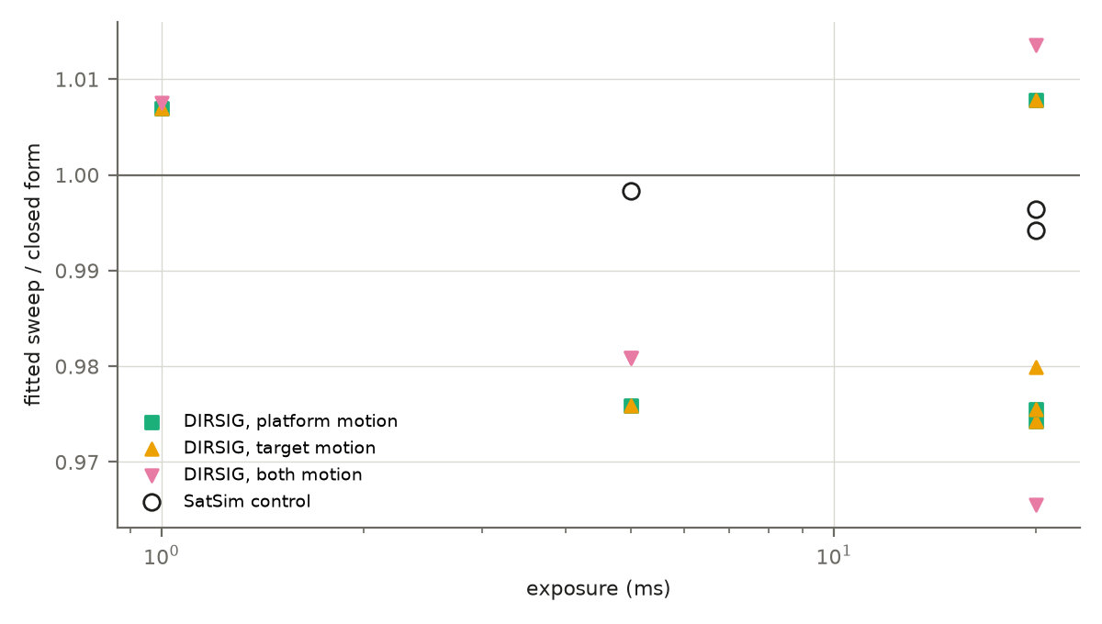
Fitted sweep over the closed form against the exposure for every family II streak of at least 1 px, by motion, and the SatSim controls of the same streaks.

The sampling-effect envelope
Table 8 groups the 110 DIRSIG records of targets at least 0.3 px across by size, motion and label, with the range of their deficits and the SatSim controls of the same geometries. 21 records are outside it: targets under 0.3 px, the look at 75 degrees, and the orbit point whose range is the element set’s. Of its 21 rows, 4 hold every deficit within 1 %.
Deficits against the closed forms by target size in pixels, motion and label.
Size (px) | Motion | Labelled | Records | Flux deficit | Streak deficit | SatSim controls
0.3 to 0.5 | fixed | yes | 4 | +2.3 % to +27.4 % | - | none
0.3 to 0.5 | fixed | no | 1 | +68.0 % | - | none
0.5 to 1 | fixed | yes | 24 | -16.1 % to +12.5 % | - | 4: flux +0.0 %
0.5 to 1 | fixed | no | 5 | -6.8 % to +46.6 % | - | none
0.5 to 1 | target | yes | 1 | +22.2 % | - | none
1 to 2 | fixed | yes | 4 | -0.3 % to +2.1 % | - | none
1 to 2 | fixed | no | 1 | -6.8 % | - | none
1 to 2 | target | yes | 1 | +12.7 % | - | 2: flux +0.0 %
2 to 6 | fixed | yes | 1 | +1.1 % | - | none
2 to 6 | tracked | yes | 2 | -0.6 % | - | none
2 to 6 | platform | yes | 1 | -0.8 % | -0.8 % | none
2 to 6 | target | yes | 1 | -0.8 % | -0.8 % | none
2 to 6 | both | yes | 1 | +3.7 % | -1.4 % | none
6 to 13 | fixed | yes | 13 | -2.3 % to +2.7 % | - | none
6 to 13 | platform | yes | 1 | +0.9 % | +2.4 % | none
6 to 13 | target | yes | 2 | +0.9 % to +1.0 % | +2.0 % to +2.4 % | 1: flux -0.0 %, streak +0.6 %
6 to 13 | both | yes | 1 | +1.3 % | +3.4 % | none
over 13 | fixed | yes | 34 | -1.0 % to +0.0 % | - | none
over 13 | platform | yes | 4 | -0.1 % to +0.2 % | -0.7 % to +2.6 % | none
over 13 | target | yes | 4 | -0.1 % to +0.2 % | -0.7 % to +2.6 % | 2: flux +0.0 %, streak +0.2 % to +0.4 %
over 13 | both | yes | 4 | -0.2 % to -0.0 % | -0.8 % to +1.9 % | none
Figure 3 shows the same records one by one. The spread narrows with size: under one pixel it is set by placement, the label and the hit count, from 2 px up by the edge pixels’ sampling scatter, except under combined motion.
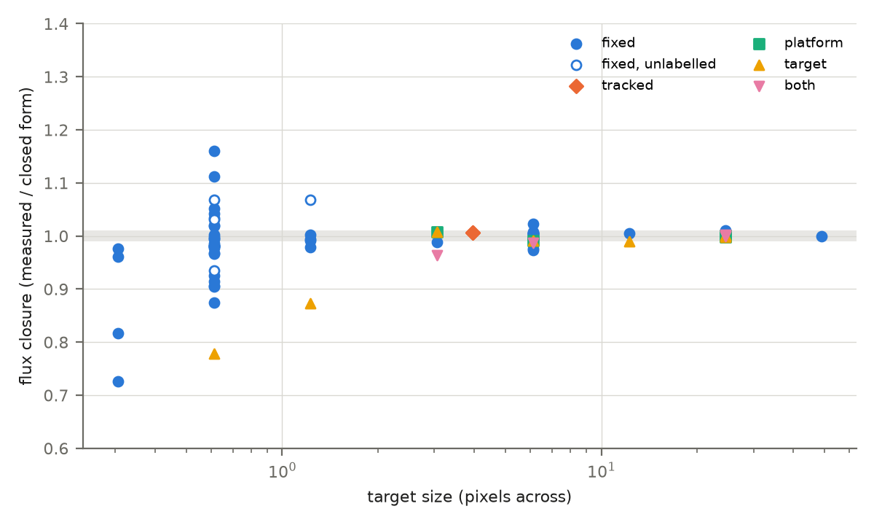
Flux closure of every DIRSIG record of a target at least 0.3 px across against its size in pixels, by motion; open markers are unlabelled targets. The band is ±1 %.

The SatSim control and the attribution of the deficits
SatSim models a target as a point (a Lambertian sphere of any diameter) or as a sprite carrying a stated flux, deposits it on a frame oversampled 15 times, and has no per-pixel ray sampling. Nine controls image the geometries of DIRSIG’s deficits at the same window, with no optical spread (DIRSIG’s specifications state none), with the target’s flux from SatSim’s sphere model or set by construction for a sprite (Table 9, Figure 4). Every control holds its flux to 6.3e-6, the floor SatSim applies to each pixel’s count, and places the target within 0.085 px of its intended position.
SatSim controls and their DIRSIG counterparts.
SatSim control | Flux closure | Centre offset (px) | Sweep / closed form | DIRSIG counterpart | DIRSIG flux closure | DIRSIG sweep / closed form
s2s-satsim-ctl-plate-r100km-v1000mps-e20ms-l0-d0-w64 | 1.000000 | 0.028 | 0.9942 | s2s2-blur-target-r100km-e20ms-w64 | 0.9911 | 0.9755
s2s-satsim-ctl-plate-r12p5km-v1000mps-e5ms-l0-d0-w64 | 0.999995 | 0.022 | - | s2s-unresolved-r12p5km-v1000mps-e5ms-l0-z0-d0-w64 | 0.8727 | -
s2s-satsim-ctl-plate-r25km-v0mps-e5ms-l60-d0-w64 | 0.999996 | 0.047 | - | s2s-unresolved-r25km-v0mps-e5ms-l60-z0-d0-w64 | 0.9051 | -
s2s-satsim-ctl-plate-r25km-v1000mps-e20ms-l0-d0-w64 | 1.000000 | 0.035 | 0.9965 | s2s2-blur-target-e20ms | 0.9980 | 0.9743
s2s-satsim-ctl-plate-r25km-v1000mps-e5ms-l0-d0-w64 | 1.000000 | 0.033 | 0.9983 | s2s2-blur-target-e5ms | 1.0002 | 0.9759
s2s-satsim-ctl-sphere-r12p5km-v1000mps-e5ms-l0-d0-w64 | 0.999994 | 0.085 | - | s2s-unresolved-r12p5km-v1000mps-e5ms-l0-z0-d0-w64 | 0.8727 | -
s2s-satsim-ctl-sphere-r25km-v0mps-e5ms-l0-d0-w64 | 0.999997 | 0.000 | - | s2s-unresolved-r25km-v0mps-e5ms-l60-z0-d0-w64 | 0.9051 | -
s2s-satsim-ctl-sphere-r25km-v0mps-e5ms-l0-d0p25-w64 | 0.999999 | 0.000 | - | s2s-unresolved-r25km-v0mps-e5ms-l60-z0-d0p25-w64 | 0.9985 | -
s2s-satsim-ctl-sphere-r25km-v0mps-e5ms-l0-d0p5-w64 | 0.999999 | 0.000 | - | s2s-unresolved-r25km-v0mps-e5ms-l60-z0-d0p5-w64 | 1.0188 | -
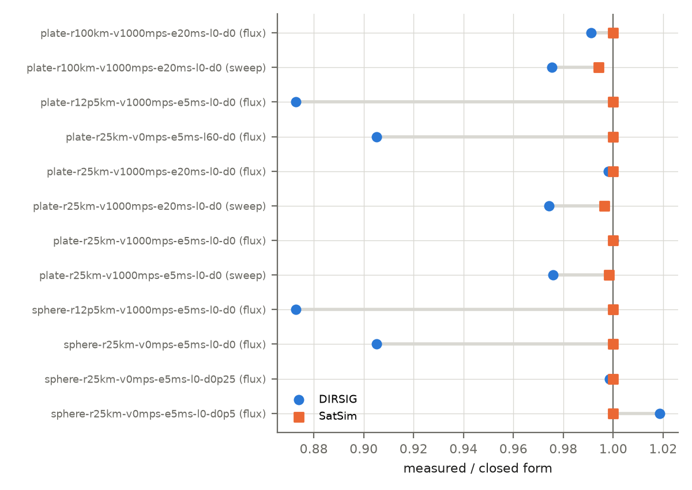
Each SatSim control beside its DIRSIG counterpart: the flux closure and, for a streak, the fitted sweep over the closed form.
The pixel-corner deficit is absent in SatSim: a point on the corner divides into four equal pixels and keeps its flux, and so does the 60 degree plate’s rectangle across the four pixels’ edges. DIRSIG’s own plate moved off the corner holds the closed form. The deficit at the corner is therefore DIRSIG’s sampling of a sub-pixel object lying across pixel edges; its mechanism inside the hypersampled sampling is not isolated.
The streak shortfall is absent in SatSim, which reads 0.9942 to 0.9983 of the closed form through the same fit where DIRSIG reads 0.9743 to 0.9759. Controls outside the run-spec vocabulary, in which the assembled job’s platform file fixes DIRSIG’s path count per pixel, isolate the cause (Appendix B). At a fixed 1000 paths per pixel the sweep reads 0.9988 and 0.9983 at the two geometries. At a fixed 20 paths it reads 0.9874 and 0.9923 for two seeds, not the $(n−1)/n$ of a sweep sampled at $n$ instants. The shortfall goes with DIRSIG’s adaptive stop, which ends a pixel’s sampling between 20 and 100 paths; how it shortens the share of the ramp pixels is not isolated.
The flux lost by a moving sub-pixel object is absent in SatSim: the moving sprite and sphere at 1.22 px keep 0.999995 and 0.999994 of it where DIRSIG keeps 0.8727. No control exists at 0.61 px. Three deficits have no attribution in the records: combined motion at a resolved size, the moving plate at 0.61 px, and the resolved plate’s look alone. Each needs a fixed path count, which no run-spec member states.

Determinism and reproducibility
With one rendering thread and a stated seed, DIRSIG5 repeats a render bit for bit. All 62 family I and II images rendered again on a later day carry the digest first recorded (62 of 62). Three jobs, each rendered under a fresh home directory, the same one again and the user’s, give equal products in 3 of 3 cases with 0 writes to the home directory. Batches of up to 8 concurrent one-thread jobs give the single job’s image in 8 of 8 batches. Two full one-thread renders of the install’s LightCurve1 demonstration are identical in all 1,681 outputs.
At more than one thread the result depends on the work’s division (Table 10, Figure 5). A frame of 4,010,000 values from the same demonstration, rendered at one, two, four and the default thread count, gives two patterns. At two and four threads, values differ by at most 2.2e-6 relative, a few single-precision roundings from the order of summation; two renders at two threads were identical, two at four were not. At the default count, 4 to 13 of the 2,923 lit pixels drew other random samples and differ in many bands by up to 3.3 % of a value; the frame’s sum moves by at most 1.4e-5 relative. In a sweep of the install’s demonstrations at the default thread count, 43 of 125 gave different digests on repeat. One thread costs 3.1 to 3.7 times the default wall time. A seed alone does not make repeats identical; the thread count must be one, and it is part of the specification and of its run identifier.
Pair (threads: t1, t2, t4, default td) | Values differing | Pixels differing (of lit) | Largest relative difference | RMS difference / RMS signal | Image sum, relative | Class
t1-a vs t2-a | 19 | 1 of 2,923 | 1.1e-7 | 1.8e-10 | 8.1e-13 | float-order
t1-a vs t4-a | 639 | 2 of 2,923 | 2.2e-6 | 4.2e-8 | 8.3e-10 | float-order
t1-a vs t4-b | 27 | 1 of 2,923 | 1.1e-7 | 4.2e-10 | 2.1e-12 | float-order
t1-a vs td-a | 1,122 | 4 of 2,923 | 3.1e-2 | 2.6e-4 | 7.4e-6 | sampling-noise
t1-a vs td-b | 2,110 | 11 of 2,923 | 3.3e-2 | 6.7e-4 | 6.7e-6 | sampling-noise
t1-a vs td-c | 1,400 | 9 of 2,923 | 1.6e-2 | 2.3e-4 | 4.4e-6 | sampling-noise
t2-a vs t2-b | 0 | 0 of 2,923 | 0.0e0 | 0.0e0 | 0.0e0 | identical
t2-a vs t4-a | 658 | 3 of 2,923 | 2.2e-6 | 4.2e-8 | 8.3e-10 | float-order
t4-a vs t4-b | 666 | 3 of 2,923 | 2.2e-6 | 4.2e-8 | 8.3e-10 | float-order
td-a vs td-b | 2,756 | 13 of 2,923 | 3.3e-2 | 7.2e-4 | 1.4e-5 | sampling-noise
td-a vs td-c | 1,882 | 9 of 2,923 | 3.1e-2 | 3.5e-4 | 3.0e-6 | sampling-noise
td-b vs td-c | 2,540 | 12 of 2,923 | 3.3e-2 | 7.1e-4 | 1.1e-5 | sampling-noise
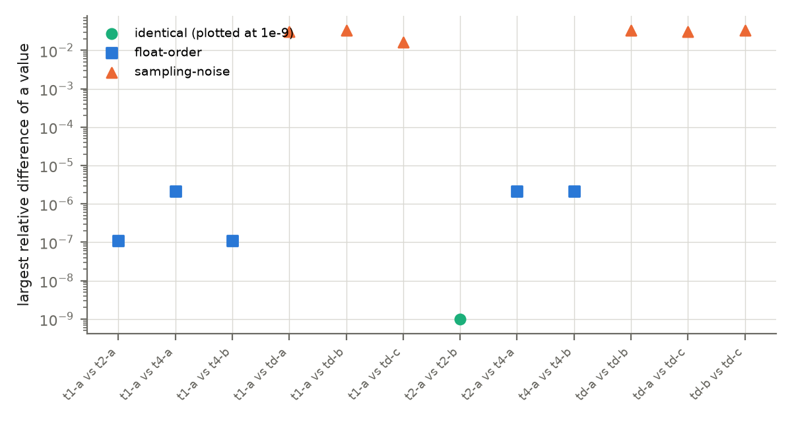
Largest relative difference of a value of one LightCurve1 frame between two renders, by the thread counts of the pair and the class of the difference.
Table: Value-by-value comparison of one frame of LightCurve1 between renders at one (t1), two (t2), four (t4) and the default (td) number of threads.

Limitations
Window. The small window moves the image sum by up to 1.3 % for a sub-pixel target. Small-window angle cases are referred to the window’s own nadir record; a small-window record is not a substitute for a native one.
Label. At this template’s multiplier a labelled pixel takes 2000 paths and an unlabelled one at most 100, so a labelled and an unlabelled sub-pixel target differ in hit-count scatter by a factor of about 4.5, and an effect of the label itself on a deficit of a few percent cannot be separated from that scatter.
Unexpressible cases. The run specification cannot state a fixed path count per pixel, the control that would test every unattributed deficit; it was applied here only by editing an assembled job. Every generated scene has one Lambertian material, so a specular facet is not exercised. A specification takes one scene, and no committed scene holds an Earth model, so the Earth’s limb and albedo as a background are not exercised. One task window holds one capture. A surface more than about 20 km along a ray inside the scene was not intersected, which bounds the depth of a scene’s geometry.
Optics. The sensor specification has no point-spread function; DIRSIG applies an aperture-dependent spread of its own, fitted as a Gaussian of $σ=0.18$ px, which no member changes.
Scope. One sensor, one band, black backgrounds and a uniform atmosphere; no comparison with a real sensor’s images and no hardware validation.

References
DIRSIG5 documentation, Rochester Institute of Technology, release 2026.38.0.a020954 as installed.
SatSim 0.26.1 software and documentation, as installed.
Standard radiometry: the Lambertian sphere’s phase function and the radiance of a Lambertian surface.

Appendix A: case definitions
Specifications by family and group: the number of specifications, the number recorded, and the values of each axis.
Family | Group | Specs | Recorded | Range (km) | Exposure (ms) | Look (deg) | Solar zenith (deg) | Relative speed (m/s) | Offset (px) | Window (px)
I | hyperresolved | 21 | 21 | 12.5, 25, 50, 100 | 1, 5, 20 | 0, 30, 45, 60 | 0, 30, 45, 60, 75 | 0 | 0, 0.5 | 64, 500
I | unresolved | 41 | 41 | 12.5, 25, 50, 100, 200, 400, 773.093, 800 | 1, 5, 20 | 0, 1.8, 15, 30, 45, 50, 55, 60, 65 | 0, 30, 60 | 0, 1000, 7500 | 0, 0.25, 0.5, 0.75 | 64, 500
I | unresolved plain | 26 | 8 | 12.5, 25, 50, 100, 200, 400, 800 | 1, 5, 20 | 0, 30, 60 | 0, 30, 60 | 0 | 0, 0.25, 0.5, 0.75 | 64, 500
II | both | 10 | 6 | 25, 100, 200 | 0.1, 1, 5, 20 | 0 | - | 2000 | - | 64, 500
II | look | 6 | 6 | 25 | 5 | 0, 15, 30, 45, 60, 75 | - | - | - | 500
II | orbit | 2 | 2 | - | 0.1, 20 | - | - | - | - | 500
II | platform | 6 | 6 | 25, 100, 200 | 0.1, 1, 5, 20 | 0 | - | 1000 | - | 64, 500
II | static | 2 | 2 | 25, 200 | 5, 20 | 0 | - | - | - | 64, 500
II | target | 7 | 7 | 25, 50, 100, 200 | 0.1, 1, 5, 20 | 0 | - | 1000 | - | 64, 500
III | background | 4 | 4 | 25 | 5 | 0 | 0, 30, 60, 75 | - | - | 500
III | hyperresolved | 16 | 16 | 25, 100 | 5 | 0, 10, 20, 30, 40, 50, 60, 67.5, 75 | 0, 10, 20, 30, 40, 50, 60, 67.5, 75 | - | - | 64, 500
III | unresolved | 9 | 9 | 25 | 5 | 0, 10, 20, 30, 40, 50, 60, 67.5, 75 | 0, 10, 20, 30, 40, 50, 60, 67.5, 75 | - | - | 500
III | unresolved plain | 3 | 3 | 25 | 5 | 0, 40, 75 | 0, 40, 75 | - | - | 500
SatSim control | moving, plate | 1 | 1 | 12.5 | 5 | 0 | - | 1000 | 0 | 64
SatSim control | moving, sphere | 1 | 1 | 12.5 | 5 | 0 | - | 1000 | 0 | 64
SatSim control | streak, plate | 3 | 3 | 25, 100 | 5, 20 | 0 | - | 1000 | 0 | 64
SatSim control | subpixel, plate | 1 | 1 | 25 | 5 | 60 | - | 0 | 0 | 64
SatSim control | subpixel, sphere | 3 | 3 | 25 | 5 | 0 | - | 0 | 0, 0.25, 0.5 | 64

Appendix B: controls outside the records
The figures below are stated in the committed characterization and determinism documents and are not records: scratch renders in which the assembled job was edited (a fixed path count, another seed), truth renders, and counts. docs/study/data/document_figures.csv holds each with its document and the commit that added it.
Figures from committed documents used in the text.
Id | Value | Unit | Round | Definition
fixed1000_both_25km_5ms | 0.9988 | sweep / closed form | 39 | fitted sweep of s2s2-blur-both-e5ms-w64 rendered at a fixed 1000 paths per pixel (focal-plane convergence, scratch)
fixed1000_target_100km_20ms | 0.9983 | sweep / closed form | 39 | fitted sweep of s2s2-blur-target-r100km-e20ms-w64 at a fixed 1000 paths per pixel (scratch)
fixed20_seed1 | 0.9874 | sweep / closed form | 39 | fitted sweep of s2s2-blur-both-e5ms-w64 at a fixed 20 paths per pixel, seed 1 (scratch)
fixed20_seed2 | 0.9923 | sweep / closed form | 39 | the same at a fixed 20 paths per pixel, seed 2 (scratch)
seed2_100km | 0.99641 | flux closure | 30 | 20 m plate at 100 km (native, default sampling), seed 2 (scratch)
seed3_100km | 1.01350 | flux closure | 30 | 20 m plate at 100 km (native, default sampling), seed 3 (scratch)
seed2_50km | 0.99694 | flux closure | 30 | 20 m plate at 50 km (native, default sampling), seed 2 (scratch)
seed3_50km | 1.00495 | flux closure | 30 | 20 m plate at 50 km (native, default sampling), seed 3 (scratch)
fixed1000_16px_100km | 1.0009 | flux closure | 30 | 20 m plate at 100 km, 16 x 16 window, fixed 1000 paths per pixel (scratch)
fixed20_16px_100km | 1.01857 | flux closure | 30 | 20 m plate at 100 km, 16 x 16 window, fixed 20 paths per pixel (scratch)
nocore_ratio | 1.0039 | flux closure | 30 | labelled 0.5 m plate at 25 km with no backstop and –disable_earth_core; byte-identical to the backstop render (16 x 16, scratch)
sphere_fixed1000_a150 | 0.9998 | flux closure | 31 | 10 m sphere at phase 150, 64 x 64, fixed 1000 paths per pixel (scratch)
sphere_seed_sigma_a0 | 0.04 | standard deviation | 31 | 0.25 m labelled sphere at phase 0, five seeds at 16 x 16
sphere_seed_sigma_a150 | 0.24 | standard deviation | 31 | 0.25 m labelled sphere at phase 150, five seeds at 16 x 16
sphere_200k_a150 | 0.996 | flux closure | 31 | 0.25 m labelled sphere at phase 150 with 2000 focal-plane paths times the template’s multiplier 100 (scratch)
fixed_paths_hi | 1000 | paths per pixel | 39 | the fixed path count per pixel of the streak controls (focal-plane convergence, scratch)
fixed_paths_lo | 20 | paths per pixel | 39 | the lower fixed path count per pixel of the streak controls (scratch)

