

RAFIN COMPANY WEBSITE REDESIGN BRIEF
Codex Planning Input — based on the current live site, current repository state, supplied client notes, and the user-provided visual references

Document intent
- This document translates the client requests into a clear English brief for Codex.
- Client requests are preserved as locked scope items and are separated from additional recommendations that come from the repository audit.
- Recommended implementation direction: keep the existing static HTML/CSS/JS architecture and extend it carefully rather than rebuilding the site into a new framework.

Prepared on 09 April 2026

1. Purpose, references, and scope lock
Important scope rule
Items under "Locked client requirements" are fixed client instructions. Codex should implement them as stated and should not reinterpret, soften, remove, or replace them. The section titled "Additional recommendations from repo audit" is advisory and clearly separate from the fixed scope.

Primary references reviewed
- Current live website: rafincompany.com
- Current public repository: KevinLika005/RafinCompany
- Client content file: Plani-Struktura.txt
- User-supplied visual references for footer input/button sizing, careers card format, projects filter bar, and project previous/next navigation
- Eberhard reference direction for Building Materials and Careers visual language
Current codebase summary for Codex
- The website is currently a static multi-page HTML/CSS/JavaScript site, not a React/Vue/Next.js project.
- The current flow already uses page-specific templates: index.html, projects.html, category.html, and project.html.
- Structured content is already partially data-driven through /data/*.js and consumed by /js/*.js helpers.
- Header and top-strip markup are duplicated across multiple page templates, so global header changes must be applied across every page, not only on the homepage.
- The redesign should therefore extend the existing architecture, clean it up, and centralize repeated patterns where practical, instead of changing stacks.
Key repository files already shaping the current experience
File | Current role in the site
index.html | Homepage shell with top strip, header, services, categories grid, certifications, careers section, and footer mount point.
projects.html | All-projects page with current button-based category filters and project grid.
category.html | Category detail page with hero, description, and filtered project grid.
project.html | Single-project page with hero slider, info sidebar, and current previous/next navigation.
data/categories.js / data/projects.js | Current project taxonomy and sample project content.
data/jobs.js / js/jobs-section.js | Current careers data and the current simple card renderer.
js/footer-company.js | Current footer and homepage stats renderer.
css/phase9-fixes.css | Current patch layer for dropdown, projects page filters, footer responsiveness, jobs cards, and project navigation responsiveness.

2. Locked client requirements (translated into English)
Instruction handling note
The items below intentionally preserve the client meaning. They are presented in English only for clarity to Codex. No scope reduction has been applied.

2.1 Global header and top-of-page changes
- Remove the entire top strip that currently sits above the main website header. This is the strip with the social icons, location, and phone numbers.
- Keep the main header/navigation bar, but update it so that the Careers section is also included in the header menu bar.
- The Projects item must continue to support the project-category dropdown behavior on hover.
2.2 New Building Materials section
- Add a new section for the construction materials used by the company.
- The visual reference for this section is the Building Materials section from eberhard.ch.
- This is a new section and must be incorporated into the redesigned website structure.
2.3 Careers section requirements
- The Careers section must remain part of the website and must also be reachable from the header menu bar.
- The Careers section must support filtering. Each job position must have two filters: Career Level and Job Category.
- Job Category values must use the categories from the client content file: Transport, Construction, Construction Management, Service and Maintenance, and Vehicle Technology.
- Each job position card must follow the supplied reference layout style.
- The exact job positions to include are: Truck Driver, Construction Worker, Surveyor, Machinery Mechanic, Electrical Engineer, Mechanical Engineer, Industrial Electrician, Team Leader, and Mechatronics Technician.
2.4 Projects page and project-detail requirements
- The projects page filter controls must be redesigned. Instead of the current button set, the page must use a top filter bar styled like the supplied reference image.
- This projects filter bar must stay fixed at the top of the page while the user scrolls.
- Project previous/next navigation on the single project page must be redesigned to match the supplied reference layout.
- The project previous/next navigation must continue to navigate only within the same project group/category, exactly as required in the original client brief.
- The existing project-detail behavior from the earlier brief remains in force: project pages open with a hero banner/slider at the top, project information below, and same-category previous/next links before the footer.
2.5 Footer changes
- Social media icons in the footer must be larger and more visible.
- The footer e-mail field and the Send button must be the same height/size. The current mismatch must be corrected.
- The footer must continue to contain the company logo, department contact information, address, and social icons.
2.6 Contacts section
- Add a dedicated Contacts section.
- This Contacts section must contain a contact data form with a message field.
- This Contacts section must also contain two maps for two different locations, with one map on the left side and the other on the right side.

3. Client content that Codex must preserve and wire into the redesign
3.1 Service / project category list to use
Category | Notes for implementation
Civil Buildings | Use as one of the homepage category labels and projects grouping options.
Road Infrastructure | Use in homepage categories, projects filters, and project grouping.
Electrical Infrastructure | Use in homepage categories, projects filters, and project grouping.
Industrial Projects (Oil) | Use in homepage categories, projects filters, and project grouping.
Technology | Use in homepage categories, projects filters, and project grouping.
Water Infrastructure | Use in homepage categories, projects filters, and project grouping.

3.2 Careers taxonomy and positions to load
Job position | Job category
Truck Driver | Transport
Construction Worker | Construction
Surveyor | Construction Management
Machinery Mechanic | Service and Maintenance
Electrical Engineer | Service and Maintenance
Mechanical Engineer | Service and Maintenance
Industrial Electrician | Service and Maintenance
Team Leader | Construction Management
Mechatronics Technician | Vehicle Technology

3.3 Departments, certifications, stats, and address
Content type | Exact client data to carry into the redesign
Departments | Technical Department, Legal Department, Finance Department — all three in one location.
Construction materials note | Include recycling of construction materials as part of the updated company presentation / materials story.
Certificates | ISO 9001:2015; ISO 50001:2018; ISO 14001:2015; ISO 450001:2018; ISO 39000:2012; ISO 27001:2013; ISO 39001:2012; PAS 99:2012; ISO 3834-2:2012; EN 1090-1:2009+A1:2011.
Stats | 570 completed projects; 300 staff; 11 certifications.
Address | Tiranë. Rruga “Haxhi Kika”, Administrative Unit No. 5, Property No. 6/538 H 1, Apartment 4.

Data-model note for Codex
Career Level is required by the client, but current jobs.js only stores title and job category. Codex must extend the jobs dataset so every job has a Career Level value in addition to Job Category, while preserving the client-defined job categories listed above.

4. Visual references supplied for implementation direction
Reference A — Footer e-mail field and Send button must visually align to the same height

Reference A. Use this as the sizing/alignment target for the footer subscription/contact input and the Send button.

Reference B — Careers card format

Reference B. Careers cards should follow this visual direction: image-led card, strong title block, and visible meta information for filtering.

5. Project browsing references
Reference C — Sticky projects filter bar
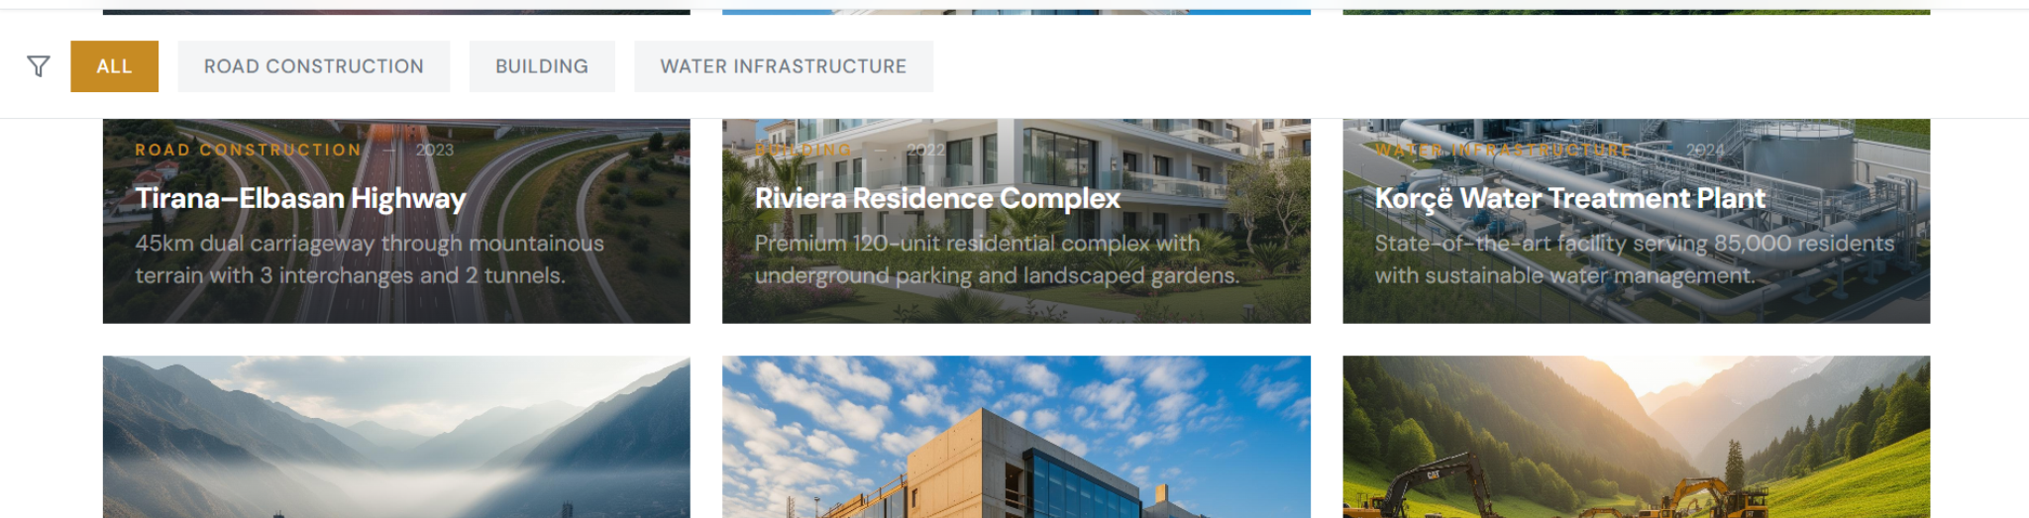
Reference C. Replace the current button-based project filters with a sticky top filter bar in this direction.

Reference D — Previous / Next project navigation layout
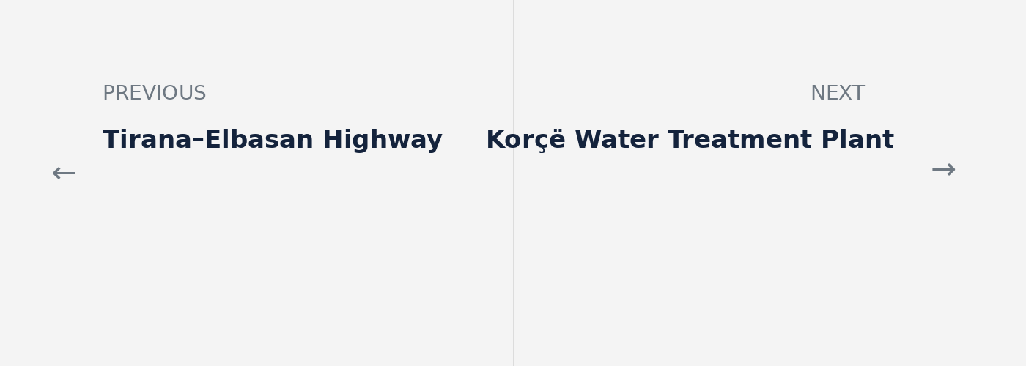
Reference D. Replace the current small buttons with large previous/next navigation blocks styled in this direction.

6. Additional recommendations from repository audit (advisory, not locked scope)
- Do not redesign only index.html. The top strip, primary navigation, and footer structure are duplicated across index.html, projects.html, category.html, and project.html, so global changes must be applied consistently across all templates.
- Create a dedicated materials data source, for example data/materials.js, instead of hardcoding construction materials directly into HTML. This will make the Building Materials section editable without changing templates.
- Create a dedicated contacts data source, for example data/contacts.js, to hold the two map locations, addresses, labels, and contact details for the new Contacts section.
- Replace placeholder or legacy social links. The current code still contains placeholder Facebook/Twitter/Google Plus/Vimeo/YouTube/Pinterest links in some templates. After the redesign, only the intended channels should remain and all URLs should be real.
- Normalize and centralize styling. The current implementation mixes base CSS, patch CSS, page-level inline styles, and style injection from JavaScript. For the redesign phase, Codex should move new section styling into a dedicated stylesheet to reduce drift and duplication.
- Keep the current static architecture. The repository already has a workable data-driven layer with /data and /js helpers. A careful extension of this architecture is lower risk than a framework migration.
- Preserve and improve the current invalid-slug / empty-state behavior for projects and categories. The code already has fallback handling; it should remain after the redesign and be visually polished.
- Add keyboard, hover, focus, and mobile interaction coverage for dropdowns, sticky filters, career filters, project cards, and map embeds.
- Because the top strip is being removed, re-check sticky header offsets and scroll calculations on desktop and mobile. The current RD Navbar offsets were tuned for a taller header stack.
Repository findings that justify the recommendations above
- Current jobs.js and jobs-section.js only render simple title/category cards, so the careers redesign will require a schema extension and a new renderer.
- Current projects.html uses simple button filters rather than a sticky bar, so the filter DOM and CSS both need replacement.
- Current project.html uses small primary buttons for previous/next plus a middle all-projects button, so the page layout must be rebuilt to match the supplied navigation reference.
- Current data/projects.js contains only a small sample project set and not all categories are populated with real project content, so content migration is required before final QA.
- Current footer-company.js already generates footer markup, which is useful, but the design still needs resizing, stronger social icon visibility, and the corrected input/button proportions requested by the client.

7. File impact map and acceptance checklist for Codex
7.1 High-probability file impact map
File | Expected redesign responsibility
index.html | Remove the top strip, add Careers to nav, insert Building Materials section, update Careers section mount, and add the new Contacts section.
projects.html | Replace the current filter button area with a sticky filter bar shell and updated project cards.
project.html | Replace the current previous/next button strip with the new two-column navigation layout.
category.html | Align category page project cards and header/footer structure with the redesigned project browsing system.
js/jobs-section.js + data/jobs.js | Extend the jobs schema and render the new filterable careers UI.
js/projects-page.js | Implement sticky project filters and updated active-state behavior.
js/project-page.js | Keep same-category navigation logic, but output the new previous/next layout and neighboring project titles.
js/footer-company.js | Resize footer social icons, equalize input/button sizing, and align footer structure with the new design.
data/materials.js + js/materials-section.js | New data/model and renderer for Building Materials.
data/contacts.js + js/contacts-section.js | New data/model and renderer for the dedicated Contacts section with two maps.
data/translations.js | Add all new UI labels for Careers, Career Level, Job Category, Materials, Contacts, and map/location labels.
css/phase9-fixes.css or a new redesign stylesheet | Centralize all redesign-specific CSS instead of adding more inline styles.

7.2 Minimum acceptance checklist
- Top strip removed on every relevant page template, not only on the homepage.
- Careers is visible in the main navigation on all relevant pages.
- Building Materials section exists and matches the intended Eberhard-inspired visual direction.
- Every career item is filterable by Career Level and Job Category, and every card follows the supplied visual format.
- Project filters use a sticky top bar, not the old button cluster.
- Project previous/next navigation matches the new layout and still stays within the same category only.
- Footer social icons are visibly larger and the footer e-mail input and Send button are the same height.
- Dedicated Contacts section exists with a contact form and two side-by-side maps for two different locations.
- Desktop, tablet, and mobile layouts are checked after the sticky header/top-strip change.
- No placeholder social links, placeholder maps, or sample-only project data remain in the final launch-ready version.
Final implementation note for Codex
Treat this document as the scope and architecture brief, not as permission to improvise beyond the locked client requirements. Where the repo audit adds recommendations, they are clearly marked as advisory. Where the client specified a change, that change takes priority.

