1. Missing Value

|  |  |  |  |  |  |  |
| --- | --- | --- | --- | --- | --- | --- |
|  | A1 | A2 | A3 | A4 | A5 | A6 |
| 001 | 0 | 0 | 0 | 0 | 0 | 0 |
| 002 | 0 | 0 | 0 | 0 | 0 | 0 |
| 003 | 0 | 0 | 0 | 0 | 0 | 0 |
| 004 | 0 | 0 | 0 | 0 | 0 | 0 |
| 005 | 0 | 0 | 0 | 0 | 0 | 0 |
| 006 | 0 | 0 | 0 | 0 | 0 | 0 |
| 007 | 0 | 0 | 0 | 0 | 0 | 0 |
| 008 | 0 | 0 | 0 | 0 | 0 | 0 |
| 009 | 0 | 0 | 0 | 0 | 0 | 0 |
| 010 | 0 | 0 | 0 | 0 | 0 | 0 |
| 011 | 0 | 0 | 0 | 0 | 0 | 0 |
| 012 | 0 | 0 | 0 | 0 | 0 | 0 |
| 013 | 0 | 0 | 0 | 0 | 0 | 0 |
| 014 | 0 | 0 | 0 | 0 | 0 | 0 |
| 015 | 2 | 2 | 2 | 2 | 2 | 2 |
| 016 | 2 | 2 | 2 | 2 | 2 | 2 |
| 017 | 2 | 2 | 2 | 2 | 2 | 2 |
| 018 | 2 | 2 | 2 | 2 | 2 | 2 |
| 019 | 2 | 2 | 2 | 2 | 2 | 2 |
| 020 | 2 | 2 | 2 | 2 | 2 | 2 |
| 021 | 2 | 2 | 2 | 2 | 2 | 2 |
| 022 | 0 | 0 | 0 | 0 | 0 | 0 |
| 023 | 0 | 0 | 0 | 0 | 0 | 0 |
| 024 | 0 | 0 | 0 | 0 | 0 | 0 |

37, 134

|  |  |  |
| --- | --- | --- |
| Input_C_001-007,  Input_C_015-020 ,  Input_C_022,  Input_C_031-034,  Input_C_131-137 | 0 |  |
| Input_C_008-014  Input_C_013 | 3 | 197, 346, 347 |
| Input_C_021 | 1 | 172 |
| Input_C_023-026,  Input_C_028,  Input_C_030 | 1 | 165 |
| Input_C_027 | 2 | 107, 165 |
| Input_C_029 | 2 | 165, 206 |
| Input_C_035-038 | 1 | 173 |
| Input_C_039-062  Input_C_046  Input_C_049  Input_C_050  Input_C_057  Input_C_058 | 5 | 197, 249, 345, 346, 347 |
| Input_C_063-066,  Input_C_072 | 90 | 3, 4, 8, 9, 11, 13, 14, 16, 18, 20, 24, 28, 30, 31, 32, 34, 36, 40, 41, 44, 47, 48, 50, 52, 55, 58, 64, 69, 70, 73, 74, 77, 78, 85, 86, 87, 91, 94, 95, 96, 97, 102, 111, 117, 119, 124, 125, 126, 131, 132, 136, 137, 141, 142, 145, 153, 161, 162, 168, 172, 174, 177, 179, 181, 183, 187, 189, 191, 197, 199, 200, 204, 205, 207, 211, 212, 215, 216, 218, 219, 226, 236, 241, 242, 247, 250, 251, 252, 256, 263 |
| Input_C_067-071,  nput_C_077-081 | 91 | 3, 4, 8, 9, 11, 13, 14, 16, 18, 20, 24, 28, 30, 31, 32, 34, 36, 40, 41, 44, 47, 48, 50, 52, 55, 58, 64, 69, 70, 73, 74, 77, 78, 85, 86, 87, 91, 94, 95, 96, 97, 102, 111, 117, 119, 124, 125, 126, 131, 132, 136, 137, 141, 142, 145, 153, 161, 162, 168, 172, 174, 177, 179, 181, 182, 183, 187, 189, 191, 197, 199, 200, 204, 205, 207, 211, 212, 215, 216, 218, 219, 226, 236, 241, 242, 247, 250, 251, 252, 256, 263 |
| Input_C_073-076,  Input_C_082 | 92 | 3, 4, 8, 9, 11, 13, 14, 16, 18, 20, 24, 28, 30, 31, 32, 34, 36, 40, 41, 44, 47, 48, 50, 52, 55, 58, 64, 69, 70, 72, 73, 74, 77, 78, 85, 86, 87, 91, 94, 95, 96, 97, 102, 111, 117, 119, 124, 125, 126, 131, 132, 136, 137, 141, 142, 145, 153, 161, 162, 168, 172, 174, 177, 179, 181, 182, 183, 187, 189, 191, 197, 199, 200, 204, 205, 207, 211, 212, 215, 216, 218, 219, 226, 236, 241, 242, 247, 250, 251, 252, 256, 263 |
| Input_C_083-091 | 91 | 3, 4, 8, 9, 11, 13, 14, 16, 18, 20, 24, 28, 30, 31, 32, 34, 36, 40, 41, 44, 47, 48, 50, 52, 55, 58, 64, 69, 70, 73, 74, 77, 78, 85, 86, 87, 91, 94, 95, 96, 97, 102, 111, 117, 119, 124, 125, 126, 131, 132, 136, 137, 141, 142, 145, 146, 153, 161, 162, 168, 172, 174, 177, 179, 181, 183, 187, 189, 191, 197, 199, 200, 204, 205, 207, 211, 212, 215, 216, 218, 219, 226, 236, 241, 242, 247, 250, 251, 252, 256, 263 |
| Input_C_092-131  Input_C_096 | 3 | 70, 86, 197 |

Impute：mean, median, 0

1. Similarity of A

001

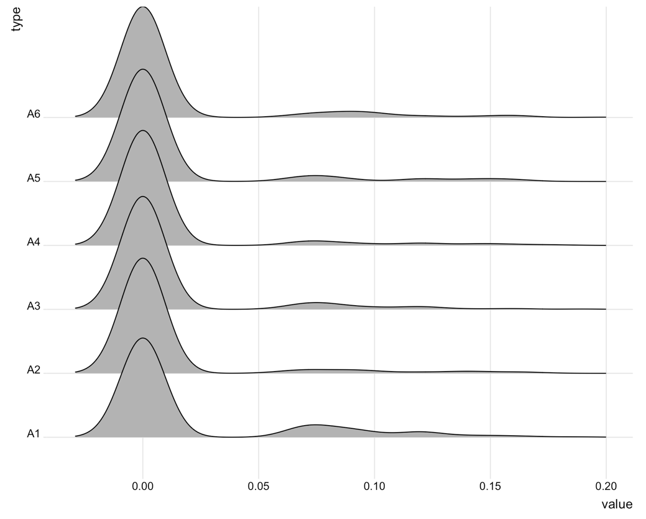

002

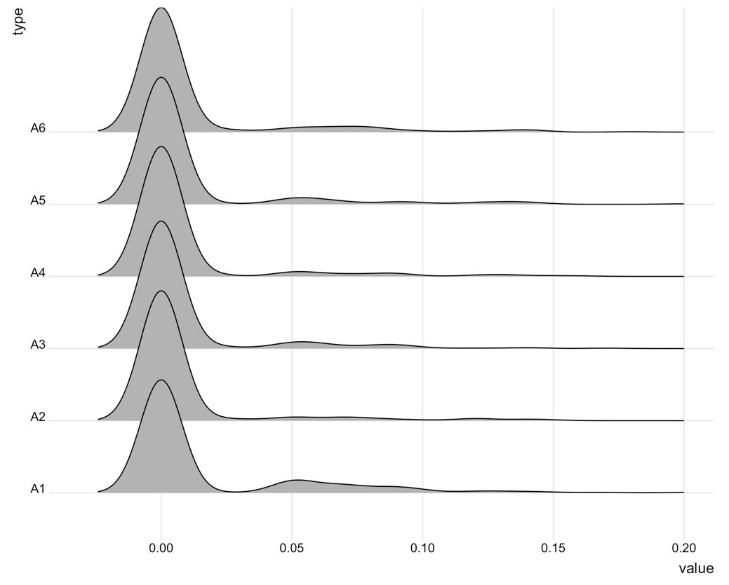

003

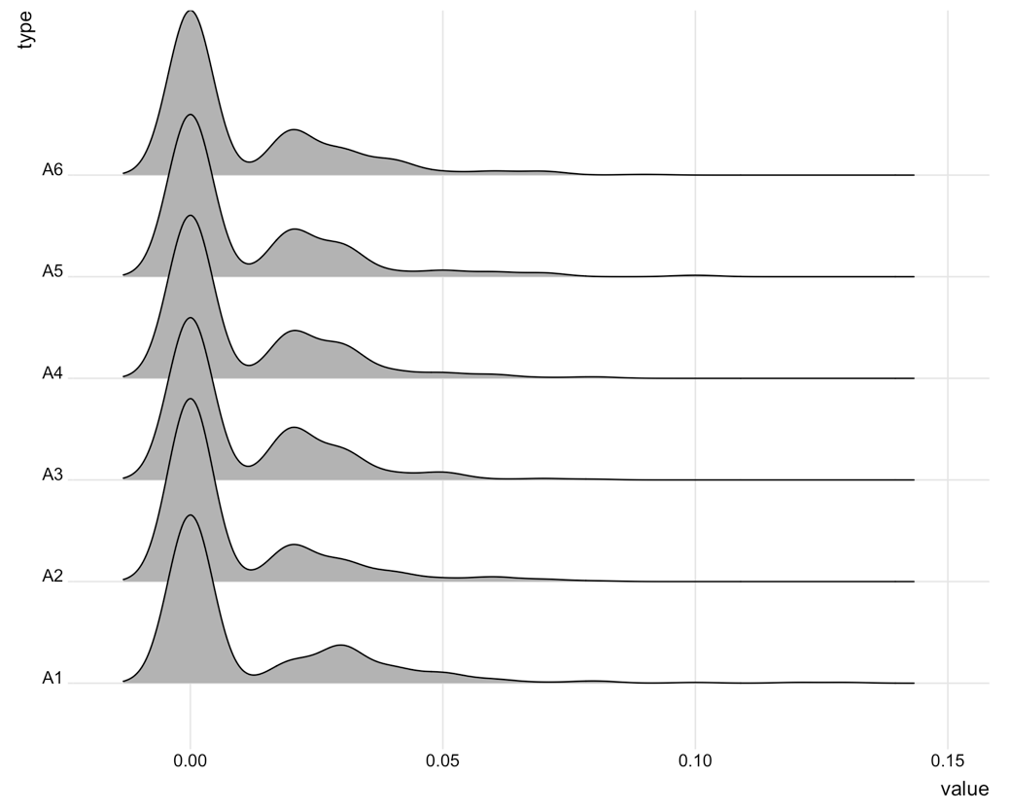

004

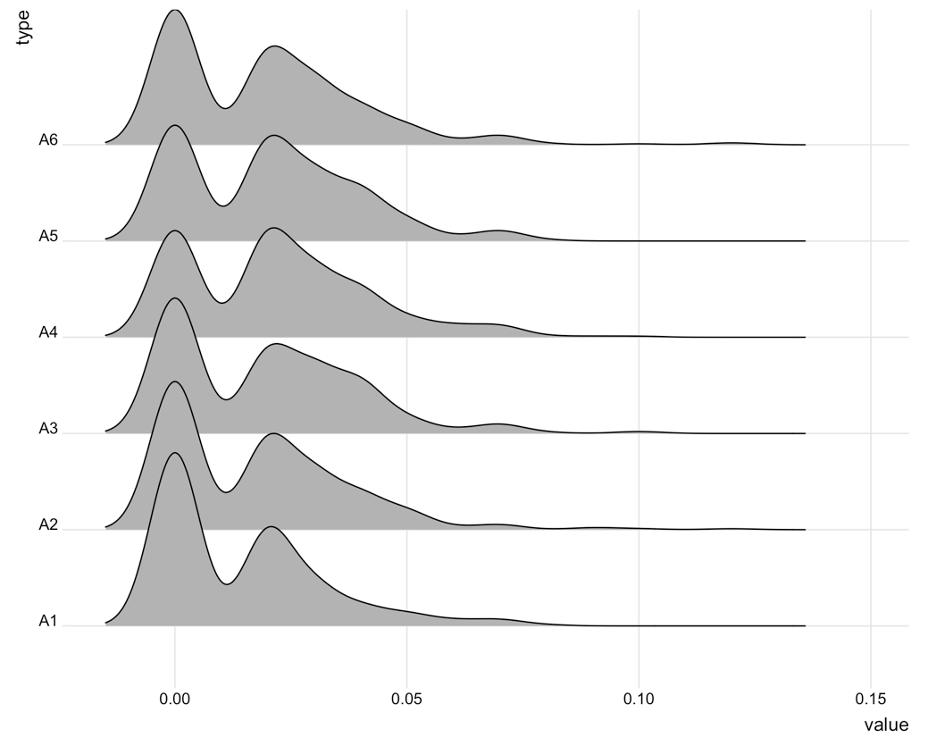

005

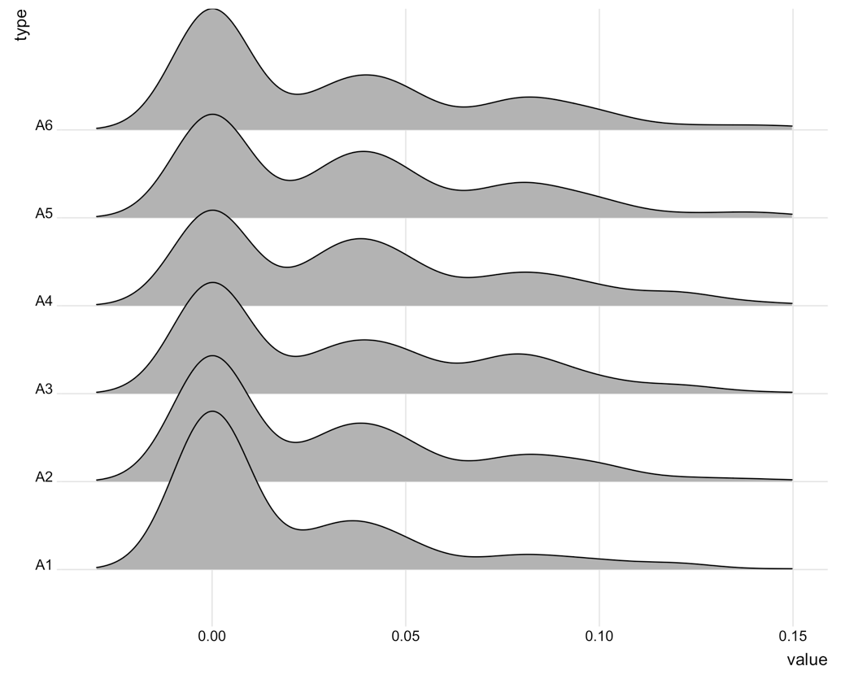

006

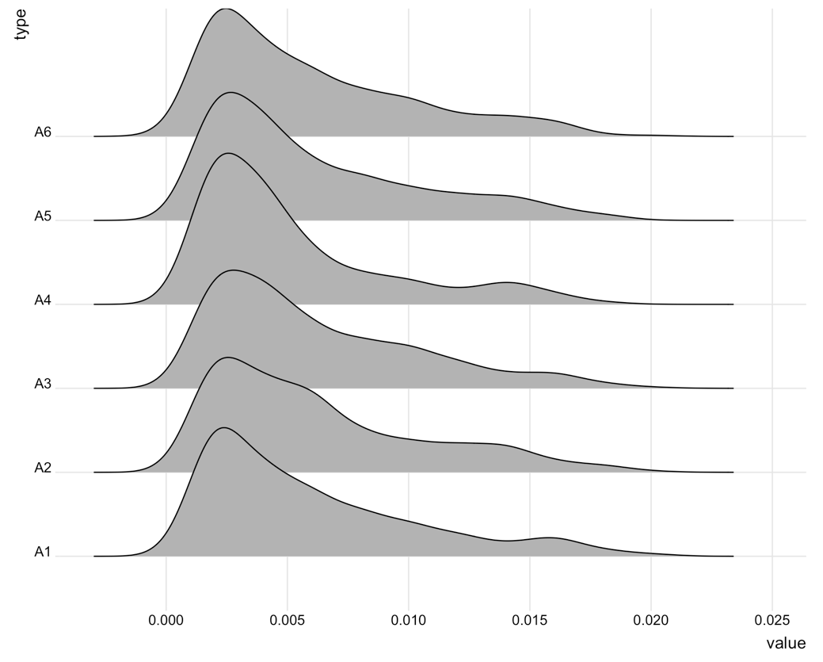

007

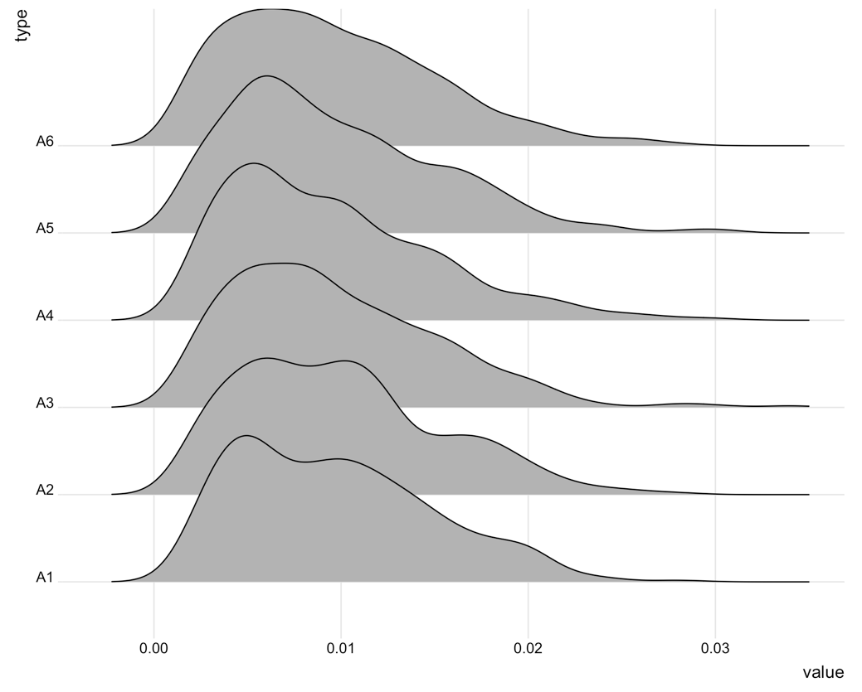

008

Input_A2_002只有單一值：0.002 （沒有解釋力）

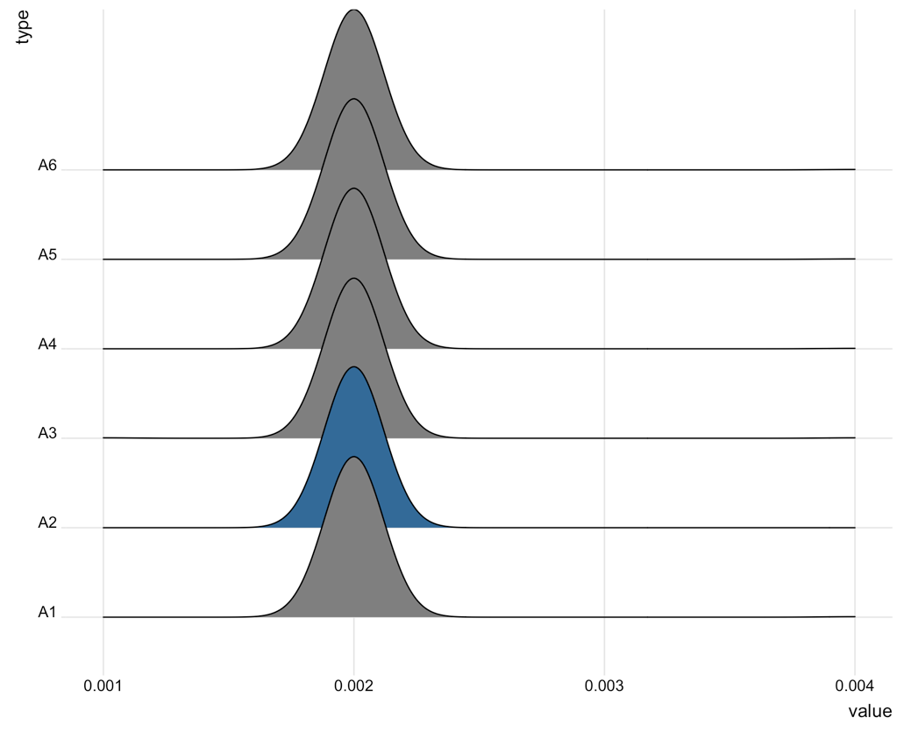

009

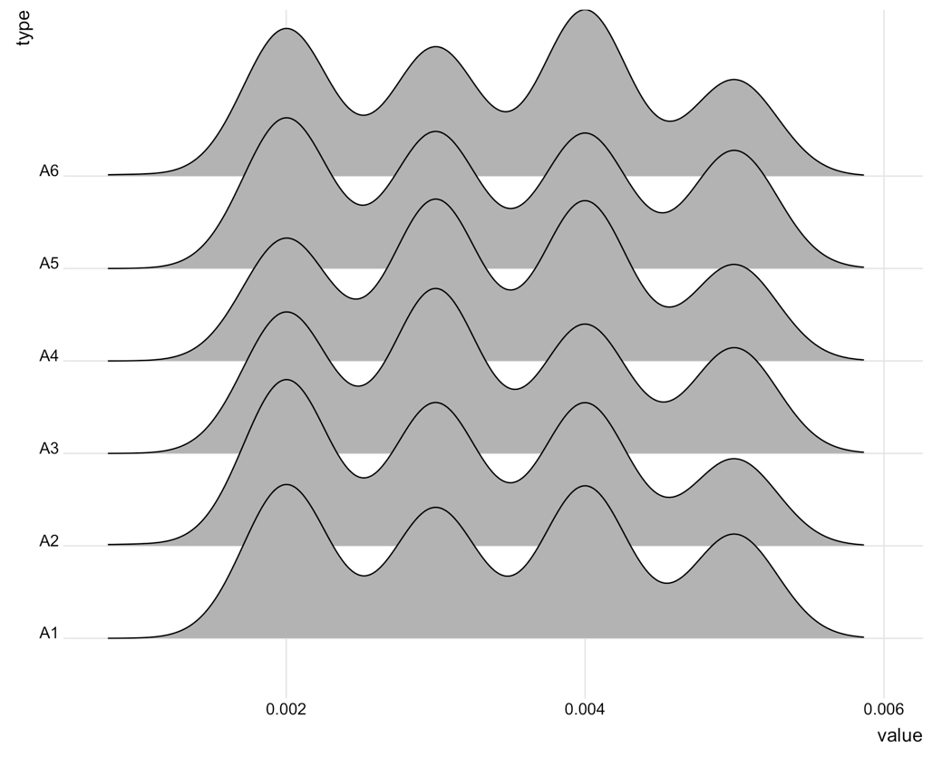

010

Input_A1_010, Input_A2_010, Input_A4_010, Input_A5_010, Input_A6_010只有單一值：0.002

Input_A3_010：0.002, 0.001

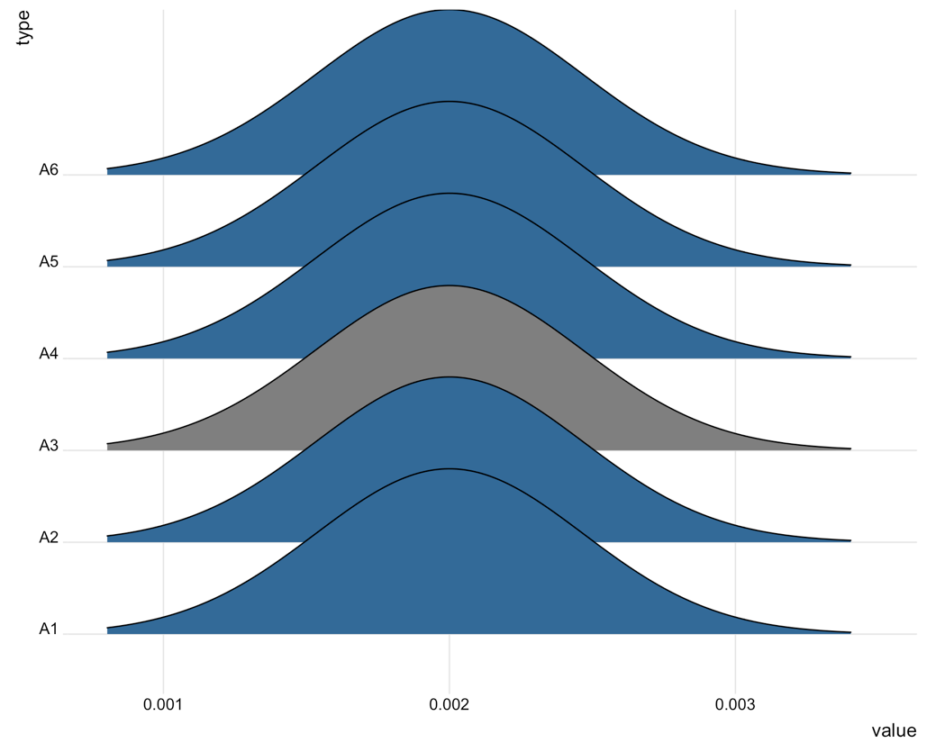

011

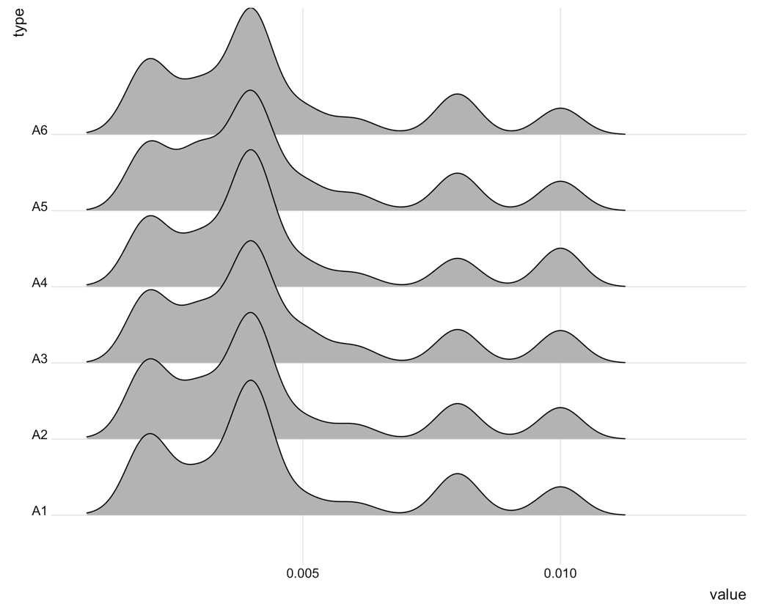

012

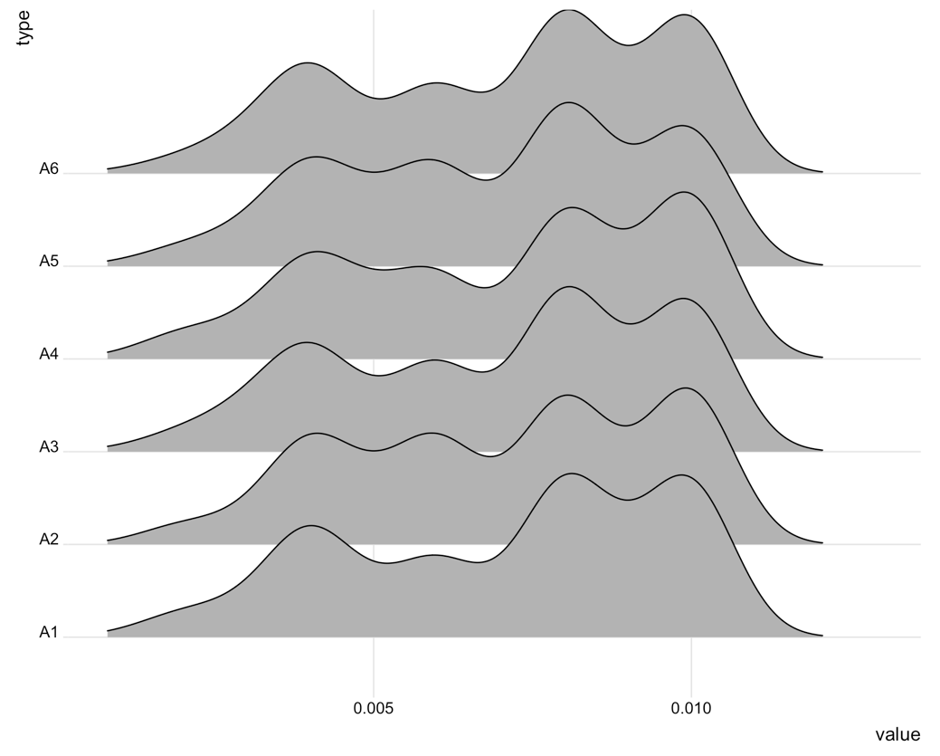

013

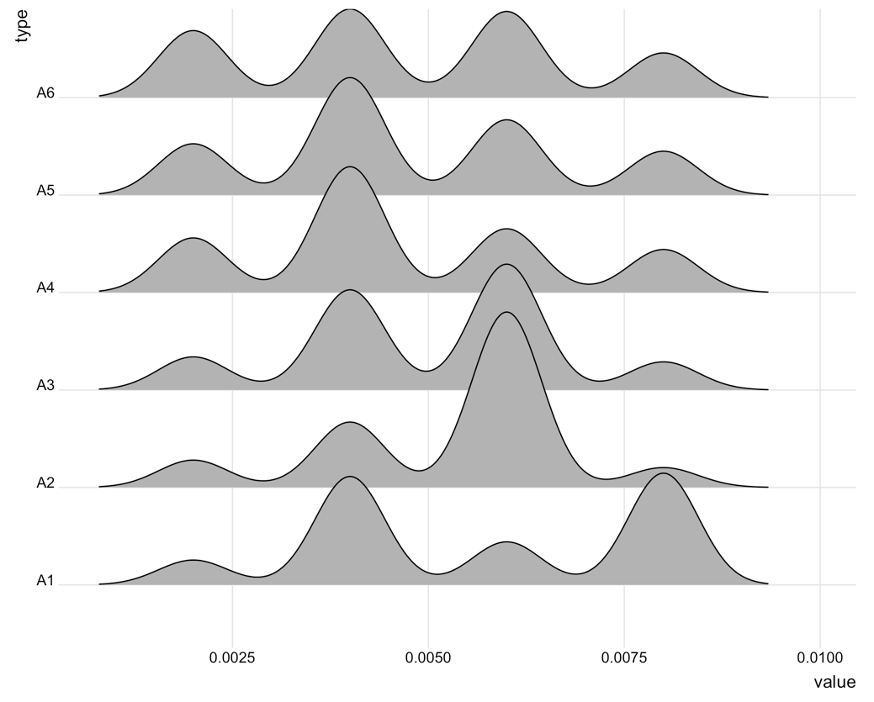

014

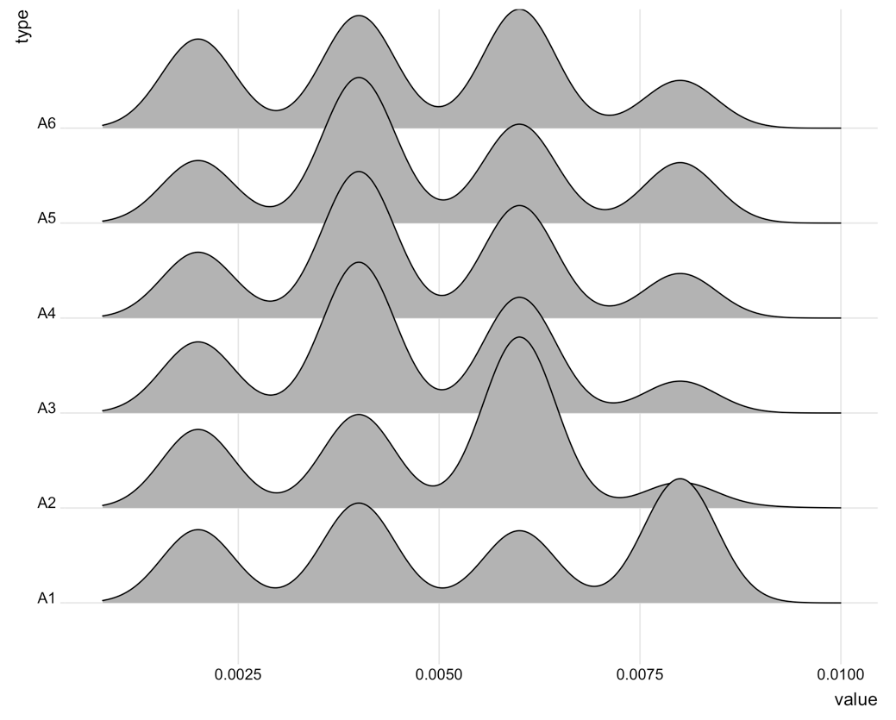

015

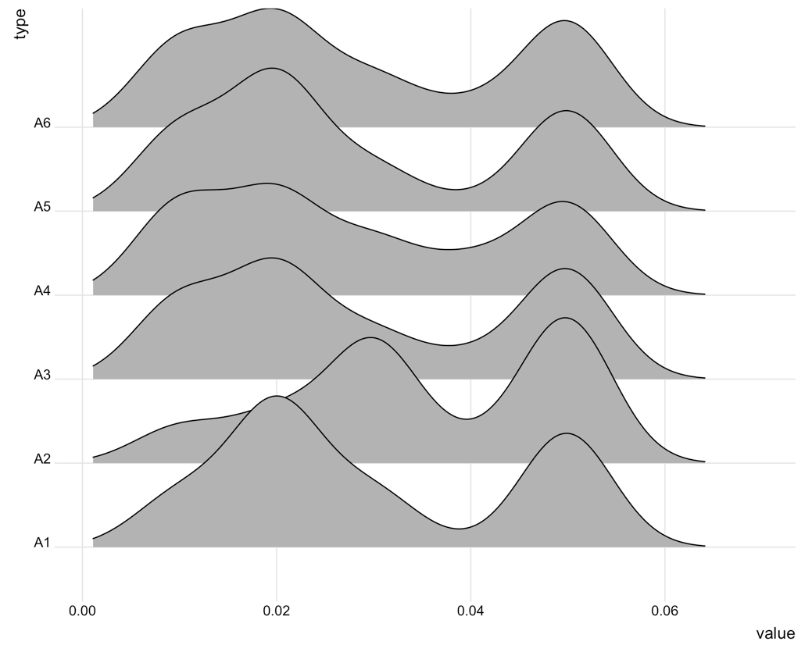

016

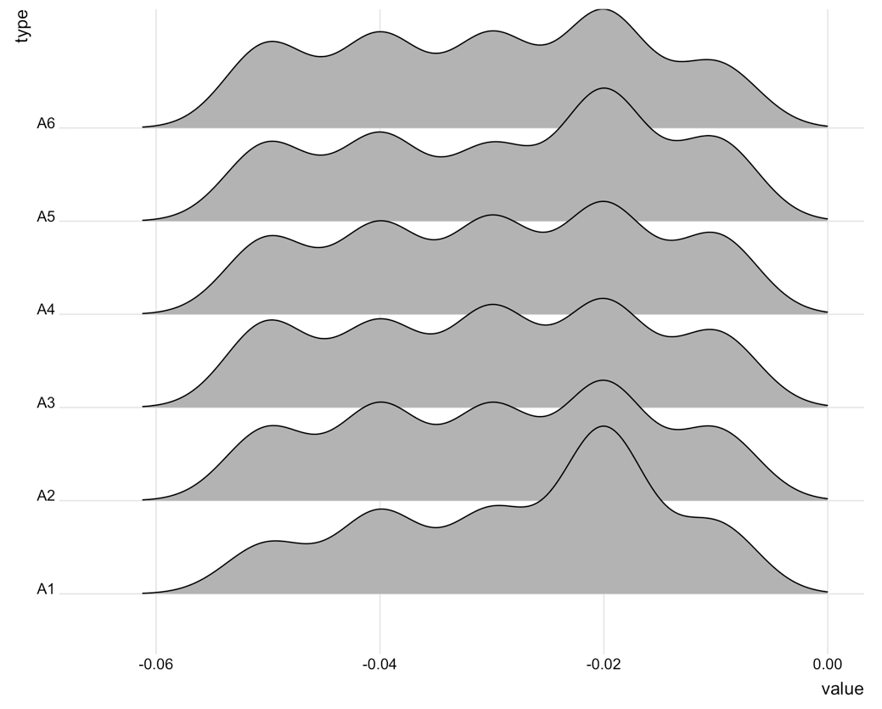

017

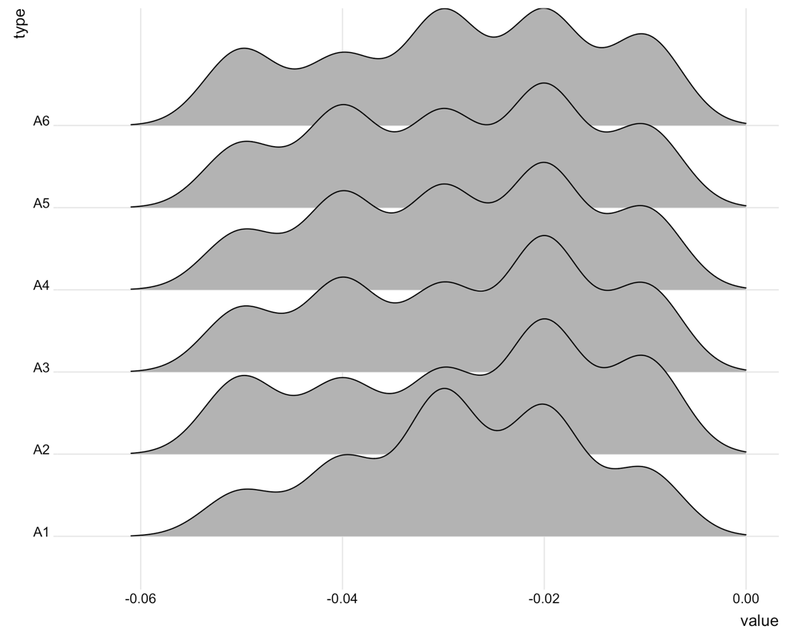

018

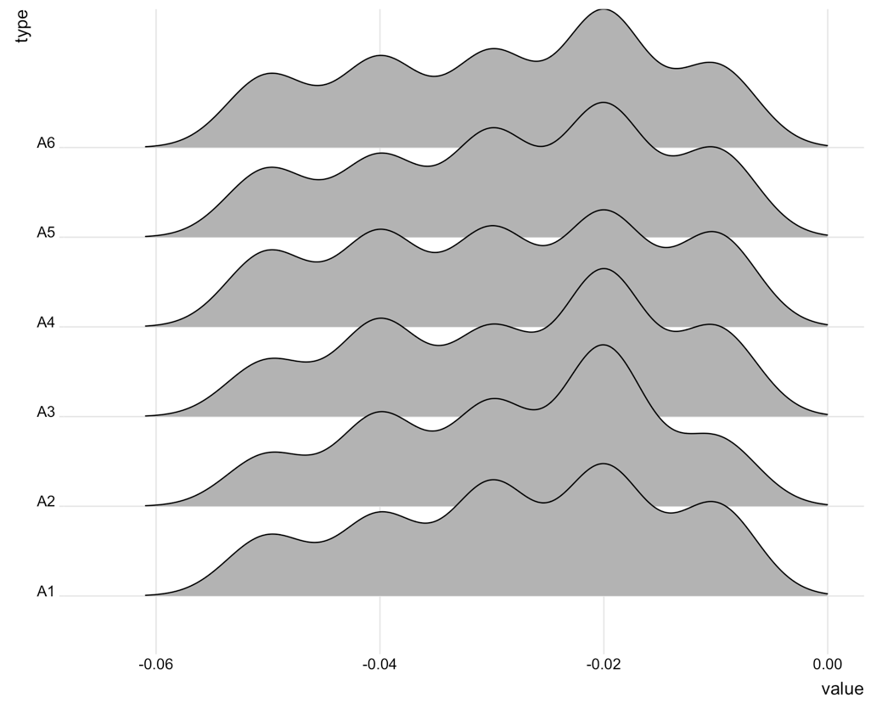

019

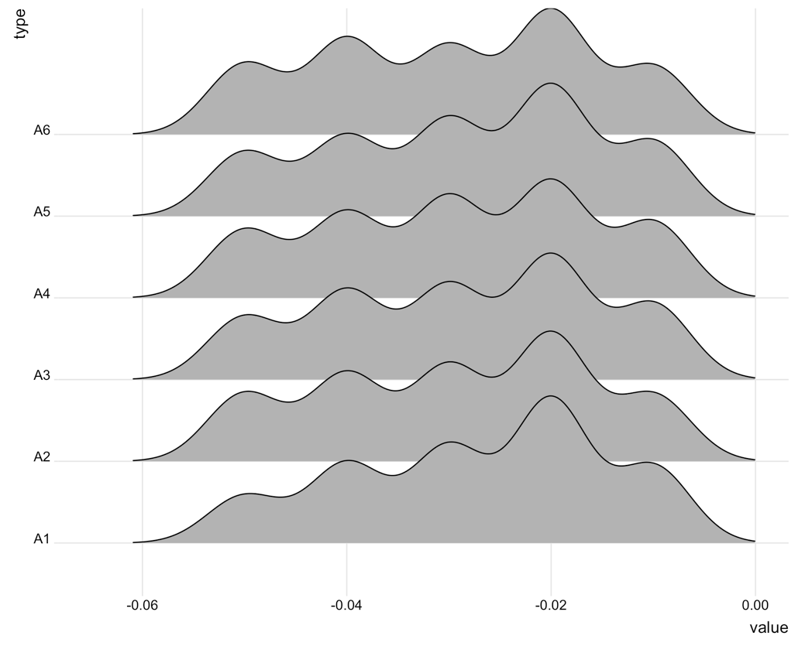

020

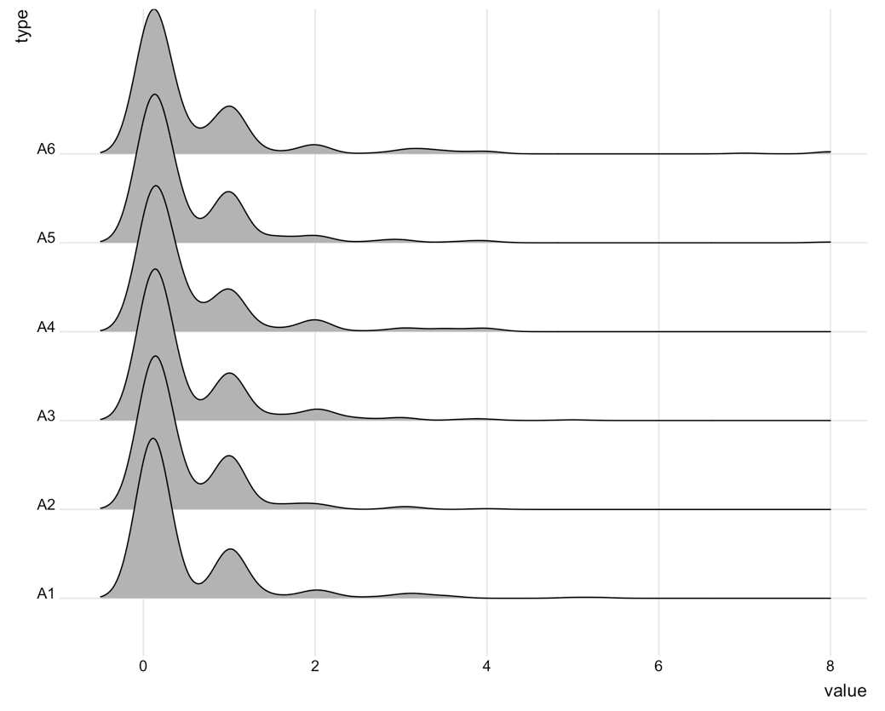

021

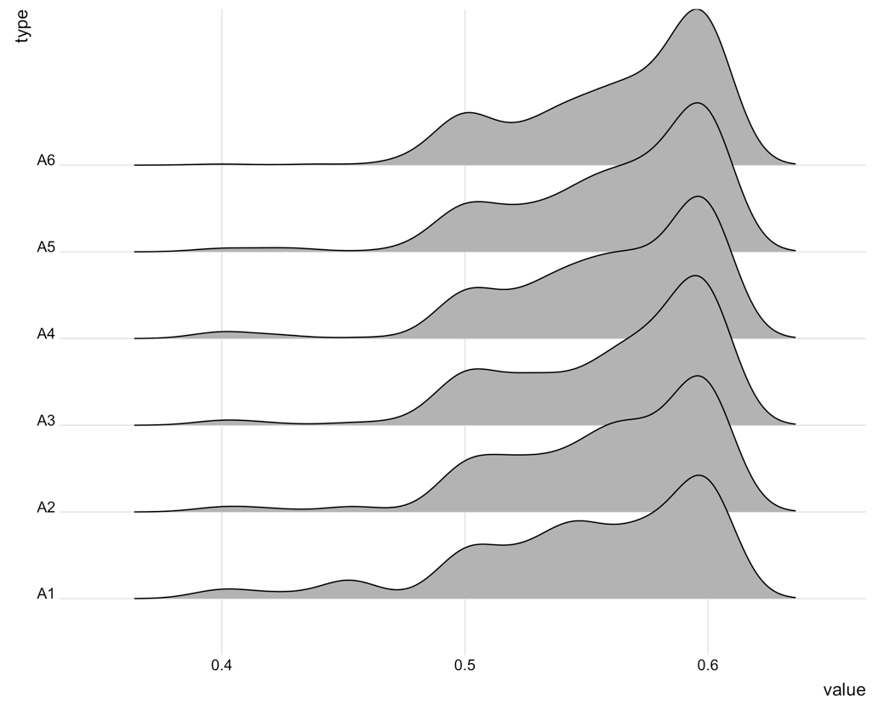

022

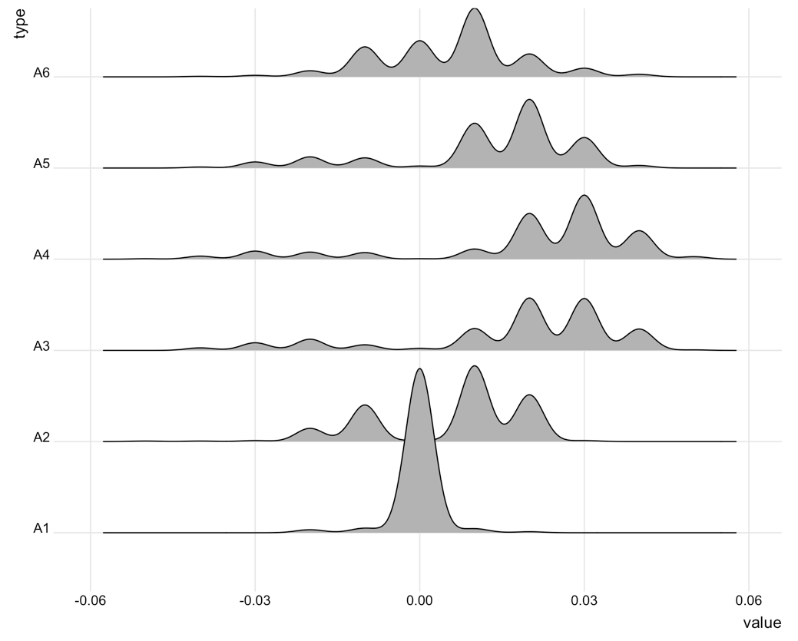

023

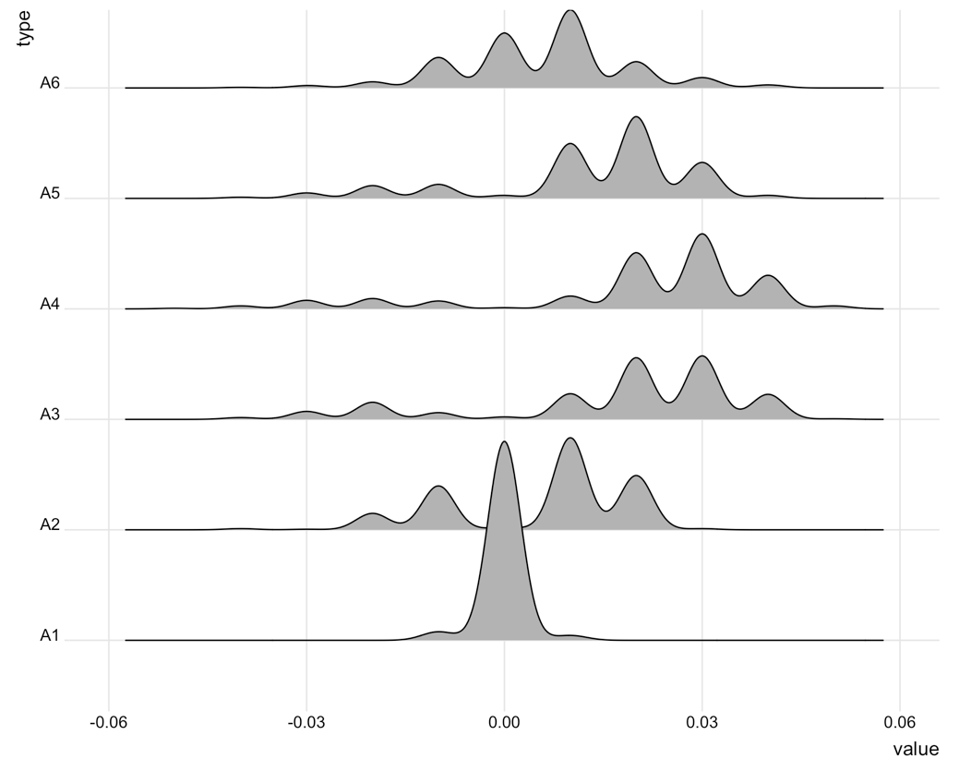

024

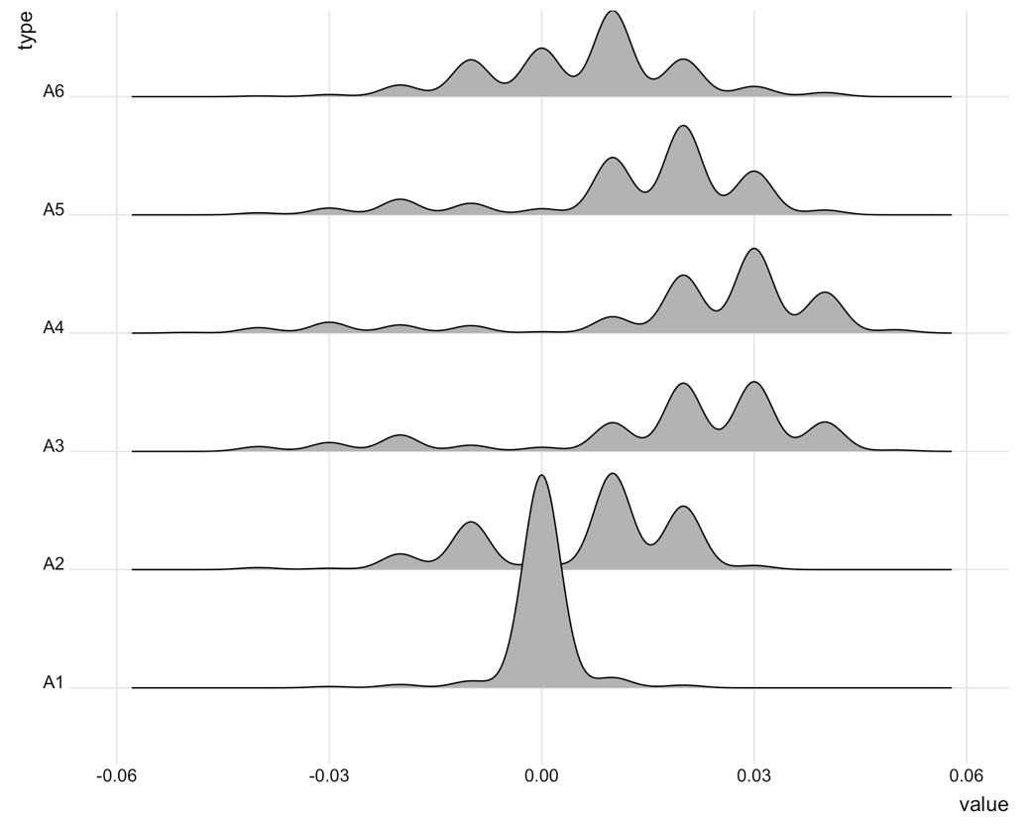

大部分編號相同的Input_A的分佈都相近，除了022, 023, 024，尤其是A1。

重要變數：Input_A6_024、Input_A3_016、Input_C_013、Input_A2_016、Input_A3_017、Input_C_050、Input_A6_001、Input_C_096、Input_A3_018、Input_A6_019、Input_A1_020、Input_A6_011、Input_A3_015、Input_C_046、Input_C_049、Input_A2_024、Input_C_058、Input_C_057、Input_A3_013、Input_A2_017

A_001, A_011, A_013, A_015, **A016**, **A_017**, A_018, A_019, A_20, **A_024**

C_013, C_046, C_049, C_050, C_057, C_058, C_096

畫feature分布 Recipe

SPC