口语篇
- DI
DI 数据图模板
数据图关键词：items, X axis, Y axis, 最高和最低的item以及数据本身
第一句 The [image] provided is about a [type] that [is about] (theme)
[image] = picture, chart, graph
[type] = bar chart, pie chart, line graph, flow chart, table, map
[is about] = give information about, show, presents, tell us about, mention, talk about, is talking about, illustrate
第二句 From this chart, we can see [X axis shows…, and Y axis shows…]
[X axis shows…, and Y axis shows…] = many items, such as…, … and … (mention items instead of axis); …, …, and … are also involved (in this chart)
第三句 So, it is clear that the [largest] number is…, which is…
[largest] = highest, biggest
第四句 [On the contrary], it can also be seen that the [smallest] [number] is, which [belongs to]…
[on the contrary] = contrarily, in contrast, whereas, however, while
[smallest] = lowest
[number] = value, figure/ percentage, proportion
[belong to] = is related to, is connected with
第五句 [Another point is that we can notice an increase/ a decrease, and a number of … rise/ fall from … to …] / [A slight increase/decrease can be seen on…, from… to… the number of _XX_ is much higher/lower than that of _XX_.] / [we can see that 坐标1 is almost 数字 times larger than 坐标2]
第六句 [in conclusion], the [type] [reflects] (theme)
[in conclusion] = overall, to sum up, in general, generally speaking, all in all
[reflect] = give information about, show, present, tell us about, mention, talk about, is about

DI 流程图模板
第一句 [The picture provided is a flow chart/ process diagram, which is about (theme)] / [The flow chart is about (theme)]
第二句 [As we can see, the whole process involves 数字 stages/ steps] / [There are 数字 stages/ steps in the whole process.]
第三句 According to the chart, [the first step starts from…]
[the first step starts from…] = the first step begins with… , the first step is…
第四句 [After that], we can see […in the second step].
[After that] = next, then, followed by that, at the following stage
[… in the second step] = … is also displayed here
第五句 [what is more], [it is clear] that the third step is…
[it is clear] it can be seen that, it can be noticed that, it can be found that, it is obvious that, we can see that, we can notice that, we can find that
第六句 [In conclusion], [the whole process ends up with (the last step)]
[the whole process ends up with…] = we can see final step is…, we can know the trend of (theme)

DI 纯图，地图模板
非常规关键词：方位，颜色，动作等
图片描述顺序：从左边到中间到右边
第一句 The picture [is about] (theme)
[is about] = give information about, show, present, reflect, tell us about, mention, talk about, is talking about, show the changes in, illustrate
第二句 And from the [left] part of the picture, we can see…, which is…
[left] = middle, right, top, bottom, outside, central
第三句 However, we can see a 颜色 area in the central part, which means…
第四句 [What’s more], [there is … on the right side, which is close to…]
[there is … on the right side, which is close to…] = A transform to/ become/ turn into B
[is close to] = is related to, is connected with, is relevant to, is far from, is next to, is opposite to
第五句 in conclusion, this picture/ map illustrates 主题/标题
[in conclusion] = overall, to sum up, in general, generally speaking, all in all
[illustrate] = give information about, show, present, tell us about, mention, talk about, is talking about, show the changes in

写作篇
- SWT
评分准则 1. 5-75词的一句话，不能出现两个句 2. 文本内容全部总结，使用paraphrase，使用合适的连接词，删减细节
模板框架 选择3-4个重点句（通常是首尾+中间一到两句话）
三句话模板：s1, and s2, but s3. Although s1, s2, and s3.
四句话模板: While s1, s2; s3, and s4.
使用规范 先摘抄重点句，一定要保证没有拼写错误。按照句子数量选择合适的模板，若不足50+单词请继续找重点句。连接好所有句子后，将缩写全部写全，并可以适当同义词替换一些单词或短语。
- WE
判断题型
总结构
P1 introduction; P2 Present idea1; P3 Present idea 2; P4 Summarize
得分点 句式多样性；语法；拼写；200-300单词
做题流程
1针对正反观点脑暴支撑论点，脑暴opinion
2用Power-这个论点足够strong and relevant吗？Proof-针对此论点可以给出清晰可信的例子吗？personalizable-能够和真实事件联系起来嘛？过滤观点，为正反观点都过滤出3个论点
3将idea转为小论句【Claim your point, Why the logic, Example about something concrete, 使用one or two opinion Link back to the 观点】
论点展开
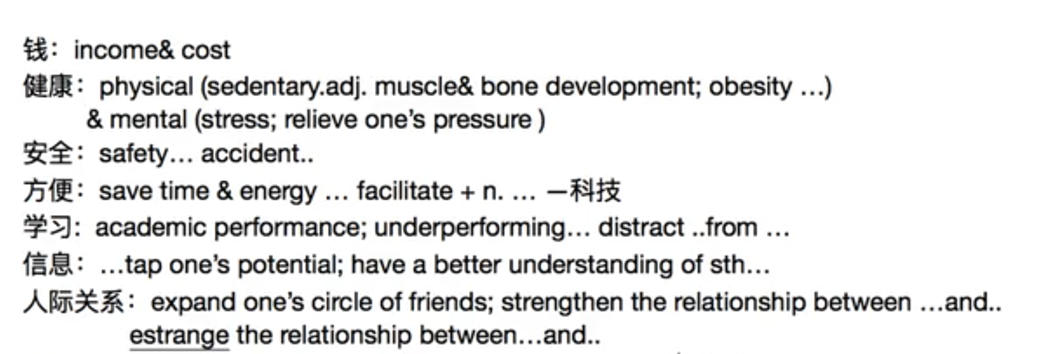
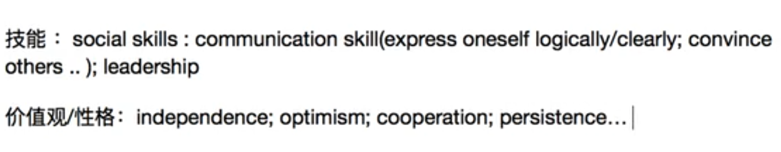
例题分析：同不同意ads如今过多地影响了人们的选择？
不同意论点1.ads帮人们省钱 2.ads更加方便，节省人们的时间 3.ads增加了信息的流通效率，让人们能有更好的选择 4.反驳“有的人可能认为广告带来misleading points”，指正：广告都是基于personalization推荐的，并不会带来wrong information.
具体题型具体分析
- 单边讨论 单纯陈述句+agree or disagree 看到you/agree
In Recent years, the issue of whether [主题句] has sparked considerable debate among the public. While some people argue that…, others disagree with this idea. In this essay, I will explain why I strongly believe that [立场].

First and foremost, one of the most convincing reasons is that [论点1]. Specifically, [解释]. For example, [a recent study conducted by Texas A&M University revels that--].

Furthermore, [论点2]. To elaborate, [解释]. On the other hand, some believe that [反方观点]. However, [反驳反方].

In conclusion, I strongly maintain that [重申立场], as it not only [论点1] but also [论点2]. Taking these factors into account, it is evident that the advantages of [主题句] far outweigh its drawbacks, making it a phenomenon that deserves wider recognition.
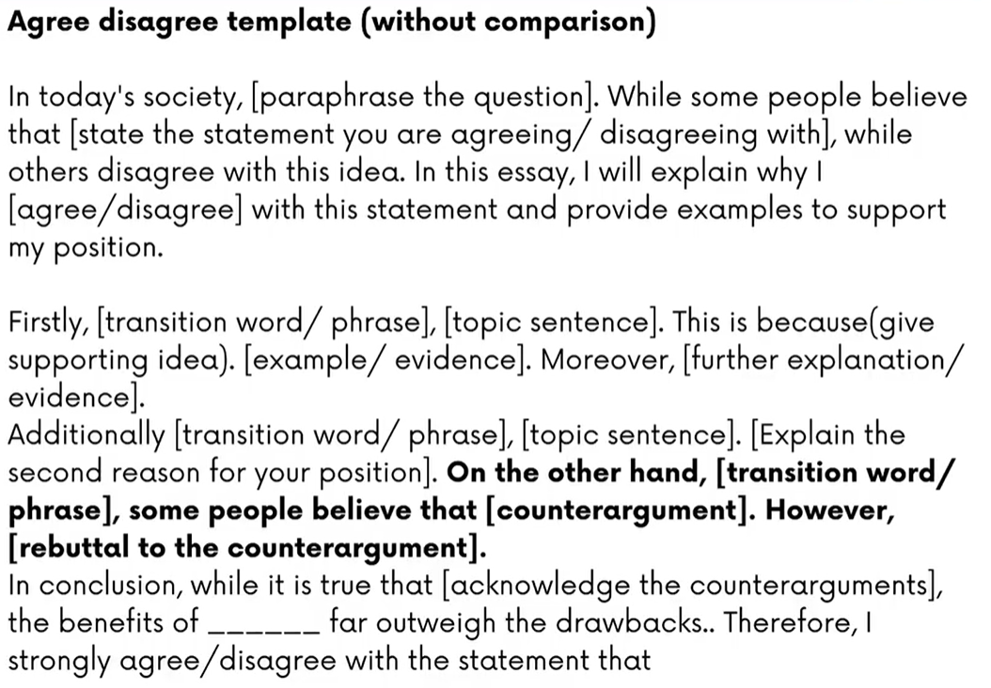
- 双边偏向性讨论 more than, outweigh类带比较的词汇都要讨论双边
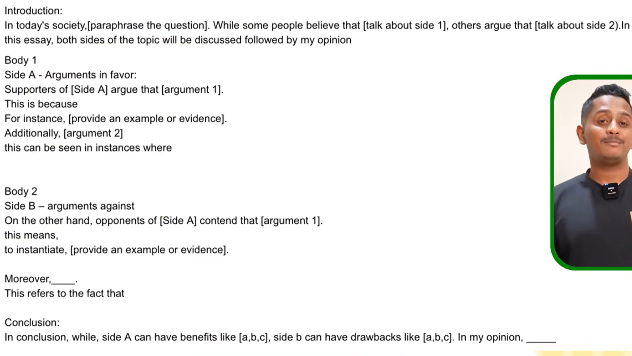
- 问题解决
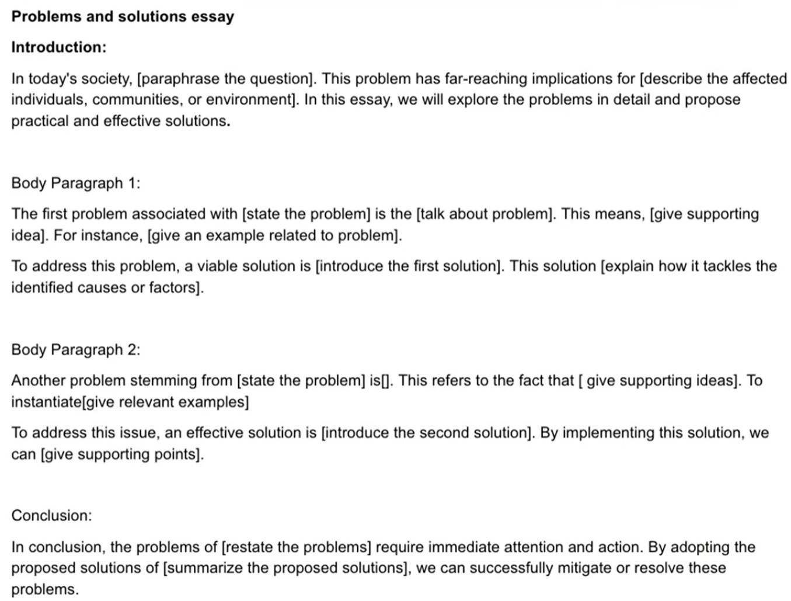
开头段[state the statement you are agreeing/ disagreeing with]需要同义词替换或同义转述
控制在260-270词内

