**Distracted Driver Detection**

A PROJECT REPORT

Submitted by

## 17CP057 : Kevin Mavani 17CP058 : Bhavesh Varma

*in partial fulfilment for the award of the degree of*

**B. TECH. (COMPUTER ENGINEERING)**

*Under the course of*

## CP441: PROJECT – I



**BIRLA VISHVAKARMA MAHAVIDYALAYA ENGINEERING COLLEGE**

*(An Autonomous Institute)*

**VALLABH VIDYANAGAR**

*Affiliated to*



**GUJARAT TECHNOLOGICAL UNIVERSITY, AHMEDABAD**

### Academic Year: 2020 – 2021

B. V. M. ENGINEERING COLLEGE, VALLABH VIDYANAGAR-388120

# APPROVAL SHEET

The project work entitled “**Distracted Driver Detection**“ carried out by

### KEVIN MAVANI (17CP057) AND BHAVESH VARMA (17CP058) is approved for the submission in the course CP441, Project-I (UDP) for the partial fulfilment for the award of the degree of B. Tech. (Computer Engineering).

Examiner(s) Name & Designation:

Signature:

Date:

Place: Birla Vishvakarma Mahavidyalaya, Vallabh Vidyanagar, Anand.

# CERTIFICATE

This is to certify that Project Work embodied in this project report titled “**Distrected Driver Detection”** has been carried out BY **KEVIN MAVANI (17CP057)** and **BHAVESH VARMA (17CP058)** under the course CP441, Project-I (UDP) for the partial fulfillment for the award of the degree of B. Tech. (Computer Engineering). Following are the supervisors at the institute.

Date:

Place: Birla Vishvakarma Mahavidyalaya, Vallabh Vidyanagar, Anand.

(Dr. Udesang K Jaliya) (Ms. Arpita Sanghani)

Assistant Prof. of Computer Engineering, BVM Assistant Prof. of Computer Engineering, BVM

(Dr. Darshak G Thakore) Prof. & Head

Computer Engineering Department, BVM

# DECLARATION OF ORIGINALITY

We hereby declare that we are the sole authors of this report under the course **CP441: Project-I** and that neither any part of this report nor the whole of the report has been submitted for a degree to any other University or Institution.

We declare that, to the best of our knowledge, the current report does not infringe upon anyone’s copyright nor violate any proprietary rights and that any ideas, techniques, quotations or any other material from the work of other people included in our report, published or otherwise, are fully acknowledged in accordance with the standard referencing practices. Furthermore, to the extent that we have included copyrighted material that surpasses the boundary of fair dealing within the meaning of the Indian Copyright (Amendment) Act 2012, we certify that we have obtained a written permission from the copyright owner(s) to include such material(s) in the current report and have included copies of such copyright clearances to our appendix.

We declare that this is a true copy of report, including any final revisions, as approved by report review committee.

We have checked write up of the present report using anti-plagiarism database and it is in allowable limit. Even though later on in case of any complaint pertaining of plagiarism, we are sole responsible for the same and we understand that as per UGC norms, University can even revoke the degree conferred to the student submitting this report.

Date:

Institute code: 007

|  |  |  |
| --- | --- | --- |
| Kevin Mavani |  | BhaveshVarma |
| (17CP057) |  | (17CP058) |

# ACKNOWLEDGMENT

We would like to express our sincere gratitude **to Dr. Udesang K Jaliya** and **Ms. Arpita Sanghani** as well as **Dr. D.G Thakore** for their guidance and constant supervision. We would also like to thank our institution for their support towards achieving our goal.

We are indebted to Birla Vishvakarma Mahavidyalaya Engineering College and our project guides for providing necessary information regarding the project and for their support in completing the project. With their feedback, we were able to improve our project in various aspects.

Date:

|  |  |  |
| --- | --- | --- |
| Kevin Mavani |  | BhaveshVarma |
| (17CP057) |  | (17CP058) |

# PLAGIARISM REPORT

**Average Value of Plagiarism: 2%**

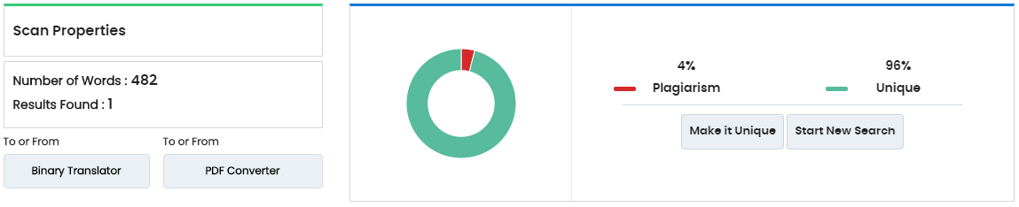

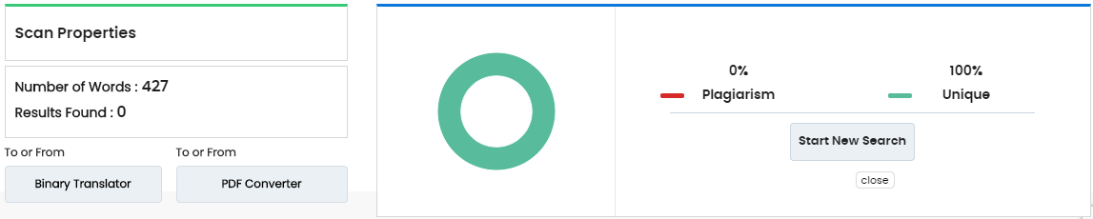

Tool used: <https://www.duplichecker.com/>

# ABSTRACT

We all can see that by the time road accidents is continuously increasing. As per survey of National Highway Traffic Safety Administrator approximate one in five vehicle crashes because of distracted driver. 425000 people injured and 3000 people killed by distracted driving every year. We tried to make system which can detect distracted driver not only detect but it also identifies cause of distraction. We use CNN (convolution neural network of computer vision) to make our system which can show whether driver is driving safe or distracted, if distracted then it show also cause of distraction. We used VGG16 pretrained model with some changes to get good accuracy

# List of Tables

|  |  |  |
| --- | --- | --- |
| **Table**  **Number** | **Table Description** | **Page**  **Number** |
| 5.1 | Result analysis | 11 |

# List of Figures

|  |  |  |
| --- | --- | --- |
| **Figure Number** | **Figure Description** | **Page Number** |
| 2.1 | Different activities of driver (10 classes) | 4 |
| 3.1 | Convolution operation | 5 |
| 3.2 | Work flow of CNN | 6 |
| 3.3 | Architecture of VGG16 | 7 |
| 3.4 | Model Summary original VGG16 | 8 |
| 4.1 | Model summary of updated VGG16 | 10 |

# LIST OF SYMBOLS, ABBREVIATIONS, AND NOMENCLATURE

* + - **CNN –** Convolution neural network
    - **VGG –** Visual Graphics Group

# TABLE OF CONTENTS

APPROVAL SHEET II

CERTIFICATE II

DECLARATION OF ORIGINALITY IV

ACKNOWLEDGEMENT V

PLAGIARISM REPORT VI

ABSTRACT VII

LIST OF TABLES VIII

LIST OF FIGURES IX

LIST OF SYMBOLS, ABBREVIATIONS AND NOMENCLATURE XI

CHAPTER 1: INTRODUCTION 1

* 1. Motivation 1
  2. Objective 1
  3. Scope 1
  4. Tools & Technology 1
     1. Programming Languages 1
     2. Tools 1
     3. Libraries 1
  5. Functional Requirements 2

1.6 Non Functional Requirements  2

CHAPTER 2: LITERATURE SURVEY 3

CHAPTER 3: TECHNICAL APPROCH 5

* 1. Convolution Neural Network 5
     1. Input layer 5
     2. Convolution layer 5
     3. Pooling layer 5
     4. ReLU layer 6
     5. Flattning 6
     6. Fully Connected layer 6
  2. Transfer Learning 6
     1. Why we used transfer learning? 6
     2. VGG16 6

CHAPTER 4: IMPLEMENTATION 9

CHAPTER 5: RESULT ANALYSIS 11

CHAPTER 6: CONCLUSION and FUTURE WORK 13

REFERENCES 14

## CHAPTER 1

**Introduction**

### Motivation

According to WHO(world health organization) 1.3 million people across world die in road accidents in each year and as per the report of (NCRB) National Crime Research Bureau Govt. of India, There is continuously increasing road accidents since 2006. The main reason for accidents is driver error and this error probability increased when driver distracted by somethings. So this thing motivate us to make system so we can able to classify different driver activities.

### Objectives

Objective of this project is to warn driver whenever he/she get distracted by something. here in

our project we get state farm dataset which provide images of 10 different classes. Name of

different classes as safe driving, reaching behind and talking to passenger eating or drinking

adjusting radio, texting on mobile phones using right or left hand, talking on mobile phones using right

or left hand, hair and makeup.

### Scope

Anyone can implement this system in their vehicle. They required extra hardware support like camera which can be mounted at opposite side of driver so that it can capture images and process it.

### Tools & Technology:

#### Programming Languages:

* Python

#### 1.4.2 Tools:

* Jupyter

#### 1.4.3 Libraries:

* Pandas : To work with csv file.
* Keras : To Making CNN model
* Numpy : To work efficient with array.
* Os : To Working with directory
* random : To get random number here we use it for choosing images randomly from set of images
* Matplotlib: To plot graph of accuracy .

### Functional Requirements:

* System Requirements:
  + Memory Space Required: Up to 4 GB
  + A Webcam or External Camera
  + Min. RAM: 4 GB(approximately)
  + Python and required Library should be downloaded
  + Jupyter Notebook

### Non Functional Requirements

* Able to run program in jupyter
* Photo should be side view of driver

## 

## CHAPTER - 2

**Literature Survey**

* In this section we just see work done on distracted driver detection from some literatures. The major cause of distraction is use of mobile phone[2].
* After getting motivate some of the researchers worked on cell phone usage detection while driving.

1. Zhang created a database using a camera and used Hidden Conditional Random Fields model to detect cell phone usage.1It only operates on face, mouth, and hand.
2. In 2015, Nikhil created aadataset for hand detection in the automotive environment and achieved average precision of 70.09% using Aggregate Channel Features (ACF) object detector.
3. Seshadriaalso created their own dataset for cell phone usage detection. Authors used Supervised Descent Method, Histogram ofGGradients (HoG) and an AdaBoost classifier. The system could operate in a near real-time speed (7.5 frames per second).
4. UCSDs Laboratory of Intelligent and Safe Automobiles has done significant contribution in this domain problem but they dealt with only three types of distractions :

1.adjusting the radio,2.adjusting mirrors 3.operating gear.

1. There has solution given by C. H. .Zhao, B. L. Zhang, J. He, and J. Lian which can distinguish four activities of driver:

1.Safe driving 2.operating shift lever 3.eating something 4.talking on phone.

They have used random forest. The datasets that they used is concentrated on only limited set of distractions and this dataset are not publicly available.

1. This earlier solution used some limited dataset which can not used to classify driver activity in different class. Then StateFarm’s [1] distracted driver detection competition on Kaggle defined ten postures to be detected (Safe driving + nine distracted behaviours) and gives large dataset of images belong to 10 different category.

* C0 : safe driving
* C1 : texting right
* C2 : talking on the phone – right
* C3 : texting – left
* C4 : talking on phone – left
* C5 : Operating the radio
* C6 : drinking
* C7 : reaching the behind
* C8 : hair and makeup
* C9 : talking to passenger

#### 

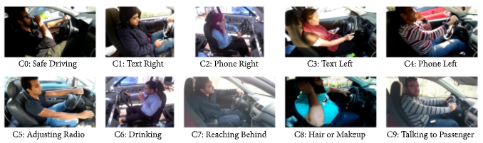

**Fig. 2.1 Different activities of driver classify to 10 classes[1]**

* Here we are using state farm dataset because it gives more classes to classify driver activity and because large dataset we can get good accuracy as well

## 

## CHAPTER 3

**Technical Approach**

This part gives basic information about CNN and how it work and this also gives information about VGG16 that we used in our project :

**3.1 CNN (convolution neural network)**

A **Convolutional Neural Network (CNN)** is a neural network which is effectively used for image recognition and classification. So, we give images as input to the CNN model. It consists of input layer, output layer and number of hidden layers. Hidden layers include the Convolution layer, Pooling layer, Rectified Linear Units layer, Flattning layer and Fully Connected layer.

**3.1.1 Input layer :**

Input layer contain raw pixel value of an images. In our project images are colored with resolution of

640*480 pixels which are scaled down to 224*224 to reduce training time.

**3.1.2 Convolution layer:**

In this layer convolution operation is performed to extract feature from mages.

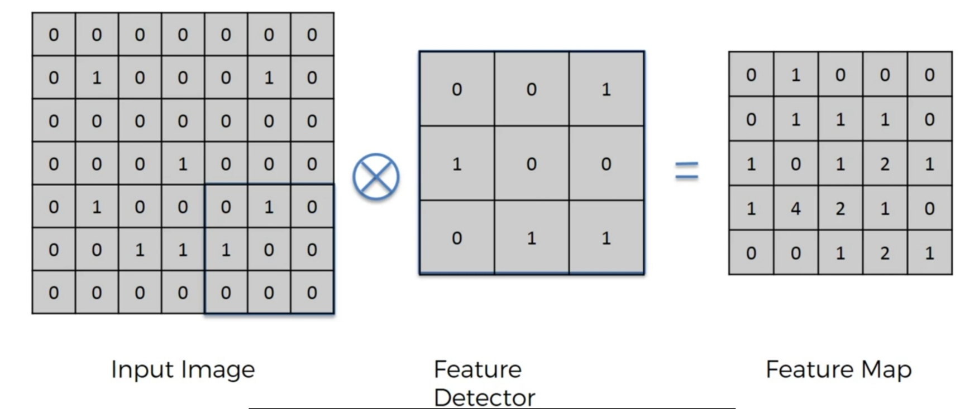

**Fig. 3.1 Show how convolution operarion work**

**3.1.3 Pooling :**

Pooling layer is used to reduce the sizeoof feature map. It is used to reducing the complexity of our

model without reducing its performance.

**3.1.4 Relu layer :**

ReLU is rectified liner unit is used to increase the non-linearity of model.

**3.1.5 Flattning :**

Flattning will flatten all the feature map in pooling layer into the single huge vector and it give as input

of fully connected layer.

**3.1.6 Fully Connected layer:**

Fully connected layer contain neuron is connected to the output of previous layer. This layer classify

the class of an input images. In our project there are 10 classes, each class contain various distracted

activity of driver. Fully connected layer contain 10 neurons.

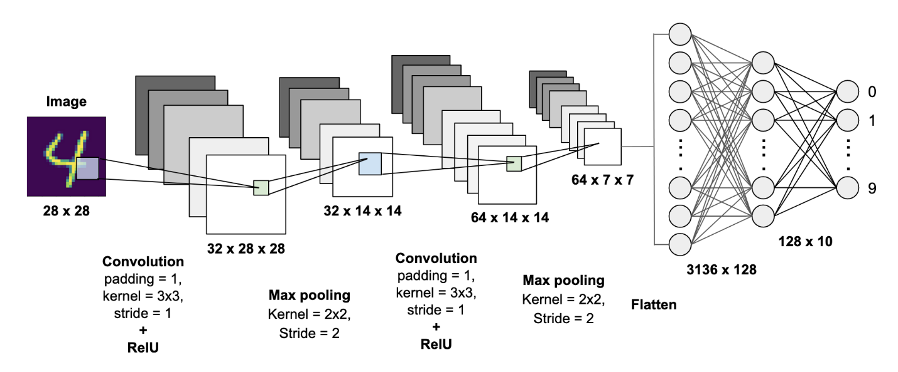

**Fig. 3.2 Show how entire CNN work[3]**

**3.2 Transfer Learning**

Transfer learning is a machine learning methodmwhere a model developed for a task is reused as

the starting point foraa model on a second task.

**3.2.1 Why we used transfer learning?**

In transfer learning, we can use knowledge like features and weights from previously trained models for

training newer models so we require less data for new task. And also taken less time to converge the

model.

**3.2.2 VGG16**

We are using VGG16 pretrained model which built to classify 1000 classes which is trained on

imagenet dataset.

In VGG16, 16 refers to there are 16 layers in architecture that have weights. VGG16 has convolution

layers of 3x33filter with a stride 1 and always used same padding and maxpool layer of 2x2 filter of

stride22.This arrangement of convolution and max pool layers consistently remain same throughout the

whole architecture. And after this arrangement it has two fully connected layer and it followed by

softmax layer for output.

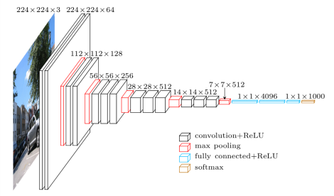

**Fig. 3.3 All layer Original VGG16[4]**

We can see model summary by writing **model.summary()** .

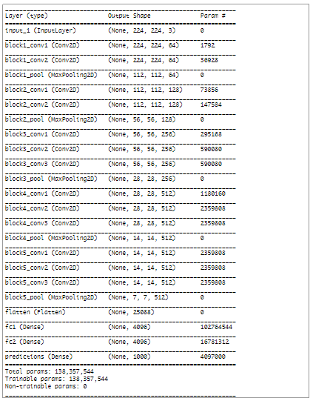

**Fig. 3.4 Gives model summary of VGG16**

**CHAPTER 4**

**Implementation**

### Step 1: Import different required library

### The first step we import all the packages that we need to make our project.

### Sequential package is used to initialize our neural network. Conv2D is used to add convolution layer

### in our model.

### 

### Step 2: Getting all the images.

### We get the list of all files and directories from the specified directory which is passed as argument into

### the listdir().

### 

### Step 3: Randomly shuffling images and splitting images in test and train.

### Step 4: Converting image to array.

### Step 5: Get VGG16 model and update it.

### 

### 

### Fig. 3.4 Show updated VGG16 model summary

### Step 6: Compile model.

## CHAPTER 5

**Result Analysis**

**After compiling model we try by giving some random images and here are some of the outputs.**

**Table 5.1 Result Analysis**

|  |  |  |
| --- | --- | --- |
| **Input Images** | **Prediction is Right//Wrong** | **Actual Class** |
|  | Right | Texting-right |
|  | Wrong | Reaching behind |
|  | Right | Talking on phone-left |
|  | Rignt | Drinking |
|  | Right | Hair and makeup |

## CHAPTER 6

**Conclusion and Future Work**

We can conclude that if we make our own CNN model from scratch then it takes to much time to trained model and also we don’t get good accuracy as well. So we use transfer learning so we can make some changes on pretrained model get good accuracy with less data as well.

We have used VGG16 pre trained model with some changes and get upto 90% of accuracy.

In Future we can add sound so when driver found distracted then it start and we make good user interface by using some framework.

## REFERENCES

1. (State-farm’s dataset for distrected driver detection

(<https://www.kaggle.com/c/state-farm-distracted-driver-detection>)

1. National highway traffic safety administration traffic safety facts

(<https://www.nhtsa.gov/risky-driving/distracted-driving/>)

1. Towards datascience mnist-handwritten classification using CNN (<https://towardsdatascience.com/mnist-handwritten-digits-classification-using-a-convolutional-neural-network-cnn-af5fafbc35e9> )
2. Transfer learning :

(<https://machinelearningmastery.com/how-to-use-transfer-learning-when-developing-convolutional-neural-network-models/> )

1. Deep learning Nptel cource (<https://www.youtube.com/playlist?list=PLyqSpQzTE6M9gCgajvQbc68Hk_JKGBAYT>)
2. Udemy course Deep learning A-Z

( <https://www.udemy.com/course/deeplearning/> )

1. Tools made by Adam harly which gives good visulaization of how CNN works

( <https://www.cs.ryerson.ca/~aharley/vis/conv/flat.html> )