**Lecture 16: Scale for GPU Pool**

# IEEE754: Float Point System

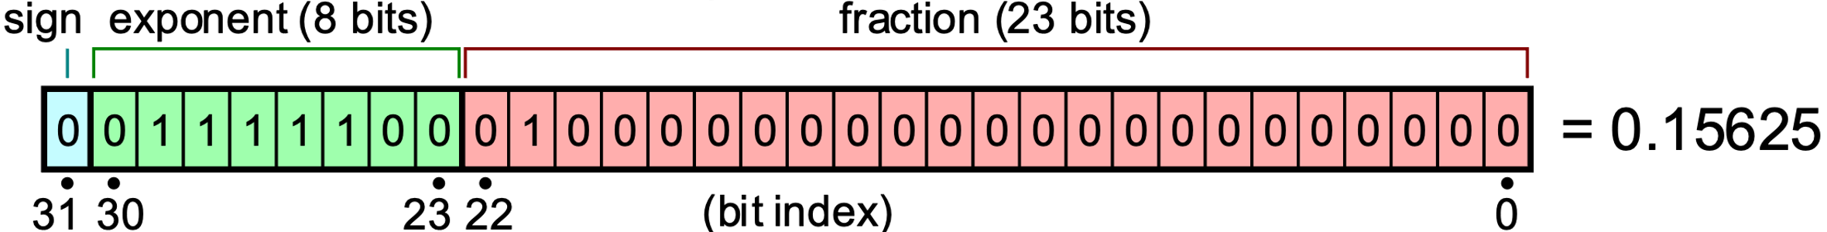

$$V={\left(-1\right)}^{sign}⋅\underset{Exponent}{\underbrace{2^{E-127}}}⋅\underset{Mantissa}{\underbrace{\left(1+\sum_{i=1}^{23}{b_{23-i}2^{-i}}\right)}}$$

$E-127$ 可以理解为把 u8 转化为 i8 $[0,255]→\left[-127, 128\right]$

Mantissa 忽略先导1（考虑二进制，科学计数法总是 1Exxx，先导1总是出现，这也是为什么1+项对出现）。 $2^{-i}$ 表示小数权重（$2^{-1},2^{-2}, etc.$）：



$$Mantissa=1+\underset{\sum_{i=1}^{23}{b_{23-i}2^{-i}}}{\underbrace{\frac{b_{22}}{2^{-1}}+\frac{b_{21}}{2^{-2}}+\frac{b_{20}}{2^{-3}}+⋯+\frac{b_{1}}{2^{-22}}+\frac{b_{0}}{2^{23}}}}$$

GPU Memory Footprint (llama 65B @ FP32)

|  |  |  |
| --- | --- | --- |
| Llama 1 65B | | |
| $$D$$ | Model dimension | 8192 |
| $$N$$ | Sequence Length | 2048 |
| $$B$$ | Batch size | 1 |
| $$L$$ | Number of layers | 80 |
| $$H$$ | Number of attention heads | 64 |

Inference Stage: $32bit ×\left(65×{10}^{9}\right)=2.08×{10}^{12}bit=260GB$

Training Stage: Model: 260 GiB, Gradient: 260 GiB  
Optimiser: 520 GiB (Adam = Momentum + Variance)