-

Team members

*(Team Leader)* Jonathan Leathem 40059090

Steven Kennedy 40025827

Conor McAleavey 40047330

Chris McClune 40138365

Kevin O’Hare 15481042

Abstract

We intend to design and develop an educational application aimed at children ages three to seven. This application will follow a level-based format and shall quiz children on a range of subject areas. Mathematics, English, Geometrics and Science will be the main subject focus of our application.

Team Report

Web and Mobile App Development Group Project CSC7054

Project title

Children’s Educational Quiz App

Table of Contents

1. Project Proposal and Introduction2
2. Customer Statement of Requirements (CSR)2
   1. Problem Statement2
   2. Glossary of Terms 3
3. System Requirements3
   1. Functional Requirements3
   2. Nonfunctional Requirements4
   3. On-Screen Appearance Requirements4
4. Functional Requirements Specification4
   1. Stakeholders4
   2. Actors and Goals5
5. **Project Introduction and Proposal**

We intend to design and develop an educational application aimed at children ages three to seven. This application will follow a level-based format and shall quiz children on a range of subject areas. Mathematics, English, Geometrics and Science will be the main subject focus of our application.

In order to successfully target our defined age groups, we shall closely follow the National Curriculum Framework for Early Years Foundation Stage (EYFS) and Key Stage 1 (KS1). Applying this framework to our quiz questions will ensure our application meets the minimum requirements on education, set by the UK government, following the introduction of the Education Reform Act (1998).

It is our intention to develop a multi-layer scoring system. Unlike many other quiz apps on the market, which only score users based on the number of correct answers, our application will also take into account the length of time spent by the user on each question and award an adjusted score accordingly. Opportunities for bonus points may also be implemented. The app will incorporate different input methods, including, but not limited to, multiple choice, fill-in-the-blanks and text input.

We aim to use a database to store a user’s personal high scores for each level, and separately, the high scores of other users. Furthermore, based on the user’s high scores per level, they may be awarded bronze, silver, or gold medals, as a way of rewarding the users and encouraging them to gain higher scores, which in turn should help educate them.

Targeting a young demographic, we are conscious of the importance of ensuring our application adopts a vibrant and playful experience, whilst maintaining its underlying usefulness as an educational quiz application. Finding the optimal balance between the learning experiences offered and the visual effects on show, will go a long way in determining how well our application is accepted by our primary stakeholders.

Our fundamental goal is to create an application that helps children to learn core foundational skills in key subject areas for their age range, in an environment that the user will find fun and engaging.

1. **Customer Statement of Requirements (CSR)**
   1. **Problem Statement**

I am a middle-aged woman from Belfast with two children aged four and six respectively. They have started primary school recently and are getting along well, however, at home they spend a lot of time playing on their tablet and I am worried that this could be distracting them from their homework. I believe that if they were spending time on a fun, but educational application, while using their tablet, it would benefit them in school, motivate them to learn, whilst making learning a more enjoyable experience for them.

This application should be aimed at children who are old enough to operate a tablet or smartphone, but still learning basic maths and English, among other skills at a primary school level. It should quiz children on subject-specific areas, reflecting what they would be learning in school at their age. Therefore, it would be helpful if the quizzes could be divided into different difficulties, recommended based on age.

A scoring system for each quiz would be suitable for the children to understand which questions they got correct and which they got incorrect. Also, there should be a timer on each question to prevent them from simply going off and looking up the answer. Score bonuses for answering questions correctly in less time may also motivate the children. Based on their high scores per level they may be awarded bronze, silver or gold medals as a way of rewarding them and encouraging them to gain higher scores, which in turn will educate them.

* 1. **Glossary of Terms**

*List important terms and their definitions to ensure consistency and avoid ambiguity in the system specification. Use the language of the application domain and avoid uncommon terms or define these as well.*

*It is helpful to illustrate the complex terms by providing images and graphics to help reader’s understanding.*

*Another option is to provide web links where to find more complete definitions of your terms.*

1. **System Requirements**

**3.1 Functional Requirements**

|  |  |  |
| --- | --- | --- |
| **No.** | **Description** | **Priority Weight** |
| 1 | Upon opening the application, the user shall be directed to the *Home* page. |  |
| 2 | Upon selecting the ‘PLAY’ button on the *Home* page, the user shall be directed to the *Select Age* page. |  |
| 3 | Upon selecting either the ‘3-5YRS’ button or the ‘5-7YRS’ button on the *Select Age* page, the user shall be directed to the *Select Level* page. |  |
| 4 | Upon selecting the ‘LEVEL 1’ button, the ‘LEVEL 2’ button, or the ‘LEVEL 3’ button on the *Select Level* page, the user shall be directed to the *Quiz* page corresponding to the user’s selected age group and level. |  |
| 5 | Upon selecting an answer to a question on the *Quiz* page the selected button shall change colour from yellow to red. Selecting a different answer shall change the colour of that button to red and revert the colour of the previously selected button to yellow. |  |
| 6 | The first time the user selects an answer on the *Quiz* page, a red arrow pointing to the right shall appear in the bottom right corner. Selecting this arrow shall confirm the user’s selection of answer and shall direct the user to the next question. |  |
| 7 | Upon selecting the red arrow on the *Quiz* page for the final question the user shall be directed to the *Results* page. |  |
| 8 | Upon selecting the ‘HIGHSCORES’ button on the *Home* page, the user shall be directed to the *High Scores* page. |  |
| 9 | Upon selecting the ‘ON’ button on the *Home* page, the music shall turn on and the ‘OFF’ button shall be toggled off. |  |
| 10 | Upon selecting the ‘OFF’ button on the *Home* page, the music shall turn off and ‘ON’ button shall be toggled off. |  |
| 11 | Upon selecting the ‘EXIT’ button in the *Home* page, the application shall close. |  |

**3.2 Non-Functional Requirements**

|  |  |  |
| --- | --- | --- |
| **No.** | **Description** | **Priority Weight** |
| 12 | The application shall consist of the following web pages: *Home, Select Age, Select Level, Quiz, Results,* and *High Scores.* |  |
| 13 | The *Home* page shall consist of the application logo at the top of the page with a button below it labelled as ‘PLAY’ followed by another labelled ‘HIGHSCORES’. Below this shall be a text view reading ‘MUSIC:’ adjacent to two buttons labelled ‘ON’ and ‘OFF’. There shall be another button below this labelled ‘EXIT’. The logo and the buttons shall all be aligned along the vertical centre. |  |
| 14 | Music shall play throughout the application while the ‘ON’ button is toggled on. |  |
| 15 | The *Select Age* page shall consist of the application logo at the top of the page with a text view instructing the user to select their age group below it. Below the text view shall be a button labelled as ‘3-5YRS’ followed by another button labelled ‘5-7YRS’. The logo, text view, and buttons shall all be aligned along the vertical centre. |  |
| 16 | The *Select Level* page shall consist of the application logo at the top of the page with three buttons labelled as ‘LEVEL 1’, ‘LEVEL 2’, and ‘LEVEL 3’ below it. The logo and the buttons shall all be aligned along the vertical centre. |  |
| 17 | Upon first use of the application, only the ‘LEVEL 1’ button shall be enabled. Completing ‘LEVEL 1’ successfully shall enable the ‘LEVEL 2’ button and completing ‘LEVEL 2’ successfully shall enable the ‘LEVEL 3’ button. |  |

1. **Functional Requirements Specification**
   1. **Stakeholders**

Stakeholders include but not limited to:

* The product owners
* Young children
* Parents of young children
* Northern Ireland Education and Library Board
* Local primary schools
* Primary school teachers
* After school clubs
  1. **Actors and Goals**

*Identify the roles of people or devices that will directly interact with the system, their types (initiating vs. participating) and the goals of the initiating actors.*

Our application will be made openly available for download to the general public. There are a number of different actors expected to interact with our application, each with different motivations. The users who we expect will directly interact with the system the most, are children aged three to seven. We are aware, however, that are app will be individuals who will use this system for educational purposes

However, we are aware that varying degrees exist regardless of age.

Their goal will be to complete all of the levels of their age range with as high a score as possible.

**4.3 Use Cases**

**4.3.1 Casual Description**

|  |  |  |
| --- | --- | --- |
| **No.** | **Description** | **Related Requirement(s)** |
| 1 | User wants to select a quiz to do based on their age and level. | 1, 2, 3, 4, 12, 13, 15, 16, 17. |
| 2 | User wants to attempt to complete a quiz and then find out their results. | 5, 6, 7, |
| 3 | User wants to view their high scores. | 1, 8, |
| 4 | User wants to toggle the music on or off. | 1, 9, 10, 12, 14. |
| 5 | User wants to exit the application. | 1, 11. |

**4.3.2 Use Case Diagram**

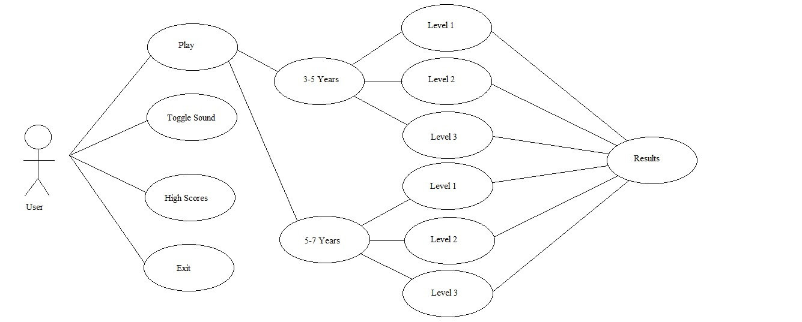

**4.3.3 Traceability Matrix**

*Show how your system requirements map to your use cases. Calculate the priority weights of your use cases. The use cases with the highest priority should be elaborated and planned.*

**4.3.4 Fully-Dressed Description**

*Select a few most important use cases and provide detailed (“fully dressed”) description. The “most important” use cases are indicated by your traceability matrix. Your event flows must show step-by-step every action that the initiating actor (“user”) can take while running the given use case.*

**4.4 System Sequence Diagrams**

*Draw the system sequence diagrams for the few most important use cases selected above.*

1. **User Interface Specification**

*The user interface should be specified only for the use cases elaborated in the previous section (“fully dressed” use cases).*

**5.1 Preliminary Design**

*For a given use case, show step-by-step how the user enters information and how the results appear on the screen.*

*Use screen mock-ups and describe exactly what fields the user enters and buttons the user presses. Describe navigational paths that the user will follow.*

**5.2 User Effort Estimation**

*Select several typical usage scenarios and, as you walk through the flow of events, count and report the number of mouse clicks and/or keystrokes that are needed to accomplish the task. What fraction of these goes to user-interface navigation vs. clerical data entry?*

[*http://www.ece.rutgers.edu/~marsic/Teaching/SE1/report1-appA.html*](http://www.ece.rutgers.edu/~marsic/Teaching/SE1/report1-appA.html)

1. **Domain Analysis**

**6.1 Domain Model**

*Show the process of deriving the domain model and then draw the diagram. Provide text description of:*

* *Concept definitions*
* *Association definitions*
* *Attribute definitions*
* *Traceability matrix - show how your use cases map to your domain concepts.*

**6.2 System Operation Contracts**

*Should be provided only for the operations of the fully-dressed use cases elaborated in Section 3.c), (Use Cases) for their system operations identified in Section 3.d). (System Sequence Diagrams)*

**6.3 Mathematical Model**

*Do you use any mathematical models? E.g., you may use a statistical model for stock price prediction, or a geometric model for computing the trajectories for animate figures in a video game. If NO, skip to the next item; if YES, describe precisely your model.*