Sales for Retail and Food Services in U.S.A.

1)Top-performing industries in terms of sales for a year 2021, and how do their sales compare month-over-month?
WITH monthly_sales AS (
SELECT
year,
month,
industry,
SUM(sales) AS total_sales
FROM
retail_sales
WHERE
year = 2021
GROUP BY
year,
month,
industry
),
top_industries AS (
SELECT
year,
month,
industry,
total_sales,
RANK() OVER (PARTITION BY year, month ORDER BY total_sales DESC) AS industry_rank
FROM
monthly_sales
)
SELECT
year,
month,
industry,
total_sales
FROM
top_industries
WHERE
industry_rank = 1
ORDER BY
year,
month;

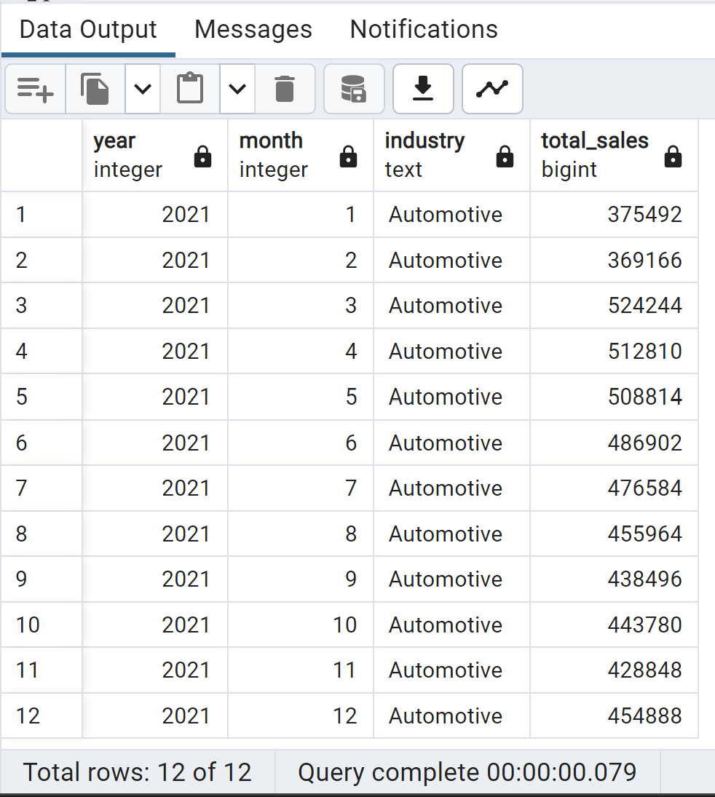

2)Top-performing industries in terms of sales for a year 2022, and how do their sales compare month-over-month?
WITH monthly_sales AS (
SELECT
year,
month,
industry,
SUM(sales) AS total_sales
FROM
retail_sales
WHERE
year = 2022
GROUP BY
year,
month,
industry
),
top_industries AS (
SELECT
year,
month,
industry,
total_sales,
RANK() OVER (PARTITION BY year, month ORDER BY total_sales DESC) AS industry_rank
FROM
monthly_sales
)
SELECT
year,
month,
industry,
total_sales
FROM
top_industries
WHERE
industry_rank = 1
ORDER BY
year,
month;
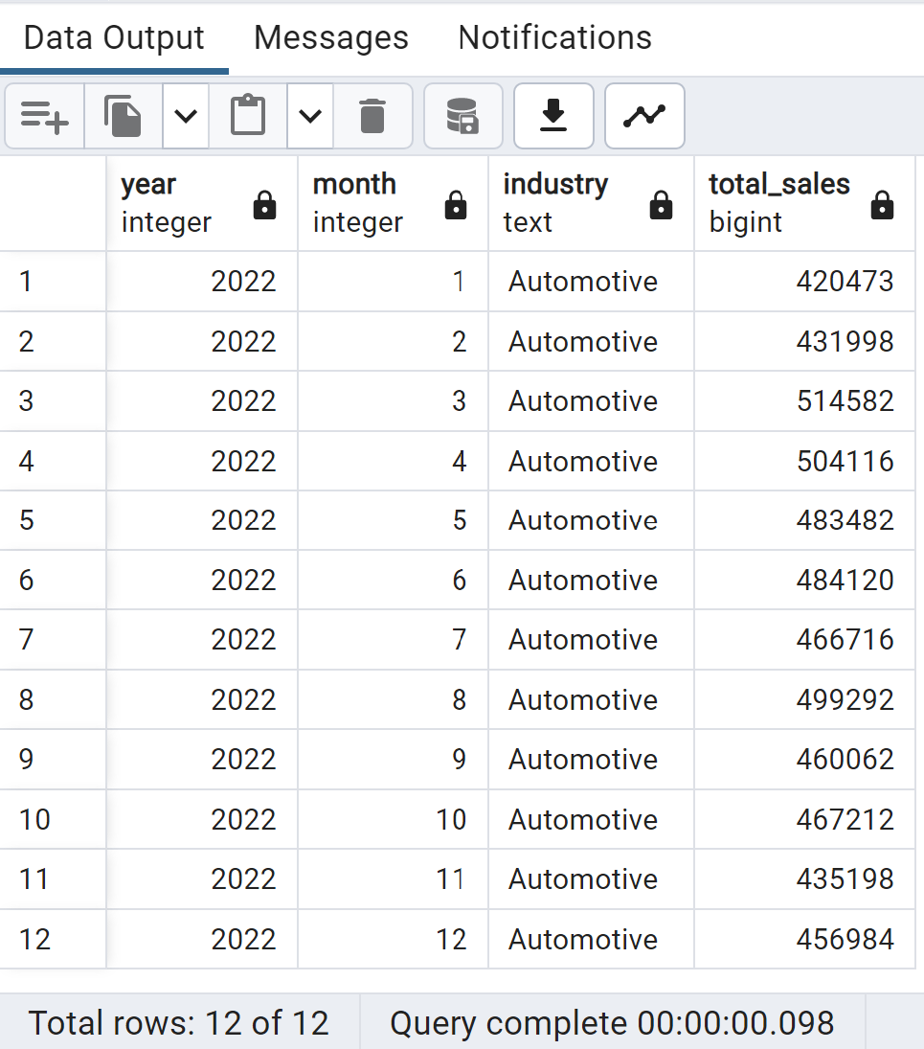

3)Top-performing industries in terms of sales for a year 2020, and how do their sales compare month-over-month?
WITH monthly_sales AS (
SELECT
year,
month,
industry,
SUM(sales) AS total_sales
FROM
retail_sales
WHERE
year = 2020
GROUP BY
year,
month,
industry
),
top_industries AS (
SELECT
year,
month,
industry,
total_sales,
RANK() OVER (PARTITION BY year, month ORDER BY total_sales DESC) AS industry_rank
FROM
monthly_sales
)
SELECT
year,
month,
industry,
total_sales
FROM
top_industries
WHERE
industry_rank = 1
ORDER BY
year,
month;
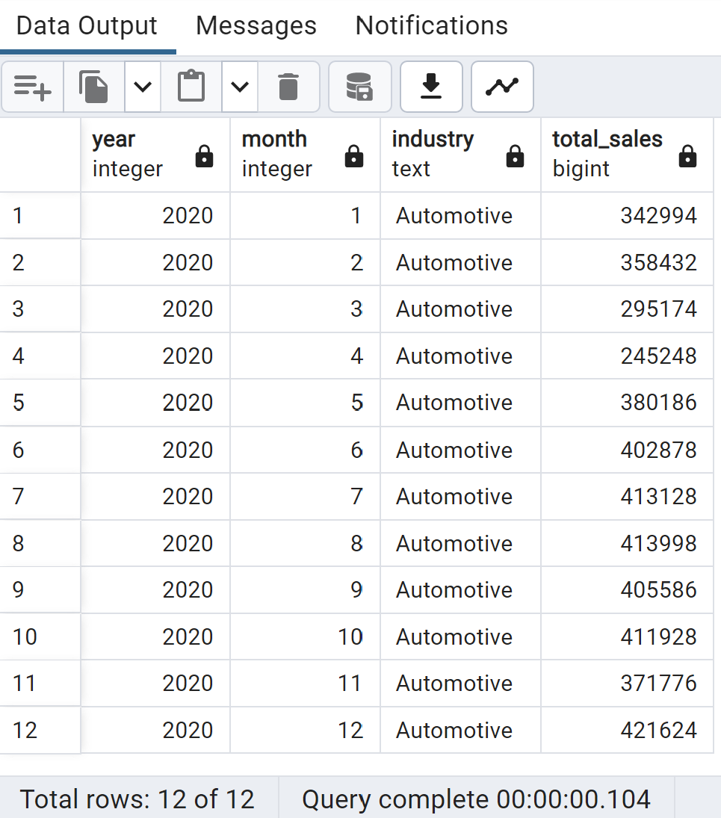
4)Top-performing industries in terms of sales for a year 2019, and how do their sales compare month-over-month?
WITH monthly_sales AS (
SELECT
year,
month,
industry,
SUM(sales) AS total_sales
FROM
retail_sales
WHERE
year = 2019
GROUP BY
year,
month,
industry
),
top_industries AS (
SELECT
year,
month,
industry,
total_sales,
RANK() OVER (PARTITION BY year, month ORDER BY total_sales DESC) AS industry_rank
FROM
monthly_sales
)
SELECT
year,
month,
industry,
total_sales
FROM
top_industries
WHERE
industry_rank = 1
ORDER BY
year,
month;
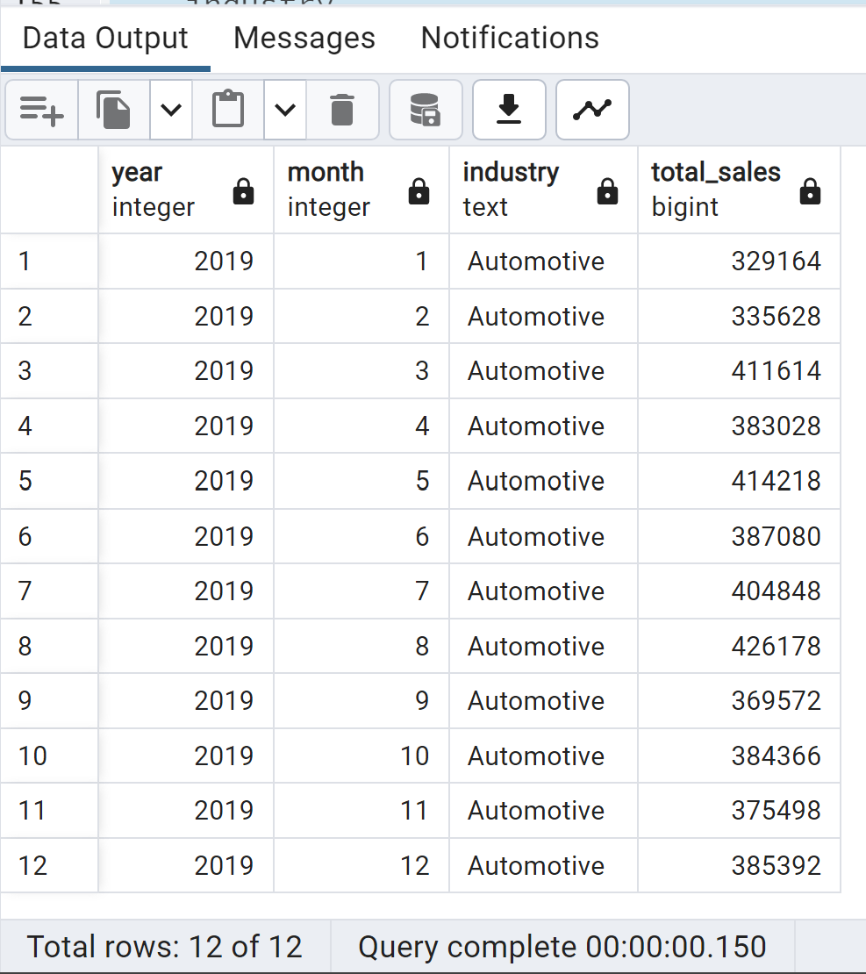

Business Question
5) Which specific kind of businesses contribute the most to total sales, and how does their performance vary across industries?
SELECT
kind_of_business,
industry,
SUM(sales) AS total_sales
FROM
retail_sales
GROUP BY
kind_of_business,
industry
ORDER BY
total_sales DESC;
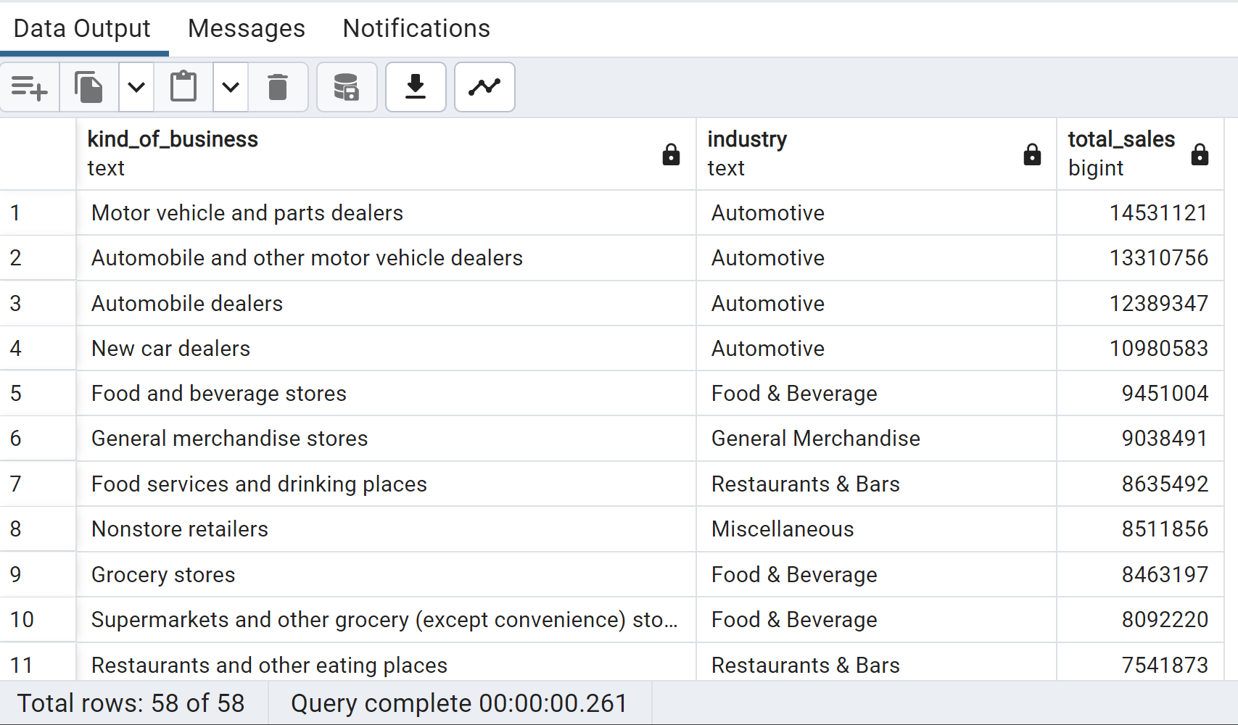
6) Is there any seasonality in sales for specific industries, and how do they perform month-over-month?
SELECT
industry,
year,
month,
SUM(sales) AS total_sales
FROM
retail_sales
GROUP BY
year,
industry,
month
ORDER BY
year,
industry,
month;

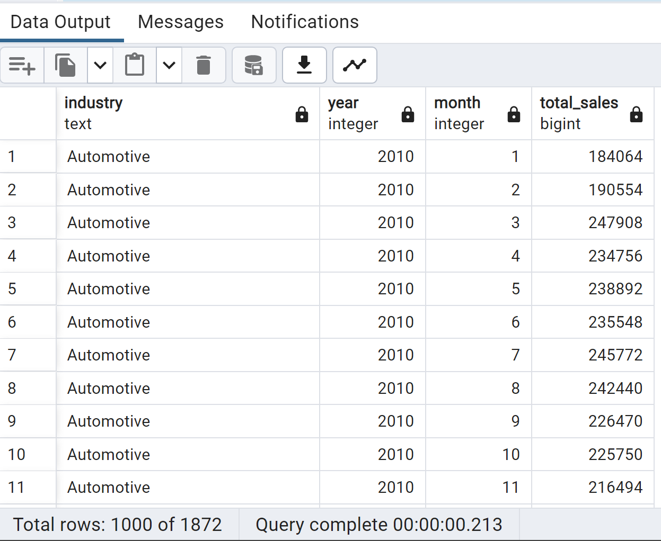
7) How does the sales distribution vary among industries based on their North American Industry Classification System (NAICS) codes?
SELECT
naics_code,
industry,
SUM(sales) AS total_sales
FROM
retail_sales
GROUP BY
naics_code,
industry
ORDER BY
naics_code,
total_sales DESC;
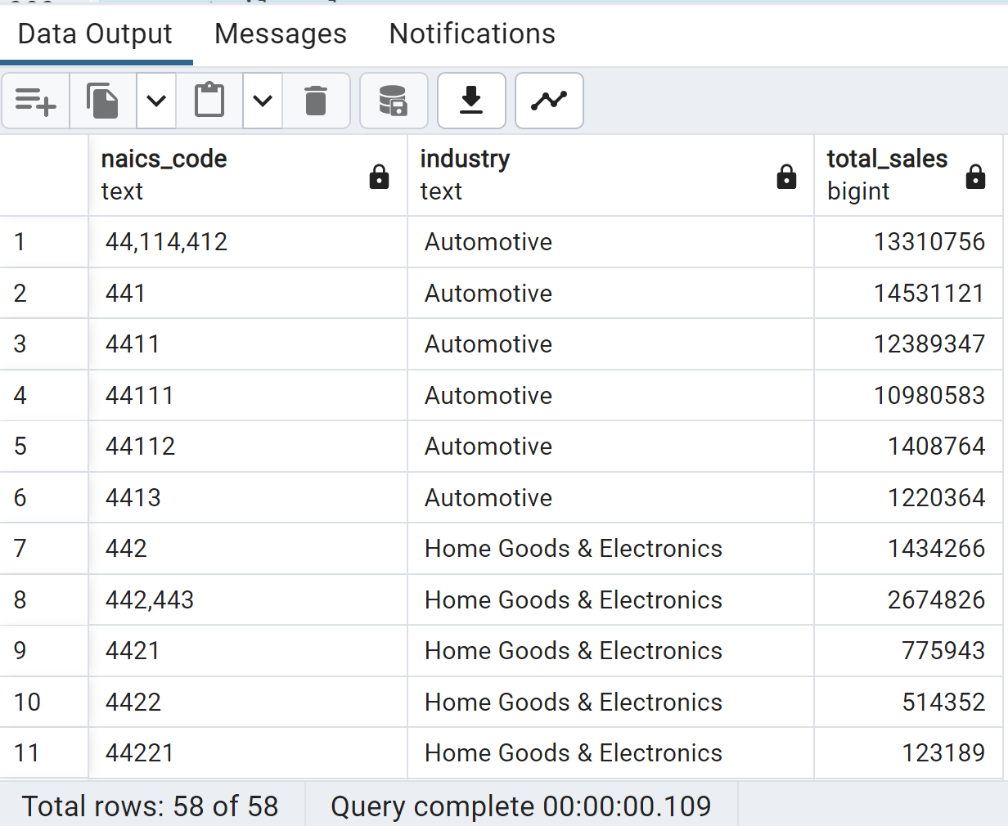
8) Are there any outliers or significant changes in sales for specific industries during particular months or years?
SELECT
industry,
year,
month,
sales
FROM
retail_sales
WHERE
(industry, year, month) IN (
SELECT
industry,
year,
month
FROM (
SELECT
industry,
year,
month,
sales,
LAG(sales) OVER (PARTITION BY industry ORDER BY year, month) AS prev_sales,
LEAD(sales) OVER (PARTITION BY industry ORDER BY year, month) AS next_sales
FROM
retail_sales
) AS sales_analysis
WHERE
sales > 1.5 * COALESCE(prev_sales, 0) OR sales > 1.5 * COALESCE(next_sales, 0)
)
ORDER BY
industry,
year,
month;

9)Which businesses all-time average sale was above 10 billion dollars?
SELECT
kind_of_business,
AVG(sales) AS average_sale
FROM
retail_sales
GROUP BY
kind_of_business
HAVING
AVG(sales) > 10000; -- 10 billion dollars in cents (1 dollar = 100 cents)

10)Which kind of businesses within the automotive industry had the highest sales revenue for 2022?
SELECT
kind_of_business,
SUM(sales) AS total_sales
FROM
retail_sales
WHERE
industry = 'Automotive' AND year = 2022
GROUP BY
kind_of_business
ORDER BY
total_sales DESC
;
11)What is the contribution percentage of each business in the automotive industry this year?
WITH automotive_sales AS (
SELECT
kind_of_business,
SUM(sales) AS total_sales
FROM
retail_sales
WHERE
industry = 'Automotive' AND
year = 2022
GROUP BY
kind_of_business
),
total_sales_automotive AS (
SELECT
SUM(sales) AS total_sales_automotive
FROM
retail_sales
WHERE
industry = 'Automotive' AND
year = 2022
)
SELECT
kind_of_business,
ROUND((total_sales / total_sales_automotive.total_sales_automotive) * 100, 2) AS contribution_percentage
FROM
automotive_sales
CROSS JOIN
total_sales_automotive;

----------------
--

with total_sales as(select year, industry, sum(sales) as sales_sum
from retail_sales
GROUP BY 1,2)

SELECT curr.industry, prev.year as previous_year, curr.year as current_year,
(curr.sales_sum - prev.sales_sum) / prev.sales_sum * 100 as YoY

from total_sales as curr
join total_sales as prev
on curr.year=prev.year+1 AND curr.industry=prev.industry
ORDER BY industry, curr.year DESC;

12 )What are the year-over-year growth rates for each industry per year?
with total_sales as(select year, industry, sum(sales) as sales_sum
from retail_sales
GROUP BY 1,2)

SELECT curr.industry, prev.year as previous_year, curr.year as current_year,
(curr.sales_sum - prev.sales_sum) / prev.sales_sum * 100 as YoY

from total_sales as curr
join total_sales as prev
on curr.year=prev.year+1 AND curr.industry=prev.industry
ORDER BY industry, curr.year DESC;

--OR--
SELECT
year,
industry,
(sales - LAG(sales) OVER (PARTITION BY industry ORDER BY year)) / LAG(sales) OVER (PARTITION BY industry ORDER BY year) * 100 AS growth_rate
FROM
retail_sales
ORDER BY
industry, year;

13)What are the yearly total sales for women's clothing stores and men's clothing stores?

SELECT
year,
sum(CASE WHEN kind_of_business = 'Women''s clothing stores' THEN sales ELSE 0 END) as women_sales,
sum(CASE WHEN kind_of_business = 'Men''s clothing stores' THEN sales ELSE 0 END) as men_sales
FROM
retail_sales
GROUP BY
year;

14)What is the yearly ratio of total sales for women's clothing stores to total sales for men's clothing stores?
SELECT year, women_sales/men_sales as Women_to_Men_ratio
FROM (
SELECT year,
sum(CASE WHEN kind_of_business = 'Women''s clothing stores' THEN sales ELSE 0 END) as women_sales,
sum(CASE WHEN kind_of_business = 'Men''s clothing stores' THEN sales ELSE 0 END) as men_sales
FROM retail_sales
GROUP BY 1
) subquery;

15)What is the year-to-date total sale of each month for 2019, 2020, 2021, and 2022 for the women’s clothing stores?

SELECT
rs.month,
rs.year,
rs.sales,
(
(
SELECT SUM(sales)
FROM retail_sales rs2
WHERE rs2.year = rs.year
AND rs2.month <= rs.month
AND rs2.kind_of_business = 'Women\'s clothing stores'
)
) AS ytd_sales
FROM
retail_sales AS rs
WHERE
rs.kind_of_business = 'Women\'s clothing stores'
AND rs.year IN (2019, 2020, 2021, 2022);

16)What is the month-over-month growth rate of women’s clothing businesses in 2022?

-- Query 1
SELECT
month,
sales AS current_sales,
-- now we want the sales from 1 previous period
LAG(sales, 1) OVER (ORDER BY month) AS prev_sales
FROM
retail_sales
WHERE
kind_of_business = 'Women\'s clothing stores'
AND year = 2022;

-- Query 2
SELECT
month,
sales AS current_sales,
LAG(sales, 1) OVER (ORDER BY month) AS prev_sales,
(sales - LAG(sales, 1) OVER (ORDER BY month)) / LAG(sales, 1) OVER (ORDER BY month) * 100 AS growth_rate
FROM
retail_sales
WHERE
kind_of_business = 'Women\'s clothing stores'
AND year = 2022;

Data Source: U.S. Government, Open available data
GitHub Repo: https://github.com/tushar2704/Sales-for-Retail-and-Food-Services
Author: © 2023 Tushar Aggarwal

