**Project 4: Machine Learning Model for Car Crash Data**

By: Kevin Carney, Paris Lee, Samantha Schutz, and Joy Weishan

October 3, 2024

Table of Contents

**Data Analytics Team1**

**Introduction1**

**Color Palette1**

**Predictions1**

**Data Engineering1**

**Machine Learning/Interpretations**

Model 15

Model 25

Model 35

**Visualizations**

Visualization 15

Visualization 25

**Creating the Web App1**

**Finding and Conclusions1**

**Car Crash Data**

**Team (Joy)**

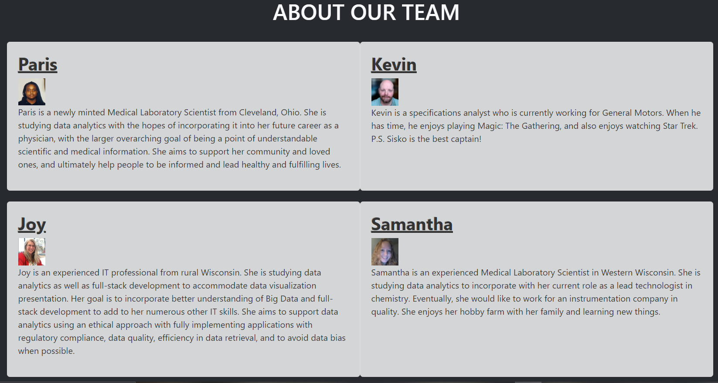

**Introduction (Joy)**

Automobiles are an everyday part of our lives, as such a crash is always a possible danger. Understanding the recent data that shows what the factors were that caused various accidents of differing levels of severity are of interest to us since three of us work in or adjacent to the medical field, and one of us works for General Motors.

**Color Palette (Joy)**

We used <https://bootswatch.com/slate/>

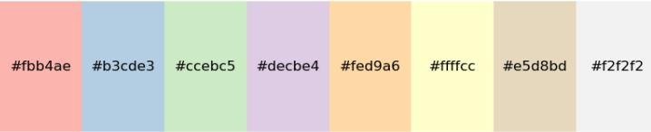

**Predictions (Joy/Team):**

BLAH BLAH BLAH

**Dataset Cleaning Machine Learning (Kevin)**

BLAH BLAH BLAH

**Dataset Cleaning Machine Tableau (Samantha)**

BLAH BLAH BLAH

**Machine Learning/Interpretations (Kevin)**

BLAH BLAH BLAH

**Model 1**

BLAH BLAH BLAH

**Model 2**

BLAH BLAH BLAH

**Model 3**

**Visualizations (Samantha)**

Blah Blah Blah

**Chart Picture goes hare**

Blah Blah Blah

**Chart Picture goes hare**

Blah Blah Blah

**Chart Picture goes hare**

**Maps (Samantha)**

BLAH BLAH BLAH

PICTURE OF MAP GOES HERE

**Visualizations (Paris)**

Blah Blah Blah

**Chart Picture goes hare**

Blah Blah Blah

**Chart Picture goes hare**

Blah Blah Blah

**Chart Picture goes hare**

Blah Blah Blah

**Chart Picture goes hare**

**The Web App (Joy)**

We created six HTML files corresponding to six different pages in our web app: a home page, a Tableau/visualization page, an ML form, our report, an about us page, and a works cited page.

The ML form has 15 user inputs: 9 dropdowns and 6 fill-ins for each of the demographics in our

model.

We set up a Flask application deployed to PythonAnywhere to provide access to the site. Our

link is: https://sphilli.pythonanywhere.com/

BLAH BLAH BLAH

**Findings/Conclusion(Team)**

BLAH BLAH BLAH

**Sources (Joy)**

Kaggle Dataset:

* [Economic Atlas of Rural and Small-Town America (Kaggle)](https://www.kaggle.com/datasets/davidbroberts/atlas-of-rural-and-smalltown-america) - Source of the dataset used for the project.

Xpert Learning Assistant:

* [Xpert Learning Assistant](https://github.com/cisnerosjp/project3Team2/tree/main) - Used for debugging certain codes.

chatGPT:

* chatGPT- Used for debugging certain codes.

GitHub Repository:

* https://github.com/cisnerosjp/project3Team 2/tree/main - Served as a reference for project organization and structure.

Texas Tribune Article:

* <https://www.texastribune.org/2023/11/21/texas-immigrants-pewresearch/#:~:text=Unauthorized%20immigrants%20make%20up%208,networks%20that%20encourage%20further%20immigration> - Provided valuable context and background information related to immigration trends, which informed the broader narrative of the project.

USA Today Article:

* [://www.usatoday.com/story/news/politics/2023/06/21/florida-immigration-lawbusiness-owners-fear-exodus-of-workersconstruction-landscaping/703416320](https://www.usatoday.com/story/news/politics/2023/06/21/florida-immigration-lawbusiness-owners-fear-exodus-of-workersconstruction-landscaping/703416320) - Offered insights into the impact of immigration policies on the workforce, contributing to the understanding of economic factors in rural areas.