Report

**Data Visualization**

|  |  |  |
| --- | --- | --- |
|  |  |  |
|  |  |  |

**Data Distribution**

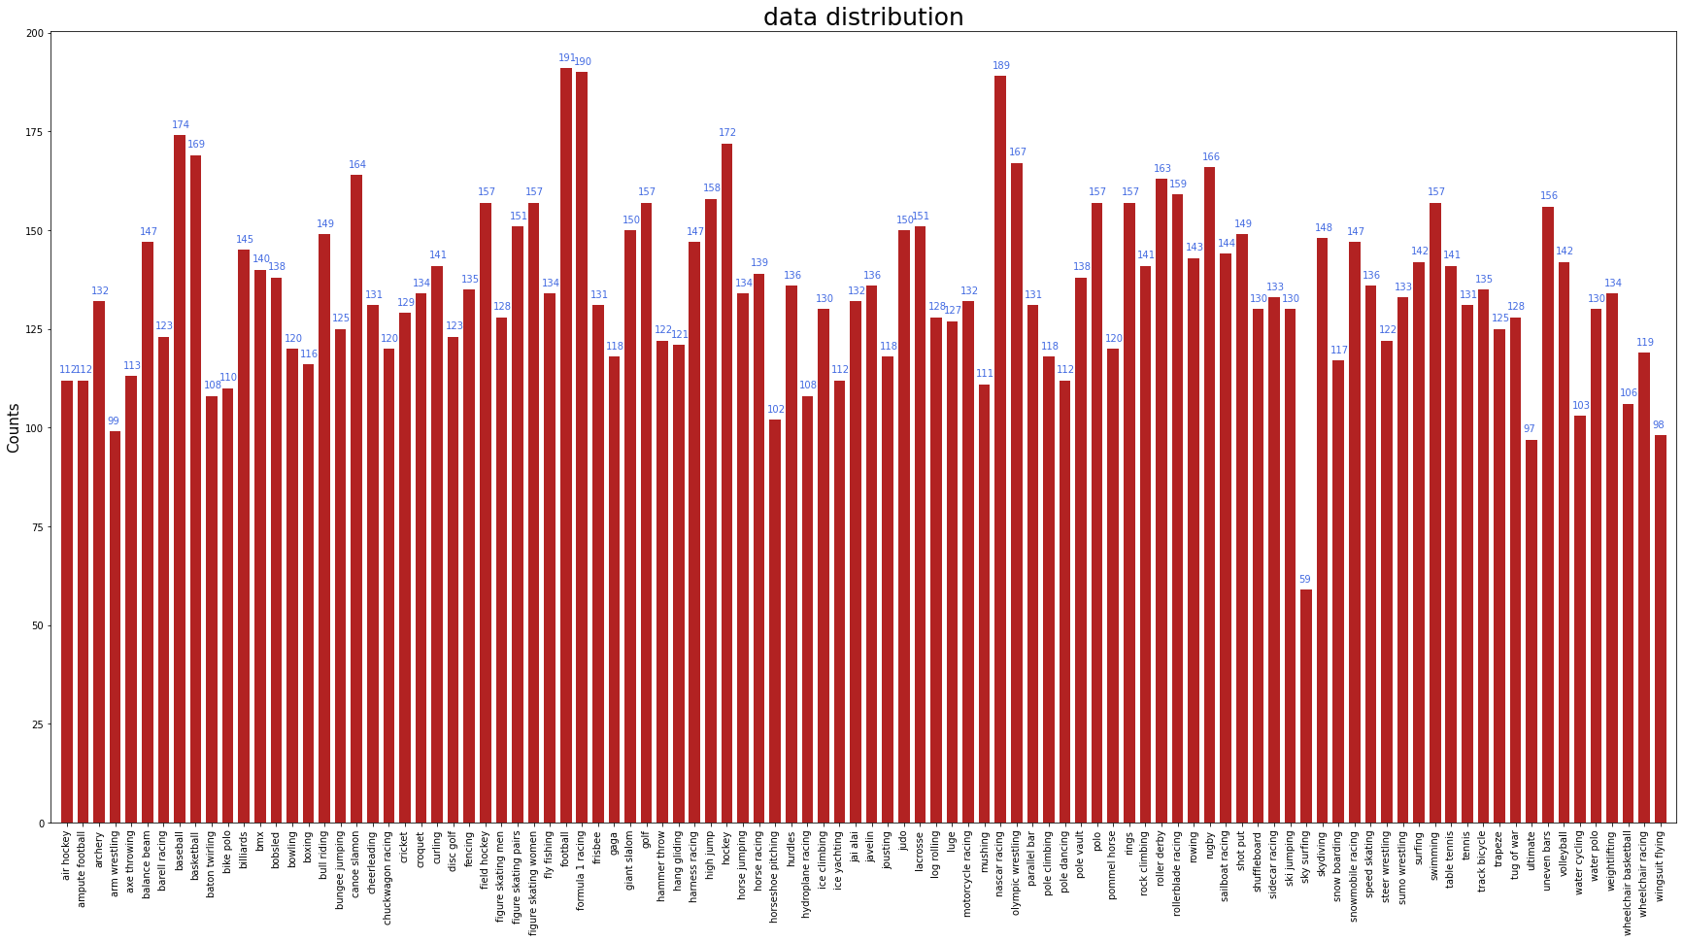

**Model Training**

Epoch 0/30

100%|██████████| 106/106 [00:33<00:00, 3.17it/s, Loss=4.54, Acc=1.18]

100%|██████████| 2/2 [00:14<00:00, 7.06s/it, Loss=4.54, Acc=0.8]

Epoch 1/30

100%|██████████| 106/106 [00:09<00:00, 11.18it/s, Loss=3.4, Acc=39.5]

100%|██████████| 2/2 [00:00<00:00, 2.04it/s, Loss=2.19, Acc=73.6]

Epoch 2/30

100%|██████████| 106/106 [00:09<00:00, 11.22it/s, Loss=1.72, Acc=74.1]

100%|██████████| 2/2 [00:01<00:00, 1.98it/s, Loss=1.11, Acc=80.6]

…

Epoch 29/30

100%|██████████| 106/106 [00:09<00:00, 11.52it/s, Loss=0.0931, Acc=96.6]

100%|██████████| 2/2 [00:00<00:00, 2.02it/s, Loss=0.232, Acc=88.8]

Epoch 30/30

100%|██████████| 106/106 [00:09<00:00, 11.35it/s, Loss=0.0913, Acc=96.6]

100%|██████████| 2/2 [00:00<00:00, 2.10it/s, Loss=0.227, Acc=89.2]

|  |  |
| --- | --- |
|  |  |

**Test data performance**

100%|██████████| 2/2 [00:13<00:00, 6.79s/it, Loss=0.212, Acc=90.8]

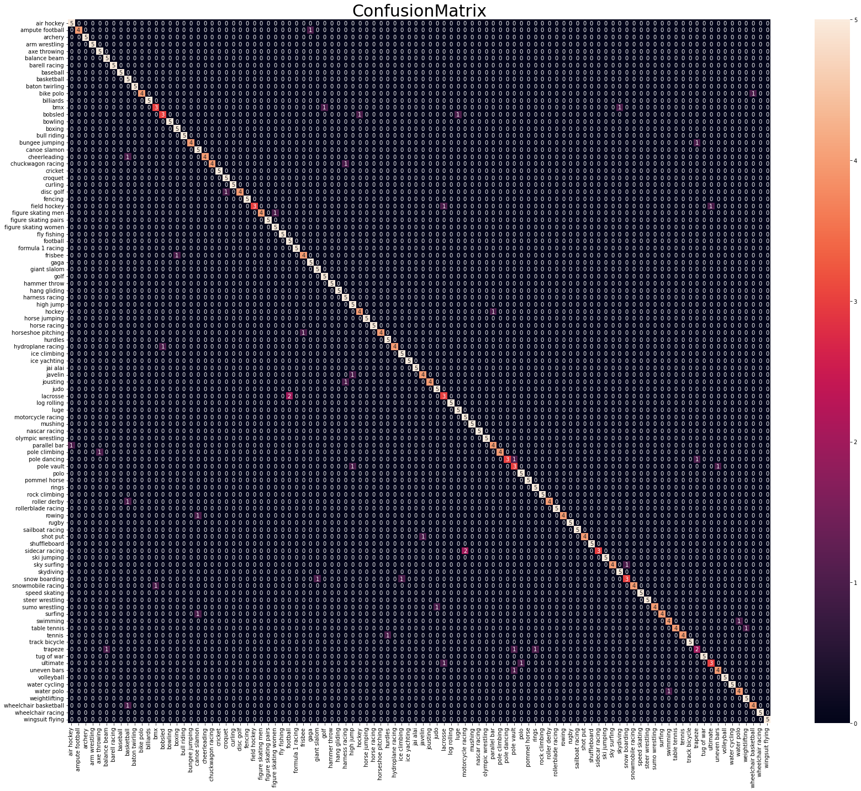

**GUI**

