**Data Visualization**

>> Architecturally, the school has a Catholic character. Atop the Main Building's gold dome is a golden statue of the Virgin Mary. Immediately in front of the Main Building and facing it, is a copper statue of Christ with arms upraised with the legend "Venite Ad Me Omnes". Next to the Main Building is the Basilica of the Sacred Heart. Immediately behind the basilica is the Grotto, a Marian place of prayer and reflection. It is a replica of the grotto at Lourdes, France where the Virgin Mary reputedly appeared to Saint Bernadette Soubirous in 1858. At the end of the main drive (and in a direct line that connects through 3 statues and the Gold Dome), is a simple, modern stone statue of Mary.

> To whom did the Virgin Mary allegedly appear in 1858 in Lourdes France?

= Saint Bernadette Soubirous

>> In the Balearic Islands, IEC's standard is used but adapted for the Balearic dialect by the University of the Balearic Islands's philological section. In this way, for instance, IEC says it is correct writing cantam as much as cantem ('we sing') but the University says that the priority form in the Balearic Islands must be "cantam" in all fields. Another feature of the Balearic standard is the non-ending in the 1st person singular present indicative: jo compr ('I buy'), jo tem ('I fear'), jo dorm ('I sleep').

> How is the standard used there?

= adapted for the Balearic dialect

>> The city is recognised for its mix of modern architecture which intersects with an extensive range of nineteenth and early twentieth century buildings. Some of the most architecturally noteworthy historic buildings include the World Heritage Site-listed Royal Exhibition Building, constructed over a two-year period for the Melbourne International Exhibition in 1880, A.C. Goode House, a Neo Gothic building located on Collins Street designed by Wright, Reed & Beaver (1891), William Pitt's Venetian Gothic style Old Stock Exchange (1888), William Wardell's Gothic Bank (1883) which features some of Melbourne's finest interiors, the incomplete Parliament House, St Paul's Cathedral (1891) and Flinders Street Station (1909), which was the busiest commuter railway station in the world in the mid-1920s.

> In what year was construction on the Flinders Street Station completed?

= 1909

>> During the 18th and 19th centuries, federal law traditionally focused on areas where there was an express grant of power to the federal government in the federal Constitution, like the military, money, foreign relations (especially international treaties), tariffs, intellectual property (specifically patents and copyrights), and mail. Since the start of the 20th century, broad interpretations of the Commerce and Spending Clauses of the Constitution have enabled federal law to expand into areas like aviation, telecommunications, railroads, pharmaceuticals, antitrust, and trademarks. In some areas, like aviation and railroads, the federal government has developed a comprehensive scheme that preempts virtually all state law, while in others, like family law, a relatively small number of federal statutes (generally covering interstate and international situations) interacts with a much larger body of state law. In areas like antitrust, trademark, and employment law, there are powerful laws at both the federal and state levels that coexist with each other. In a handful of areas like insurance, Congress has enacted laws expressly refusing to regulate them as long as the states have laws regulating them (see, e.g., the McCarran-Ferguson Act).

> What type of property are trademarks and copyrights?

= intellectual property

>> Apple's HyperCard scripting language provided Macintosh computer users with a means to design databases of slides, animation, video and sounds from LaserDiscs and then to create interfaces for users to play specific content from the disc through software called LaserStacks. User-created "stacks" were shared and were especially popular in education where teacher-generated stacks were used to access discs ranging from art collections to basic biological processes. Commercially available stacks were also popular with the Voyager company being possibly the most successful distributor.

> Where were "stacks" created with the LaserStack software used?

= in education

>> Other historical points of interest include St. John's Church, the site of Patrick Henry's famous "Give me liberty or give me death" speech, and the Edgar Allan Poe Museum, features many of his writings and other artifacts of his life, particularly when he lived in the city as a child, a student, and a successful writer. The John Marshall House, the home of the former Chief Justice of the United States, is also located downtown and features many of his writings and objects from his life. Hollywood Cemetery is the burial grounds of two U.S. Presidents as well as many Civil War officers and soldiers.

> Who gave a speech that contained the famous saying "Give me liberty or give me death"?

= Patrick Henry

**Model Training**

Epoch 0/8

100%|██████████| 13140/13140 [17:23<00:00, 12.59it/s, Loss=10.3, PPL=3.37e+4]

100%|██████████| 730/730 [01:50<00:00, 6.60it/s, Loss=10.1, PPL=3.28e+4]

Epoch 1/8

100%|██████████| 13140/13140 [41:58<00:00, 5.22it/s, Loss=1.23, PPL=11.7]

100%|██████████| 730/730 [02:12<00:00, 5.50it/s, Loss=1.16, PPL=3.35]

Epoch 2/8

100%|██████████| 13140/13140 [44:11<00:00, 4.96it/s, Loss=1.16, PPL=3.24]

100%|██████████| 730/730 [02:12<00:00, 5.51it/s, Loss=1.16, PPL=3.34]

…

Epoch 7/8

100%|██████████| 13140/13140 [44:13<00:00, 4.95it/s, Loss=1.13, PPL=3.16]

100%|██████████| 730/730 [02:12<00:00, 5.50it/s, Loss=1.15, PPL=3.32]

Epoch 8/8

100%|██████████| 13140/13140 [44:12<00:00, 4.95it/s, Loss=1.13, PPL=3.16]

100%|██████████| 730/730 [02:12<00:00, 5.50it/s, Loss=1.15, PPL=3.32]

**Test Performance**

100%|██████████| 881/881 [02:14<00:00, 6.54it/s, Loss=1.12, PPL=3.37]

>> Super Bowl 50 was an American football game to determine the champion of the National Football League (NFL) for the 2015 season. The American Football Conference (AFC) champion Denver Broncos defeated the National Football Conference (NFC) champion Carolina Panthers 24–10 to earn their third Super Bowl title. The game was played on February 7, 2016, at Levi's Stadium in the San Francisco Bay Area at Santa Clara, California. As this was the 50th Super Bowl, the league emphasized the "golden anniversary" with various gold-themed initiatives, as well as temporarily suspending the tradition of naming each Super Bowl game with Roman numerals (under which the game would have been known as "Super Bowl L"), so that the logo could prominently feature the Arabic numerals 50.

> Which NFL team represented the AFC at Super Bowl 50?

= Denver Broncos

< American Football Conference (AFC) champion Denver Broncos

>> In the United States, each state determines the requirements for getting a license to teach in public schools. Teaching certification generally lasts three years, but teachers can receive certificates that last as long as ten years. Public school teachers are required to have a bachelor's degree and the majority must be certified by the state in which they teach. Many charter schools do not require that their teachers be certified, provided they meet the standards to be highly qualified as set by No Child Left Behind. Additionally, the requirements for substitute/temporary teachers are generally not as rigorous as those for full-time professionals. The Bureau of Labor Statistics estimates that there are 1.4 million elementary school teachers, 674,000 middle school teachers, and 1 million secondary school teachers employed in the U.S.

> What must a public school teacher have, at a minimum?

= a bachelor's degree

< Bachelor's degree

>> The 2007 Lisbon Treaty explicitly recognised fundamental rights by providing in Article 6(1) that "The Union recognises the rights, freedoms and principles set out in the Charter of Fundamental Rights of the European Union of 7 December 2000, as adopted at Strasbourg on 12 December 2007, which shall have the same legal value as the Treaties." Therefore, the Charter of Fundamental Rights of the European Union has become an integral part of European Union law, codifying the fundamental rights which were previously considered general principles of European Union law. In effect, after the Lisbon Treaty, the Charter and the Convention now co-exist under European Union law, though the former is enforced by the European Court of Justice in relation to European Union measures, and the latter by the European Court of Human Rights in relation to measures by member states.

> When was the Lisbon Treaty established?

= 2007

< 2007

>> One theory suggests the name stems from a palatalised version of the Mongolian and Turkic word tenggis, meaning "ocean", "oceanic" or "wide-spreading". (Lake Baikal and ocean were called tenggis by the Mongols. However, it seems that if they had meant to call Genghis tenggis they could have said, and written, "Tenggis Khan", which they did not.) Zhèng (Chinese: 正) meaning "right", "just", or "true", would have received the Mongolian adjectival modifier -s, creating "Jenggis", which in medieval romanization would be written "Genghis". It is likely that the 13th century Mongolian pronunciation would have closely matched "Chinggis".

> What spelling of Genghis most closely matches its probable pronunciation?

= Chinggis

< kins

>> Kenya’s armed forces, like many government institutions in the country, have been tainted by corruption allegations. Because the operations of the armed forces have been traditionally cloaked by the ubiquitous blanket of “state security”, the corruption has been less in public view, and thus less subject to public scrutiny and notoriety. This has changed recently. In what are by Kenyan standards unprecedented revelations, in 2010, credible claims of corruption were made with regard to recruitment and procurement of Armoured Personnel Carriers. Further, the wisdom and prudence of certain decisions of procurement have been publicly questioned.

> Why has the corruption not be in the public view?

= Because the operations of the armed forces have been traditionally cloaked by the ubiquitous blanket of “state security”

< Public view

**GUI**

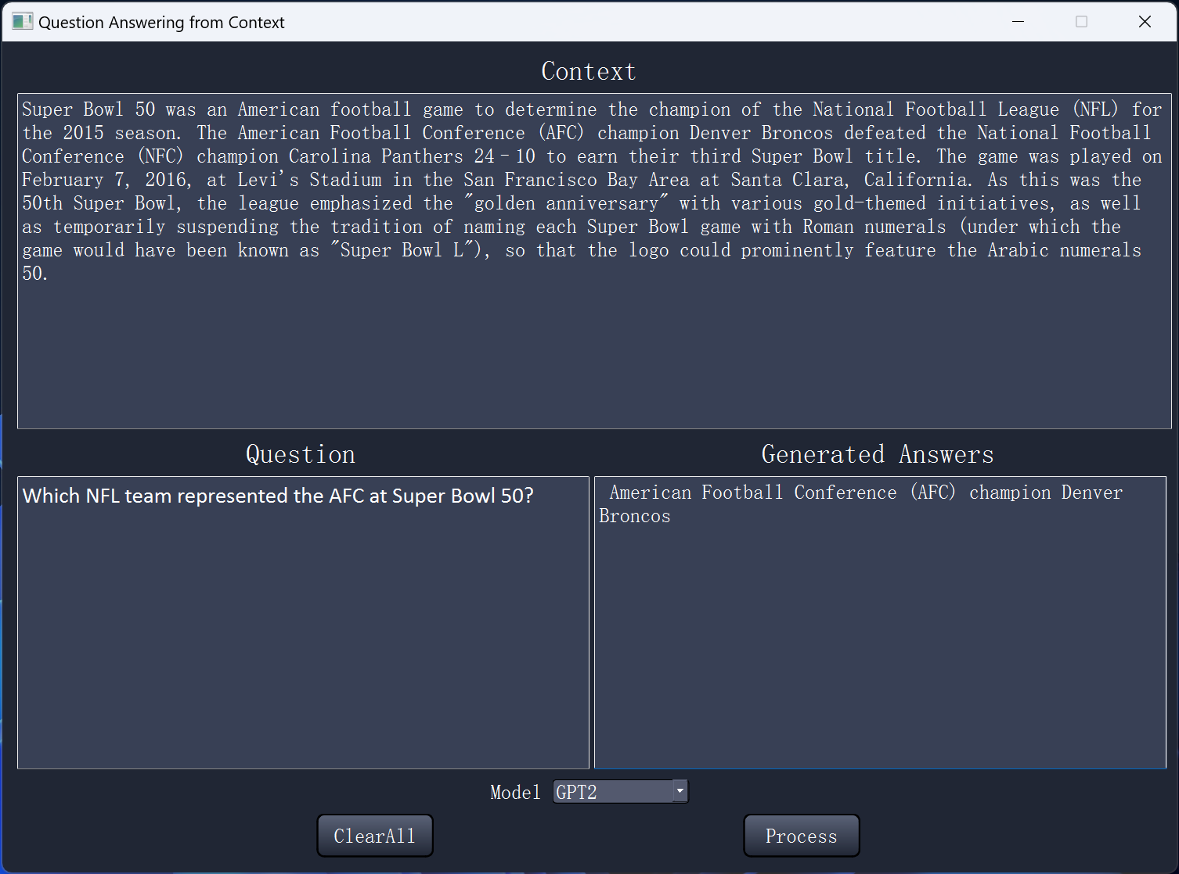

User Manual:

1. The Dropdown Model menu lets you pick which model to use.
2. Enter Context and Question.
3. Press “Process” button to generate new Text.
4. Press “Clear” to clear all text