Data Processing

Each image is resized down to 288, 384 (original size: 600, 800) to reserve memory and maintain the aspect ratio.

Data Visualization

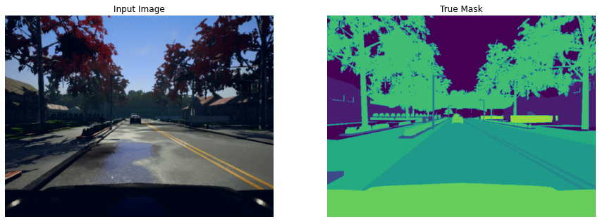

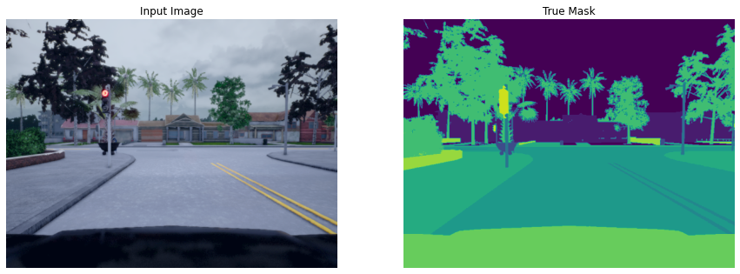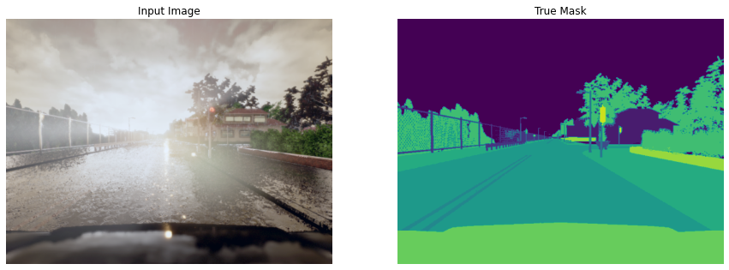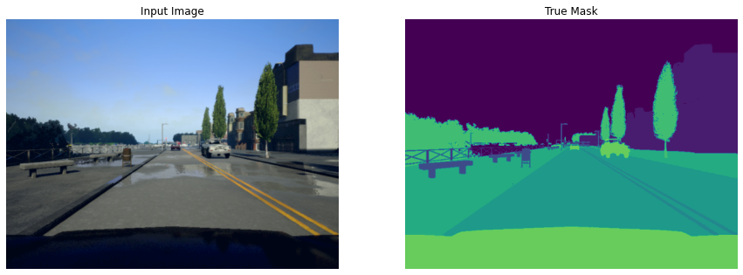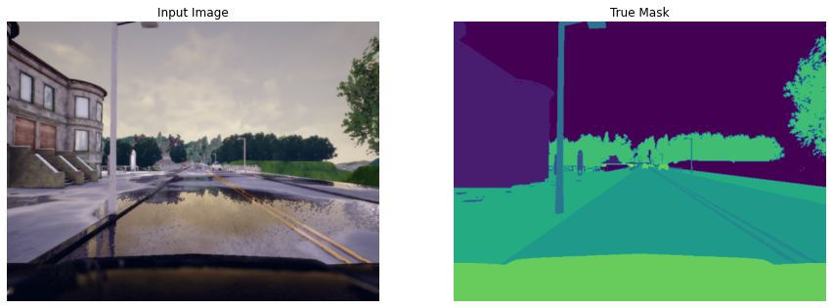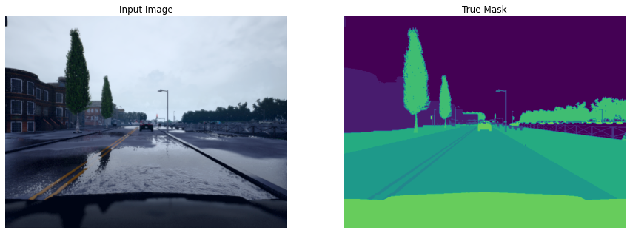

**Model**

================================================================

Total params: 31,033,175

Trainable params: 31,033,175

Non-trainable params: 0

----------------------------------------------------------------

Input size (MB): 2.85

Forward/backward pass size (MB): 1254.87

Params size (MB): 118.38

Estimated Total Size (MB): 1376.10

----------------------------------------------------------------

**Training**

Loss Function:

This project uses Focal Loss to mitigate data imbalance (under-represented class such as “Pole”, “Fence”, etc).

Evaluation:

1. Mean Pixel Accuracy (Acc)
2. Mean Intersect over Union (MIoU)

Epoch 0/50

100%|██████████| 1000/1000 [02:58<00:00, 5.59it/s, Loss=2.18, Acc=4.8, MIoU=0.6]

100%|██████████| 63/63 [00:28<00:00, 2.23it/s, Loss=2.18, Acc=4.7, MIoU=0.6]

Epoch 1/50

100%|██████████| 1000/1000 [07:40<00:00, 2.17it/s, Loss=0.759, Acc=66, MIoU=20.1]

100%|██████████| 63/63 [00:19<00:00, 3.17it/s, Loss=0.513, Acc=74.5, MIoU=25.5]

Epoch 2/50

100%|██████████| 1000/1000 [07:40<00:00, 2.17it/s, Loss=0.424, Acc=79.9, MIoU=30.8]

100%|██████████| 63/63 [00:19<00:00, 3.17it/s, Loss=0.35, Acc=83.9, MIoU=34.2]

Epoch 3/50

100%|██████████| 1000/1000 [07:40<00:00, 2.17it/s, Loss=0.326, Acc=85, MIoU=36]

100%|██████████| 63/63 [00:19<00:00, 3.17it/s, Loss=0.315, Acc=85.5, MIoU=37]

…

Epoch 49/50

100%|██████████| 1000/1000 [07:40<00:00, 2.17it/s, Loss=0.0616, Acc=96.2, MIoU=72.1]

100%|██████████| 63/63 [00:19<00:00, 3.17it/s, Loss=0.0669, Acc=96.1, MIoU=72.8]

Epoch 50/50

100%|██████████| 1000/1000 [07:40<00:00, 2.17it/s, Loss=0.058, Acc=96.3, MIoU=72.9]

100%|██████████| 63/63 [00:19<00:00, 3.17it/s, Loss=0.0651, Acc=96.2, MIoU=73.2]

|  |  |
| --- | --- |
|  |  |
|  |  |

**Test dataset Performance**

100%|██████████| 63/63 [00:28<00:00, 2.23it/s, Loss=0.063, Acc=96.3, MIoU=73.5]

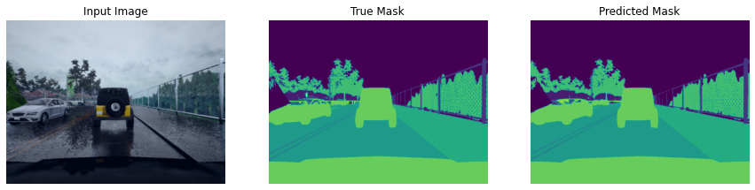

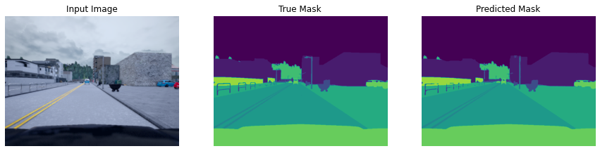

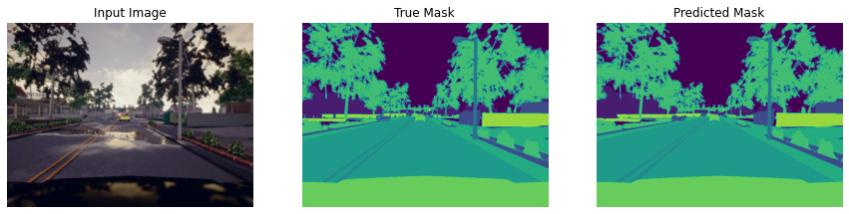

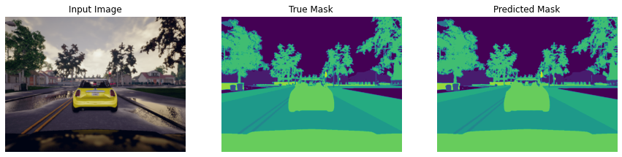

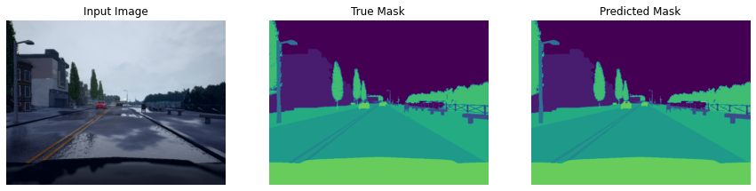

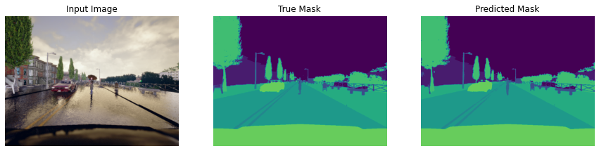

**GUI**

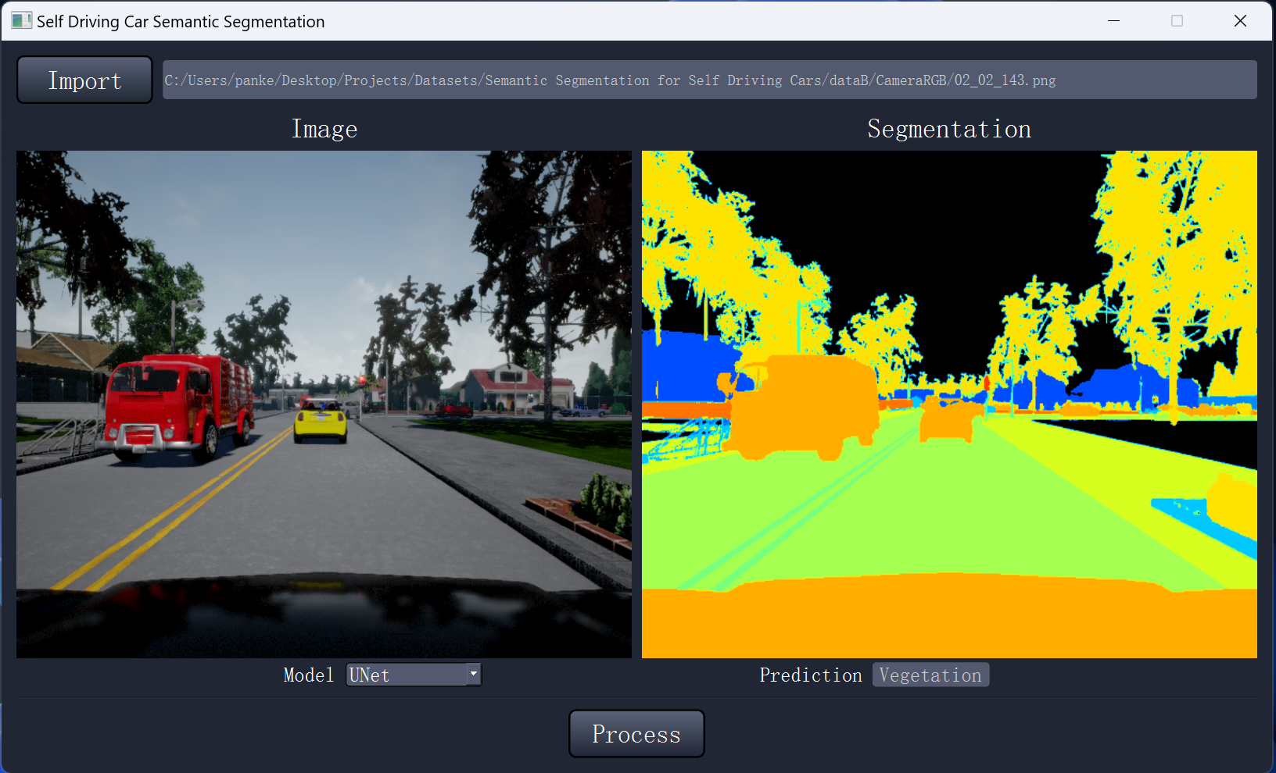

User Manual:

1. Press “Import” button to load an image.
2. The Dropdown Model menu lets you pick which model to use.
3. Then press “Process: button to generate a segmentation map.
4. Hover the mouse over the Segmentation map to see the Prediction of that pixel.