**Data Visualization**

> as much as i love rodney dangerfield, this was a terrible movie. the plot was kind of a holistic rip off of various movies, but unfortunately they forgot to rip off any good jokes. in addition it was annoying and boring and that's being kind. if you're looking for a good laugh, rent a copy of private parts.

= Negative

> a wonderful film to watch with astonishing scenes and talented actors, such as misa shimizu and nagiko tono. after 15 minutes of watching, your eyes get locked on the screen and you do nothing but breathing in the atmosphere of the film waiting what the destiny will bring to the characters. this film makes you leave your position as a standard audience, it takes you in, it makes you a part of the story... costumes and settings are brilliant ; especially the district of the okiyas is skillfully built. it is definitely not very akira kurosawa, however it still gets a lot from the master, especially the stylistic story telling tells us we're in a distinguished land of cinema which is quite far from hollywoodish flamboyance.

= Positive

> wow, what can i say about this film? it's a lousy piece of crap. i'm surprised that it got rated as high as it did. what's wrong with this film? here's a better question : what's not wrong with this film. the story itself is just crap and cliche. here's pretty much what it's about... some kinda nerdy kid with no friends gets picked on, gets killed, and comes back as a scarecrow for revenge. " all " of that is packed into 86 minutes of worthless film. if you haven't seen this movie don't waste your time watching it. also, the second one isn't much better, so don't bother watching that either... i rated this movie a three because i liked the scarecrow's outfit, not because there was anything good about the movie. i think you get the picture.

= Negative

> i was prepared for a turgid talky soap opera cum travelogue, but was pleased to find a fast - paced script, an underlying moral, excellent portrayals from all the actors, especially peter finch, amazing special effects, suspense, and beautiful cinematography - - there's even a shot of the majestic stone buddhas recently destroyed by the taliban. not to mention elizabeth taylor at her most gloriously beautiful and sympathetic, before she gave in to the gaspy hysterics that marred her later work. all the supporting players round it out, and i do wonder who trained all those elephants. speaking of the stone - buddha sequence, you really can discern that it's vivien leigh in the long shots. her shape and the way she moves is distinct from taylor's. the only thing marring that sequence are the poorly done process shots, where the background moves by much too fast for horses at a walk. if you want a thought - provoking film that is beautiful to watch and never boring, spend a few hours with elephant walk.

= Positive

> return of the jedi is certainly the most action packed of the series, and is a fine conclusion to the star wars saga. with han solo imprisoned by jabba the hut and the empire building a new death star, the rebel alliance is facing an uphill struggle against the dark side, and only our favourite heroes can pull it off. the opening sequence, set on tatooine, we see jabba's palace, a pit of slavery and scum, and new home to han solo, as luke and the gang prepare for his rescue, and with luke's jedi powers, they have the edge. we also witness a tremendous triple battle at the end. han, leia and chewy battle it out on endor, desperate to deactivate the shields protecting the death star. the rebel fleet led by lando, battle with the imperial fleet while they wait for the shields to go down, and luke has a final showdown with darth vader. an epic end to a classic saga, and it's only just of the pace of the first two. 10 / 10

= Positive

**Model**

================================================================

Total params: 66,955,010

Trainable params: 7,680,002

Non-trainable params: 59,275,008

----------------------------------------------------------------

Input size (MB): 0.00

Forward/backward pass size (MB): 4.50

Params size (MB): 255.41

Estimated Total Size (MB): 259.91

----------------------------------------------------------------

**Training**

Epoch 0/8

100%|██████████| 313/313 [02:24<00:00, 2.16it/s, Loss=0.696, Acc=49.8]

100%|██████████| 40/40 [00:35<00:00, 1.12it/s, Loss=0.694, Acc=50.8]

Epoch 1/8

100%|██████████| 313/313 [03:30<00:00, 1.49it/s, Loss=0.36, Acc=84.6]

100%|██████████| 40/40 [00:35<00:00, 1.13it/s, Loss=0.255, Acc=89]

Epoch 2/8

100%|██████████| 313/313 [03:30<00:00, 1.49it/s, Loss=0.247, Acc=90.1]

100%|██████████| 40/40 [00:35<00:00, 1.12it/s, Loss=0.247, Acc=89.6]

Epoch 3/8

100%|██████████| 313/313 [03:29<00:00, 1.49it/s, Loss=0.228, Acc=91.1]

100%|██████████| 40/40 [00:35<00:00, 1.12it/s, Loss=0.241, Acc=90]

…

Epoch 7/8

100%|██████████| 313/313 [03:30<00:00, 1.49it/s, Loss=0.184, Acc=92.9]

100%|██████████| 40/40 [00:35<00:00, 1.13it/s, Loss=0.228, Acc=90.9]

Epoch 8/8

100%|██████████| 313/313 [03:29<00:00, 1.49it/s, Loss=0.171, Acc=93.3]

100%|██████████| 40/40 [00:35<00:00, 1.13it/s, Loss=0.23, Acc=90.8]

|  |  |
| --- | --- |
|  |  |

**Test dataset Performance**

100%|██████████| 196/196 [02:58<00:00, 1.10it/s, Loss=0.202, Acc=92.3]

> i went and saw this movie last night after being coaxed to by a few friends of mine. i'll admit that i was reluctant to see it because from what i knew of ashton kutcher he was only able to do comedy. i was wrong. kutcher played the character of jake fischer very well, and kevin costner played ben randall with such professionalism. the sign of a good movie is that it can toy with our emotions. this one did exactly that. the entire theater ( which was sold out ) was overcome by laughter during the first half of the movie, and were moved to tears during the second half. while exiting the theater i not only saw many women in tears, but many full grown men as well, trying desperately not to let anyone see them crying. this movie was great, and i suggest that you go see it before you judge.

= Positive

< Positive

> i saw two hands back in sydney a few years ago and it instantly became one of my all - time favourite films. it's got action, adventure, comedy and romance all rolled up into one ( and a bit of zen thrown in for good measure ). like much australian film, the plot is easy to follow yet wonderfully engaging, and jordan should justly feel proud of his work. anyway, it was on tv just now on channel 4 in london, and my two favourite comedy scenes of not just this movie, but indeed any movie, had been cut out! so if you watch this movie, make sure it's the original version.

= Positive

< Positive

> i have no words to really describe this series. the premise behind this concept ( a highly hyperactive girl with a very eccentric personality which ends up whirling up a team of oddballs into her own rendering of the world, which after all was a creation of haruhi, since she wants a world with aliens, espers and time travelers ) is a breath of fresh air in a world ridden with repetitive anime series and non innovative tv shows. characters are well developed, and you will end up loving them, some less than others. the word to describe the animation job does not exist, since " excellent " would really fall short to describe how was done. there are many funny situations which either will make you smile or put you into deep thoughts. don't fall for the impression of the first episode, since that's only the tip of the iceberg, as the novels are yet to come. the only problem comes due to the lack of chronological order in the episodes, but you can solve that problem, no? conclusion : unquestionably, one of the best series of 2006.

= Positive

< Positive

> i chose to watch this film because i am a stephen nichols fan. unfortunately, i am unhappy with mr. nichols'choice to do this movie. the film was slow, badly acted, and included some very graphic sex scenes of mr. nichols'character with a very young woman. watch at your own peril!

= Negative

< Negative

> this film had a lot of potential - it's a great story and has the potential to be very creepy. but of course tim burton doesn't really do creepy films, he does wacky cartoonish films. and i usually like tim burton's stuff. but i thought this film was really weak. the best thing about the film ( and it is actually worth seeing just for this ) was the art direction - the film has an amazing intangible quality to it. the script was not good. it was boring in parts and confusing in other parts, and there was no building of characters. i never really cared that people were having their heads lopped off by a headless being. i thought johnny depp had a good thing going with his approach to the character, but given that the script was weak he couldn't go too far with it - and i was very irritated by the attempts at a slight accent on his and christina ricci's parts. anyway, it is sadly not a great film and not worth seeing unless you are interested in the art direction.

= Negative

< Negative

**GUI**

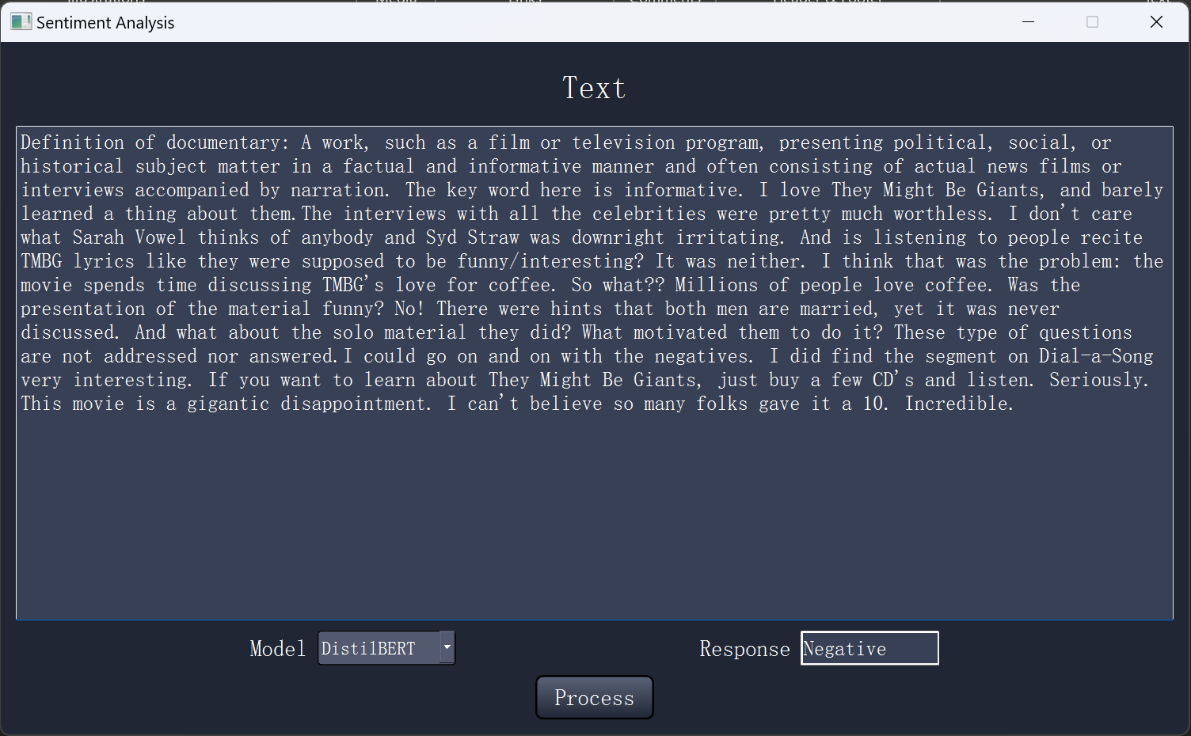

User Manual:

1. Enter or paste comments.
2. The Dropdown Model menu lets you pick which model to use.
3. Then press “Process” button to generate a response.