Report

Data Visualization

Data Processing

Training Curves (GPT2)

Test dataset Performance (GPT2)

GUI

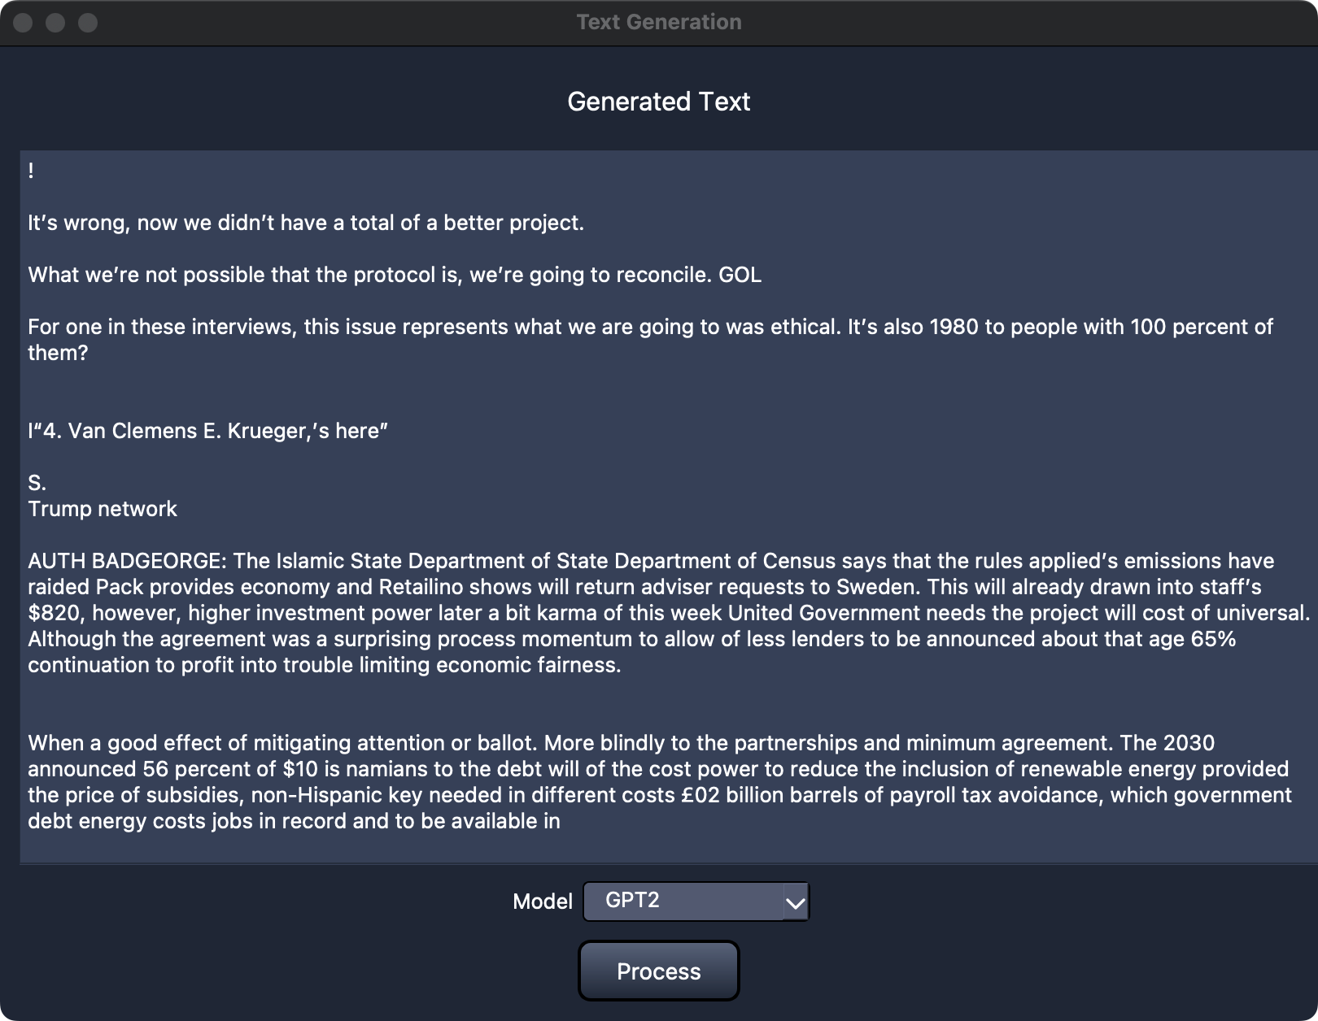

User Manual:

1. The Dropdown Model menu lets you pick which model to use.
2. Then press “Process: button to generate new Text.