**Project Title :** Social Media Application (Web Based)

**Current System :**

This web based social media application which allows the users to connect with their friends and family with just a click. It helps find people with similar interests and preferences through the medium of events and groups. Users can post photos/videos/audios and let their friends know about their life. It is a very easy way to stay in touch with the people you cannot meet on a daily basis.

**Project Type** **:** Website

**Customer Details :**

|  |  |
| --- | --- |
| **User** | * Users can interact with the people from all around the world and discuss anything. * They can chat with each other and even like photos and videos posted by their friends. * They can join events of their interest and invite friends to groups and be a part of them. * Users can create their ads and attract customers to their business pages. * Users can host their events and let others join . * Blocked users will not be allowed to login and perform any activity following that. |
| **Admin** | * Admin can create the ads of different type and prices and can be activated by the users to run on the website. * Admin can search for particular data and get the website info. * Admins can restrict the access of the user if he finds any inappropriate activity. |

**Modules :**

|  |  |
| --- | --- |
| User Module | This module is used to store user details which will be used to login to user or admin dashboard according to the admin property. |
| User Contact-Info Module | This module is used to store user Contact info and links to other social media accounts which will be displayed in the profile for others to see and get in touch with you. |
| User Education Module | This module is used to store user Education info and links to other social media accounts which will be displayed in the profile for others to see and get in touch with you. |
| User Skills Module | This module is used to store user skills info and links to other social media accounts which will be displayed in the profile for others to see and get in touch with you. |
| User Work Module | This module is used to store user work info and links to other social media accounts which will be displayed in the profile for others to see and get in touch with you |
| Country Module | This module is used to store all countries so that the user can add the address and country accordingly |
| State Module | This module is used to store all states with respect to the country so that the user can add the address and country accordingly |
| City Module | This module is used to store all cities according to the state and country so that the user can add the address and country accordingly |
| Ads Module | This module is used to store all ads type and price and limit to be activated on the website by the user |
| User Ads Module | This module is used to store all user ads subscriptions and the details about the ad running on the platform. |
| Chat Module | This module is useful for everyone to chat with their friends and send messages and emojis to make it more fun |
| Friend Request Module | This module is used to store all friend requests that the particular user gets and the user can decide whether t approve or delete the request |
| Friend List Module | This module is used to store all friend requests that the particular user accepts and be friends with them |
| Post Module | This module is used to store all posts that the user post on the website in his feed or in group feed in video, image or audio type |
| Like Module | This module is used to store the likes count a particular post of the particular user gets. |
| Comment Module | This module is used to store the comments count a particular post of the particular user gets. |
| Event Module | This module is used to store the Events that the user hosts on the website for others to join.. |
| Event User-Count Module | This module is used to store the users that are interested in attending the events on the website. |
| Group Module | This module is used to store the groups that the user creates on the website for others to join |
| Group Member Module | This module is used to store the users that are joined in a particular group or not. |
| Activity Feed Module | This module is used to store the user’s activity with respect to comments, likes, groups and posts |

**Use-Case Diagram**

**Admin :**

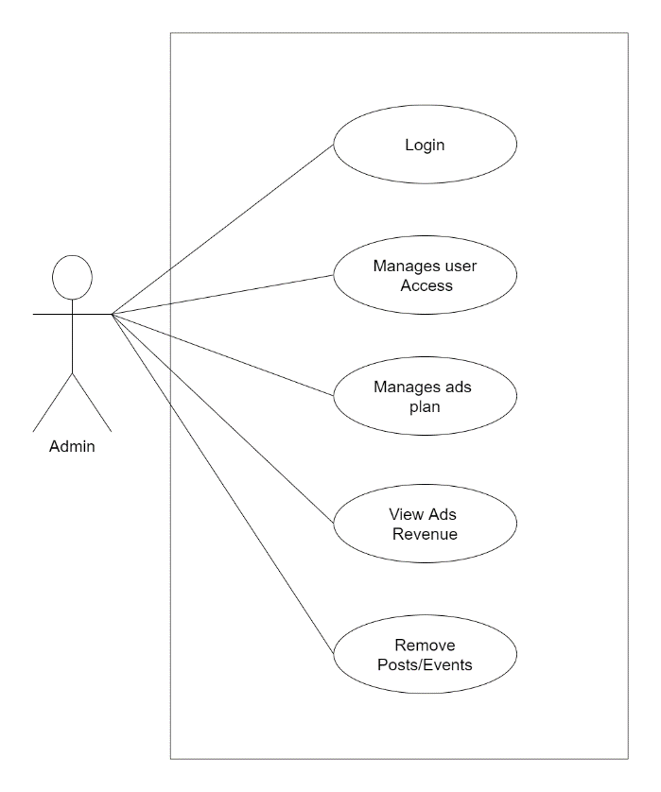

**User :**

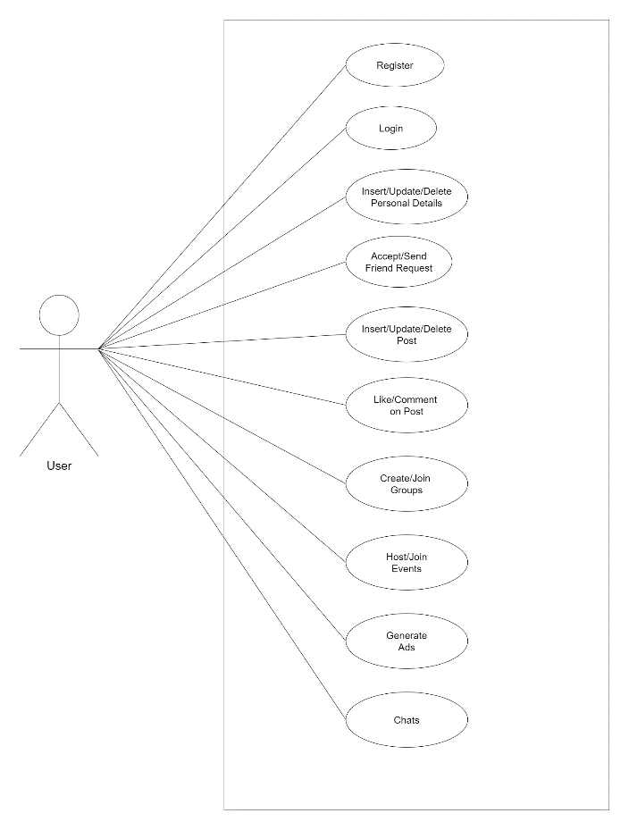

**ER Diagram :**

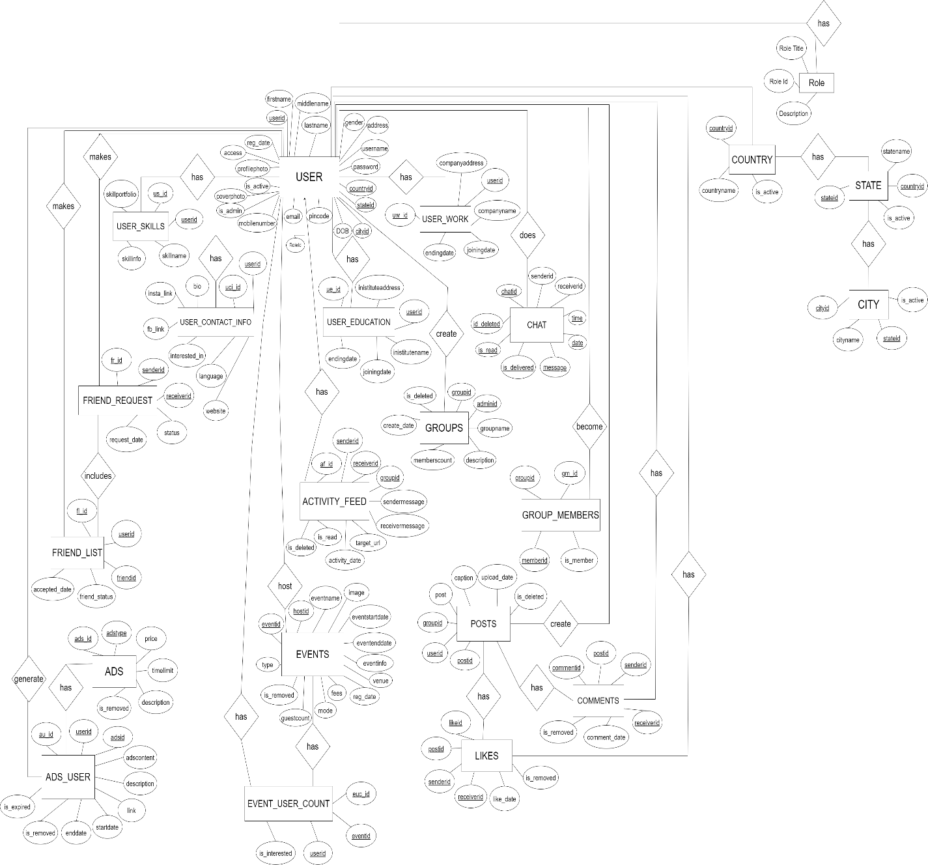

**User Activity Diagram :**

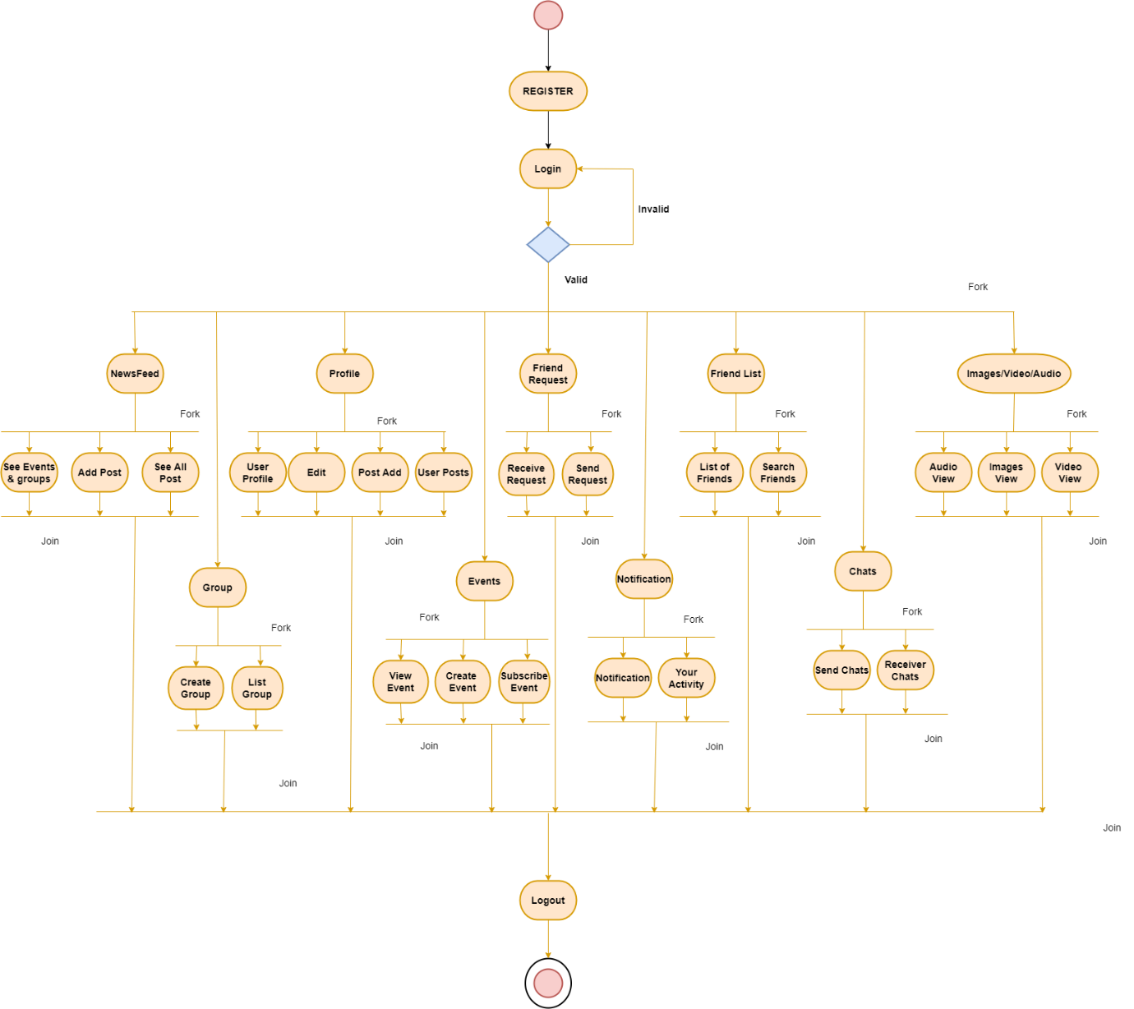

**Admin Activity Diagram :**

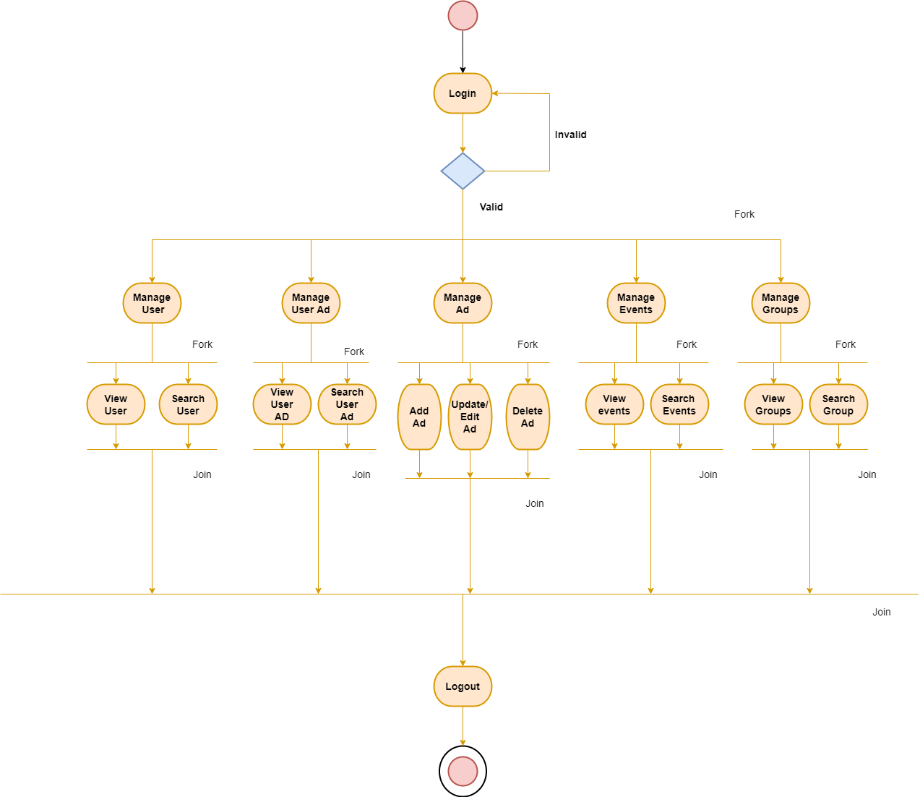

**User Sequence Diagram :**

