ASRC Fuel Tank Robot Simulation Review
  - Current concept and findings through 5 November 2026
The fixed oblique telescopic rear remains a plausible support concept, but the current simulations do not yet demonstrate a deployable robot carrying a 500 g inspection head. The main obstacle is the flexible front: tendon control can improve its shape, while the best straightening results still require large axial compression whose physical validity has not been established.
The latest segmented tendon study reduced the U9/M1 front’s maximum deviation from the insertion axis to 2.44 mm. That solution has 13.94% maximum absolute axial strain and only 459.3 mm axial projection. A subsequent collision check cleared a partial insertion path after the head was already inside. These are useful design clues, not validation of complete entry, material behavior or hardware.

Our objective
Objective | Current definition and status
Inspection task | Carry a camera and induction thermography sensor into confined aircraft spaces and the fuel tank.
Project targets | 500 g head payload, approximately 1.5 m reach and diameter below 100 mm. These remain development targets [1].
Current front | Nominal 0.5 m using Uni directional U modules followed by Medium stiffness M modules. The final U/M ratio remains open.
Current rear | Axial telescoping only. Set and lock the installation angle before operation; no active rear pitch, yaw or roll.

Current design direction
Mount an independently supported telescopic unit outside a bottom access port. Feed the front along a fixed inclined axis, with U modules oriented so their stiffer bending plane resists gravity. Allow tendon tension during insertion. Retain the U/M front concept while revising its load path and tendon routing before selecting a complete mechanism.
This report consolidates the saved CAD section studies, ideal rear beam calculations, single anchor tension search and latest segmented tendon comparison. All results are numerical screening; no physical prototype test is represented here.

Installation geometry and tank access
The selected tank CAD is approximately 1600 mm long, 1100 mm wide and up to 450 mm high. It has a nonrectangular cavity and two bottom elliptical openings with nominal inner dimensions of 500 by 200 mm, approximately 700 mm apart [2].
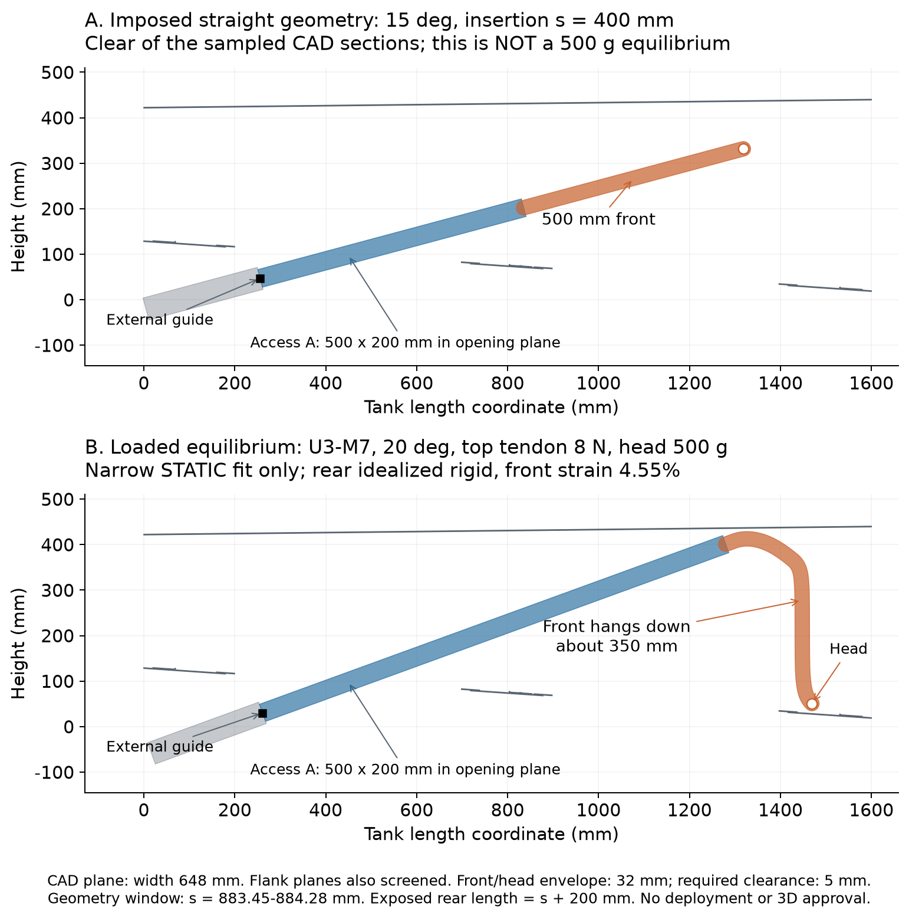
Figure 1 Fixed oblique installation concept and the earlier loaded front. The upper straight front is imposed geometry; it is not a 500 g equilibrium.
The front guide is assumed to lie 200 mm outside the opening along the axis. Interface coordinate s is measured from the opening; exposed rear length is s plus 200 mm. Installation angles are study variables, not a selected final setting. Five sampled CAD width sections, a 32 mm front envelope and a 5 mm additional clearance were used. Complete three dimensional swept volume remains unverified.

Rear support calculations
The rear was screened as an ideal aluminium cantilever with self weight, front weight and the full front force and moment. The moving beam uses a 40 by 40 by 2 mm proximal tube and a 30 by 30 by 2 mm distal tube, each occupying half the exposed length. A 50 by 50 by 2 mm fixed housing sits behind the guide.
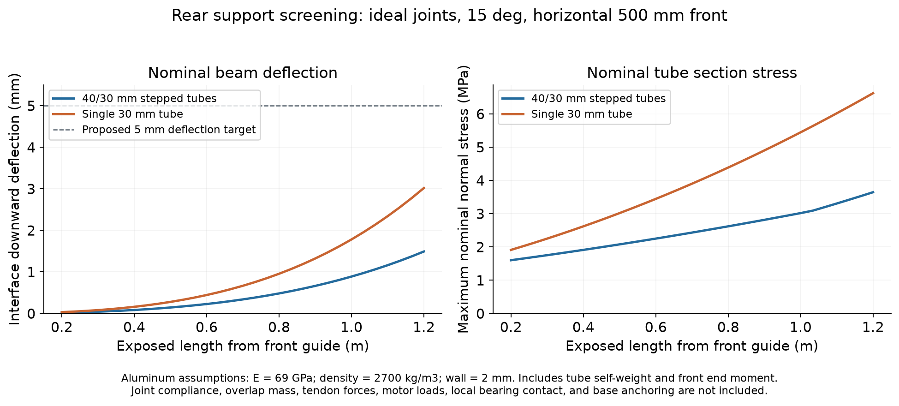
Figure 2 Ideal tube body screening over the studied exposure lengths. Joint flexibility, actuator forces and complete telescopic hardware are excluded.
At 1 m exposure and 15 degrees | Stepped 40 and 30 mm | Single 30 mm
Exposed tube mass | 0.713 kg | 0.605 kg
Interface vertical deflection | 0.887 mm | 1.780 mm
Maximum nominal normal stress | 3.017 MPa | 5.444 MPa

This example imposes a horizontal 0.5 m front, a 500 g head and a provisional 50 g front assembly allowance. The stepped beam base moment is 10.91 N m and its interface rotation is about 0.105 degrees. These values describe the tube bodies under the assumed gravity load; they do not establish a telescopic assembly rating.
Required rear design work includes stage overlap, guide spacing, antirotation, backlash, local tube contact, drive and tendon reactions, locking and external base anchorage. The assumed elastic modulus is 69 GPa and density 2700 kg/m³. Alloy and temper are unselected; the stored 240 MPa yield reference is only a placeholder, so no certified safety factor is claimed.

Front behavior with one anchor set

Initial loaded equilibrium and clearance
For the initial U3/M7, U5/M5 and U7/M3 fronts, gravity produced large downward deflection despite the U stiff plane already being aligned against gravity. Fine mesh representative low strain states showed approximately 328 to 389 mm vertical head drop. Increasing tendon force cannot be assumed to straighten the front because it also introduces axial compression.
One U3/M7 case at 20 degrees with 8 N upper tendon tension passed the earlier local stability, 5% strain diagnostic and static CAD screens. Its interface window was only s = 883.45 to 884.28 mm, a width of 0.83 mm. Maximum strain was 4.55%; front envelope clearance was about 5.09 mm, barely above the 5 mm screen. A separate rear deflection of about 0.83 mm was not coupled into that placement. Holding this sagged shape during insertion caused collision. This is not a usable installation window.

Increasing U and applying insertion tension
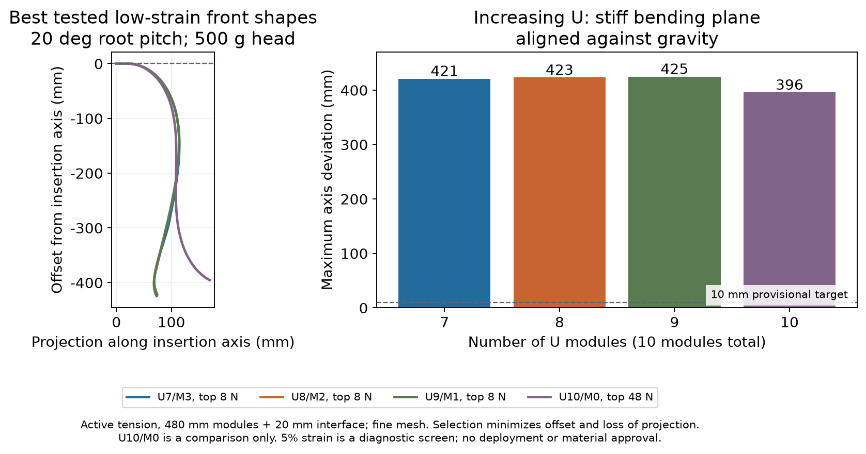
Figure 3 Increasing the U fraction under a single head anchor set. Axis offset is measured relative to the inclined insertion axis and is different from vertical drop.
The follow up covered U7/M3, U8/M2, U9/M1 and an all U control at 15, 20 and 25 degrees, with upper tendon settings up to 200 N and common baseline tension of 0 or 2 N per rope. Of 912 attempts, 752 converged. No saved solution met all provisional straightening checks: axis offset at most 10 mm, tangent error at most 5 degrees, projection at least 475 mm and absolute axial strain at most 5%.
These are finite searches and provisional diagnostics, not a proof that all controls fail. The tension bounds are numerical settings, not actuator ratings. The 5% strain threshold has not been established by physical module tests.

Latest results from segmented tendons
The newest study compares U8/M2 and U9/M1 at 20 degrees with a 500 g head. Each tendon runs from the base through actual disk guides to its anchor. Distal tendons therefore also compress proximal modules. Four ropes are counted per anchor set; the planar optimization adjusts upper rope tension. Added rope mass is included, while new anchor and routing hardware mass is excluded.
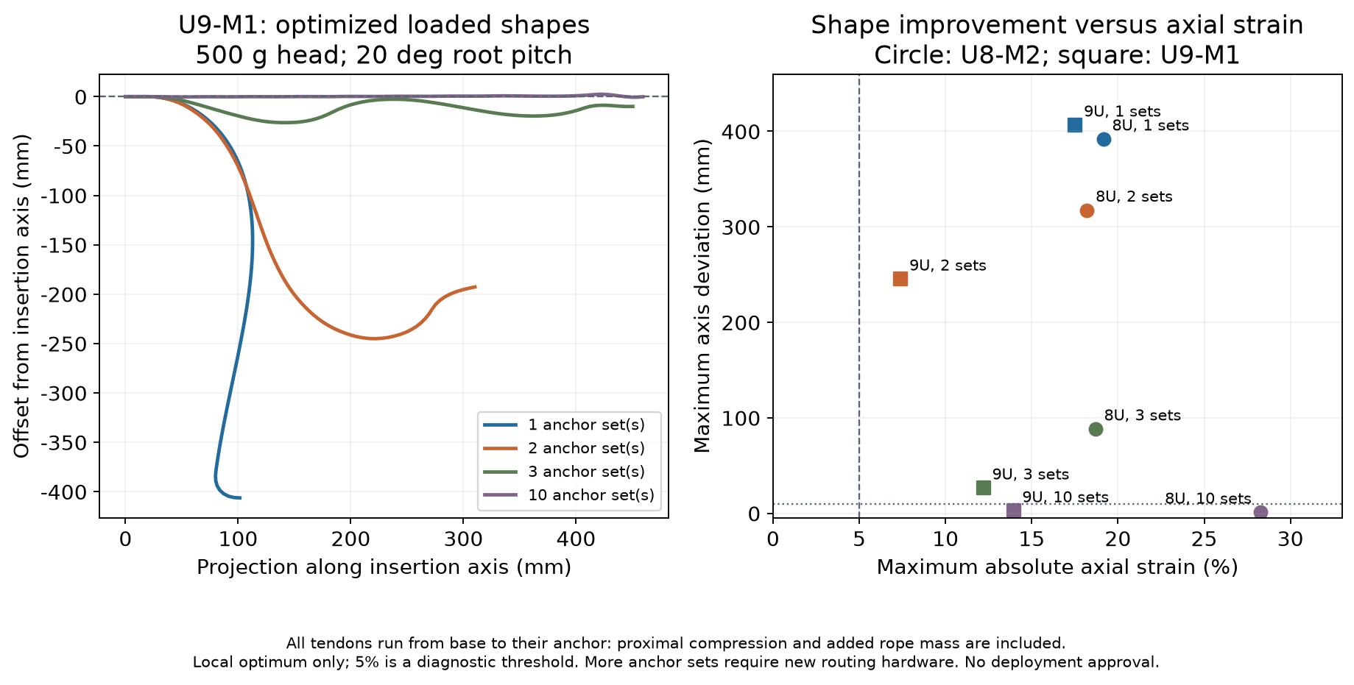
Figure 4 Best local stationary solutions found for each anchor layout. Shape improvement is accompanied by substantial axial strain; ten sets represent a complexity comparison.
U9 and M1 layout | Axis offset mm | Projection mm | Max strain | Local stability
One set at head | 406.37 | 101.5 | 17.52% | Pass
Two sets | 245.13 | 310.2 | 7.40% | Fail
Three sets | 26.36 | 450.3 | 12.20% | Pass
Ten sets | 2.44 | 459.3 | 13.94% | Pass

The two set U9/M1 equilibrium fails the local stability diagnostic with 1 m additional free rope. The ten set solution passes that diagnostic, but still has 8.93 degrees maximum tangent error and fails the provisional projection and strain checks. Its upper tendon tensions sum to 158.4 N at the base; maximum compression occurs in the first U module.
U8/M2 with ten sets gives only 0.97 mm axis offset, but 28.26% maximum strain, concentrated in the first M module. The original linear axial stiffness is being extrapolated at these strains. No plasticity, local buckling or durable module behavior has been validated. More anchors also require new guides; the existing four holes do not establish space for this routing.
A separate local optimization constrained coarse mesh strain to 5% for all four U9/M1 layouts. It found no near straight solution. At unchanged tensions, fine mesh strain rose to approximately 5.03 to 5.23%; the coarse boundary solutions therefore do not strictly pass the diagnostic after refinement. Global infeasibility is not established.

Latest partial insertion path
The saved ten set equilibrium was translated along the 20 degree axis through the retained CAD section polygons. The check covers s = −180 to 400 mm in 2 mm increments. The head is already inside at the start; this calculation does not include initial head entry.
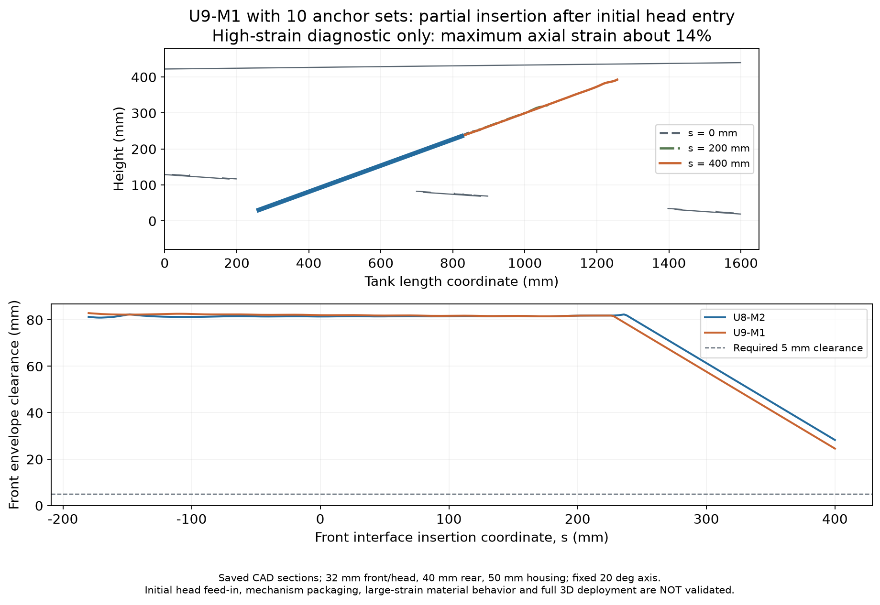
Figure 5 Partial geometric path for the high strain diagnostic shapes. The result applies to the sampled section envelopes and saved fixed shapes only.
U9 and M1 path quantity | Result
Minimum front envelope clearance | 24.52 mm
Final rear envelope clearance | 76.88 mm
Fixed housing clearance | 73.86 mm
End position | s = 400 mm; exposed rear length = 600 mm

The sampled path clears the 5 mm geometric screen and the final front envelope lies inside the sampled cavity. This establishes a possible geometric corridor once a suitable shape is already present. It does not validate the 13.94% strain shape, initial feeding, tube storage, internal cable packaging, rear compliance or complete three dimensional deployment. It also does not demonstrate the project’s approximately 1.5 m reach target.

Problems to resolve and recommended work
The immediate priority is to obtain a physically credible front load path and a complete entry sequence. Selecting a rear stroke or fabricating a full telescopic assembly before resolving these two points would leave the main feasibility questions open.
Priority and problem | Required action and decision evidence
1 Axial compression | Measure U and M force extension behavior, bending stiffness, hysteresis and load limits. Replace large strain extrapolation with a calibrated model. Establish an experimentally supported allowable range.
2 Front load path | Compare a limited number of anchor sets with increased axial stiffness or a temporary insertion support. Include tendon compression and routing hardware mass. Preserve the desired U/M bending function.
3 Complete tank entry | Add actual head CAD and an outside start state. Solve a changing shape and tension sequence through initial feeding, extension, working posture and retraction. Include cable and head envelopes.
4 Rear joints and mounting | Detail tube overlap, guides, antirotation, drive, locks and external support. Calculate compliance and local contact with tendon forces and measured front reactions.
5 Integrated validation | Couple rear deflection to front equilibrium and collision checks. Run a full three dimensional sweep with tolerances, then test an unloaded entry mockup before incremental payload testing.

Proposed measures for the next iteration
Record payload and centre of mass, usable reach, maximum external envelope, maximum axis offset, tangent error, axial projection, minimum obstacle clearance, measured strain, tendon tension and rear tip deflection. During physical tests, also record extension repeatability, guide play, force hysteresis and successful entry and retraction cycles.
Use the existing 5 mm clearance and the 10 mm offset, 5 degree tangent and 475 mm projection checks only as provisional comparison criteria. The 5% strain value is a numerical diagnostic. Final acceptance limits must follow measured material and module behavior, task tolerances and the actual head geometry; numerical tension ceilings must not become hardware ratings.

Recommended decision now
Retain the fixed oblique telescopic rear as a candidate. Keep U9/M1 and a small number of segmented anchors as front design candidates, while treating ten anchors as an upper complexity reference. First validate axial load capacity and a complete head entry sequence. No final U/M ratio, anchor layout, rear stroke or installation angle is selected by the current evidence.

Model assumptions and evidence
Model input | Value and interpretation
Front length and diameter | Ten 48 mm modules give 480 mm flexible length plus a massless 20 mm rigid interface. Nominal total 500 mm; front envelope diameter 32 mm.
U stiffness | Strong plane EI 0.061 N m²; weak plane EI 0.0057 N m²; axial EA 1150.19 N; mass 3.9 g per module.
M stiffness | EI 0.0046 N m²; axial EA 85.07 N; mass 4.0 g per module. Original module properties are retained without rescaling.
Head and ropes | 500 g point mass, no eccentric moment. Head envelope provisionally 32 mm. Tendon guide radius 13 mm; rope diameter 2 mm; PA6 solid stock surrogate; friction omitted.
Numerical scope | Planar geometrically nonlinear extensible rods; four and eight cells per module. Segmented upper tension bound 250 N per set is numerical. Stability is local and planar.
CAD scope | Five width planes at 628, 632, 648, 664 and 668 mm; 362 retained nonempty tank and hardware leaves. Section curve chord error 0.1 mm; joining tolerance 0.02 mm.

Verification and interpretation
Fifteen representative initial states were refined at unchanged tendon tension from four to eight cells per module; maximum head position difference was approximately 0.106 mm. Segmented tendon derivative checks gave error measures of 1.27 × 10⁻⁹ for the energy gradient and 1.82 × 10⁻¹⁰ for the Hessian vector product, with single anchor equivalence checked. The lightweight polygon clearance check agrees with the saved CAD reference within 10⁻⁶ mm. These checks support implementation consistency, not physical validity at large strain.

Source register
[1] ASRC October project briefing Project objectives and hybrid concept. Open source
[2] Fuel Tanke Setup 2nd design STEP Tank geometry dated 22 October 2026; retained locally as inputs/tank-v2.step. Open source
[3] Local simulation evidence Under telescopic_planar_study/results: rear_beam_summary.json; adaptive_static_fits.json; insertion_tension_summary.json; segmented_tendon_comparison.csv; segmented_low_strain.json; segmented_path_check.json; study_validation.json.
[4] Model definitions craft_data.py and the study scripts define module properties, equilibrium, tendon routing and clearance calculations. All five figures reproduce saved study outputs.

