ASRC Fuel Tank Robot Simulation Review
  - Latest design and simulation evidence through 6 November 2026
Active tendon tension improves insertion shape and enables substantial changes in endpoint orientation. The current 63 mm PA12 and NiTi design still has a significant loaded head recovery problem: no searched configuration meets both the 5% axial strain diagnostic and a head elevation held near the 20 degree base direction. Physical maximum steering angles and complete fuel tank deployment remain unverified.

Goals and current concept
Item | Definition
Inspection objective | Integrate a camera and induction thermography sensor for confined aircraft inspection.
Project targets | 500 g payload, approximately 1.5 m reach and diameter below 100 mm. These are development targets.
Rear architecture | Externally supported telescopic structure with axial motion only. Set and lock the installation angle before operation.
Front architecture | Proximal Uni directional U modules in PA12 and NiTi, followed by Medium stiffness M modules in PA12. Diameter 63 mm; tendon guide radius 24 mm.
Insertion control | Tendons may actively straighten or reshape the front during feeding. Passive sag is only a reference.

The latest requested configurations are U4 plus M2, U6 plus M3 and U8 plus M4. Their actual 96 mm module length replaces the earlier nominal half metre front assumption. No extra metal backbone is added to the supplied U properties.

Main engineering decision
Prioritize the shortest configuration for further development, while addressing M axial load transfer and the initial entry and storage mechanism. Large projected steering angles alone do not establish a useful inspection posture.

Overall mechanism and installation concept
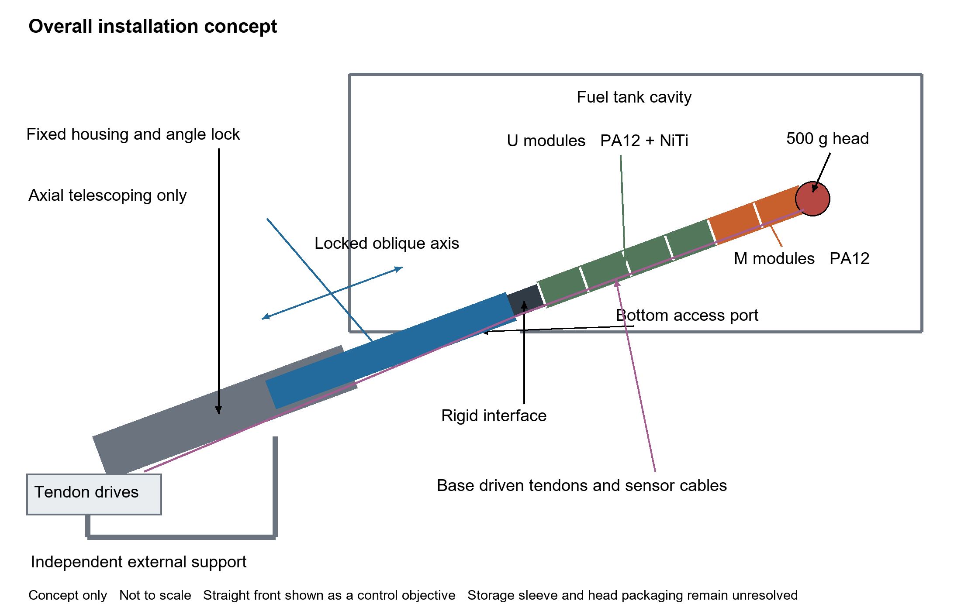
Mechanism overview Proposed assembly and functional interfaces. The straight front is a controlled target, not a validated low strain 500 g posture.
An independent stand supports an inclined telescopic assembly outside the bottom tank opening. The housing angle is set and locked before operation. During deployment, the rear provides axial extension and retraction only; it has no commanded lateral motion, elevation change or roll.
A rigid interface connects the moving rear stage to the flexible front. Proximal U modules provide greater resistance to gravity and axial compression, while distal M modules provide local bending. The front outer diameter is 63 mm and each module is 96 mm long. The U4 plus M2 arrangement is illustrated as the shortest current candidate.
Base mounted tendon drives regulate rope lengths or tensions through guides to the selected anchor disks. Active tension can reshape the front during insertion and steering. Camera and induction thermography services run alongside or through the structure to the provisional 500 g head; actual head CAD, cable bend radii and connectors are still required.

Mechanism functions and deployment sequence
Subsystem | Proposed function | Design status
External stand and lock | React weight and drive loads; set the fixed installation axis. | Support concept established; mounting details and compliance unverified.
Telescopic rear | Provide axial reach using guided stages, antirotation features and a drive. | Stage sizes, overlap, stroke, bearings, drive and locks remain to be selected.
Front interface | Transfer force and moment into the U modules. | 20 mm massless interface is a simulation assumption; hardware is not finalized.
U and M chain | Combine a gravity resistant proximal section with a compliant distal section. | Database stiffness and mass supplied; real load capacity and allowable strain need tests.
Tendon drives and guides | Coordinate four ropes per anchor set for loaded shape control. | One to three sets compared. New routing and anchor hardware must be designed.
Sensor head and services | Carry the camera, coil and thermal sensing package. | 500 g point load and provisional envelope only; integration is unresolved.

Proposed operating sequence
1. Mount the stand, align the selected bottom opening and lock the rear axis. Install the inspection head and confirm the assembled envelopes and cable routing.
2. Apply a coordinated tendon command to obtain an insertion posture while supporting the front externally. Feed and extend along the fixed axis. A future support sleeve may shorten the unsupported flexible length, but its contact and load transfer have not been simulated.
3. Once deployed, hold the rear extension and steer using the tendon groups. Record head orientation, strain and individual rope forces; the current numerical force bounds are not hardware settings.
4. Return to a retractable shape, coordinate rope take up with rear retraction and recover the head through the opening. The complete feeding and recovery sequence still requires coupled mechanism and collision validation.

Unresolved mechanical interfaces
The original 50 mm housing and 40/30 mm moving tubes are only supporting beam references. They cannot store or pass a 63 mm front. A tube deployed front therefore requires a new nesting and storage design, including clearance, guides and rope packaging. The diagram deliberately shows the functional connection without claiming that a storage sheath or initial feed fixture is already solved.

Current geometry and mechanical inputs
Parameter | U module | M module
Composition | PA12 and NiTi | PA12
Module length | 96 mm | 96 mm
Module mass | 37.990 g | 23.948 g
Axial rigidity EA | 128122 N | 166.694 N
Vertical bending EI | 22.2052 N m² | 0.0441178 N m²
Horizontal bending EI | 1.67184 N m² | 0.0441178 N m²
Whole module torsion T per angle | 4.70037 N m/rad | 0.437396 N m/rad

Configuration | Flexible length | With interface | Bare module mass
U4 plus M2 | 576 mm | 596 mm | 199.856 g
U6 plus M3 | 864 mm | 884 mm | 299.784 g
U8 plus M4 | 1152 mm | 1172 mm | 399.712 g

The input database is module_stiffness.sqlite3. Values are structural rigidities, not bulk material moduli, and are retained without scaling again for 63 mm diameter. The torsion column is a whole module spring coefficient T divided by angle; multiplying it by 0.096 m gives the rod coefficient while preserving module torsion energy under subdivision.
The head is a 500 g point mass with no eccentric moment. A 20 mm interface is assumed massless. The insertion study provisionally uses a 63 mm head envelope; actual sensor head CAD is still required. Each anchor set contains four 2 mm tendons using the previous solid PA6 surrogate stiffness and density, without friction. Routed rope mass is included; new anchors, sheaths, wiring and joint masses are not measured.

Anchor layouts
Configuration | One set | Two sets | Three sets in U | Three sets with M anchor
U4 plus M2 | [6] | [4,6] | [2,4,6] | [4,5,6]
U6 plus M3 | [9] | [6,9] | [3,6,9] | [6,7,9]
U8 plus M4 | [12] | [8,12] | [4,8,12] | [8,10,12]

Anchor numbers refer to module ends counted from the base. Every rope starts at the base and passes through actual guides to its anchor; distal tendons still compress proximal modules. Multiple sets require redesigned routing hardware.

Active straightening and insertion evidence
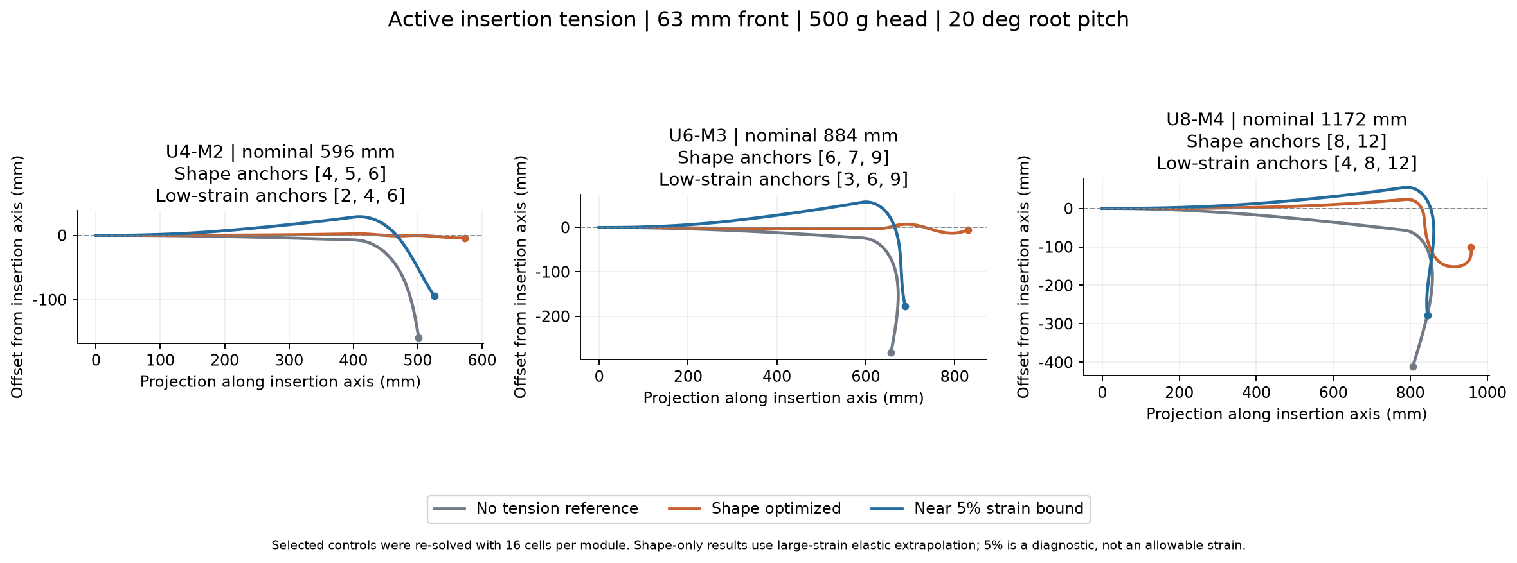
Figure 1 Active straightening at 20 degrees with a 500 g head. Shape objectives and near 5% strain objectives select different force allocations.
Configuration | Anchors | Axis offset | Max axial strain
U4 plus M2 | [4,5,6] | 4.21 mm | 17.26%
U6 plus M3 | [6,7,9] | 12.88 mm | 27.73%
U8 plus M4 | [8,12] | 151.97 mm | 20.77%

These selected shapes pass preliminary centreline and capsule screens and are re-solved with 16 cells per module. A U8 plus M4 alternative gives a smaller 74.49 mm offset at eight cells but approximately 30.17% strain and fails the local radius curvature screen; it is excluded from the table.
Under the near 5% strain diagnostic, representative offsets remain approximately 94.77, 176.86 and 278.03 mm. No saved case meets all straightness checks: 10 mm offset, 5 degree tangent error, 95% nominal axial projection, strain and local stability.
The planar search contains 504 single anchor attempts, 306 equilibria and 178 local optimization attempts. The result supports active straightening as a design direction, but the large strain solutions extrapolate constant EA and EI beyond established physical validity.

Front only entry through sampled tank sections
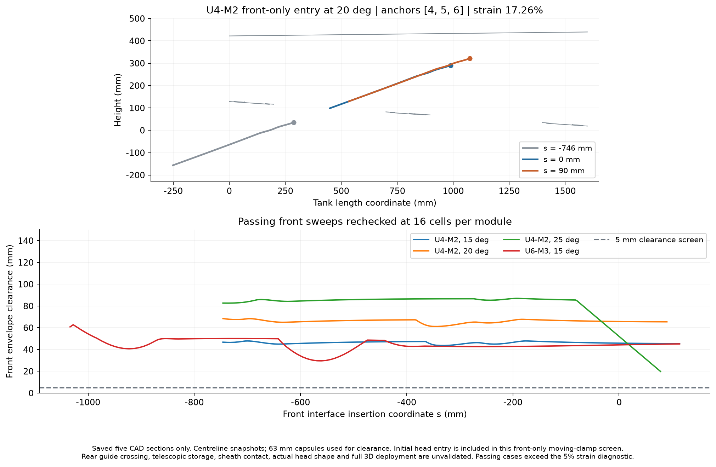
Figure 2 Front-only entry through saved CAD sections, including an initially external head. Passing curves use high strain shapes.
Active tension is maintained during the front-only sweep, starting with the head and front outside the tank. The short U4 plus M2 case at 20 degrees has approximately 61.18 mm minimum envelope clearance in the saved sections, while retaining about 17.26% axial strain. This is a geometric corridor for an assumed equilibrium shape, not a physically validated deployment.
The clamp translates from outside the tank; the calculation does not impose sleeve support, storage or guide contact. Changing-shape deployment, actual sensor head geometry and retraction remain open design tasks. The five saved sections do not span the complete width of a 63 mm front.

Tank access and rear support limitations
The retained tank CAD is approximately 1600 by 1100 mm with variable height up to about 450 mm. Two nominal bottom elliptical openings are 500 by 200 mm, approximately 700 mm apart. The cavity is not a rectangular box.
Passing front sweep | Pitch | Max strain | Minimum path gap
U4 plus M2 | 15 deg | 17.48% | 43.65 mm
U4 plus M2 | 20 deg | 17.26% | 61.18 mm
U4 plus M2 | 25 deg | 17.08% | 19.85 mm
U6 plus M3 | 15 deg | 28.08% | 29.58 mm

Eighteen fixed actively tensioned shapes were screened. Four front-only sweeps remained clear at 16 cells per module. None of the selected low strain fixed-shape sweeps passed. Changing tensions and shapes with insertion depth has not been optimized, so failed fixed-shape sweeps do not establish global deployment infeasibility.
This is a translating front clamp calculation. The base may move behind the former external guide, while tube storage, guide crossing, sheath contact, rope take-up and retraction remain unresolved. Five width planes at 628, 632, 648, 664 and 668 mm do not cover the full 616.5 to 679.5 mm band of the 63 mm front. Full width and full three dimensional clearance are not validated.
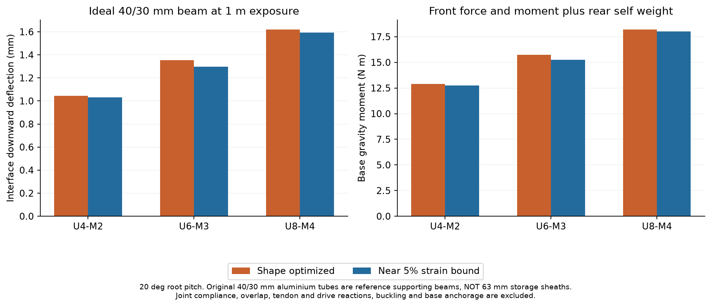
Figure 3 Updated gravity loads on the original ideal supporting beam. These tubes are not storage sheaths for the 63 mm front.
For the stepped 40 and 30 mm aluminium reference at 1 m exposure and 20 degrees, shape-objective interface deflections are approximately 1.05, 1.36 and 1.62 mm. Base gravity moments are approximately 12.89, 15.75 and 18.21 N m. Joint flexibility, overlap mass, local tendon and drive reactions, buckling and anchorage are excluded. A new telescopic or insertion sheath must be sized independently.

Latest spatial steering results
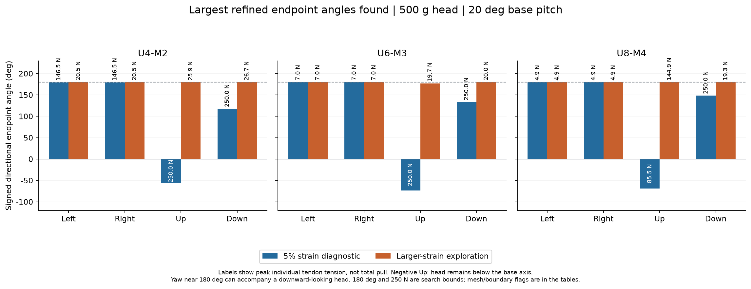
Figure 4 Largest endpoints found in bounded spatial searches. Force labels are peak individual tendon tensions. Negative Up means the head remains below the base axis.
Configuration | Left or right yaw and peak pull | Best upward candidate and peak pull | Downward turn and peak pull
U4 plus M2 | 179.42 deg / 146.48 N | minus 56.59 deg / 250 N | 117.77 deg / 250 N
U6 plus M3 | 179.94 deg / 7.04 N | minus 73.55 deg / 250 N | 133.52 deg / 250 N
U8 plus M4 | 179.64 deg / 4.90 N | minus 68.54 deg / 85.54 N | 148.33 deg / 250 N

The table uses the 5% strain diagnostic and selected eight-cell states. U6 plus M3 yaw rises to 5.0015% strain at sixteen cells, strictly above 5%, so its low strain maximum remains unconfirmed. The upward candidates are still below the base axis; they are not positive upward reach.
Yaw is the head tangent projection in world X-Z. Vertical turning is the unwrapped tangent projection in world X-Y minus base pitch. World Y is upward and Z is right. World head elevation, true three dimensional axis angle and material twist are saved separately. Each direction may select a different anchor layout and force allocation.
The spatial study includes 310 initial and supplementary local optimization attempts, 21 same-tension sixteen-cell checks, 42 fixed-force pitch sensitivities and 198 force continuation samples. Left states are independently checked reflections under symmetric stiffness and frictionless routing assumptions.

Steering posture and force interpretation
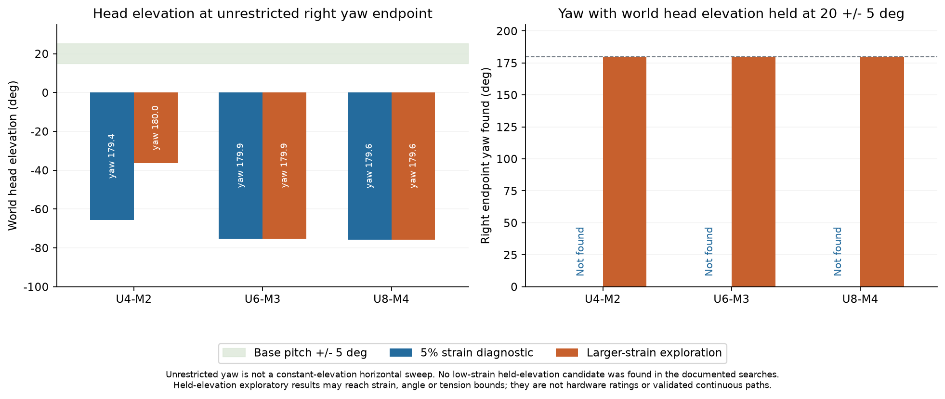
Figure 5 Large yaw can coexist with severe downward pointing. No low strain held-elevation candidate was found.
At the low strain yaw endpoints, world head elevation is approximately minus 65.67, minus 75.24 and minus 75.76 degrees. These azimuth values cannot be read as a usable constant-elevation horizontal sweep. Requiring world elevation within 20 plus or minus 5 degrees produced no low strain candidate in the documented searches.
Larger-strain exploration reaches the 180 degree orientation search cap in several directions. Held-elevation yaw candidates also reach this cap, with approximately 29.08%, 29.93% and 29.06% strain. Boundary crossings under sixteen-cell checks prevent treating these as converged physical maxima.

Corresponding tendon forces
The following example is the U4 plus M2 low strain right-yaw endpoint. Each row is one anchor set. Left yaw swaps the right and left entries. Complete forces for all configurations, directions and modes are supplied in the companion tendon_tensions.csv.
Anchor module | Up N | Right N | Down N | Left N
2 | 9.69 | 47.04 | 10.81 | 0.16
4 | 11.37 | 146.48 | 22.08 | 0.49
6 | 0.00 | 10.86 | 0.00 | 0.00

All values are per rope, not net differential force. Peak single tendon tension differs from the sum across sets. The reported allocation is one solution found for that endpoint, not a proven minimum-force solution. Several candidates hit the 250 N numerical bound; neither that force nor 180 degrees is a hardware rating or established mechanical maximum.

Numerical verification and uncertainty
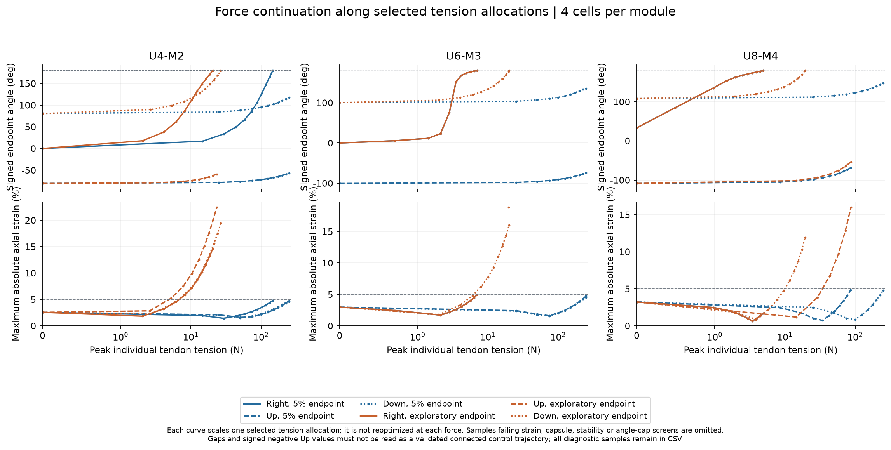
Figure 6 Four-cell force continuations scale fixed selected allocations. Samples failing applicable screens are omitted; gaps are not validated connected trajectories.
The finite-rotation spatial rod includes axial strain, independent twist and anisotropic bending with all ropes and gravity acting together. Energy gradients agree with finite differences; planar energy and deformation are reproduced, module torsion energy is preserved under subdivision, and mirror symmetry and an independent axial case are checked. Thirty saved eight-cell endpoints pass the numerical audit, with maximum equilibrium residual approximately 3.14 times ten to the minus eleven.
Initial two-cell candidates are refined at four and eight cells, with local re-optimization or documented force-ray recovery when needed. Same-force sixteen-cell checks show up to 1.790 degrees change and can cross angle, strain, geometry or posture boundaries. The report retains those warnings rather than rounding boundary values into acceptance.
Local stability uses the fixed-winch elastic rope tangent stiffness with one additional metre of free rope. Constant-tension results are retained separately. Neither establishes closed-loop dynamic stability. The 15 and 25 degree checks re-equilibrate selected 20 degree tensions; they are not new optimized maxima.
Search ranges are 0 to 250 N per rope, coarse low strain bounds of plus or minus 4.75%, and exploratory strain bounds of minus 30% to plus 15%. Local radius curvature and nonlocal 63 mm capsules provide geometric diagnostics. Detailed module contact, printed component buckling, friction, NiTi transformation, damage and fatigue remain unmodeled.

Problems and next decisions
Priority | Problem | Required work
1 | M axial load transfer | Measure tensile and compressive behavior and validate the load path. Compare a bendable axial backbone or revised M skeleton while retaining bending function.
2 | Loaded head recovery | Find a physically credible way to lift and hold the 500 g head near the desired working elevation. Reduce unsupported M length or use actual insertion support.
3 | Entry and storage | Add sensor CAD, cable envelopes, sleeve contact and telescopic storage. Solve initial feeding, changing-shape deployment and retraction.
4 | Rear mechanism | Select stage sizes, overlap, antirotation guides, drive and locking. Couple measured front and tendon reactions to joint and base compliance.
5 | Integrated task validation | Run a full three dimensional tank sweep with actual head dimensions and tolerances, then verify unloaded and incremental payload prototypes.

At 5% linear axial strain, M EA corresponds to only about 8.33 N. A straight-state scale estimate of M-root head and module gravity moment divided by the 24 mm tendon arm gives about 38.64, 59.28 and 80.81 N for the three lengths. This is not a solved tension or a failure threshold, but explains the conflict between moment compensation and M compression.
Retain the fixed oblique telescopic rear as a candidate and prioritize U4 plus M2 for the next mechanism iteration. Keep three or fewer anchor sets as the practical comparison range. Agree acceptance thresholds after material and module tests; the present 5% value is a diagnostic. If calibrated models and simple prototypes cannot meet loaded posture and entry requirements within that complexity, revise the architecture.

Evidence sources
Project targets: ASRC October 2026 briefing, PSR_PHK-3-0111-CS_HAECO_2026-10_V01-00.pdf, page 9. Tank geometry: Fuel Tanke Setup 2nd design.step, dated 22 October 2026. Both are retained project sources from Google Drive.
Current properties: module_stiffness.sqlite3, with frozen copies and SHA256 in each study. Planar evidence: stiffness_63mm_20261106/README.md and results. Spatial evidence: steering_63mm_20261106/README.md, maximum_steering.csv, tendon_tensions.csv, mesh_checks.csv and pitch_sensitivity.csv. This report supersedes the earlier numerical summary for the current 63 mm design.

Development worklist
Measure and calibrate first, verify loaded performance and inspection coverage, then select the architecture before detailing the deployment mechanism. The following work is planned; it does not represent completed validation.
1. Confirm requirements and acceptance limits. Define the required viewing surfaces, sensor standoff and surface angle, positioning accuracy, inspection cycles, operating temperature and tank constraints, including fuel compatibility, ESD and applicable safety rules. Confirm how the 1.5 m reach target is divided between the rear and front. Use approximately 0.6 m for the current U4 plus M2 baseline.
2. Define the inspection head. Measure its mass, dimensions, centre of mass and cable requirements. If hardware is unavailable, establish a mass and envelope budget.
3. Design the M module backbone. Compare 1.0 and 1.2 mm NiTi rods, including intermediate guides, end attachments and buckling resistance.
4. Test the modules. Measure modified M module compression, bending, torsion, maximum usable bend angle, hysteresis and fatigue. Check one U module and assess relevant fuel and temperature exposure.
5. Select and test tendons. Measure effective stiffness, creep, termination slip and friction using representative guides and routing. Run this alongside backbone development where practical.
6. Calibrate the simulation model. Include measured module behaviour, backbone stability, tendon friction, head offset and cable loads. Validate predictions against bench measurements.
7. Re run the loaded U4 plus M2 studies. Evaluate straightening, elevation holding and steering. Record individual tendon tensions, deformation and stability.

Coverage design reviews and integration
8. Check inspection coverage. Map reachable head positions, viewing directions and continuous paths. Report pass or fail against the requirements from step 1.
9. Hold an early architecture review. Decide whether to retain U4 plus M2 or change the M length, payload or support arrangement before detailed telescope design. Consider a roll joint if viewing coverage requires it; it does not replace adequate lifting capacity.
10. Design actuation sensing and control. Size drives for friction adjusted tension, travel and speed. Select tendon tension and head pose measurements sufficient to verify positioning accuracy and repeatability.
11. Detail the telescopic deployment mechanism. Design the external support, fixed installation axis, stage tip interface, temporary insertion support and tendon and cable management. The rear provides axial extension and retraction only.
12. Validate complete 3D deployment. Check insertion, inspection movements and withdrawal, including the head, telescopic stages, cables and self collision. Verify clearance along complete trajectories.
13. Hold the final design review. Confirm that performance, clearances, loads, sensing and applicable safety requirements meet the agreed limits before integrated testing.
14. Test incrementally. Start with an unloaded entry mockup, then increase payload gradually in a clean mock tank. Measure loads, positioning accuracy, repeatability and recovery performance. Complete the required safety review before testing in a real fuel tank.
Steps 1 and 2 and tendon evaluation can progress alongside backbone development. Detailed telescope design follows the early architecture decision. The existing 5% axial strain diagnostic threshold and 250 N numerical search limit are not validated hardware acceptance ratings.

