**Caged In- User Manual:**

*team-error-undefined*

*Ashton, Kevin, Miguel*

1. Upon opening the game located: quogame/version5/CagedIn.java the PanMainMenu will appear. In this menu, you will be prompted with buttons to: Start Game or End Game.

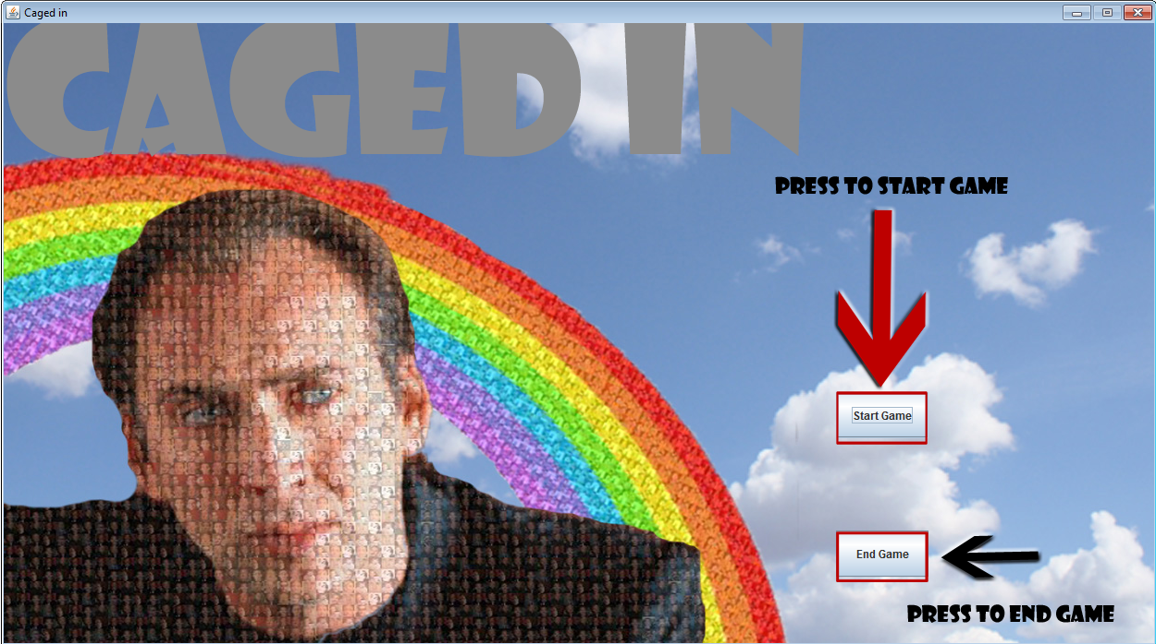

* 1. If you wish to end the game you may wish to do so now by pressing the ‘End Game’ button as indicated with the black arrow in the photo. In addition to this you can also click the red ‘X’ button at the top left side of the screen.+
  2. To start the game press the ‘Start Game’ button as indicated with the red arrow.

1. This is Your Character:

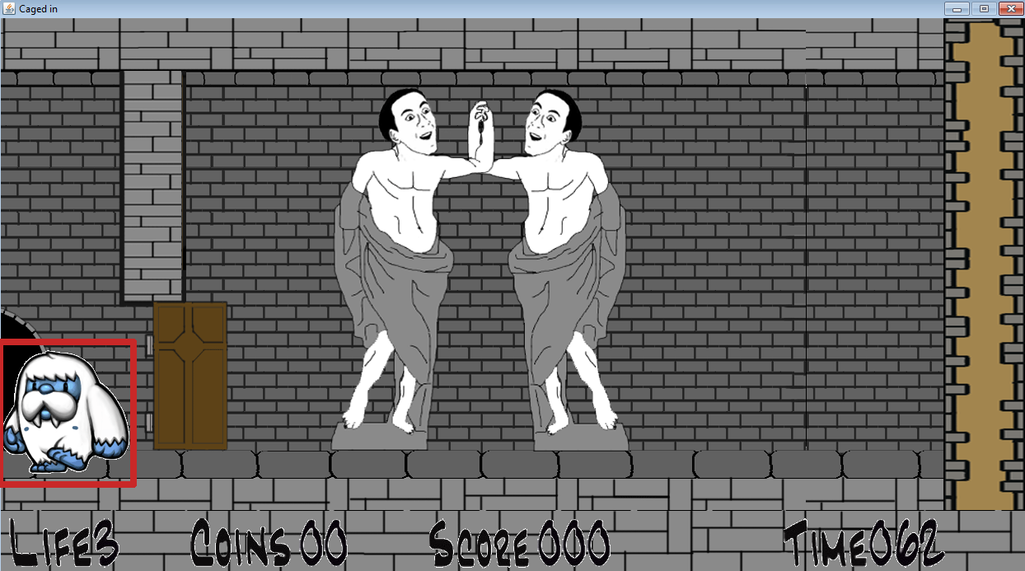

* 1. The Background will move with your character.
  2. To Jump press ‘W’, walk right with ‘D’ , walk left with ‘A’, and while jumping, press ‘S’ to move to the ground

1. This is the End:

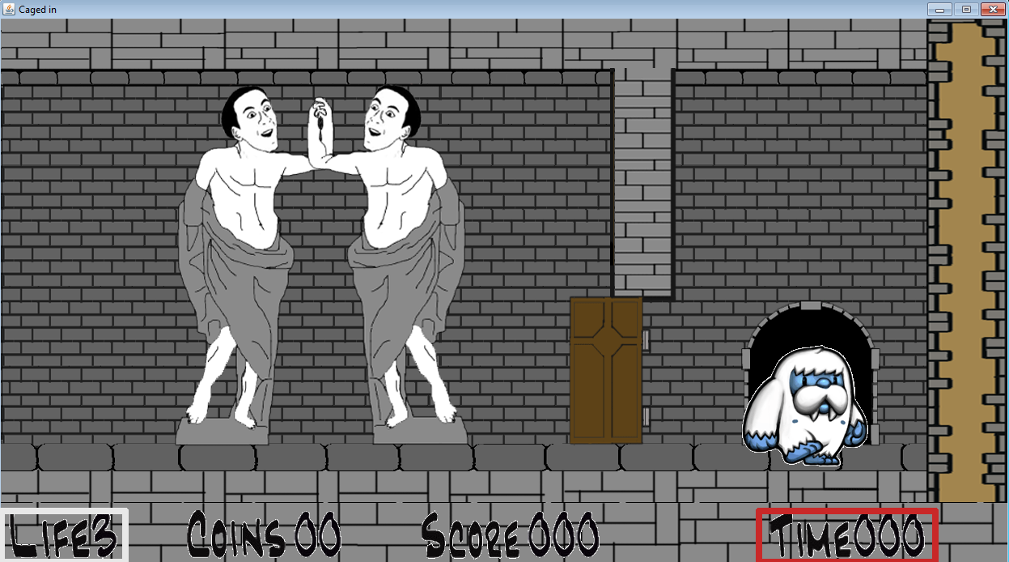

* 1. Make it to the end before the timer gets to ‘000’ or else you will lose your life
  2. If you lose all of your lives it is game over… so do your best!