MARKETING EXPENSES

Based on the marketing expenses report, which totals $515 since the campaign started, I will explain the corresponding charges.

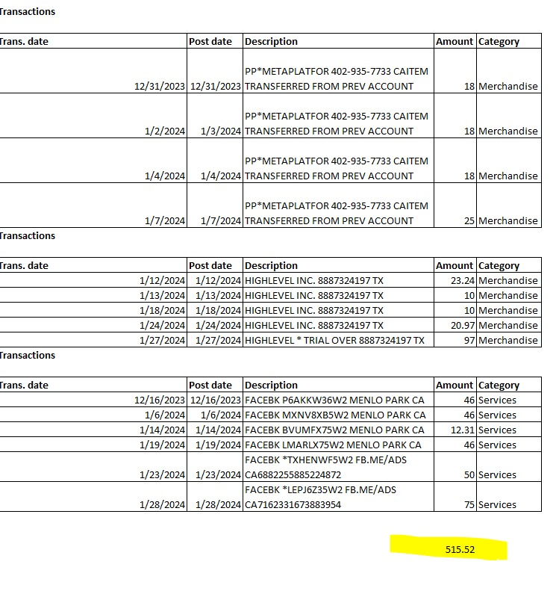

* Facebook Advertising:
  + A total of $350 has been charged to your account in ad spend. This places our ads in front of potential clients to obtain their information and close the leads in our CRM.
* CRM (Customer Relationship Management):
  + We are using High Level as our CRM to manage our entire customer database and lead generation. There are various costs associated with using this software.
  + The primary expense is the subscription, which amounts to $97 per month. This subscription includes complete access to the software and its tools.
  + The second expense is related to acquiring a phone number for marketing purposes. This consists of a one-time registration fee of $20 and a phone number cost of $2.25. This pricing covers the registration of the phone number and the application submission for approval.
  + Additionally, we will incur charges for cell phone usage, which include $0.037 per call and $0.0086 per SMS."

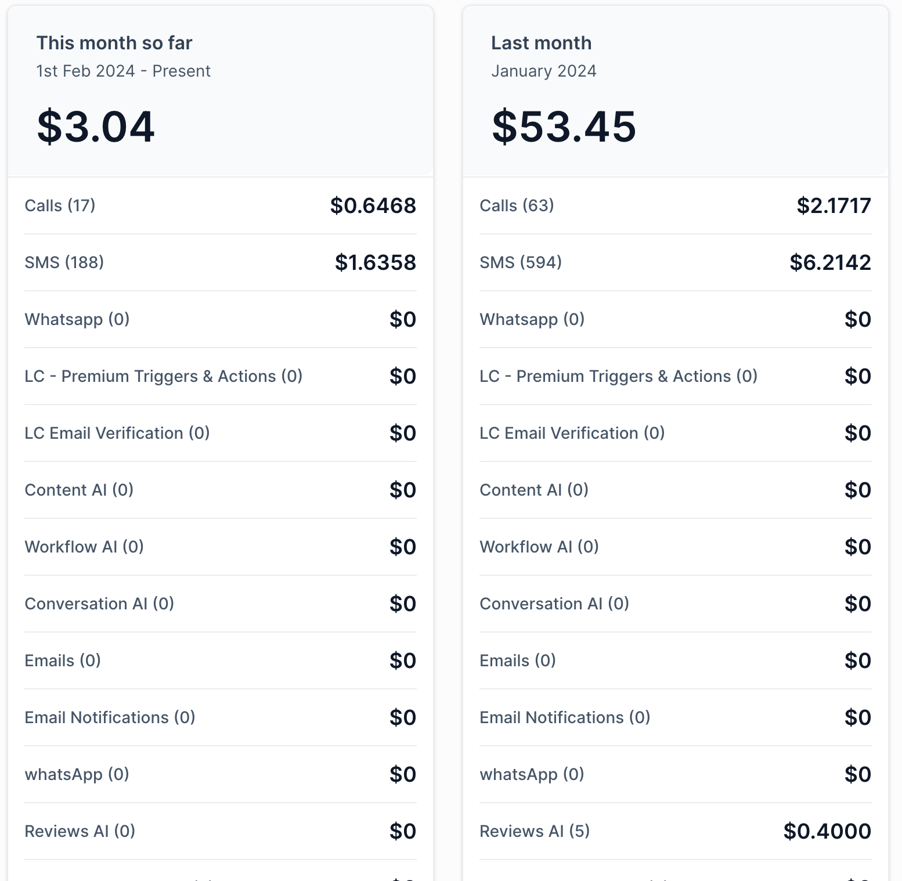

FACEBOOK BILLING REPORT

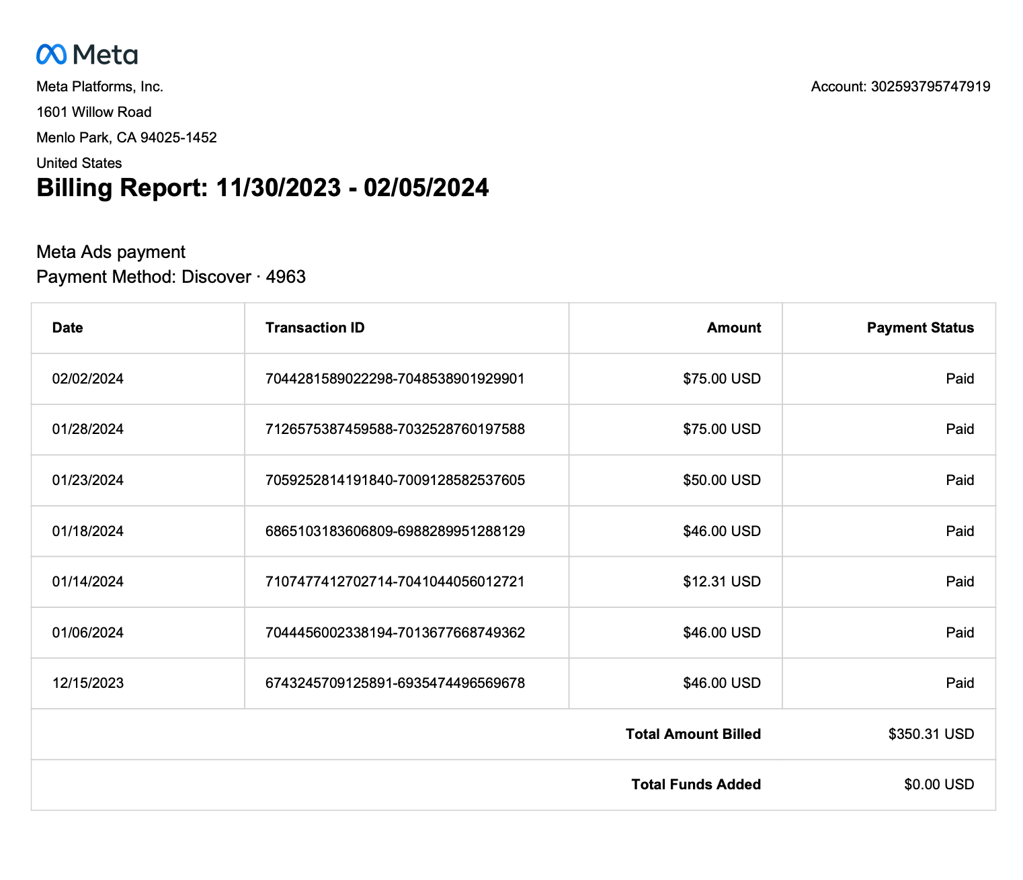

We can manage our entire marketing system through High Level, recording all calls, SMS, and emails, and implementing automations to boost productivity and response rates.