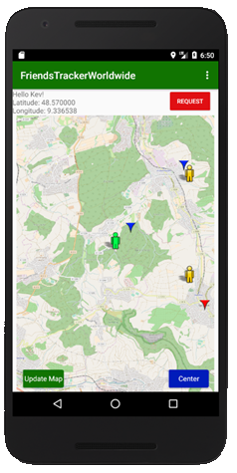**Keep an eye on your friends and your favourite places**

When being on one’s way, it’s difficult to remember interesting places that are encountered on the route. Also, from time to time one wants to share these locations with friends or even see where friends are at the moment and share the own location with them. To solve this issue, we developed the FriendsTrackerWorldwide, an Android Application that draws the location of its users into an OpenStreetMap on a mobile device. Additionally, it is possible to add personal Markers on the map and describe them so that they can be displayed on a friends’ device.

When adding a fried, a friend request will be sent to the buddy, he then has to confirm the request to complete the add-a-friend-process.  
When adding a friend to the list via the application, each location and Marker is shared with each other. You want to know where a specific point of interest or buddy is? Simply open the Marker Overview and click on the desired item, the map will then show you directly where it is, how far away it is and give you the opportunity to instantly display it on the map.

The technical side uses a remote API which is addressed by the Application to execute all relevant tasks. The API then communicates with a MongoDB Database to save and fetch user and marker information. These information will then be displayed in the Application Interface of the mobile device in FriendsTrackerWorldwide.