Overshoot Bayesian Methods

Kevin See

# 1 Goal

Estimate the number of overshoots that reach Priest. If PIT tag rates for wild steelhead were known, we could expand detection (assuming 100%) at PRD of known overshoots (juveniles PIT tagged from MCR and SR DPS and detected at PRD) to estimate overshoot abundance at PRD. Since population specific PIT tag rates are unknown we need another method to estimate overshoot abundance.

# 2 Available Data

* Number of fish tagged as juveniles from downstream areas that are detected at Priest in year ().
* Number of fish tagged as juveniles from downstream areas that are detected at Priest and detected succesfully falling back and entering downstream area which is part of the patch-occupancy model in year ().
* Estimates, from patch-occupancy model, of total fallbacks (fish that crossed Priest, then fell back and entered a downstream tributary) in year (). These are based on a different set of tags from adults tagged at Priest, who are detected downstream. It accounts for imperfect detection at the downstream arrays.
* Estimates, from patch-occupancy model, of detection probability of all downstream sites.

The detection probability estimates are shown in Table 2.1. Estimates of fallback abundance from the POM are shown in Table 2.2.

Table 2.1: Summaries of detection probabilities of sites downstream of PRD.

| Site | Avg Tags | Mean | SD of Mean | Avg SE | Avg CV |
| --- | --- | --- | --- | --- | --- |
| ICH | 279 | 0.985 | 0.010 | 0.009 | 0.009 |
| PRO | 48 | 0.810 | 0.062 | 0.085 | 0.106 |
| PRV | 5 | 0.544 | 0.371 | 0.103 | 0.222 |
| TMF | 3 | 0.625 | 0.518 | 0.000 | 0.000 |
| JD1 | 2 | 0.346 | 0.342 | 0.108 | 0.460 |

Re-create Table 2

Table 2.2: Estimates by subbasin and PTAGIS code of overshoot fallback steelhead downstream of Priest Rapids Dam. (PRO = Prosser Dam; ICH = Ice Harbor Dam; PRV = Pierce RV Park instream array; TMF = Three Mile Falls Dam; JD1 = Lower John Day at McDonald Ferry).

| Year | PRO_W | PRO_H | ICH_W | ICH_H | PRV_W | PRV_H | TMF_W | TMF_H | JD1_W | JD1_H |
| --- | --- | --- | --- | --- | --- | --- | --- | --- | --- | --- |
| 2011 | 929 | 53 | 675 | 1428 | 45 | 0 | 33 | 23 | 0 | 23 |
| 2012 | 401 | 36 | 351 | 1683 | 22 | 0 | 0 | 0 | 0 | 0 |
| 2013 | 214 | 33 | 316 | 1814 | 21 | 14 | 0 | 0 | 0 | 0 |
| 2014 | 348 | 38 | 626 | 1370 | 19 | 51 | 18 | 13 | 140 | 87 |
| 2015 | 537 | 57 | 1088 | 2451 | 69 | 21 | 48 | 21 | 115 | 35 |
| 2016 | 311 | 16 | 411 | 880 | 58 | 20 | 20 | 0 | 58 | 0 |
| 2017 | 90 | 29 | 123 | 681 | 21 | 21 | 8 | 0 | 30 | 18 |
| 2018 | 122 | 14 | 61 | 259 | 9 | 0 | 0 | 0 | 28 | 0 |
| Mean | 369 | 34 | 456 | 1321 | 33 | 16 | 16 | 7 | 46 | 20 |

# 3 Methods

First, we need to account for imperfect detection at the downstream sites so we can expand the number of known overshoot tags detected there. We do that by using the estimates of detection probablity from the patch-occupancy model for year at each site , and then summing up the estimated tags at each detection site to get an estimate of total overshoot return tags, .

Next, we develop a relationship between the number of overshoot return tags, and the total overshoot return abundance, . We assumed a log-log relationship (see Figure @(fig:tag_escp_fig)).

$$
F_i \sim e^{\beta_0} * t_i^{\beta_1}\\
\log(F_i) \sim \beta_0 + \beta_1 * \log(t_i)
$$

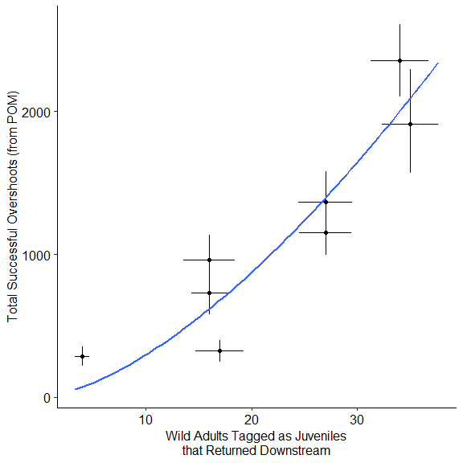

We then use that relationship, (), and the total number of known overshoot tags observed at Priest, , to predict the total overshoot abundance at Priest, . The overshoot return survival, , is the calculated from that and the estimate of total downstream abundance.

Written out mathematically, the whole things looks like this:

We fit this entire model in a Bayesian framework, using JAGS software. The JAGS model looks like this:

jags_model = function() {  
 " # PRIORS  
 for(i in 1:2) {  
 beta[i] ~ dt(0, 0.01, 1)  
 }  
 sigma ~ dt(0, 0.01, 1)T(0,)  
 tau <- pow(sigma, -2)  
   
 # MODEL  
 for(i in 1:length(tags_est)) {  
 n_tags_org[i] ~ dnorm(tags_est[i], tags_prec[i])  
 n_tags[i] <- round(n_tags_org[i])  
   
 # couldn't figure out how to incorporate this uncertainty,   
 # because n_escp_log would end up on the left side twice  
 # n_escp_log[i] ~ dlnorm(escp_est[i], escp_prec[i])  
   
 mu[i] <- beta[1] + beta[2] * log(n_tags[i])  
   
 # assuming downstream escapement estimates are known  
 escp_est_log[i] ~ dnorm(mu[i], tau)  
 }  
   
 for(i in 1:length(ovrst_tags)) {  
 # deal with uncertainty in downstream escapement estimates  
 est_dwnstrm_org[i] ~ dnorm(dwnstrm_escp[i], 1 / (dwnstrm_se[i]^2))  
 est_dwnstrm[i] <- round(est_dwnstrm_org[i])  
   
 # predict the number of overshoot fish at Priest  
 pred_mu_log[i] <- beta[1] + beta[2] * log(ovrst_tags[i])  
 pred_ovrshts_log[i] ~ dnorm(pred_mu_log[i], tau)T(log(est_dwnstrm[i]),log(1e4))  
 pred_ovrshts[i] <- round(exp(pred_ovrshts_log[i]))  
  
 # estimate survival of overshoots  
 phi[i] <- est_dwnstrm[i] / pred_ovrshts[i]  
 }"  
}

# 4 Results

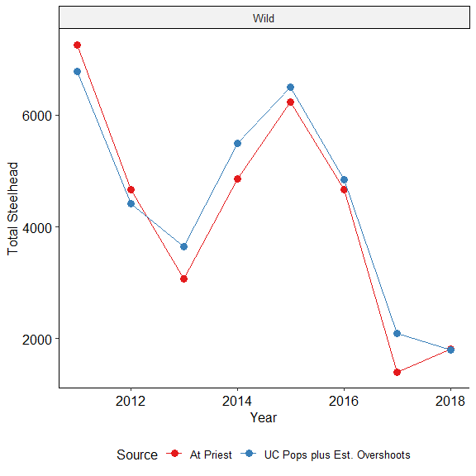

Figure 4.1: Comparison of total adusted counts at Priest and the sum of predicted overshoots and escapement to four upper Columbia steelhead populations.

# 5 Tables

Recreate Table 1 of manuscript:

Table 5.1: Steelhead abundance (adjusted for ladder re-ascension) at Priest Rapids Dam and the estimated number of overshoot fallback steelhead using the patch occupancy model, 2010-2017.

|  |  |  |  |  |  | Lower | Upper |  |  | Lower | Upper |
| --- | --- | --- | --- | --- | --- | --- | --- | --- | --- | --- | --- |
| 2010 | 7,257 | 17,938 |  | 26.3 % | 1,911 | 1,570 | 2,295 | 9.8 % | 1,755 | 1,475 | 2,022 |
| 2011 | 4,672 | 15,115 |  | 20.6 % | 963 | 799 | 1,137 | 12.8 % | 1,931 | 1,696 | 2,141 |
| 2012 | 3,065 | 13,008 |  | 23.8 % | 730 | 580 | 866 | 16.8 % | 2,180 | 1,957 | 2,399 |
| 2013 | 4,864 | 9,027 |  | 28.1 % | 1,367 | 1,161 | 1,580 | 19.5 % | 1,757 | 1,522 | 1,988 |
| 2014 | 6,232 | 12,088 |  | 37.8 % | 2,355 | 2,104 | 2,608 | 23.8 % | 2,879 | 2,644 | 3,105 |
| 2015 | 4,675 | 8,949 |  | 24.6 % | 1,150 | 995 | 1,320 | 13.2 % | 1,179 | 1,053 | 1,338 |
| 2016 | 1,404 | 4,709 |  | 23 % | 323 | 249 | 400 | 21.8 % | 1,027 | 896 | 1,151 |
| 2017 | 1,817 | 3,573 |  | 15.6 % | 284 | 217 | 351 | 15.1 % | 540 | 456 | 635 |
| Mean | 4,248 | 10,551 |  | 25 % | 1,135 | 959 | 1,320 | 16.6 % | 1,656 | 1,462 | 1,847 |
| SD | 2,040 | 4,950 |  | 6.4 % | 729 | 649 | 820 | 4.8 % | 730 | 676 | 778 |

Recreate Table 2 of manuscript:

Table 5.2: Estimates of overshoot fallback steelhead downstream of Priest Rapids Dam, by sub-basin and PTAGIS location code. (PRO = Prosser Dam; ICH = Ice Harbor Dam; PRV = Pierce RV Park instream array; TMF = Three Mile Falls Dam; JD1 = Lower John Day instream array at McDonald Ferry). Parentheses indicate PIT tag detection probability (mean, mean of SE). W = wild and H = hatchery.

| Run Year | W | H | W | H | W | H | W | H | W | H |
| --- | --- | --- | --- | --- | --- | --- | --- | --- | --- | --- |
| 2010 | 929 | 53 | 675 | 1,429 | 45 | 0 | 33 | 23 | 0 | 23 |
| 2011 | 401 | 36 | 351 | 1,683 | 22 | 0 | 0 | 0 | 0 | 0 |
| 2012 | 214 | 33 | 316 | 1,815 | 21 | 14 | 0 | 0 | 0 | 0 |
| 2013 | 348 | 38 | 626 | 1,371 | 19 | 51 | 18 | 13 | 140 | 87 |
| 2014 | 537 | 57 | 1,088 | 2,451 | 69 | 21 | 48 | 21 | 115 | 35 |
| 2015 | 311 | 16 | 411 | 880 | 58 | 20 | 20 | 0 | 58 | 0 |
| 2016 | 91 | 29 | 123 | 681 | 21 | 21 | 8 | 0 | 30 | 18 |
| 2017 | 122 | 14 | 61 | 259 | 9 | 0 | 0 | 0 | 28 | 0 |
| Mean | 369 | 34 | 456 | 1,321 | 33 | 16 | 16 | 7 | 46 | 20 |
| % | 15.9 | 1.5 | 19.7 | 57 | 1.4 | 0.7 | 0.7 | 0.3 | 2 | 0.9 |

Recreate Table 3 of manuscript:

Table 5.3: Estimated abundance of overshoot steelhead at Priest Rapids Dam and the percentage of overshoot fallback or percentage of fish observed downstream of Priest Rapids Dam prior to spawning.

| Run Year | Known Overshoot Fish | Estimate | Lower | Upper | Estimate | Lower | Upper |
| --- | --- | --- | --- | --- | --- | --- | --- |
| 2010 | 53 | 3,578 | 1,864 | 8,212 | 0.620 | 0.229 | 0.978 |
| 2011 | 18 | 1,603 | 906 | 4,097 | 0.697 | 0.234 | 0.987 |
| 2012 | 31 | 1,925 | 770 | 5,377 | 0.488 | 0.132 | 0.935 |
| 2013 | 40 | 2,708 | 1,366 | 6,770 | 0.603 | 0.198 | 0.975 |
| 2014 | 44 | 3,642 | 2,313 | 7,814 | 0.716 | 0.299 | 0.988 |
| 2015 | 35 | 2,323 | 1,165 | 6,147 | 0.595 | 0.186 | 0.970 |
| 2016 | 21 | 1,229 | 402 | 3,487 | 0.356 | 0.092 | 0.818 |
| 2017 | 6 | 542 | 263 | 1,510 | 0.649 | 0.186 | 0.983 |
| Mean | 31 | 2,194 | 1,131 | 5,427 | 0.591 | 0.194 | 0.954 |
| SD | 15 | 1,094 | 703 | 2,288 | 0.118 | 0.063 | 0.058 |