Methods (quick overview)

The first objective of the paper is to estimate overshoot fallback abundance from PIT tagged fish at PDR. We have an estimate of wild abundance at PRD and used patch occupancy model (POM) to estimate steelhead abundance for UC populations. The steelhead abundance estimates used in the overshoots paper are based on the estimates at the lowest instream PIT tag array in Wenatchee, Enitiat, Methow, and Okanogan. Since POM included detection site in the Yakima, Snake, Walla Walla, Touchet, Umatilla, and John Day abundance estimates (i.e., fallback abundance to a stream) for these populations at IHA, PRO, PRV, HST, TMF, and JD1.

The second objective of the paper is to estimate the overshoot abundance at PRD. If PIT tag rates for wild steelhead were known, we could expand detection (assuming 100%) at PRD of known overshoots (juveniles PIT tagged from MCR and SR DPS and detected at PRD) to estimate overshoot abundance at PRD. Since population specific PIT tag rates are unknown we need another method to estimate overshoot abundance.

The approach used in the paper is to use estimate an expansion factor for known overshoots (b) by using a linear regression of known overshoots tagged as juveniles (x) and the fallback abundance (y) from the POM. The number of known overshoots (x) (i.e., PIT tagged as juveniles downstream of PRD) detected as adults at Priest Rapids that are detected at any location downstream of PRD. Technically, the number of known fallbacks estimated in the paper based on the observed detected fallback and this is biased if survival from PRD tagging is 100% and there is 0% probability that a fallback PIT tag will be undetected at all the PIT tag detection sites below PRD. It is unlikely the detection probabilities are met ( Table 2 in the overshoot report). Based on Fuchs et al. 2020 it is unlikely the survival assumption is met.

Therefore, to estimate overshoot abundance the known PIT tag overshoots must be expanded to account for mortality between PRD and fallback detection sites and if the fallback detection is not 100%

ExpKPIT=ObsKPIT/(Sur \* Det)

Surv = OksKPIT/ (Det \* ExpKPIT)

where ExpKPIT is the expanded Known PIT tag detections used in the regression, ObsKPIT is the observed PIT tag detections, Sur is the survival between PRD and any detection site, and Det is the probability that a PIT tag fish that survives to the detection. We need to accurately estimate ExpKPIT based on radio tag data from Fuchs et al. (2020), the POM, or some other multistate extension of the CJS model. I am hopeful that we can used the POM to estimate survival and detection prob. After this the overshoot conversion (fallback returns/overshoots) can be estimated.

The third objective in the paper is to estimate the fallback conversion rate to natal stream based on how many dams passed (Figure 2 in overshoot papaer). I need to better understand was successful and unsuccessful are but assuming successful is overshoot that returns and unsuccessful is overshoot that does not return. A better way to display this information is based on logistic/binomial regression in the graph below.

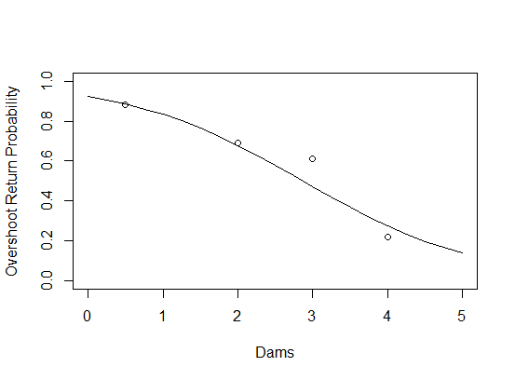

Figure 2. Relationship between the overshoot return probability and number of dams using the furthest upstream detection. Note since there is no detection at Wanapum, I assumed half of the fish last detected below RIS passed Wanapum and half did not. Could use radio tag data from Fuchs et al. to refine this assumption.

Figure 5 and 6 display the same data as a pie chart and histogram, and we only need on graph. In addition, Figure 5 is misleading. It would be appropriate to display this data in this manner if the PIT tag rates were the same for each population but this is not the case. A more accurate figure is based on PIT tag detections at PDR and IHR for different populations.

Figure 5. The percentage of known overshoots detected at PDR (black) and IHR (grey).