Estimates of Wenatchee Steelhead Redds and Spawners

Spawn Year 2022

Kevin See1,✉

April 18, 2023

This report contains estimates of total steelhead redds in the Wenatchee, after accounting for observer error. It also includes estimates of spawners, as well as prespawn mortality.

Table of Contents

1 Washington Department of Fish & Wildlife

✉ Correspondence: [Kevin See <[Kevin.See@dfw.wa.gov](mailto:Kevin.See@dfw.wa.gov)>](mailto:Kevin.See@dfw.wa.gov)

# 1 Introduction

Redd counts are an established method to provide an index of adult spawners (Gallagher et al. 2007). In the Wenatchee subbasin, index reaches are surveyed weekly during the steelhead spawning season (Mar 08, 2022 - Jun 01, 2022) and non-index reaches are surveyed once during the peak spawning period. The goal of this work is to:

1. Predict observer net error, using the model described in Murdoch et al. (2018).
2. Use estimates of observer net error rates and the mean survey interval to estimate the number of redds in each index reach, using a Gaussian area under the curve (GAUC) technique described in Millar et al. (2012) and Murdoch et al. (2018).
3. Estimate the total number of redds in the non-index reaches by adjusting the observed counts with the estimated net error where possible.
4. Sum the total number of estimated redds for the entire Wenatchee subbasin.
5. Translate the estimated number of redds into estimates of spawners, by origin.

# 2 Methods

## 2.1 Net Error Model

The net error ($NE$) for a reach $i$ is defined as

$$NE_{i}=\frac{F_{i}−V_{i}}{V_{i}}$$

where $F_{i}$ is the number of redds the surveyor reported and $V_{i}$ is the true number of redds in the reach. Therefore, if we have an estimate of net error ($\hat{NE_{i}}$), we can calculate the true number of redds based on that estimate and the number of redds the surveyor reported, $F_{i}$:

$$V_{i}=\frac{F_{i}}{\hat{NE_{i}}+1} \left(2.1\right)$$

The model for observer net error is fully described in Murdoch et al. (2018). It uses covariates of the log of observer experience, mean discharge, the observed redd density and mean thalweg CV as a proxy for channel complexity. After normalizing these covariates, the model coefficients are shown in Table 2.1. Positive coefficients indicate that higher values of that covariate lead to higher predicted values of net error, while negative coefficients cause higher values of that covariate to lead to lower predicted net errors.

We have made one slight modification to the model since that publication. We have subtracted one from the net error, to center values of net error around zero instead of one, for ease of interpretability. The response, net error, is scaled such that estimates of net error less than zero suggest more errors of omission, while estimates greater than zero suggest more errors of commission. An estimate of net error equal to zero would indicate the observed count equals the true number of redds.

Table 2.1: Net error model covariates and coefficients.

| Term | Estimate | Std Error |
| --- | --- | --- |
| (Intercept) | -0.318 | 0.043 |
| Obs. Redd Density | 0.268 | 0.063 |
| Log Surveyor Exp. | 0.123 | 0.047 |
| Mean Thalweg CV | -0.116 | 0.051 |
| Mean Discharge | 0.109 | 0.053 |

## 2.2 Data

Redd counts were conducted on a nearly weekly basis for index reaches, and once during the peak spawning period for non-index reaches. The covariates in the observer error model of Murdoch et al. (2018) were collected during each survey. The covariate of mean thalweg CV was calculated based on all measurements taken within a reach across years (assuming this covariate does not vary through time within a reach). They were compared with the covariates contained in the model data set, as well as the estimates of net error (Figure 2.1).

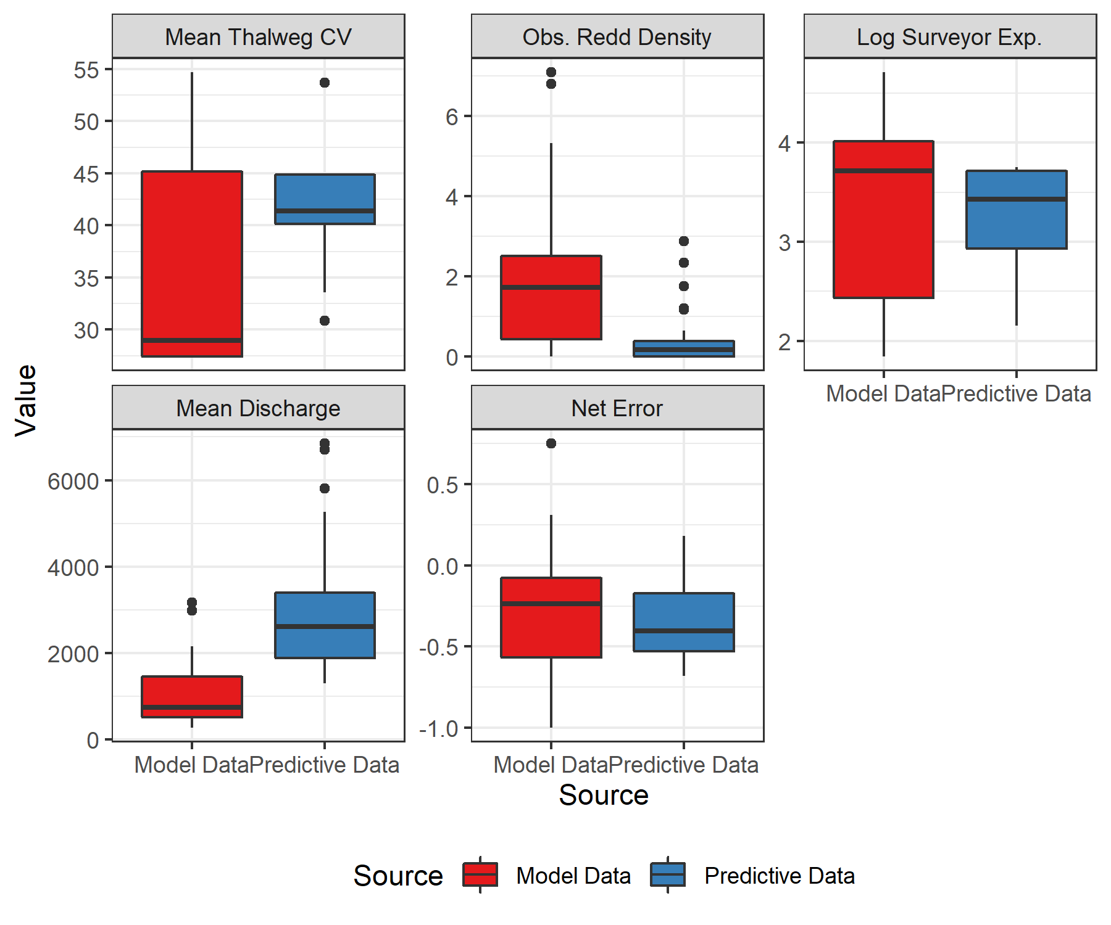

Figure 2.1: Net error covariate values. Colors correspond to either the original study (Model Data) or the reaches where the model was used in this report (Predictive Data).

Those covariates in the observer error model were collected during each survey in 2022, and predictions of net error were made for each survey. From these survey specific estimates of net error, a mean and standard error of net error was calculated for each reach. The standard deviation was calculated by taking the square root of the sum of the squared standard errors for all predictions within a reach.

## 2.3 Estimating Redds

Use of the GAUC methodology was limited to index reaches with a minimum of two redds and at least three weeks with at least one new redd found. For those reaches, we used the method described in Millar et al. (2012) and Murdoch et al. (2018). The GAUC model was developed with spawner counts in mind. As it is usually infeasible to mark every individual spawner, only total spawner counts can be used, and an estimate of average stream life must be utilized to translate total spawner days to total unique spawners. However, in adapting this for redd surveys, we note that individual redds can be marked, and therefore the GAUC model can be fit to new redds only. The equivalent of stream life is thus the difference between survey numbers, which can be fixed at 1. We applied the average net error from all the surveys when redds were visible, so as to not bias the estimate from early weeks when no redds were found, and the observed redd density was zero.

For non-index reaches, which were surveyed only once during peak spawning, the estimate of total redds was calculated by dividing the observed redds by the estimate of net error associated with that survey (Eq. (2.1)). This assumes that no redds were washed out before the non-index survey, and that no new redds appeared after that survey. As the number of redds observed in the non-index reaches ranged from 0 to 1, any violation of this assumption should not affect the overall estimates very much. Any index reaches that did not meet the thresholds described above were treated as non-index reaches, and the total observed redds in those reaches were divided by the mean estimate of net error for each reach.

When summing reach-scale estimates to obtain estimates at the stream scale, an attempt was made to incorporate the fact that the reaches within a stream are not independent. Estimates of correlation between the reaches within a stream were made based on weekly observed redds. This method may not be perfect, since spawners could use certain reaches preferentially at different times in the season, but it may be the best we can do. Because correlations are often quite high between reaches, this is a better alternative than to naively assume the standard errors between reaches are independent of one another. These correlation estimates were combined with estimates of standard error at the reach scale to calculate a covariance matrix for the reaches within each stream, which was used when summing estimates of total redds to estimate the standard error at the stream scale. Failure to incorporate the correlations between reaches would result in an underestimate of standard error at the stream scales. Different streams (and therefore reaches in different streams) were assumed to be independent.

## 2.4 Estimating Spawners

Estimates of escapement to various tributaries in the Wenatchee were made using a Dam Adult Branch Occupancy Model (DABOM) (Waterhouse et al. 2020) based on PIT tag detections of fish tagged at Priest Rapids dam. All fish that escaped to the various tributaries were assumed to be spawners (i.e. prespawn mortality only occurs in the mainstem). Reaches below the PIT tag arrays in some tributaries were surveyed for redds, but we assumed there was no observer error in those reaches.

To convert estimates of redds in mainstem areas into estimates of natural and hatchery spawners, the estimates of redds were multiplied by a fish per redd (FpR) estimate and then by the proportion of hatchery or wild fish. The fish per redd estimate was based on PIT tags from the branching patch-occupancy model observed to move into the lower or upper Wenatchee (below or above Tumwater dam), but not into tributaries upstream of Tumwater. FpR was calculated as the ratio of male to female fish, plus 1. Reaches W1 - W7 are below Tumwater, while reaches W8 - W10 are above Tumwater. Similarly, the proportion of hatchery and natural origin fish was calculated from the same group of PIT tags for areas above and below Tumwater. For reaches in tributaries below the tributary PIT tag array, FpR and proportion hatchery were calculated based on observed PIT tags moving into the lower regions of each tributary.

In some years, we have noticed a discrepancy in the sex calls at Priest Rapids and the sex calls from broodstock collection at Wells Hatchery and in the Wenatchee. Therefore, we developed a correction factor that accounts for the error rate in female and male calls independently, and adjusts the fish / redd estimate accordingly. The error rate of sex calls at Priest are shown in Appendix 7.1 in Table 7.1.

## 2.5 Prespawn Mortality

After translating estimates of redds to estimates of spawners by origin, we can then compare the spawner estimates to escapement estimates made using PIT tags, and estimate a prespawn mortality rate. Taking the total PIT-tag based escapement estimate, by origin, to the Wenatchee, we then subtract any fish removed at Tumwater or Dryden for broodstock or surplus, as well as any deaths due to harvest (Table 2.2), and then subtract the total estimate of spawners, including the tributaries, to provide an estimate of how many fish succumbed to prespawn mortality. Dividing that number by the total escapement estimate provides an estimate of the prespawn mortality rate, by origin, across the entire Wenatchee population.

Table 2.2: Known number of fish removed at dams or due to harvest, by origin.

| Spawn Year | Removal Location | Agency | Source | Hatchery | Natural |
| --- | --- | --- | --- | --- | --- |
| 2022 | Dryden & Tumwater Dams | WDFW-Wenatchee Research Office | Adult Trapping Surplus | 0 | 0 |
| 2022 | Dryden & Tumwater Dams | WDFW-Wenatchee Research Office | Brood Collections | 48 | 51 |
| 2022 | Dryden & Tumwater Dams | WDFW-Wenatchee Research Office | Harvest | 0 | 0 |

If either origin had a higher estimates of spawners compared to escapement, we fixed our prespawn mortality estimate at 0, reflecting a very low level of prespawn mortality. There is uncertainty in both the escapement and spawner estimates, which could explain why these types of scenarios could arise.

# 3 Results

## 3.1 Redd estimates

The estimated net error, observed redds and estimates of redds at the reach scale are shown in Table 3.1. Plots of the new redds and the GAUC fit to those data are shown in Figure 3.1. The results are summarized by major areas and population scale in Table 3.2.

Table 3.1: Estimates of mean net error and redds for each reach.

| River | Reach | Type | Net Error | Net Error SE | Observed Redds | Estimated Redds | Std. Err. Redds | Redds CV |
| --- | --- | --- | --- | --- | --- | --- | --- | --- |
| Chiwawa | C1 | Tributary | 0 | 0 | 0 | 0 | 0 | - |
| Nason | N1 | Tributary | 0 | 0 | 0 | 0 | 0 | - |
| Peshastin | P1 | Tributary | 0 | 0 | 0 | 0 | 0 | - |
| Wenatchee | W1 | Non-Index | 0 | 0 | 0 | 0 | 0 | - |
| Wenatchee | W2 | Index | 0 | 0 | 0 | 0 | 0 | - |
| Wenatchee | W3 | Non-Index | 0 | 0 | 0 | 0 | 0 | - |
| Wenatchee | W4 | Non-Index | 0 | 0 | 0 | 0 | 0 | - |
| Wenatchee | W5 | Non-Index | 0 | 0 | 0 | 0 | 0 | - |
| Wenatchee | W6 | Index | -0.085 | 0.175 | 4 | 4 | 2.1 | 0.514 |
| Wenatchee | W8 | Non-Index | 0 | 0 | 0 | 0 | 0 | - |
| Wenatchee | W8 | Index | -0.52 | 0.139 | 2 | 4 | 1.2 | 0.303 |
| Wenatchee | W9 | Non-Index | -0.184 | 0.148 | 0 | 0 | 0 | - |
| Wenatchee | W9 | Index | -0.428 | 0.145 | 4 | 7 | 1.9 | 0.265 |
| Wenatchee | W10 | Non-Index | 0.003 | 0.115 | 1 | 1 | 0.1 | 0.114 |
| Wenatchee | W10 | Index | -0.42 | 0.088 | 4 | 9 | 6.4 | 0.709 |

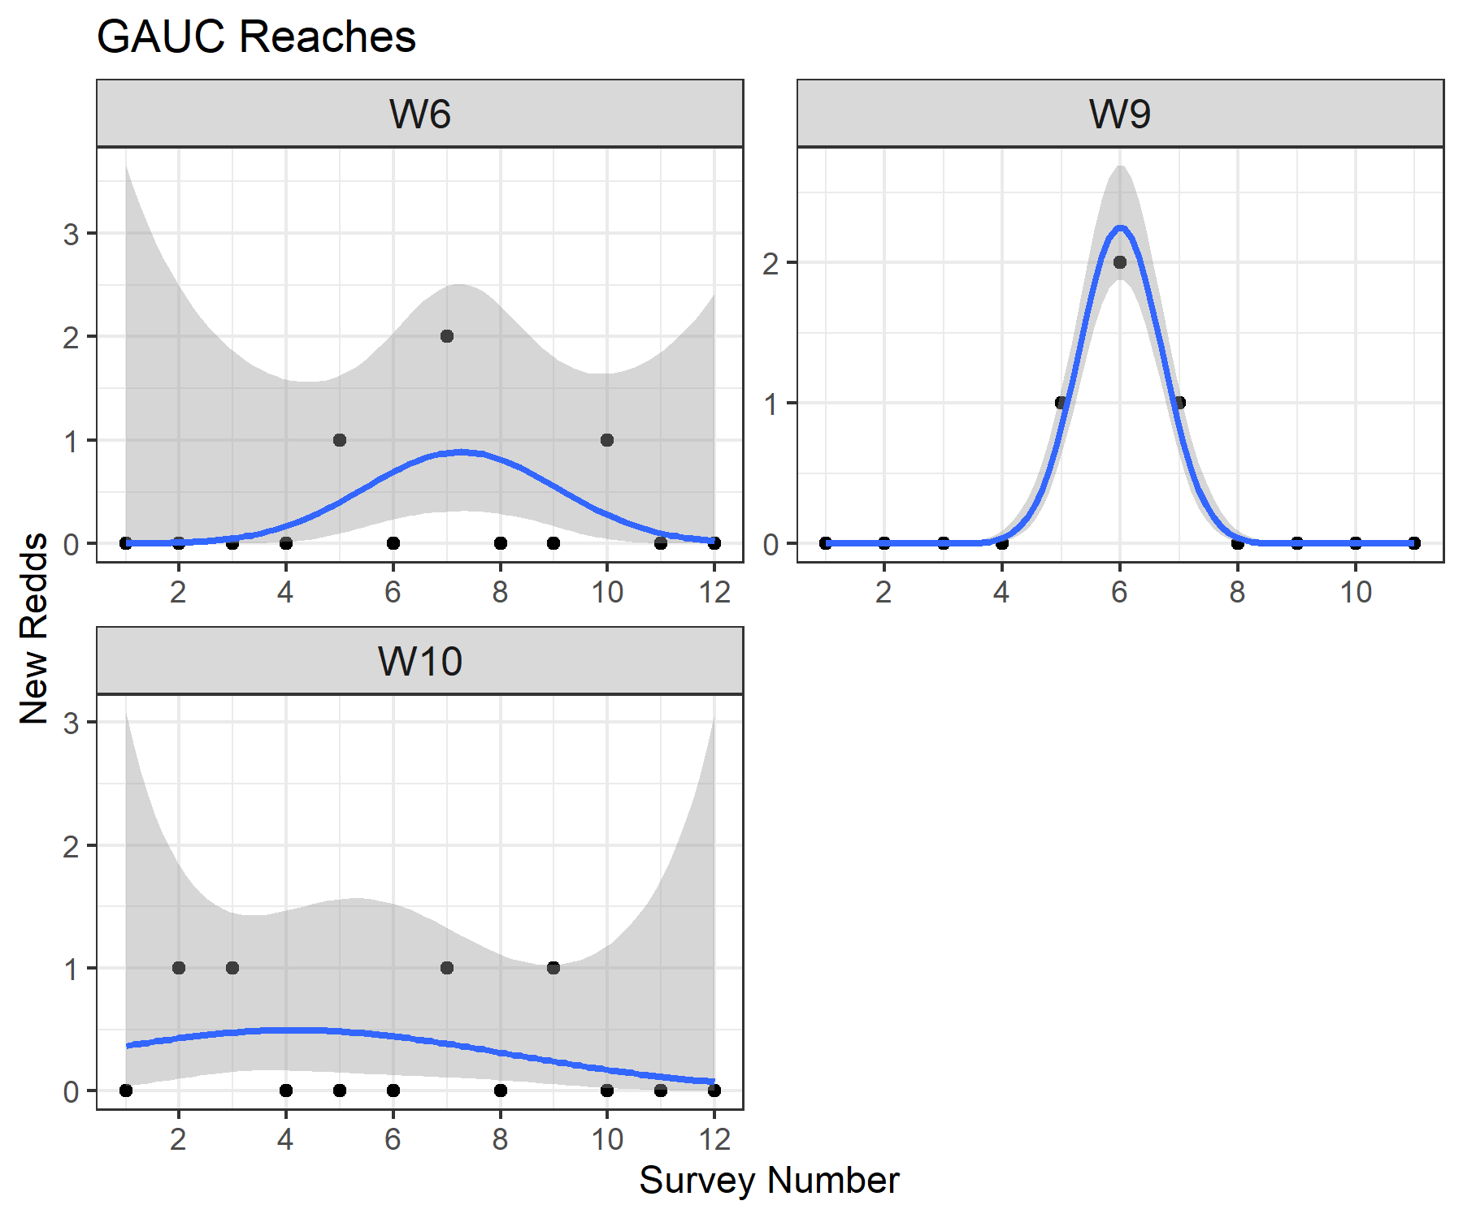

Figure 3.1: Plots of observed redd counts (black dots) through time for each qualifying index reach, and the fitted curve from the GAUC model (blue line) with associated uncertainty (gray).

Table 3.2: Estimate of redds in mainstem Wenatchee, above and below Tumwater Dam, and any tributaries surveyed.

| River | Index | Location | # Reaches | Observed Redds | Estimated Redds | Std Err Redds | Redds CV |
| --- | --- | --- | --- | --- | --- | --- | --- |
| Chiwawa | Tributary | Tributaries | 1 | 0 | 0 | 0 | - |
| Nason | Tributary | Tributaries | 1 | 0 | 0 | 0 | - |
| Peshastin | Tributary | Tributaries | 1 | 0 | 0 | 0 | - |
| Wenatchee | N | Below Tumwater (mainstem) | 4 | 0 | 0 | 0 | - |
| Wenatchee | Y | Below Tumwater (mainstem) | 2 | 4 | 4 | 2.1 | 0.514 |
| Wenatchee | N | Above Tumwater (mainstem) | 3 | 1 | 1 | 0.1 | 0.114 |
| Wenatchee | Y | Above Tumwater (mainstem) | 3 | 10 | 20 | 7.3 | 0.366 |
| Total | - | - | 15 | 15 | 25 | 7.6 | 0.304 |

## 3.2 Spawner Estimates

Demographic data about sex and origin were derived from the PIT tags detected within each area (Table 3.3).

Table 3.3: Number of PIT tags detected in each area by sex and origin.

| Location | Sex | Origin | N Tags |
| --- | --- | --- | --- |
| Below Tumwater (mainstem) | F | H | 2 |
| Below Tumwater (mainstem) | F | W | 3 |
| Below Tumwater (mainstem) | M | H | 1 |
| Above Tumwater (mainstem) | F | H | 4 |
| Above Tumwater (mainstem) | F | W | 8 |
| Above Tumwater (mainstem) | M | H | 3 |
| Above Tumwater (mainstem) | M | W | 5 |
| Peshastin | F | W | 7 |
| Peshastin | M | H | 1 |
| Nason | F | W | 4 |
| Nason | M | W | 1 |
| Chiwawa | F | W | 1 |
| Chiwawa | M | W | 1 |

Parameter estimates for fish / redd and proportion hatchery based on this PIT tag data after adjusting for the sex call error rate (Appendix 7.1) are shown in Table 3.4.

Table 3.4: Fish per redd and hatchery origin proportion estimates.

| Area | Fish / redd | FpR Std. Error | Prop. Hatchery | Prop Std. Error |
| --- | --- | --- | --- | --- |
| Below Tumwater (mainstem) | 2.000 | 0.154 | 0.500 | 0.204 |
| Above Tumwater (mainstem) | 3.333 | 0.333 | 0.350 | 0.107 |
| Peshastin | 2.000 | 0.162 | 0.125 | 0.117 |
| Nason | 2.500 | 0.236 | 0.000 | 0.000 |
| Chiwawa | 2.000 | 0.093 | 0.000 | 0.000 |

Combining PIT tag-based estimates of spawners in the tributaries with adjusted redd-based estimates of spawners in the mainstem areas, Table 3.5 shows all of them, broken down by reach or tributary and origin. Table 3.6 shows a summary of spawners by origin across various areas including the Wenatchee mainstem and each tributary.

Table 3.5: Estimates (CV) of spawners by reach or tributary and origin.

| River | Area | Reach | Type | Natural | Hatchery |
| --- | --- | --- | --- | --- | --- |
| Wenatchee | Below Tumwater (mainstem) | W1 | Non-Index | 0 (-) | 0 (-) |
| Wenatchee | Below Tumwater (mainstem) | W2 | Index | 0 (-) | 0 (-) |
| Wenatchee | Below Tumwater (mainstem) | W3 | Non-Index | 0 (-) | 0 (-) |
| Wenatchee | Below Tumwater (mainstem) | W4 | Non-Index | 0 (-) | 0 (-) |
| Wenatchee | Below Tumwater (mainstem) | W5 | Non-Index | 0 (-) | 0 (-) |
| Wenatchee | Below Tumwater (mainstem) | W6 | Index | 4 (0.66) | 4 (0.66) |
| Wenatchee | Above Tumwater (mainstem) | W8 | Index | 9 (0.36) | 5 (0.44) |
| Wenatchee | Above Tumwater (mainstem) | W8 | Non-Index | 0 (-) | 0 (-) |
| Wenatchee | Above Tumwater (mainstem) | W9 | Index | 15 (0.33) | 8 (0.42) |
| Wenatchee | Above Tumwater (mainstem) | W9 | Non-Index | 0 (-) | 0 (-) |
| Wenatchee | Above Tumwater (mainstem) | W10 | Index | 20 (0.73) | 11 (0.78) |
| Wenatchee | Above Tumwater (mainstem) | W10 | Non-Index | 2 (0.22) | 1 (0.34) |
| Icicle | Icicle | - | DABOM | 79 (0.35) | 19 (0.68) |
| Peshastin | Peshastin | P1 | Tributary | 0 (-) | 0 (-) |
| Peshastin | Peshastin | - | DABOM | 70 (0.37) | 14 (0.88) |
| Mission | Mission | - | DABOM | 15 (0.82) | 13 (0.88) |
| Chumstick | Chumstick | - | DABOM | 22 (0.66) | 0 (-) |
| Chiwaukum | Chiwaukum | - | DABOM | 21 (0.7) | 10 (0.98) |
| Chiwawa | Chiwawa | C1 | Tributary | 0 (-) | 0 (-) |
| Chiwawa | Chiwawa | - | DABOM | 25 (0.78) | 0 (-) |
| Nason | Nason | N1 | Tributary | 0 (-) | 0 (-) |
| Nason | Nason | - | DABOM | 41 (0.46) | 0 (-) |
| Little Wenatchee | Little Wenatchee | - | DABOM | 0 (-) | 0 (-) |
| White River | White River | - | DABOM | 0 (-) | 0 (-) |
| Total | - | - | - | 323 (0.17) | 85 (0.3) |

Table 3.6: Estimates (CV) of spawners by area and origin.

| River | Location | Natural | Hatchery |
| --- | --- | --- | --- |
| Chiwaukum | Chiwaukum | 21 (0.7) | 10 (0.98) |
| Chiwawa | Chiwawa | 25 (0.78) | 0 (-) |
| Chumstick | Chumstick | 22 (0.66) | 0 (-) |
| Icicle | Icicle | 79 (0.35) | 19 (0.68) |
| Little Wenatchee | Little Wenatchee | 0 (-) | 0 (-) |
| Mission | Mission | 15 (0.82) | 13 (0.88) |
| Nason | Nason | 41 (0.46) | 0 (-) |
| Peshastin | Peshastin | 70 (0.37) | 14 (0.88) |
| Wenatchee | Below Tumwater (mainstem) | 4 (0.66) | 4 (0.66) |
| Wenatchee | Above Tumwater (mainstem) | 46 (0.34) | 25 (0.36) |
| White River | White River | 0 (-) | 0 (-) |
| Total | - | 323 (0.17) | 85 (0.3) |

## 3.3 Prespawn Mortality

The estimates of overall prespawn mortality within the Wenatchee population, by origin, are shown in Table 3.7.

Table 3.7: Wenatchee prespawn mortality estimates. Includes estimates (standard error) of escapement, spawners, rate of prespawn mortality, and standard error and coefficient of variation of this rate, separated by origin.

| Origin | Escapement | Spawners | Prespawn Mortality | SE | CV |
| --- | --- | --- | --- | --- | --- |
| Natural | 355 (60) | 323 (55) | 0.090 | 0.218 | 2.417 |
| Hatchery | 95 (36) | 85 (25) | 0.105 | 0.432 | 4.106 |

# 4 Discussion

Most of the covariates collected in 2022 were within the range of those in the model data set from Murdoch et al. (2018), leading to estimates of net error in a very similar range to the model dataset (Figure 2.1). However, some reaches did not meet the minimum thresholds of number of observed redds or number of weeks with at least one new redd observed, so we only used the GAUC method in three reaches.

Hatchery and natural origin steelhead PIT-tagged at Priest Rapids dam were not detected in a number of tributaries this year, leading to estimates of zero hatchery spawners in those tributaries (Table 3.6). Because these estimates are based on a sample of the entire Upper Columbia steelhead run, it’s possible a handful of steelhead may have spawned in those tributaries, but it’s potentially more likely that the estimate of zero steelhead spawners in those areas is correct.

# 5 Acknowledgements

The data for this report was collected by Washington Department of Fish and Wildlife, and funded by Chelan County Public Utility District.

# 6 References

Gallagher, S. P., P. K. J. Hahn, and D. H. Johnson. 2007. Salmonid field protocols handbook: Techniques for assessing status and trends in salmon and trout populations. Pages 197–234 *in* D. H. Johnson, editor. American Fisheries Society, Bethesda, Maryland.

Millar, R. B., S. McKechnie, and C. E. Jordan. 2012. Simple estimators of salmonid escapement and its variance using a new area-under-the-curve method. Canadian Journal of Fisheries and Aquatic Sciences 69(6):1002–1015.

Murdoch, A. R., C. J. Herring, C. H. Frady, K. See, and C. E. Jordan. 2018. Estimating observer error and steelhead redd abundance using a modified gaussian area-under-the-curve framework. Canadian Journal of Fisheries and Aquatic Sciences (999):1–10.

Waterhouse, L., J. White, K. See, A. Murdoch, and B. X. Semmens. 2020. A bayesian nested patch occupancy model to estimate steelhead movement and abundance. Ecological Applications.

# Appendices

# 7 Appendix A

## 7.1 Sex Errors at Priest Rapids

Fish collected for broodstock at various locations throughout the Upper Columbia (e.g. Wells Hatchery and within the Wenatchee) had a known sex. Based on PIT tag detections of this broodstock collection, those sexes could be compared with the sex call at Priest when the fish was initially tagged. Assuming that this error rate is systematic across the entire run within a brood year, we combined all tags with this kind of comparison. Table 7.1 shows the sample sizes and results.

These error rates were used to adjust the counts of male and female tags within particular spawning areas before re-calculating the fish/redd estimate. For example, the adjusted number of males would be the initial number of males, minus the number of initial males times the error rate for male identification, plus the number of initial females times the error rate for female identification.

Table 7.1: Error rate in sex calls at Priest Rapids.

| Spawn Year | Sex | N Tags | N True | N False | Perc False | Perc SE | LowerCI | UpperCI |
| --- | --- | --- | --- | --- | --- | --- | --- | --- |
| 2011 | F | 22 | 18 | 4 | 0.182 | 0.082 | 0.073 | 0.385 |
| 2011 | M | 16 | 14 | 2 | 0.125 | 0.083 | 0.035 | 0.360 |
| 2012 | F | 40 | 33 | 7 | 0.175 | 0.060 | 0.087 | 0.319 |
| 2012 | M | 20 | 19 | 1 | 0.050 | 0.049 | 0.009 | 0.236 |
| 2013 | F | 28 | 26 | 2 | 0.071 | 0.049 | 0.020 | 0.226 |
| 2013 | M | 23 | 23 | 0 | 0.000 | 0.000 | 0.000 | 0.143 |
| 2014 | F | 52 | 47 | 5 | 0.096 | 0.041 | 0.042 | 0.206 |
| 2014 | M | 55 | 53 | 2 | 0.036 | 0.025 | 0.010 | 0.123 |
| 2015 | F | 73 | 69 | 4 | 0.055 | 0.027 | 0.022 | 0.133 |
| 2015 | M | 62 | 59 | 3 | 0.048 | 0.027 | 0.017 | 0.133 |
| 2016 | F | 69 | 63 | 6 | 0.087 | 0.034 | 0.040 | 0.177 |
| 2016 | M | 66 | 65 | 1 | 0.015 | 0.015 | 0.003 | 0.081 |
| 2017 | F | 77 | 76 | 1 | 0.013 | 0.013 | 0.002 | 0.070 |
| 2017 | M | 47 | 46 | 1 | 0.021 | 0.021 | 0.004 | 0.111 |
| 2018 | F | 85 | 79 | 6 | 0.071 | 0.028 | 0.033 | 0.146 |
| 2018 | M | 79 | 77 | 2 | 0.025 | 0.018 | 0.007 | 0.088 |
| 2019 | F | 61 | 55 | 6 | 0.098 | 0.038 | 0.046 | 0.198 |
| 2019 | M | 34 | 33 | 1 | 0.029 | 0.029 | 0.005 | 0.149 |
| 2020 | F | 38 | 31 | 7 | 0.184 | 0.063 | 0.092 | 0.334 |
| 2020 | M | 33 | 32 | 2 | 0.061 | 0.042 | 0.017 | 0.196 |
| 2021 | F | 36 | 32 | 4 | 0.111 | 0.052 | 0.044 | 0.253 |
| 2021 | M | 11 | 8 | 3 | 0.273 | 0.134 | 0.097 | 0.566 |
| 2022 | F | 58 | 31 | 27 | 0.466 | 0.065 | 0.343 | 0.592 |
| 2022 | M | 21 | 21 | 0 | 0.000 | 0.000 | 0.000 | 0.155 |