Estimates of Wenatchee Steelhead Redds in 2018

Kevin See1,✉

29 January, 2020

This report contains estimates of total steelhead redds in the Wenatchee, after accounting for observer bias.

Table of Contents

1 Biomark, Inc.

✉ Correspondence: [Kevin See <[Kevin.See@biomark.com](mailto:Kevin.See@biomark.com)>](mailto:Kevin.See@biomark.com)

# Introduction

Redd counts are an established method to provide an index of adult spawners (Gallagher et al. 2007). In the Wenatchee and Methow subbasins, index reaches are surveyed weekly during the steelhead spawning season (Mar 12, 2018 - Jun 11, 2018) and non-index reaches are surveyed once during the peak spawning period. The goal of this work is to:

* Predict observer net error, using the model described in Murdoch et al. (2018).
* Use estimates of observer net error rates and the mean survey interval to estimate the number of redds in each index reach, using a Gaussian area under the curve (GAUC) technique described in Millar et al. (2012).
* Estimate the total number of redds in the non-index reaches by adjusting the observed counts with the estimated net error.

# Methods

## Net Error Model

The model for observer net error (observed redd counts / true number of redds) is fully described in Murdoch et al. (2018). It uses covariates of the log of observer experience, mean discharge, the observed redd density and mean thalweg CV as a proxy for channel complexity. After normalizing these covariates, the model coefficients are shown in Table 1.

Table 1: Net error model covariates and coefficients.

|  |  |  |  |  |
| --- | --- | --- | --- | --- |
| Covariate | Estimate | Std. Error | t value | Pr(>|t|) |
| (Intercept) | 0.682 | 0.039 | 17.529 | 0.000 |
| Obs. Redd Density | 0.277 | 0.053 | 5.218 | 0.000 |
| Mean Thalweg CV | -0.169 | 0.043 | -3.937 | 0.000 |
| Mean Discharge | 0.116 | 0.048 | 2.426 | 0.020 |
| Log Surveyor Exp. | 0.115 | 0.042 | 2.760 | 0.009 |

## Data

Redd counts were conducted on a nearly weekly basis for index reaches, and once during the peak spawning period for non-index reaches. The covariates in the observer error model of Murdoch et al. (2018) were collected during each survey. They were compared with the covariates contained in the model data set, as well as the estimates of net error (Figure 1).

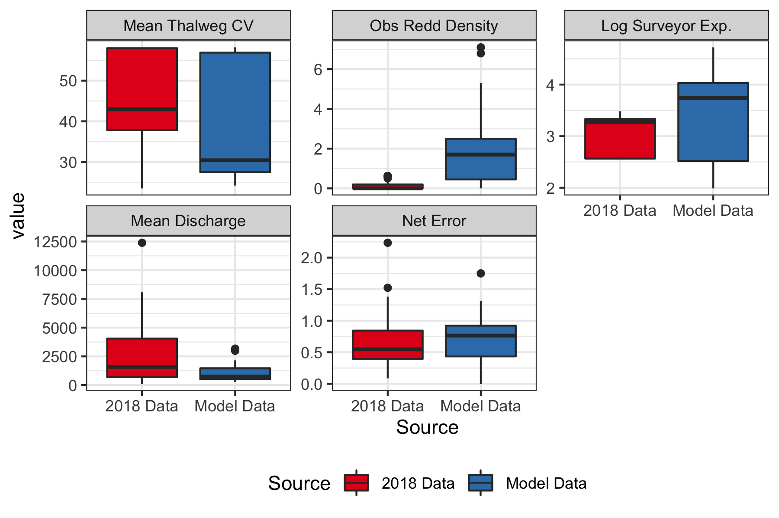

Figure 1: Net error covariate values from the original study the predicted reaches in this report.

Those covariates in the observer error model were collected during each survey in 2018, and predictions of net error were made for each survey. From these survey specific estimates of net error, a mean and standard error of net error was calculated for each reach. The standard deviation was calculated by taking the square root of the sum of the squared standard errors for all predictions within a reach.

## Estimating Redds

Estimates of total redds were made for each index reach with a minimum of 2 redds and at least 3 weeks with at least one new redd found using the GAUC model described in Millar et al. (2012) and Murdoch et al. (2018). The GAUC model was developed with spawner counts in mind. As it is usually infeasible to mark every individual spawner, only total spawner counts can be used, and an estimate of average stream life must be utilized to translate total spawner days to total unique spawners. However, in adapting this for redd surveys, we note that individual redds can be marked, and therefore the GAUC model can be fit to new redds only. The equivalent of stream life thus the difference between survey numbers which can be fixed at 1.

For non-index reaches, which were surveyed only once during peak spawning, the estimate of total redds was calculated by dividing the observed redds by the estimate of net error associated with that survey. This assumes that no redds were washed out before the non-index survey, and that no new redds appeared after that survey. As the number of redds observed in the non-index reaches ranged from 0 to 0, any violoation of this assumption should not affect the overall estimates very much. Any index reaches that did not meet the thresholds described above were treated as non-index reaches, and the total observed redds in those reaches were divided by the mean estimate of net error for each reach.

# Results

## Redd estimates

The estimated net error, observed redds and estimates of redds are shown in Table 2. Plots of the new redds and the GAUC fit to those data are shown in Figure 2.

Table 2: Estimates of mean net error and redds for each reach.

|  |  |  |  |  |  |  |  |
| --- | --- | --- | --- | --- | --- | --- | --- |
| River | Reach | Type | Net Error | Net Error CV | Observed Redds | Estimated Redds | Redds CV |
| Chiwawa | C1 | Index | 1 | 0 | 0 | 0 | - |
| Nason | N1 | Index | 1 | 0 | 0 | 0 | - |
| Peshastin | P1 | Index | 1 | 0 | 1 | 1 | 0 |
| Wenatchee | W1 | Non-Index | 1 | 0 | 0 | 0 | - |
| Wenatchee | W2 | Non-Index | 1 | 0 | 0 | 0 | - |
| Wenatchee | W2 | Index | 0.736 | 0.238 | 0 | 0 | - |
| Wenatchee | W3 | Non-Index | 1 | 0 | 0 | 0 | - |
| Wenatchee | W4 | Non-Index | 1 | 0 | 0 | 0 | - |
| Wenatchee | W5 | Non-Index | 1 | 0 | 0 | 0 | - |
| Wenatchee | W6 | Non-Index | 0.925 | 0.223 | 0 | 0 | - |
| Wenatchee | W6 | Index | 0.784 | 0.232 | 2 | 3 | 0.197 |
| Wenatchee | W8 | Index | 0.484 | 0.301 | 1 | 2 | 0.31 |
| Wenatchee | W9 | Non-Index | 1.055 | 0.225 | 0 | 0 | - |
| Wenatchee | W9 | Index | 0.779 | 0.2 | 8 | 10 | 0.454 |
| Wenatchee | W10 | Non-Index | 0.558 | 0.301 | 0 | 0 | - |
| Wenatchee | W10 | Index | 0.472 | 0.357 | 16 | 34 | 0.449 |
| Total | - | - | - | - | 28 | 50 | 0.319 |

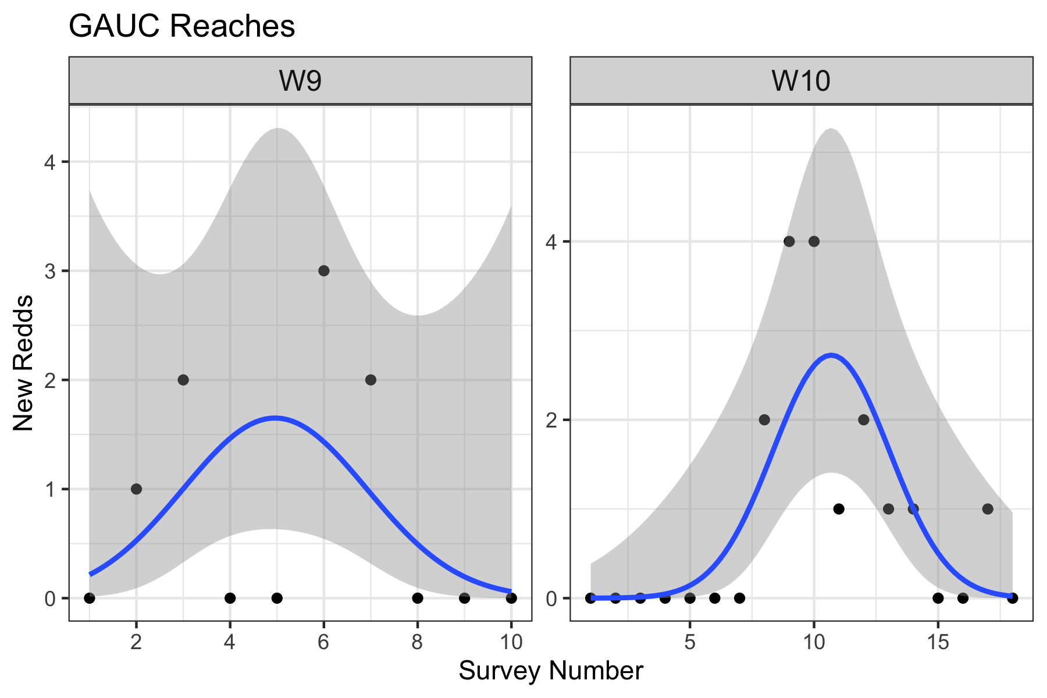

Figure 2: Plots of observed redd counts (black dots) through time for each qualifying index reach, and the fitted curve from the GAUC model (blue line) with associated uncertainty (gray).

# Discussion

Most of the covariates collected in 2018 were within the range of those in the model data set from Murdoch et al. (2018), leading to estimates of net error in a very similar range to the model dataset (Figure 1). However, most reaches did not meet the minimum thresholds of number of observed redds or number of weeks with at least one new redd observed, so we only used the GAUC method in only 2 reaches.

# Acknowledgements

# References

Gallagher, S., P. Hahn, and D. Johnson. 2007. Salmonid field protocols handbook: Techniques for assessing status and trends in salmon and trout populations. Pages 197–234 *in* D. Johnson, editor. American Fisheries Society, Bethesda, Maryland.

Millar, R., S. McKechnie, and C. Jordan. 2012. Simple estimators of salmonid escapement and its variance using a new area-under-the-curve method. Canadian Journal of Fisheries and Aquatic Sciences 69(6):1002–1015.

Murdoch, A. R., C. J. Herring, C. H. Frady, K. See, and C. E. Jordan. 2018. Estimating observer error and steelhead redd abundance using a modified gaussian area-under-the-curve framework. Canadian Journal of Fisheries and Aquatic Sciences (999):1–10.

### Colophon

This report was generated on 2020-01-29 18:14:58 using the following computational environment and dependencies:

#> ─ Session info ───────────────────────────────────────────────────────────────  
#> setting value   
#> version R version 3.6.1 (2019-07-05)  
#> os macOS Mojave 10.14.6   
#> system x86_64, darwin15.6.0   
#> ui X11   
#> language (EN)   
#> collate en_US.UTF-8   
#> ctype en_US.UTF-8   
#> tz America/Los_Angeles   
#> date 2020-01-29   
#>   
#> ─ Packages ───────────────────────────────────────────────────────────────────  
#> package * version date lib source   
#> assertthat 0.2.1 2019-03-21 [2] CRAN (R 3.6.0)  
#> backports 1.1.5 2019-10-02 [2] CRAN (R 3.6.0)  
#> bookdown 0.17 2020-01-11 [1] CRAN (R 3.6.0)  
#> broom 0.5.3 2019-12-14 [1] CRAN (R 3.6.0)  
#> callr 3.4.0 2019-12-09 [2] CRAN (R 3.6.1)  
#> cellranger 1.1.0 2016-07-27 [2] CRAN (R 3.6.0)  
#> cli 2.0.1 2020-01-08 [1] CRAN (R 3.6.0)  
#> colorspace 1.4-1 2019-03-18 [2] CRAN (R 3.6.0)  
#> crayon 1.3.4 2017-09-16 [2] CRAN (R 3.6.0)  
#> DBI 1.0.0 2018-05-02 [2] CRAN (R 3.6.0)  
#> dbplyr 1.4.2 2019-06-17 [2] CRAN (R 3.6.0)  
#> desc 1.2.0 2018-05-01 [1] CRAN (R 3.6.0)  
#> devtools 2.2.1 2019-09-24 [1] CRAN (R 3.6.0)  
#> digest 0.6.23 2019-11-23 [2] CRAN (R 3.6.0)  
#> dplyr * 0.8.3 2019-07-04 [2] CRAN (R 3.6.0)  
#> ellipsis 0.3.0 2019-09-20 [2] CRAN (R 3.6.0)  
#> english * 1.2-5 2020-01-26 [1] CRAN (R 3.6.1)  
#> evaluate 0.14 2019-05-28 [2] CRAN (R 3.6.0)  
#> expm 0.999-4 2019-03-21 [1] CRAN (R 3.6.0)  
#> fansi 0.4.1 2020-01-08 [1] CRAN (R 3.6.0)  
#> farver 2.0.3 2020-01-16 [1] CRAN (R 3.6.0)  
#> forcats * 0.4.0 2019-02-17 [2] CRAN (R 3.6.0)  
#> fs 1.3.1 2019-05-06 [2] CRAN (R 3.6.0)  
#> generics 0.0.2 2018-11-29 [2] CRAN (R 3.6.0)  
#> ggplot2 * 3.2.1 2019-08-10 [2] CRAN (R 3.6.0)  
#> glue 1.3.1 2019-03-12 [2] CRAN (R 3.6.0)  
#> gtable 0.3.0 2019-03-25 [2] CRAN (R 3.6.0)  
#> haven 2.2.0 2019-11-08 [2] CRAN (R 3.6.0)  
#> highr 0.8 2019-03-20 [2] CRAN (R 3.6.0)  
#> hms 0.5.2 2019-10-30 [2] CRAN (R 3.6.0)  
#> htmltools 0.4.0 2019-10-04 [2] CRAN (R 3.6.0)  
#> httr 1.4.1 2019-08-05 [2] CRAN (R 3.6.0)  
#> janitor * 1.2.0 2019-04-21 [1] CRAN (R 3.6.0)  
#> jsonlite 1.6 2018-12-07 [2] CRAN (R 3.6.0)  
#> knitr * 1.27 2020-01-16 [1] CRAN (R 3.6.0)  
#> labeling 0.3 2014-08-23 [2] CRAN (R 3.6.0)  
#> lattice 0.20-38 2018-11-04 [2] CRAN (R 3.6.1)  
#> lazyeval 0.2.2 2019-03-15 [2] CRAN (R 3.6.0)  
#> lifecycle 0.1.0 2019-08-01 [2] CRAN (R 3.6.0)  
#> lubridate * 1.7.4 2018-04-11 [2] CRAN (R 3.6.0)  
#> magrittr * 1.5 2014-11-22 [2] CRAN (R 3.6.0)  
#> Matrix 1.2-17 2019-03-22 [2] CRAN (R 3.6.1)  
#> memoise 1.1.0 2017-04-21 [1] CRAN (R 3.6.0)  
#> modelr 0.1.5 2019-08-08 [2] CRAN (R 3.6.0)  
#> msm * 1.6.7 2019-03-18 [1] CRAN (R 3.6.0)  
#> munsell 0.5.0 2018-06-12 [2] CRAN (R 3.6.0)  
#> mvtnorm 1.0-11 2019-06-19 [1] CRAN (R 3.6.0)  
#> nlme 3.1-142 2019-11-07 [1] CRAN (R 3.6.0)  
#> pillar 1.4.3 2019-12-20 [1] CRAN (R 3.6.0)  
#> pkgbuild 1.0.6 2019-10-09 [1] CRAN (R 3.6.0)  
#> pkgconfig 2.0.3 2019-09-22 [2] CRAN (R 3.6.0)  
#> pkgload 1.0.2 2018-10-29 [1] CRAN (R 3.6.0)  
#> prettyunits 1.1.0 2020-01-09 [1] CRAN (R 3.6.0)  
#> processx 3.4.1 2019-07-18 [2] CRAN (R 3.6.0)  
#> ps 1.3.0 2018-12-21 [2] CRAN (R 3.6.0)  
#> purrr * 0.3.3 2019-10-18 [2] CRAN (R 3.6.0)  
#> R6 2.4.1 2019-11-12 [2] CRAN (R 3.6.0)  
#> RColorBrewer 1.1-2 2014-12-07 [2] CRAN (R 3.6.0)  
#> Rcpp 1.0.3 2019-11-08 [2] CRAN (R 3.6.0)  
#> readr * 1.3.1 2018-12-21 [2] CRAN (R 3.6.0)  
#> readxl 1.3.1 2019-03-13 [2] CRAN (R 3.6.0)  
#> remotes 2.1.0 2019-06-24 [1] CRAN (R 3.6.0)  
#> reprex 0.3.0 2019-05-16 [2] CRAN (R 3.6.0)  
#> rlang 0.4.2 2019-11-23 [2] CRAN (R 3.6.0)  
#> rmarkdown 2.1 2020-01-20 [1] CRAN (R 3.6.1)  
#> rprojroot 1.3-2 2018-01-03 [1] CRAN (R 3.6.0)  
#> rstudioapi 0.10 2019-03-19 [2] CRAN (R 3.6.0)  
#> rvest 0.3.5 2019-11-08 [2] CRAN (R 3.6.0)  
#> scales 1.1.0 2019-11-18 [2] CRAN (R 3.6.0)  
#> sessioninfo 1.1.1 2018-11-05 [1] CRAN (R 3.6.0)  
#> SthdReddObsError * 0.0.0.9000 2020-01-29 [1] local   
#> stringi 1.4.5 2020-01-11 [1] CRAN (R 3.6.0)  
#> stringr * 1.4.0 2019-02-10 [2] CRAN (R 3.6.0)  
#> survival 2.44-1.1 2019-04-01 [2] CRAN (R 3.6.1)  
#> testthat 2.3.1 2019-12-01 [1] CRAN (R 3.6.0)  
#> tibble * 2.1.3 2019-06-06 [2] CRAN (R 3.6.0)  
#> tidyr * 1.0.0 2019-09-11 [2] CRAN (R 3.6.0)  
#> tidyselect 0.2.5 2018-10-11 [2] CRAN (R 3.6.0)  
#> tidyverse * 1.3.0 2019-11-21 [2] CRAN (R 3.6.0)  
#> usethis 1.5.1 2019-07-04 [1] CRAN (R 3.6.0)  
#> vctrs 0.2.1 2019-12-17 [1] CRAN (R 3.6.0)  
#> withr 2.1.2 2018-03-15 [2] CRAN (R 3.6.0)  
#> xfun 0.12 2020-01-13 [1] CRAN (R 3.6.0)  
#> xml2 1.2.2 2019-08-09 [2] CRAN (R 3.6.0)  
#> yaml 2.2.0 2018-07-25 [2] CRAN (R 3.6.0)  
#> zeallot 0.1.0 2018-01-28 [2] CRAN (R 3.6.0)  
#>   
#> [1] /Users/seek/Library/R/3.6/library  
#> [2] /Library/Frameworks/R.framework/Versions/3.6/Resources/library

The current Git commit details are:

#> Local: master /Users/seek/Documents/GitProjects/MyProjects/SthdReddObsError  
#> Remote: master @ origin (git@github.com:KevinSee/SthdReddObsError.git)  
#> Head: [5ee6582] 2020-01-30: added script to prep data for 2019, and save it.