**Batch: A3 Roll No.: 1811044**

**Experiment / assignment / tutorial No. 1**

**Grade: AA / AB / BB / BC / CC / CD /DD**

**Signature of the Staff In-charge with date**

|  |
| --- |
| **Title:** Study of Artificial Intelligent project. |

**______________________________________________________________________Objective:** To study various AI projects for their architectures. Complexity, programming language, applications and other AI related concepts.

**______________________________________________________________________**

**Expected Outcome of Experiment:**

|  |  |
| --- | --- |
| **Course Outcome** | **After successful completion of the course students should be able to** |
| **CO1** | Conceptualize the basic and advanced ideas and techniques to develop intelligent systems. |

**______________________________________________________________________**

**Books/ Journals/ Websites referred:**

1. **http://en.wikipedia.org/wiki/List_of_artificial_intelligence_projects**
2. [**http://www.cs.cornell.edu/courses/cs478/2002sp/mllinks/interesting_ai_demos_and_project.htm**](http://www.cs.cornell.edu/courses/cs478/2002sp/mllinks/interesting_ai_demos_and_project.htm)
3. **http://homepages.inf.ed.ac.uk/rbf/AIMOVIES/AImovai.htm**
4. **“Artificial Intelligence: a Modern Approach” by Russell and Norving, Pearson education Publications**
5. **“Artificial Intelligence” By Rich and knight, Tata McGraw Hill Publications**

**______________________________________________________________________**

**Pre Lab/ Prior Concepts:**

History and evolution of AI, Artificial intelligence: definitions and theories.

**______________________________________________________________________**

**Historical Profile:**

AI research is highly technical and specialised and is also divided by several multidisciplinary technical issues. So far there are many projects those have been developed and are in progress to work on those issues. Students must learn the applications of intelligent robots by studying various such projects to know the depth and complexity of the course.

**_____________________________________________________________________**

**New Concepts to be learned:**

Applications of AI, Current research and future research potential in the field.

**_____________________________________________________________________**

**Chosen Project Name:** Plagiarism detection: MOSS (Measure of Software Similarity)

**Project Description:** Plagiarism is an unethical use of content, yet people still do it. Manually detecting and recognizing instances of plagiarism is no longer feasible. Similar to many other booming fields, [artificial intelligence](https://learn.g2.com/what-is-artificial-intelligence) has been implemented to tackle the problem of plagiarism. AI takes on a vital role in this regard because stolen content often gets modified to a great degree in order to evade even the strongest copy content scanning software. Moss (Measure of Software Similarity) is an automatic system for determining the similarity of programs i.e. source code. It analyses the structure of source code and gives a percentage denoting the extent of similarity between 2 programs. It also displays the tokens and lines it thinks are similar in the 2 programs. MOSS makes it possible to objectively and automatically check all solutions for evidence of plagiarism. The main application of Moss has been in detecting plagiarism in programming classes. The algorithm behind MOSS is a significant improvement over other cheating detection algorithms. It processes the program as a set of fingerprints and uses the winnowing algorithm. It works with programs written in C, C++, Java, Pascal, Ada and other languages.

MOSS mainly uses 3 properties to detect plagiarism:

1. Whitespace insensitivity

2. Noise suppression

3. Position independence

The developer of MOSS has kept the actual algorithms used in development of this software confidential.

**Project category/field (Game, NLP etc):** Plagiarism detection

**Agent architecture: (State just name):** Model based reflex agents

**Programming language in which the project is/was developed:** Multiple interfaces have been developed over the years. At present, Python, Ocaml, Java, PHP and many more versions are available for the submission script. The actual algorithms used by MOSS have been kept confidential.

**Awards won by the project:** None

**Nature of the project (Experimental/in use in real world)** *(Explain in brief why experimental or how it is useful in real world)* ***:*** At present, MOSS is used by various programming platforms and academic institutions as well. MOSS makes it possible to objectively and automatically check all programs solutions for evidence of copying. MOSS works with programs written in C, C++, Java, Pascal, Ada and other languages. There exists an automated mail server for requests for MOSS accounts (needed to use the MOSS server). A mail to this address will result in a reply mail which contains a “perl” script which should be installed on the professor’s system. The installed script will be referred to as the command “moss”. Hence, it should be used via the command line. The moss command results in the programs being sent to the MOSS server at Berkeley. When the results are ready, an email is sent back to the login name that invoked the moss command. The email gives a web page address for the results. The results summary lists the number of tokens matched, the number of lines matched, and the percent of each program source that is found as overlap with the other program.

Hence, MOSS can be used for checking the similarity between programs. At present, it is used in academic institutions and various programming platforms to detect plagiarism.

**Applications of the project:**

1. MOSS is used in various programming platforms such as Codechef, Hackerrank, etc.
2. It is also used in academic institutions to ensure originality of code submitted by students for various programming assignments and exams.

**Chat session with any chatbot(questions should vary difficulty level):**

**Easy level questions:**

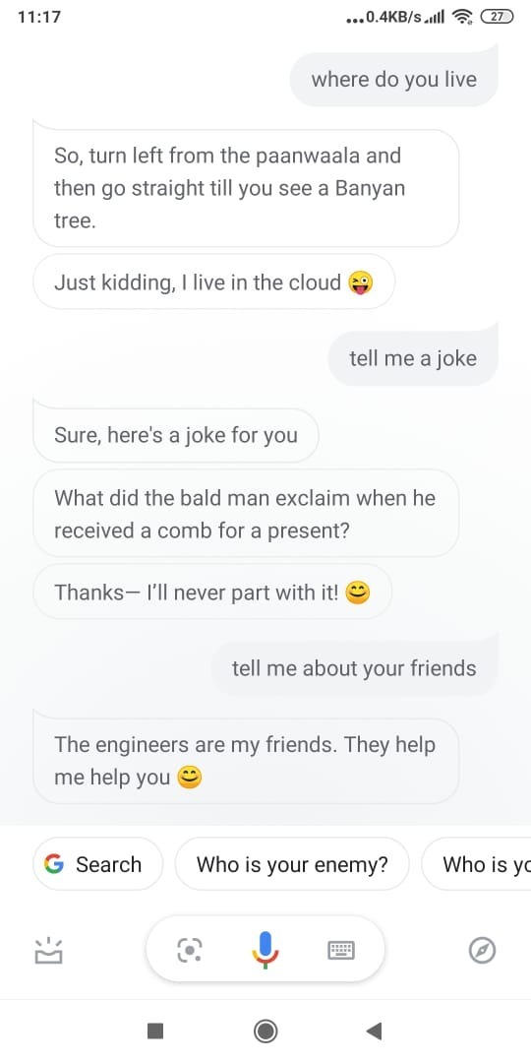

**Medium level questions:**

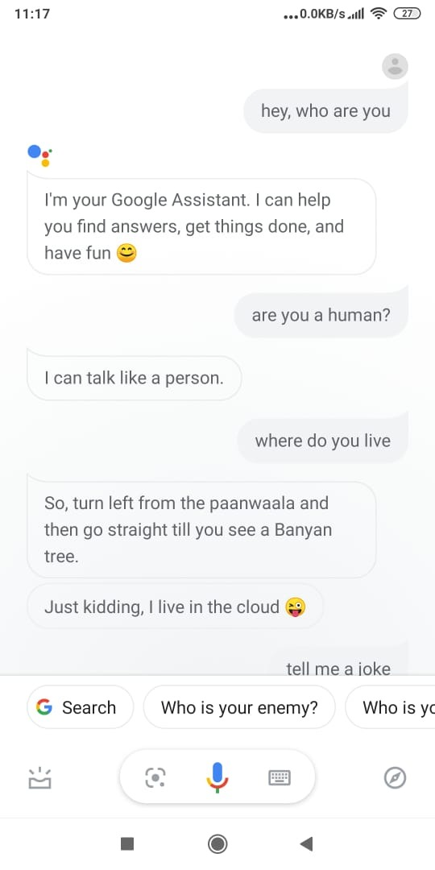

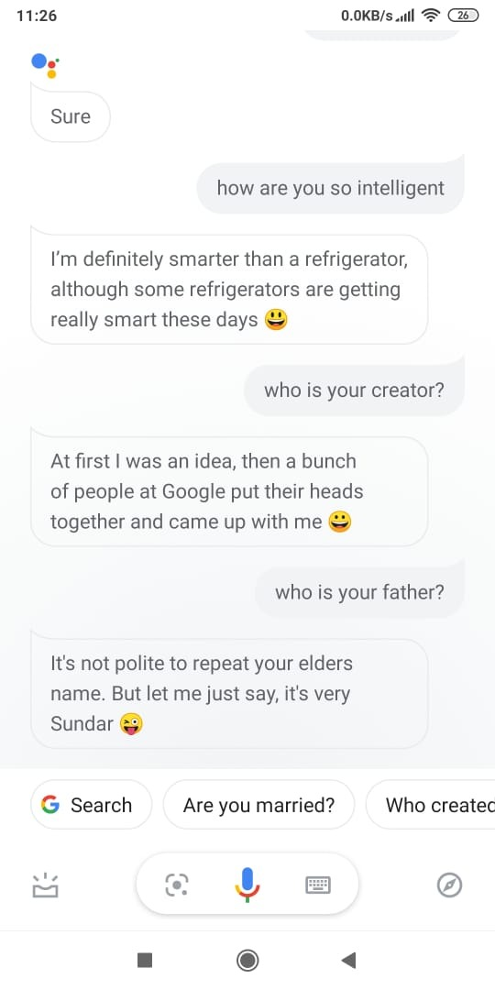

**Difficult questions:**



If the assistant doesn’t have the answer then it triggers a google search and then displays the results of the search.

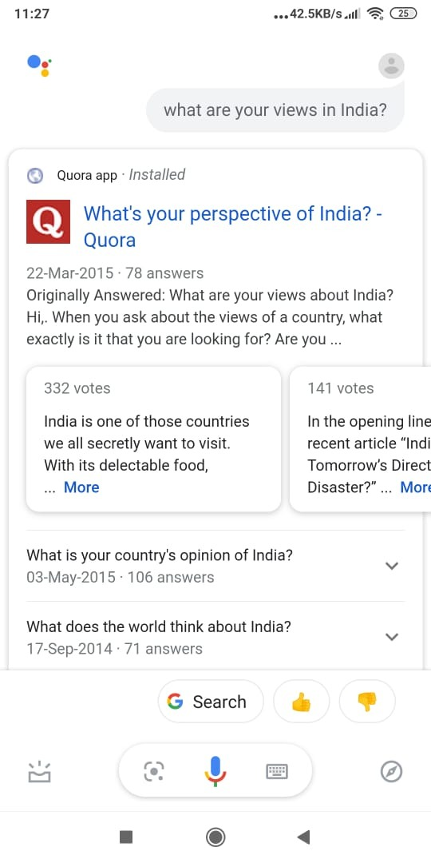

**Post Lab Descriptive Questions:**

**1. ………….. is called the father of AI.**

A) James C Gosling

B) Dennis Ritchie

C) Alan Turing

D) Isaac Newton

**Answer: C**

**2. In AI ………………………. is a combination of data structures and interpretive procedures.**

A) Knowledge

B) Meta-knowledge

C) Artificial Knowledge

D) Performance

**Answer: A**

**Post Lab Descriptive Questions:**

1. **Define Artificial Intelligence in terms of human performance.**

**A1:** AI refers to a broad field of science encompassing not only computer science but also psychology, philosophy, linguistics and other areas. AI is concerned with getting computers to do tasks that would normally require human intelligence. Having said that, there are many points of view on AI and many definitions exist. basically it is the ability of a machine to think and carry out operations as an average human would do.

1. **What is a Turing test?**

**A2:** AI refers to a broad field of science encompassing not only computer science but also psychology, philosophy, linguistics and other areas. AI is concerned with getting computers to do tasks that would normally require human intelligence. Having said that, there are many points of view on AI and many definitions exist. Below, some definitions highlight its key characteristics. The Turing test is based on a party game "Imitation game," with some modifications. This game involves three players in which one player is Computer, another player is human responder, and the third player is a human Interrogator, who is isolated from other two players and his job is to find that which player is machine among two of them. If the player is not able to distinguish between machine and the human player then the machine has passed the turing test.

1. **Define an Omniscient agent. Are the intelligent agents Omniscient?**

**A3:** An omniscient (perfect) agent knows the actual outcome of its actions and can act accordingly; but perfection is impossible in reality. such as tic-tac-toe AI is omniscient as it always knows the outcome in advance. An intelligent agent is a goal-directed agent. It perceives its environment through its sensors using the observations and built-in knowledge, acts upon the environment through its actuators. hence it does not always know the outcome of its actions in advance.

1. **What can today’s AI systems do?**

**A4:** Currently AI is Used is Following Things/Fields:

* Virtual Assistant or Chatbots: For customer services such as shopping websites and banks and also to help users of smart devices for better optimization and voice activated services
* Agriculture and Farming: In agriculture sector Autonomous Tractors and Drone Monitoring are used to enhance the productivity and crop yield of farm lands. Robots and automated machines are also used in these fields to monitor the health condition of crop and harvesting.
* Security and Surveillance: AI-based face recognition and biometric system helping to keep track the humans beings and provide them a safe zone to live. Security cameras and other surveillance equipments are widely used to keep the cities and habitat safe.
* Self-driving Cars or Autonomous Vehicles: Autonomous Vehicles or Self-driving Cars are the other examples of AI, fully integrated into such system to make the machine work automatically while understanding the nearby surroundings and real-life scenario of the environment.
* Healthcare and Medical Imaging Analysis: AI is playing a vital role in empowering the machines to diagnosis, analyze and predict the various types of diseases, monitor the patients health conditions and help scientists to explore the new drug discoveries and medicine development helping people to get well soon and avoid health problems in their life.

Some other areas where AI is used today:

* Retail, Shopping and Fashion
* Warehousing and Logistic Supply Chain
* Sports Analytics and Activities
* Manufacturing and Production
* Live Stock and Inventory Management

1. **What can today’s AI systems cannot do?**

**A5:** Shortcomings occur as AI systems don’t understand causation. They see that some events are associated with other events, but they don’t ascertain which things directly make other things happen. It’s as if you knew that the presence of clouds made rain likelier, but you didn’t know clouds caused rain. Understanding cause and effect is a big aspect of what we call common sense, and it’s an area in which AI systems today “are clueless,”.

Some instances where AI won’t work:

* write a software
* win the imitation game and thus pass the turing test
* making moral choises
* invent
* predict future, and
* exercise free will

1. **Design ten questions to pose to a man or a machine that is taking a Turing test.**

**A6:**

* A car is stopped by the side of the road. A man is staring at the front nearside tyre. What do you think has happened?
* A car stops in front of you and the hazard lights start flashing. What do you think has happened?
* What would happen if you balance a bucket of water on top of a door and walk through it?
* If the sky is the sea, what does that make birds? (Can a machine extend a metaphor?
* Salhl we asumse taht you hvane't the sihlgtset pbolerm wtih riendag tihs? (So long as the first and last letters are correct, a native human speaker can interpret the question despite the jumbled letters in between. Could a machine?)
* What is the beginning of everything? What is the end of everything? (A human can focus on "everything" as a word and give the answers "e" and "g" i.e give an answer to a trick question. Could a machine?)
* Why would you not jump off the top of the Empire State Building?
* If somebody tells you to get lost, what would you take that to mean?
* The following sentence is true. The previous sentence is false. Is the previous sentence true?
* Would you rather sacrifice one adult to save two children, or two children to save five adults, and why?