Data Mining Project 1

資工碩一 P76084300 施逢怡

**Dataset**: Adult Data Set(<https://archive.ics.uci.edu/ml/datasets/Adult>)

* Attributes: (age, workclass, education, marital-status, occupation, relationship,

race, sex, hrs-per-work, native-country, salary)

**Weka**

**Apriori**

**//每次最多顯示5筆**

1. high support, high confidence (0.7, 0.7) 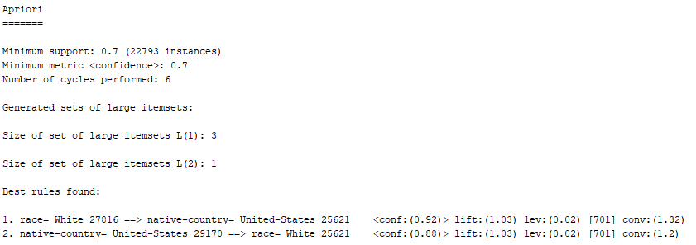
2. high support, low confidence(0.7, 0.1) 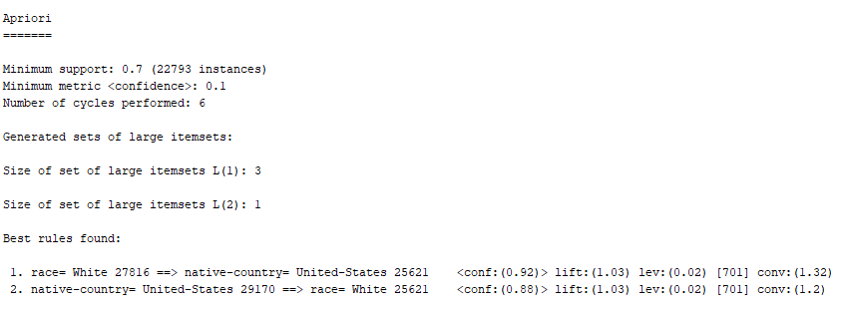
3. Low support, low confidence(0.1, 0.1)

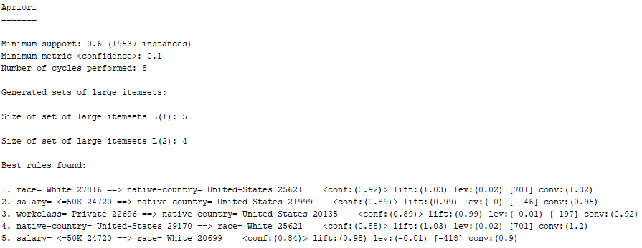

(4) Low support, high confidence(0.1, 0.9)

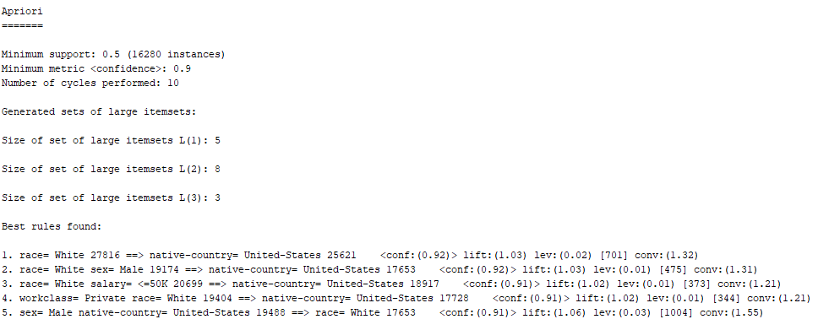

**FPGrowth**

**//每次最多顯示5筆**

1. high support, high confidence(0.7, 0.7)



1. high support, low confidence(0.7, 0.2)
2. 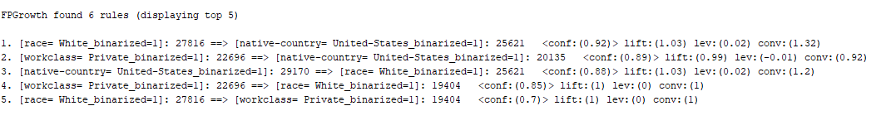Low support, low confidence(0.1, 0.1)
3. Low support, high confidence(0.2, 0.9)