V.V.P Engineering College
KEVIN SIDDHPURA | 240470107174
240470107174
GZ-1
Object Oriented programming
Lab experiments

[1.1] – Source Code
Q) Write a program to display first ‘n’ prime numbers.
import java.util.Scanner;

class PrimeCheck {
static boolean isPrime(int n) {
int flag = 0;

for(int i = 2; i < n; i++) {
if(n % i == 0) {
flag++;
break;
}
}

return flag == 0;
}

public static void main(String[] args) {
int n;

Scanner sc = new Scanner(System.in);

System.out.print("[]: Prime Checker: Provide a number: ");
n = sc.nextInt();

if(n <= 1) {
System.out.println("[]: 0 & 1, are not prime numbers.");
} else {
boolean state = isPrime(n);

System.out.println("[]: Provided input: " + n + " is " + (state ? "a" : "not a") + " prime number.");
}

sc.close();
}
}

[1.1] – Output
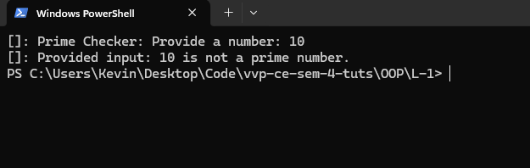
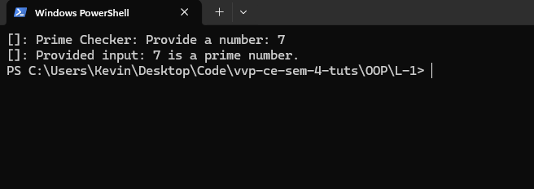

[1.2] – Source Code
Q) Write a program that takes the lengths of three sides of a triangle as input. Calculate and print the area using Heron’s formula. Validate whether the sides form a triangle.
import java.util.Scanner;

class TriangleArea {
public static void main(String[] args) {
Scanner sc = new Scanner(System.in);

System.out.println("[]: Enter the lengths of the three sides: ");
double a = sc.nextDouble();
double b = sc.nextDouble();
double c = sc.nextDouble();

if ((a + b > c) && (a + c > b) && (b + c > a)) {
double s = (a + b + c) / 2.0;
double area = Math.sqrt(s * (s - a) * (s - b) * (s - c));

System.out.println("[]: The area of the triangle is: " + area);
} else {
System.out.println("[]: The given side lengths cannot form a valid triangle.");
}

sc.close();
}
}

[1.2] – Output
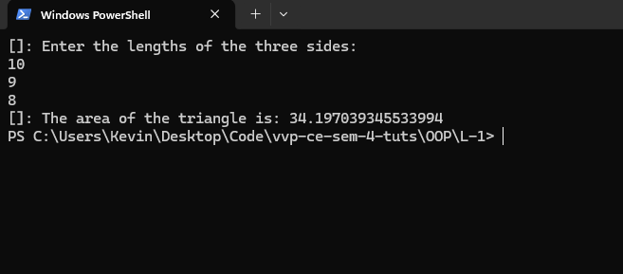
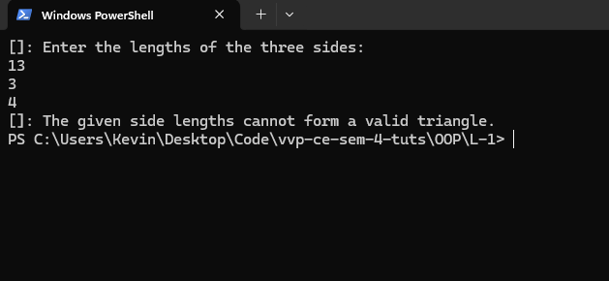

[1.3] – Source Code
Q) Write a Java program to check whether a given character is a vowel or consonant.
import java.util.Scanner;

class CharacterCheck {
public static void main(String[] args) {
Scanner sc = new Scanner(System.in);

System.out.print("[]: Enter a single letter: ");
String input = sc.next();

if (input.length() > 0) {
char ch = input.charAt(0);

if (Character.isLetter(ch)) {
char Ch = Character.toLowerCase(ch);

if (Ch == 'a' || Ch == 'e' || Ch == 'i' || Ch == 'o' || Ch == 'u') {
System.out.println("[]: "+ ch + " is a vowel.");
} else {
System.out.println("[]: " + ch + " is a consonant.");
}
} else {
System.out.println("[]: Please enter a letter.");
}
}

sc.close();
}
}

[1.3] – Output
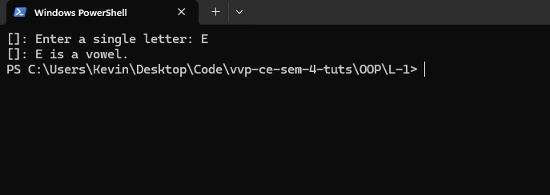
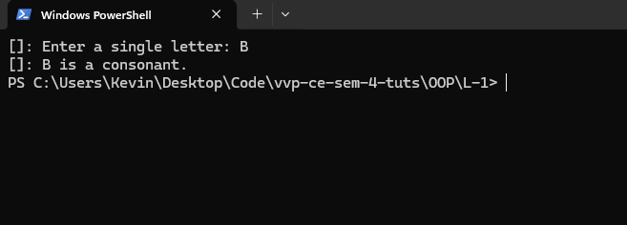

[1.4] – Source Code
Q) Write a Java program to add 1 to each digit of a 5-digit number (handle carry properly).
import java.util.Scanner;

class NumIncre {
public static void main(String[] args) {
Scanner sc = new Scanner(System.in);

System.out.print("[]: Provide a five digit number: ");
int num = sc.nextInt();

if(num >= 10000 && num <= 99999) {
int n = 0;
int mul = 1;

while (num > 0) {
int d = (num % 10) + 1;
if (d == 10) d = 0;

n = n + (d * mul);
mul *= 10;
num /= 10;
}

System.out.println("[]: Incremented Number: " + n);
} else {
System.out.println("[]: You must provide a five digit number only.");
}

sc.close();
}
}

[1.4] – Output
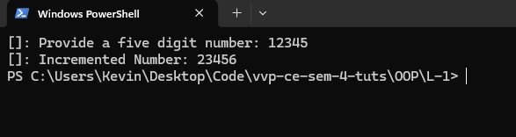

[2.1] – Source Code
Q) Write a program to validate an email address.
import java.util.Scanner;

class EmailChecker {
public static void main(String[] args) {
Scanner sc = new Scanner(System.in);

System.out.print("[]: Provide an email to check: ");
String email = sc.nextLine();

String emailRegex = "^[a-zA-Z0-9_+&*-]+(?:\\.[a-zA-Z0-9_+&*-]+)*@(?:[a-zA-Z0-9-]+\\.)+[a-zA-Z]{2,7}$";

if (email.matches(emailRegex)) {
System.out.println("[]: Valid email address.");
} else {
System.out.println("[]: Invalid email address.");
}

sc.close();
}
}

[2.1] – Output
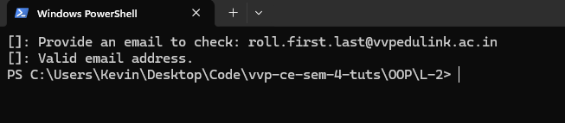
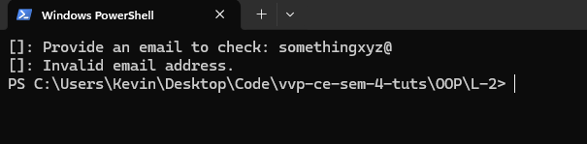

[2.2] – Source Code
Q) Write a program to validate GTU enrollment number.
import java.util.Scanner;

class GtuEnrollCheck {
public static void main(String[] args) {
Scanner sc = new Scanner(System.in);

System.out.print("[]: Provide an enrollment to check: ");
String enroll = sc.nextLine();

if(enroll.length() == 12) {
System.out.println("[]: Provided enrollment '" + enroll + "' is valid");
} else {
System.out.println("[]: Provided enrollment '" + enroll + "' is not valid");
}

sc.close();
}
}

[2.2] – Output
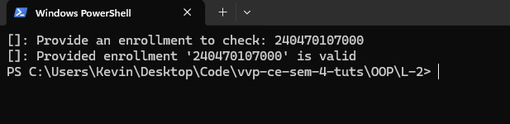
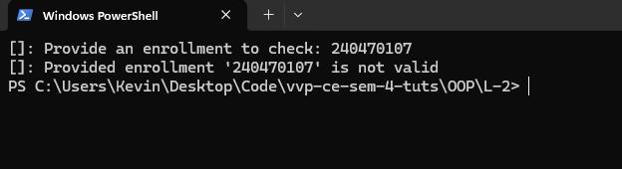

[2.3] – Source Code
Q) Write a program to check whether two strings are anagrams.
import java.util.Scanner;
import java.util.Arrays;

class AnagramCheck {
public static void main(String[] args) {
Scanner sc = new Scanner(System.in);

System.out.print("[]: Provide a string to check: ");
String str1 = sc.nextLine();

System.out.print("[]: Provide another string to check: ");
String str2 = sc.nextLine();

String Str1 = str1.replaceAll("\\s", "").toLowerCase();
String Str2 = str2.replaceAll("\\s", "").toLowerCase();

boolean isAnagram = false;

if (Str1.length() == Str2.length()) {
char[] charArray1 = Str1.toCharArray();
char[] charArray2 = Str2.toCharArray();

Arrays.sort(charArray1);
Arrays.sort(charArray2);

isAnagram = Arrays.equals(charArray1, charArray2);
}

System.out.println("[]: Provided strings " + (isAnagram ? "are" : "are not") + " anagrams of each other.");

sc.close();
}
}

[2.3] – Output
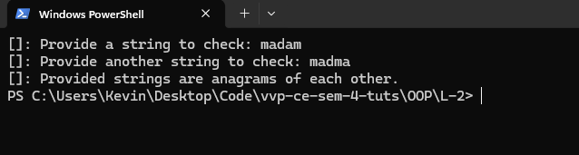
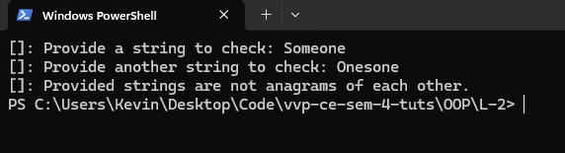

[3.1] – Source Code
Q) Create a ‘Student’ class with name, department, and 3 subject marks.
- Input details of 5 students
- Display details
- Sort based on percentage
import java.util.Scanner;

class Student {
String name;
String department;
double s1;
double s2;
double s3;
double perc;

void readStudent(Scanner sc) {
System.out.print("[]: Enter name: ");
name = sc.nextLine();

System.out.print("[]: Enter department: ");
department = sc.nextLine();

System.out.println("[]: Enter marks for 3 subjects: ");
s1 = sc.nextDouble();
s2 = sc.nextDouble();
s3 = sc.nextDouble();

perc = (s1 + s2 + s3) / 3.0;
sc.nextLine();
}

void showStudent() {
System.out.println("=: Name: " + name + " | Dept: " + department + " | Perc: " + perc + "%");
}
}

class StudentManager {
public static void main(String[] args) {
Scanner sc = new Scanner(System.in);
Student[] s = new Student[5];

System.out.println("--- Enter Details for 5 Students ---");
for (int i = 0; i < 5; i++) {
System.out.println("\nStudent " + (i + 1) + ":");
s[i] = new Student();
s[i].readStudent(sc);
}

for (int i = 0; i < s.length - 1; i++) {
for (int j = 0; j < s.length - i - 1; j++) {
if (s[j].perc < s[j + 1].perc) {
Student temp = s[j];
s[j] = s[j + 1];
s[j + 1] = temp;
}
}
}

System.out.println("\n--- Student Details ---");
for (int i = 0; i < 5; i++) {
s[i].showStudent();
}

sc.close();
}
}

[3.1] – Output
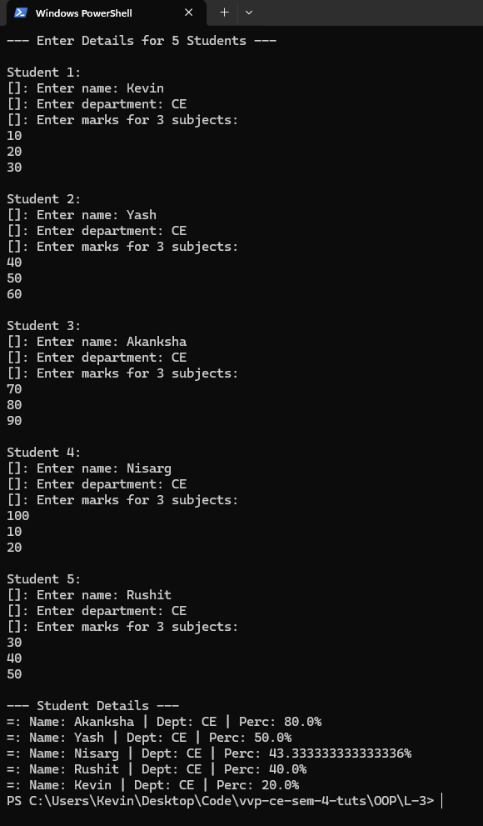

[3.2] – Source Code
Q) Create an Employee class with:
- employeeName, employeeSalary
- Methods: readEmployeeData() and displayEmployeeData()
import java.util.Scanner;

class Employee {
private String employeeName;
private double employeeSalary;

public void readEmployeeData(Scanner sc) {
System.out.print("[]: Enter name: ");
employeeName = sc.nextLine();

System.out.print("[]: Enter salary: ");
employeeSalary = sc.nextDouble();
}

public void displayEmployeeData() {
System.out.println("=: Name : " + employeeName + " | Salary: " + employeeSalary);
}
}

class EmployeeManager {
public static void main(String[] args) {
Scanner sc = new Scanner(System.in);
Employee emp = new Employee();

System.out.println("--- Enter Details ---");
emp.readEmployeeData(sc);

System.out.println("\n--- Employee Details ---");
emp.displayEmployeeData();

sc.close();
}
}

[3.2] – Output
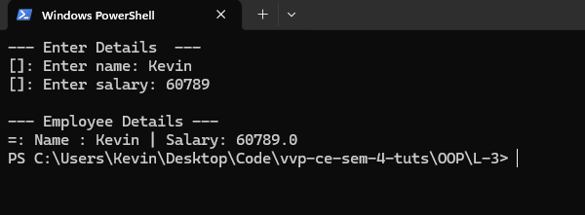

[3.3] – Source Code
Q) Create a ‘Time’ class:
- Data: hours, minutes
- Methods: setTime(), displayTime(), addTime()
import java.util.Scanner;

class Time {
int hours;
int minutes;
void setTime(int h, int m) {
this.hours = h;
this.minutes = m;
}
void displayTime() {
System.out.println(hours + ":" + minutes);
}
void addTime(Time t1, Time t2) {
int totalMinutes = t1.minutes + t2.minutes;
int extraHours = totalMinutes / 60;

this.minutes = totalMinutes % 60;
this.hours = t1.hours + t2.hours + extraHours;
}
}

public class TimeManager {
public static void main(String[] args) {
Scanner sc = new Scanner(System.in);

System.out.println("[]: Enter first time (hours & minutes):");
int h1 = sc.nextInt();
int m1 = sc.nextInt();

System.out.println("[]: Enter second time (hours & minutes):");
int h2 = sc.nextInt();
int m2 = sc.nextInt();
Time t1 = new Time();
t1.setTime(h1, m1);
Time t2 = new Time();
t2.setTime(h2, m2);
Time result = new Time();
result.addTime(t1, t2);
System.out.print("\n=: Time 1: "); t1.displayTime();
System.out.print("=: Time 2: "); t2.displayTime();
System.out.println("\n=: Total Added Time: "); result.displayTime();

sc.close();
}
}

[3.3] – Output
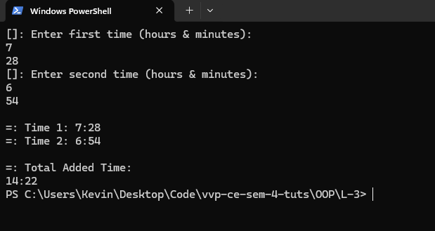

[4.1] – Source Code
Q) Create a ‘University’ class:
- Static variable: totalStudents
- Static method: getTotalStudents()
- Static block + instance block demonstration
class University {
static String universityName;
static int totalStudents;

{
System.out.println("[]: University Object created....");
totalStudents++;
}

static {
universityName = "GTU";
System.out.println("[]: Initilizing University: " + universityName);
}

int getStudents() {
return totalStudents;
}
}

class UniversityManager {
public static void main(String[] args) {
University u1 = new University();
System.out.println("[]: Students: " + u1.getStudents());

University u2 = new University();
System.out.println("[]: Students: " + u2.getStudents());
}
}

[4.1] – Output
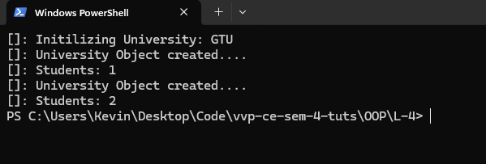

[4.2] – Source Code
Q) Method overloading program:
- Calculate volume of Cube, Rectangular Cube, Sphere
import java.util.Scanner;

class Calc {
double calculateVolume(double radius) {
return (4.0 / 3.0) * Math.PI * Math.pow(radius, 3);
}

double calculateVolume(float side) {
return Math.pow(side, 3);
}

double calculateVolume(double length, double width, double height) {
return length * width * height;
}
}

class VolumeCalc {
public static void main(String[] args) {
Scanner sc = new Scanner(System.in);
Calc calc = new Calc();

System.out.print("[]: Enter the radius of the Sphere: ");
double radius = sc.nextDouble();
System.out.println("=: Sphere Volume: " + calc.calculateVolume(radius));

System.out.print("[]: Enter the side length of the Cube: ");
float side = sc.nextFloat();
System.out.println("=: Cube Volume: " + calc.calculateVolume(side));

System.out.print("[]: Enter length, width, and height of the Rectangular Cube: ");
double l = sc.nextDouble();
double w = sc.nextDouble();
double h = sc.nextDouble();
System.out.println("=: Rectangular Cube Volume: " + calc.calculateVolume(l, w, h));

sc.close();
}
}

[4.2] – Output
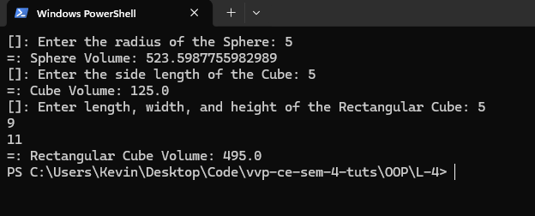

[4.3] – Source Code
Q) Method overriding program:
- Superclass: Payment
- Subclasses: CreditCardPayment, UPIPayment
import java.util.Scanner;

class Payment {
void processPayment(int amount) {
System.out.println("\n=: Payment of Rs." + amount + " done using Cash");
}
}
class CreditCardPayment extends Payment {
@Override
void processPayment(int amount) {
System.out.println("\n=: Payment of Rs." + amount + " done using Credit Card");
}
}
class UPIPayment extends Payment {
@Override
void processPayment(int amount) {
System.out.println("\n=: Payment of Rs." + amount + " done using UPI");
}
}
public class PaymentManager {
public static void main(String[] args) {
Scanner sc = new Scanner(System.in);
System.out.print("[]: Enter amount to pay: ");
int amount = sc.nextInt();
System.out.println("\n[]: Choose Payment Method:");
System.out.println("1]. Credit Card");
System.out.println("2]. UPI");
System.out.print("\n-- Enter choice (1/2): ");
int choice = sc.nextInt();

Payment payment;

switch (choice) {
case 1:
payment = new CreditCardPayment(); break;
case 2:
payment = new UPIPayment(); break;
default:
System.out.println("\n[]: Invalid Choice!");
return;
}

payment.processPayment(amount);
sc.close();
}
}

[4.3] – Output
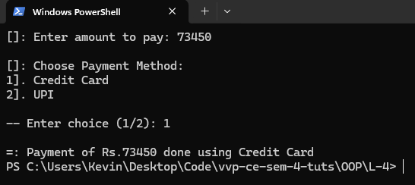
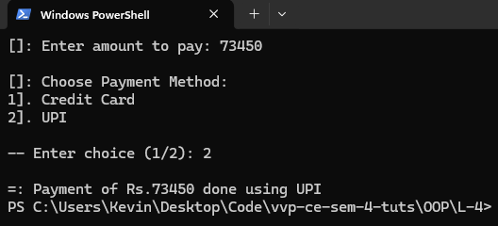

[4.4] – Source Code
Q) Inheritance + overriding:
- Base class: Employee
- Subclass: Manager
- Override displayDetails()
class Employee {
String name;
String dept;

Employee(String name, String dept) {
this.name = name;
this.dept = dept;
}
void displayDetails() {
System.out.println("[]: Employee Details");
System.out.println("=: Name: " + name);
System.out.println("=: Department: " + dept);
}
}

class Manager extends Employee {
String project;
int teamSize;

Manager(String name, String dept, String project, int teamSize) {
super(name, dept);
this.project = project;
this.teamSize = teamSize;
}

@Override
void displayDetails() {
System.out.println("[]: Manager Details");
System.out.println("=: Name: " + name);
System.out.println("=: Department: " + dept);
System.out.println("=: Project: " + project);
System.out.println("=: Team Size: " + teamSize);
}
}

class EmployeeManager {
public static void main(String[] args) {
Employee employee = new Employee("Yash", "C.E.");
employee.displayDetails();
System.out.println("\n");
Manager manager = new Manager("Kevin", "C.E.", "Project X", 5);
manager.displayDetails();
}
}

[4.4] – Output
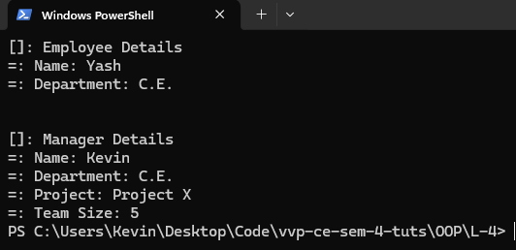

[5.1] – Source Code
Q) Abstract class Shape with subclasses Triangle, Rectangle, Circle
- Override area()
import java.util.Scanner;

abstract class Shape {
abstract double area();
}

class Triangle extends Shape {
double base, height;

Triangle(double base, double height) {
this.base = base;
this.height = height;
}

@Override
double area() {
return 0.5 * base * height;
}
}

class Rectangle extends Shape {
double length, width;

Rectangle(double length, double width) {
this.length = length;
this.width = width;
}

@Override
double area() {
return length * width;
}
}

class Circle extends Shape {
double radius;

Circle(double radius) {
this.radius = radius;
}

@Override
double area() {
return Math.PI * radius * radius;
}
}

public class Shapes {
public static void main(String[] args) {
Scanner sc = new Scanner(System.in);

System.out.println("[]: Enter base and height for Triangle:");
int base = sc.nextInt();
int height = sc.nextInt();

System.out.println("[]: Enter length and width for Rectangle:");
int length = sc.nextInt();
int width = sc.nextInt();

System.out.println("[]: Enter radius for Circle:");
int radius = sc.nextInt();

Shape triangle = new Triangle(base, height);
Shape rectangle = new Rectangle(length, width);
Shape circle = new Circle(radius);

System.out.println("\n=: Triangle area: " + triangle.area());
System.out.println("=: Rectangle area: " + rectangle.area());
System.out.println("=: Circle area: " + circle.area());

sc.close();
}
}

[5.1] – Output
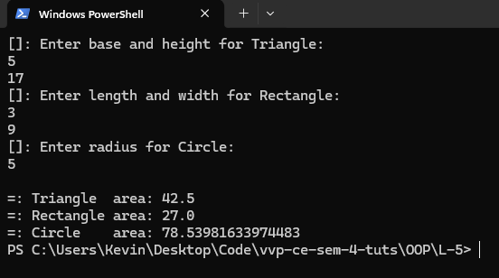

[5.2] – Source Code
Q) Interface program:
- Method: interest(p, r, n)
- Classes: SimpleInterest, CompoundInterest
import java.util.Scanner;

interface Interest {
double interest(double p, double r, int n);
}

class SimpleInterest implements Interest {
@Override
public double interest(double p, double r, int n) {
return (p * r * n) / 100;
}
}

class CompoundInterest implements Interest {
@Override
public double interest(double p, double r, int n) {
return p * Math.pow(1 + r / 100, n) - p;
}
}

public class InterestCalc {
public static void main(String[] args) {
Scanner sc = new Scanner(System.in);

System.out.println("[]: Enter principal amount:");
double principal = sc.nextDouble();

System.out.println("[]: Enter rate of interest:");
double rate = sc.nextDouble();

System.out.println("[]: Enter time period:");
int time = sc.nextInt();

Interest si = new SimpleInterest();
Interest ci = new CompoundInterest();

System.out.println("\nPrincipal : " + principal);
System.out.println("Rate : " + rate + "%");
System.out.println("Time : " + time + " years");
System.out.println("-----------------------------------");
System.out.println("Simple Interest : " + si.interest(principal, rate, time));
System.out.println("Compound Interest : " + ci.interest(principal, rate, time));
sc.close();
}
}

[5.2] – Output

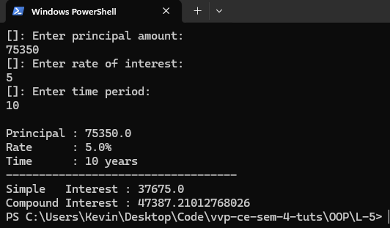

[5.3] – Source Code
Q) Create and import a package.
- Main Code File: Calc.java
import java.util.Scanner;
import myutil.Stuff;

public class Calc {
public static void main(String[] args) {
Scanner sc = new Scanner(System.in);

int A, B;

System.out.println("[]: Enter first number:");
A = sc.nextInt();

System.out.println("[]: Enter second number:");
B = sc.nextInt();

System.out.println("\n[]: Results:");
System.out.println("Addition : " + Stuff.add(A, B));
System.out.println("Subtraction : " + Stuff.sub(A, B));

Stuff s = new Stuff();
System.out.println("Multiplication : " + s.mul(A, B));
System.out.println("Division : " + s.div(A, B));

sc.close();
}
}

- Package File: Stuff.java (myutil/Stuff.java)
package myutil;

public class Stuff {
public static int add(int a, int b) {
return a + b;
}
public static int sub(int a, int b) {
return a - b;
}
public int mul(int a, int b) {
return a * b;
}
public int div(int a, int b) {
return a / b;
}
}

[5.3] – Output
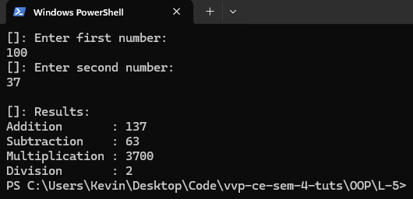

[6.1] – Source Code
Q) Use command-line arguments for numerator & denominator
- Handle exceptions
public class Cli {
public static void printf(String s) {
System.out.println(s);
}

public static void main(String[] args) {
try {
if (args.length != 2) {
throw new IllegalArgumentException("Usage: java cli <n> <d>");
}

int n = Integer.parseInt(args[0]);
int d = Integer.parseInt(args[1]);

int result = n / d;

printf("N: " + n);
printf("D: " + d);

printf("Result: " + result);

} catch(ArithmeticException e) {
printf("ArithmeticException: D can not be 0.");
} catch(NumberFormatException e) {
printf("NumberFormatException: Enter valid numbers.");
} catch(Exception e) {
printf("Exception: " + e.getMessage());
} finally {
printf("Program Finished");
}
}
}

[6.1] – Output

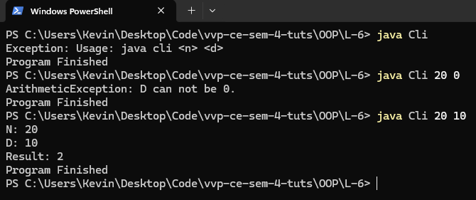

[6.2] – Source Code
Q) Demonstrate throw and throws.
public class Throw_s {

public static void isAdult(Integer age) throws Exception {
if (age < 18) {
throw new Exception("Exception: You are a minor.");
}

System.out.println("Congrats, you are an adult.");
}

public static void main(String[] args) {
try {
if (args.length != 1) {
throw new IllegalArgumentException("ArgumentMissing: Provide your age as an argument");
}

isAdult(Integer.parseInt(args[0]));
} catch (NumberFormatException e) {
System.out.println("NotNumber: Provide a valid number.");
} catch (Exception e) {
System.out.println("Exception: " + e.getMessage());
}
}
}

[6.2] – Output

