**Kennesaw State University**

**CSE 3502 Operating Systems – Spring 2020**

**Project 1 - System call**

Instructor: Kun Suo

Points Possible: 100

**Assignments**

**Assignment 0: Build the Linux kernel (50 points)**

Create a virtual machine using VirtualBox on your machine. As the kernel compiling is pretty large, please make sure your VM has at least 4GB memory and 40GB storage.

**Step 1: Get the Linux kernel code**

Before you download and compile the Linux kernel source, make sure you have development tools installed on your system. We recommend you work this project on your virtual machine.

In Ubuntu, install this software using apt:

$ sudo apt-get install -y gcc libncurses5-dev make wget flex bison vim libssl-dev libelf-dev

To obtain the version of your current kernel, type:

$ uname -r

5.0

Then, download kernel 5.1 and extract the source:

$ wget https://cdn.kernel.org/pub/linux/kernel/v5.x/linux-5.1.tar.gz

$ tar xvzf linux-5.1.tar.gz

We will refer LINUX_SOURCE to the top directory of the kernel source. Go to the linux source code folder:

$ cd linux-5.1

**Step 2: Configure your new kernel**

Before compiling the new kernel, a .config file needs to be generated in the top directory of the kernel source. To generate the config file and make possible changes to the default kernel configurations, type:

$ make menuconfig

No changes to the default configuration are needed at this time. Press SAVE and OK, and then exit the configuration menu and a default config file will be generated. You can check .config using the following command under kernel folder. (<https://youtu.be/UyOGF4UOoR0>)

$ ls -al

**Step 3: Compile the kernel**

In LINUX_SOURCE, compile to create a compressed kernel image:

$ make

You can use "make -j N" to accelerate the compiling. Here N denotes the number of CPUs on your VM.

To compile kernel modules:

$ make modules

You can use "make modules -j N" to accelerate the compiling. Here N denotes the number of CPUs on your VM.

**Step 4: Install the kernel**

Install kernel modules (become a root user, use the su command):

$ sudo make modules_install

Install the kernel:

$ sudo make install

If you are using Ubuntu, you need to create an init ramdisk manually:

$ sudo mkinitramfs -o /boot/initrd.img-5.1.0

$ sudo update-initramfs -c -k 5.1.0

The kernel image and other related files have been installed into the /boot directory. You can check it from /boot/grub/grub.cfg. Linux will boot by default using the 1st menu item.

**Step 5: Modify grub configuration file**

If you are using Ubuntu: change the grub configuration file:

$ sudo vim /etc/default/grub

Make the following changes:

GRUB_DEFAULT=0

GRUB_TIMEOUT=10

Then, update the grub entry:

$ sudo update-grub2

**Step 6: Reboot your VM**

Reboot to the new kernel:

$ sudo reboot

After boot, check if you have the new kernel:

$ uname -r

5.1.0

**Assignment 1: Add a new system call into the Linux kernel (50 points)**

In this assignment, we add a simple system call helloworld to the Linux kernel. The system call prints out a hello world message to the syslog. You need to implement the system call in the kernel and write a user-level program to test your new system call. Go the kernel source code folder.

**Step 1: register your system call**

$ vim arch/x86/entry/syscalls/syscall_64.tbl

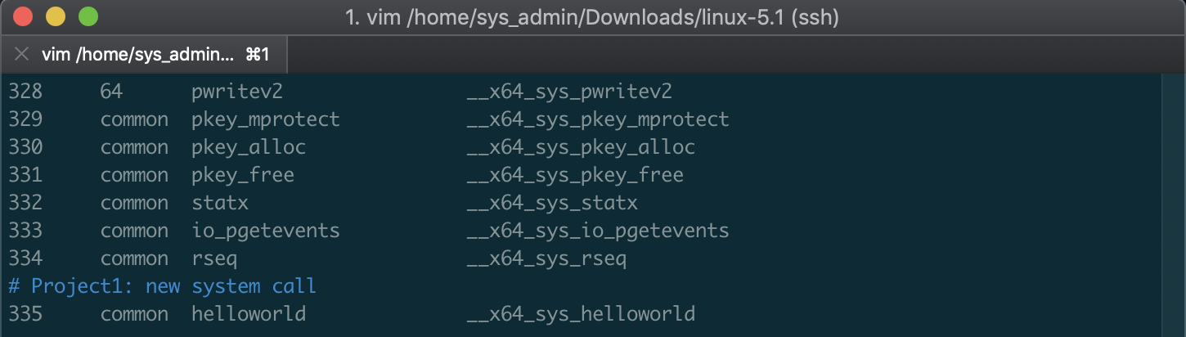

**Step 2: declare your system call in the header file**

$ vim include/linux/syscalls.h

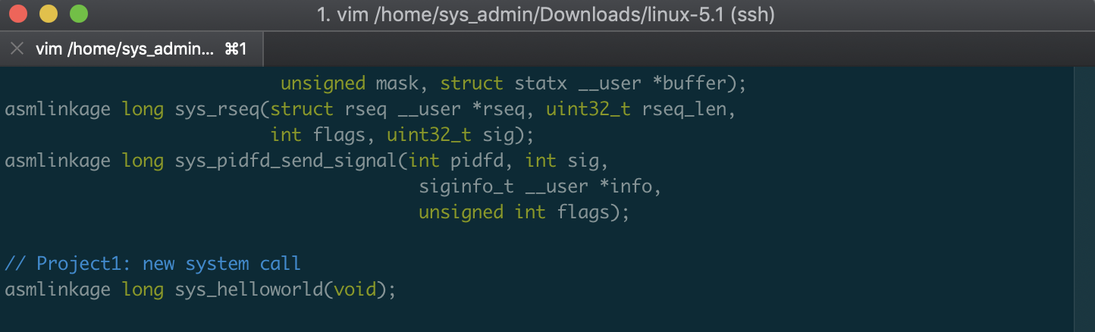

**Step 3: implement your system call**

$ vim kernel/sys.c

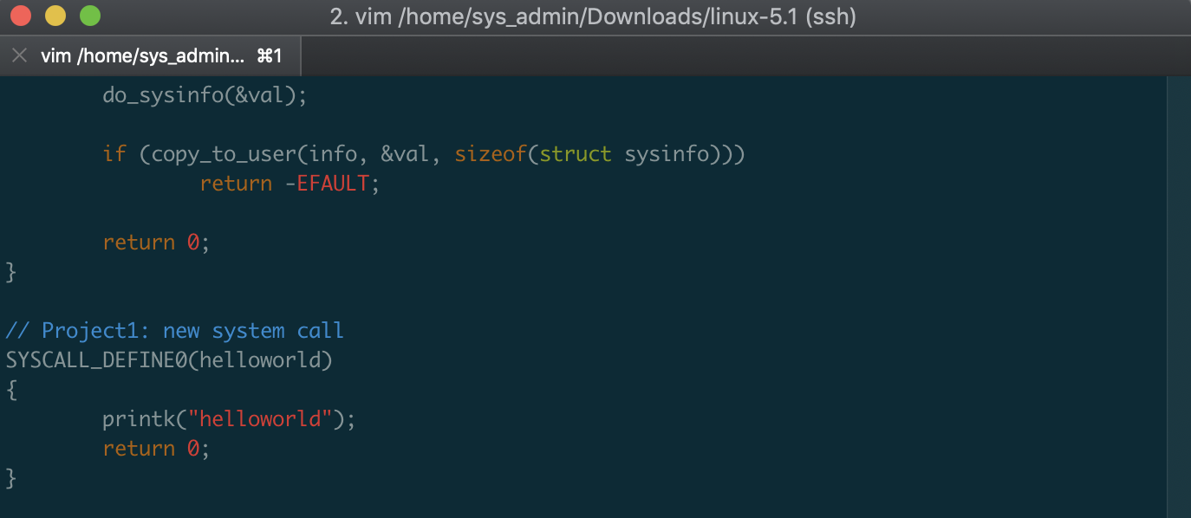

Repeat step 3 and 4 in assignment 0 to re-compile the kernel and reboot to the new kernel.

**Step 4: write a user-level program to test your system call**

Go to your home directory and create a test program test_syscall.c

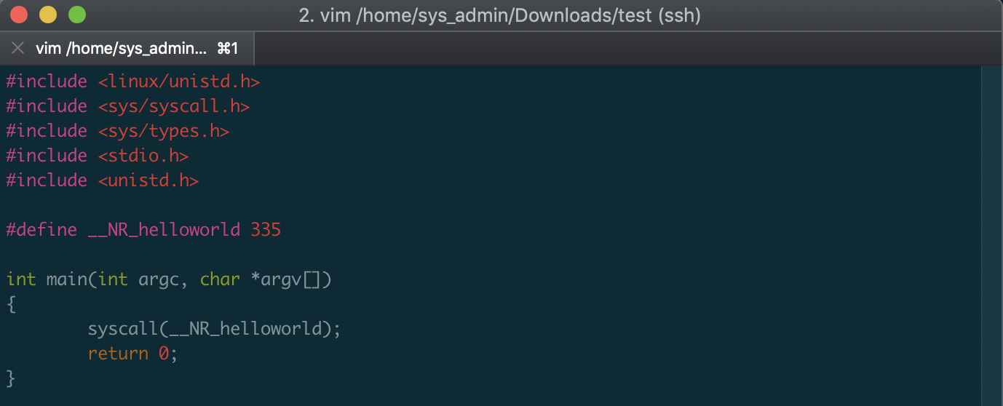

Compile the user level program:

$ gcc test_syscall.c -o test_syscall

Test the new system call by running:

$ sudo ./test_syscall

The test program will call the new system call and output a helloworld message at the tail of the output of dmesg.

$ dmesg | grep hello

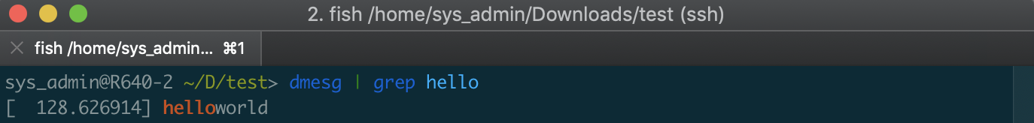

Submission of assignment 0:

Please submit the screenshot of $uname -r

Submission of assignment 1:

Please have two copies of kernel source code: 1) the original kernel source code without any modification; 2) the kernel source code you modified. You can define the folder name based on your need. Here I use *linux-5.1* as the original source code without modification and *linux-5.1-modified* as the source code I worked on.

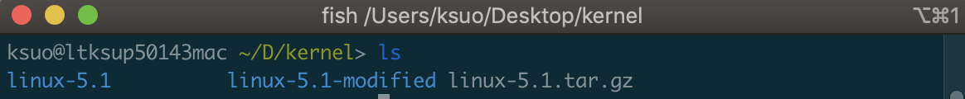

Please use diff command to highlight your modification (Here the original_file.c refers the file or file path of the original file source code; the modified_file.c refers the file or file path of the file source code you have modified):

$ diff -u original_file.c modified_file.c > result.txt

For example, to show the difference between file include/linux/syscalls.h, just use the command below:

For the kernel code, please do not add the entire kernel source code. Just add your modification code, e.g., result1.txt, result2.txt, result3.txt, …

Please submit the screenshot of $ dmesg | grep hello and result1.txt, result2.txt, result3.txt, …