# CS 6041 Theory of Computation

# Homework 2

You can use online tool to draw the figure: <http://madebyevan.com/fsm/>

1. (40 points) Please give the state diagram of a DFA for the language given. In all parts, Σ = {a, b}.
2. {w| w has an even number of a’s}
3. {w| w has one or two b’s}
4. {w| w has even length}
5. {w| w has an odd number of a’s}

Your solution should be a DFA solution.

1. (30 points) The alphabet is {0, 1}, and the language A= {w| w contains an even number of 0s, or contains exactly two 1s}.

Give the state diagram of an NFA N that recognizes A, i.e., L(N) = A.

1. (30 points) THEOREM 1.39: Every nondeterministic finite automaton has an equivalent deterministic finite automaton.

Use the construction given in Theorem 1.39 to convert the following nondeterministic finite automata to equivalent deterministic finite automata.

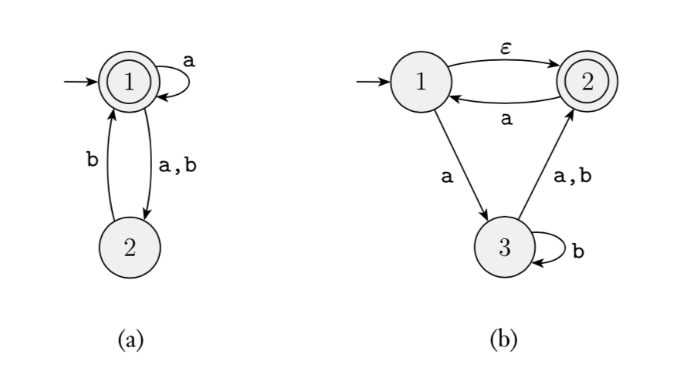

You also need to use a concise sentence to describe the language A recognized by the finite automaton, i.e., A = { w | w ……}.