# CS 6041 Theory of Computation

# Homework 5

1. This exercise concerns TM M2, whose description and state diagram appear in Example 3.7. In each of the parts, give the sequence of configurations that M2 enters when started on the indicated input string. (25 points)
2. 0.
3. 000000.

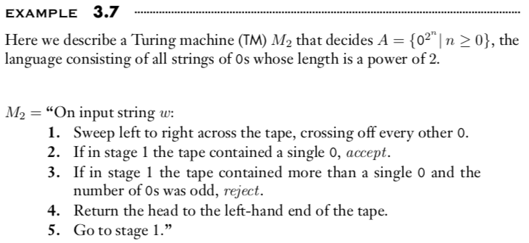

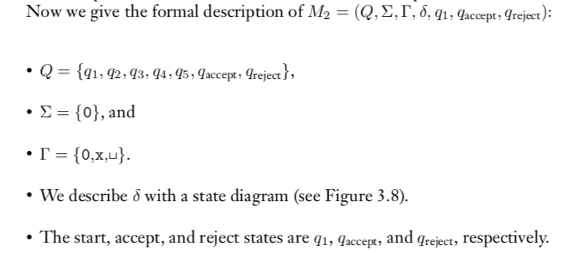

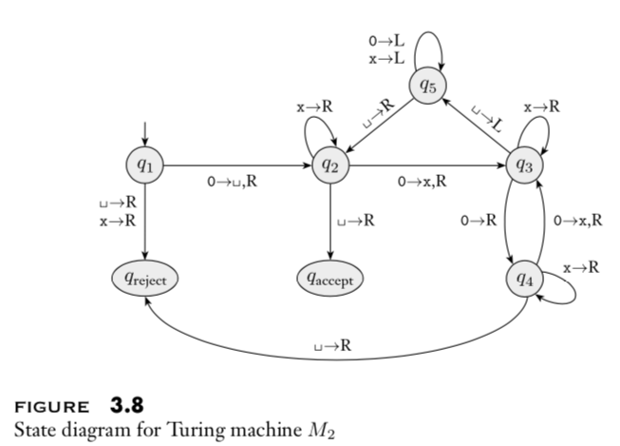

1. Give implementation-level descriptions of Turing machines that decide the following languages over the alphabet {0,1}.

{w| w contains twice as many 0s as 1s} , (25 points)

1. Let ALLDFA = {⟨A⟩| A is a DFA and L(A) = Σ∗ }. Show that ALLDFA is decidable. (25 points)

Hint: You can use the TM T that we constructed in Theorem 4.4 as a subroutine. You also need to recall the closure properties of regular language and consider what will be the input to that subroutine.

1. Let AεCFG = {⟨G⟩| G is a CFG that generates ε}. Show that AεCFG is decidable. (25 points)

Hint: You can use the TM S that we constructed in Theorem 4.7 as a subroutine.