Description

Intended User

Features

User Interface Mocks

Screen 1

Screen 2

Key Considerations

How will your app handle data persistence?

Describe any corner cases in the UX.

Describe any libraries you’ll be using and share your reasoning for including them.

Next Steps: Required Tasks

Task 1: Project Setup

Task 2: Implement UI for Each Activity and Fragment

Task 3: Your Next Task

Task 4: Your Next Task

Task 5: Your Next Task

**GitHub Username**: KevinTaron

myCoupons

# Description

You want to save money with coupons and voucher?

You are a huge coupon or voucher fan? But you always miss the expired date?

This app helps you to handle your coupon and vouchers.

Save your personal coupons private on your device and set a reminder to use the coupon before the coupon expires.

Access the public coupon database to get even more coupons!

Main features:

* Save your personal coupons
* Create reminder and never miss a coupon again
* Find public coupons and save MONEY!

# Intended User

The intended user of this app is everyone who is using coupons and voucher often but don’t want to handle that on paper. Also everyone who is forgetting to use these coupons and need a reminder. Last but not least everyone who want to use a public coupon to save money.

# Features

List the main features of your app. For example:

* Saves coupon information’s
* Provides public available coupons (api)
* Shows coupons near by the user
* Search for coupons
* Reminder before the coupon is invalid

# User Interface Mocks

These can be created by hand (take a photo of your drawings and insert them in this flow), or using a program like Photoshop or Balsamiq.

## Screen 1: My Coupon Overview

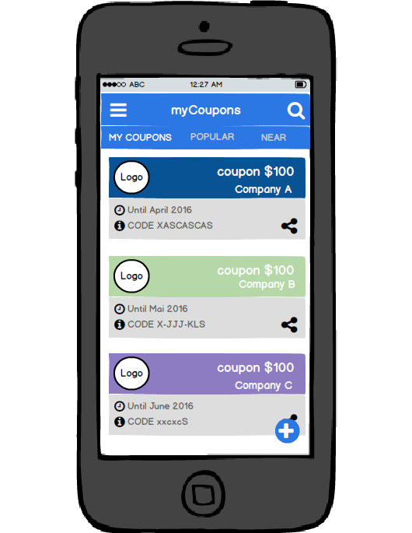

First Tab – Shows your personal coupons and voucher. You can search for your coupons, CRUD your coupons. That is one of the three main features of myCoupons. You can share your coupons.

## Screen 2: POPULAR TAB

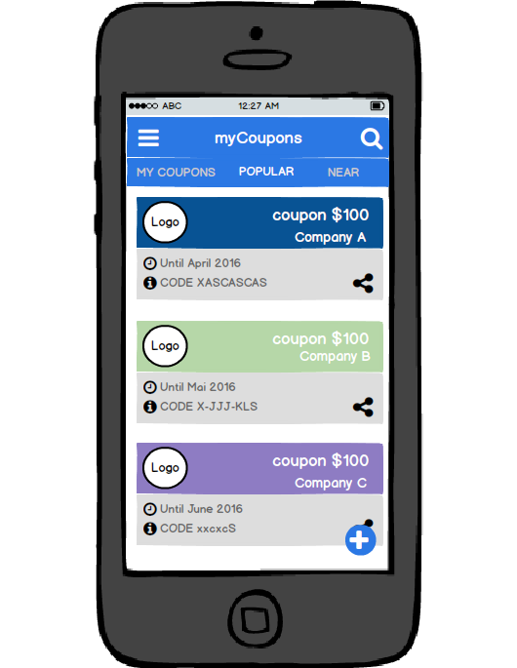

Second Tab – Shows popular coupons and voucher. You can search for popular and public coupons. You can share public coupons and add new coupons to the public library. If I find a public library for coupon this tab is connected to an api.

That is one of the three main features of myCoupons.

## Screen 3: NEAR TAB

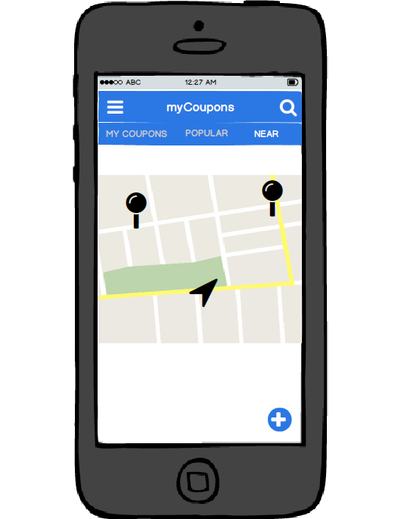

Third Tab – Shows your coupons and voucher nearby you. You can search for local coupons in your city.

## Screen 3: COUPON DETAILVIEW

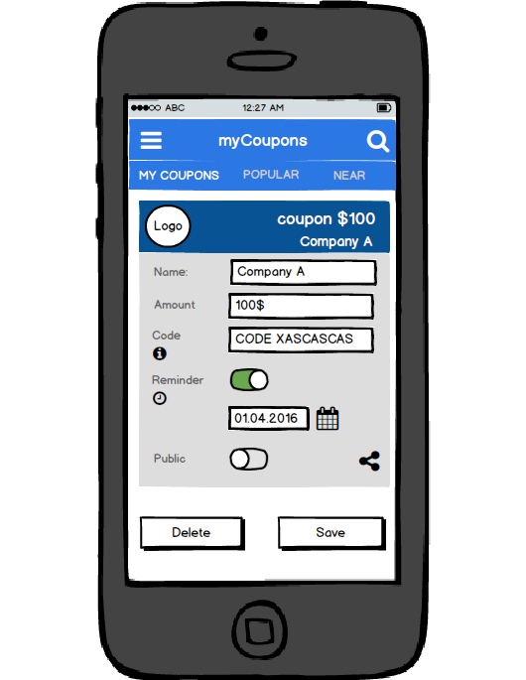

Coupon detail view – Here you can read, update and delete your personal coupons. Also here you can share the coupon.

## Screen 4: New COUPON

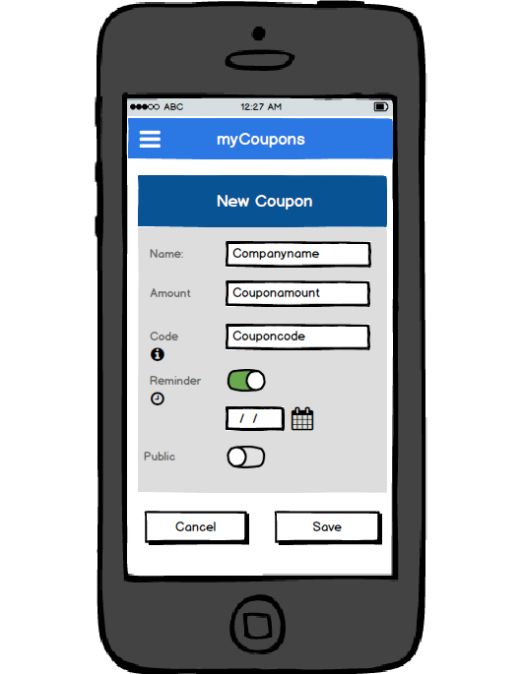

New coupon view – Here you can create a new coupon.

# Key Considerations

### How will your app handle data persistence?

Content Provider + local database. Also if there is none coupon api that I can use I will have to create a small coupon api on my own.

### Describe any corner cases in the UX.

There shouldn’t be any corner cases in the UX. Everything is straight forward. In the menu there will be option to login to G+, filter, ordering and also link to every tab.

### Describe any libraries you’ll be using and share your reasoning for including them.

Picasso to handle the loading and caching of images.

Butterknife for field and method binding.

GooglePlayServices for login and google maps.

# Next Steps: Required Tasks

This is the section where you can take the main features of your app (declared above) and decompose them into tangible technical tasks that you can complete incrementally until you have a finished app.

## Task 1: Project Setup

Setup the project and create all necessary activity’s.

List of subtasks:

* Configure libraries
* Create activity’s
* Create fragments
* Generate assets
* Register for api’s like google maps and the coupon api

## Task 2: Implement UI for Each Activity and Fragment

List the subtasks:

* Build UI for MyCoupons
* Build UI for listview (coupon)
* Build UI for nearby coupon
* Build UI for CRUD coupon
* Build UI menu

## Task 3: Create Content provider + local database

Create the content provider and a local database to make sure the user can save his own coupons.

## Task 4: Connect to API

Connect and sync with the api frequently.

## Task 5: Implement Google Play Services

Implement google play services. Add coupon locations to map and create a search function for that map.

## Task 5: Sort, filter and search

Create the functions to sort, filter and search the private and public coupons.

## Task 5: Error handling, Debug and test cases

Find bugs and add error handling. Create some test cases to make sure the api connection etc. works fine.