**Hollow**

by

Productive Outlaws

Designer

Alex Baio

Programmer

Kevin Thomas

Artist

Sai Teja Sarangu

Producer

Pranav Kamble



**Overview**

|  |  |
| --- | --- |
| Genre | Action, Adventure, Platformer |
| Platform | PC |
| Team Size | 4 |

**Key Points**

* Follows the story of two adventurers in search of treasure and fame.
* Play as both characters with differing abilities, switching between them at will.
* One character focuses on melee with a sword and is stronger but slower.
* The other uses a bow for ranged attacks and is faster but not as strong.
* Focus on action and exploration, with puzzles that require the use of both characters’ abilities to succeed.

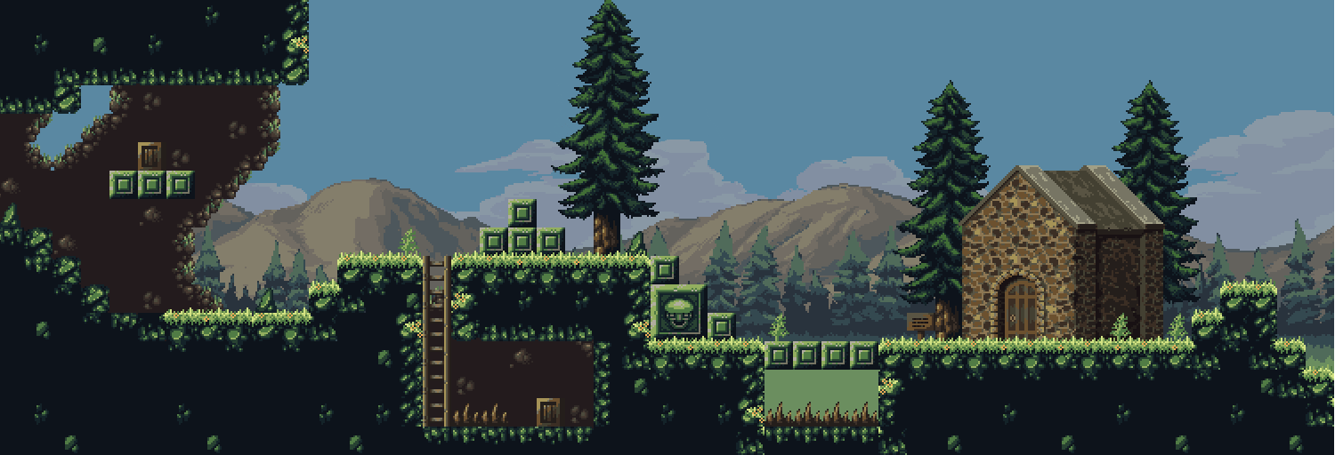

**Team Biographies**

**Alex Baio**

I grew up playing flash games on dial-up internet and quickly graduated to PlayStation 1 and 2 games as I got older. Eventually ditching consoles in favor of the one true game system, the PC. I always dreamed of turning my love for games into a career and turning my ideas and inspirations into real games. Working at Productive Outlaws has seen that dream come true, and continues to see those ideas and inspirations become reality.

**Kevin Thomas**

My fascination with video games began at a very early age. While other kids my age got excited to go outdoors and play after school, I just wanted to stay home and help Dave traverse his dangerous world or save Peach from her impenetrable prison. Over time, this fascination turned into something more, prompting me to explore all the things I needed to make those stories into reality. As a result, I got myself a Bachelor’s degree in Engineering, specializing in Information Technology, giving me considerable expertise in software engineering, project management and the use of programming languages. I am currently working on honing my skills by pursuing a Master’s degree in Computer Science.

Aside from my technical side, I have a background in the performing arts, having received formal training in contemporary music theory and performance. I have also worked as a composer, arranger, sound designer and writer for close to a dozen plays and short film and worked as a recording artist in my free time. All these skills, along with a perfectionist work ethic, make it possible for me to work towards creating meaningful and immersive video game experiences.

**Pranav Kamble**

Hello everyone! This is Pranav Kamble, currently pursuing Masters from the University of North Carolina at Charlotte. I completed my bachelors in 2014 and was working in the IT industry for the past 4 years in web application development in various multinational organizations. I wish to complete my masters with Artificial Intelligence concentration.

I am very excited to work on this game concept due to the fact that we are working on making an intelligent friend to play along with you. I hope this novel idea and the gameplay will interest and engage you to the core! I am sure that this game has a major takeaway in the end which will surely make this game worth playing.

May the force be with you!

**Sai Teja Sarangu**

Hello, my name is Sai Teja Sarangu. I am currently doing my masters at the University of North Carolina at Charlotte. I desire to finish my masters with a specialization in Artificial Intelligence. Playing games was the first thing that interested me in computers. I always had the interest to develop games but never really got a chance. I hope you enjoy our game.

**Game Description**

The story follows two adventurers, out to find fame, fortune and glory. They’ve been traveling and adventuring together for years, their different skills and attributes complimenting each other perfectly, forming a strong team. Their partnership is almost unbeatable, each of them being an integral part of the puzzle. Recently down on their luck and in need of money, the two heard a word of an ultimate hidden treasure that should solve their problem and make them famous in the process.

The gameplay involves elements of action-adventure platformer games with the added feature of switching between the two main characters in the game. With the press of a button, the player can switch between the fast and nimble Archer and the strong and steady Saber. Each character is specifically suited to specific situations. Archer is a master of the bow, taking out foes from afar and providing covering fire. Saber is an elite swordsman, vanquishing all who choose to stand against him. Both are equally abled of the strengths they possess.

The players fight the enemies of different strengths along the way to reach the final stage of the game. The game consists of three levels that also pose enough challenge in the game. At the end of each level, the game will present a puzzle to solve in order to go to the next level. The puzzle will require actions that require the player to play as both characters. For example, the player may have to hit something that can only be reached using ranged attacks, making playing as Archer necessary, or ones that require greater strength of Saber that will be required to unlock the puzzle question.

The game necessarily progresses through the challenge and builds up a fable in this progression. The game has two goal states - losing goal state refers to the death of either of the player. Winning state is the completion of the game by defeating the boss at the final stage and find a great treasure supposedly lost to time. The game also incorporates role-playing elements such as experience and leveling up. Players gain experience by defeating enemies and solving puzzles. Higher leveled characters deal more damage and better abilities, making it possible to overcome more difficult situations. Enough gold and wealth to set two people for life. The fact that the player has an ability to choose between the character also adds up a challenge to choose the appropriate player in the situations that build up in the game. The choice of the right player at the right time certainly makes it crucial in order to kill the enemy and ultimately win the level.

**Sprites**

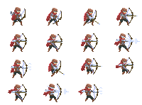



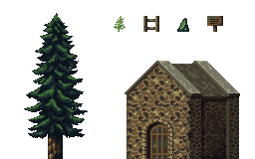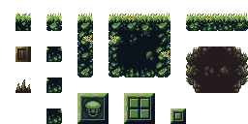

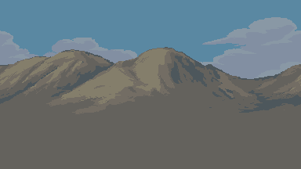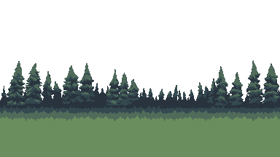

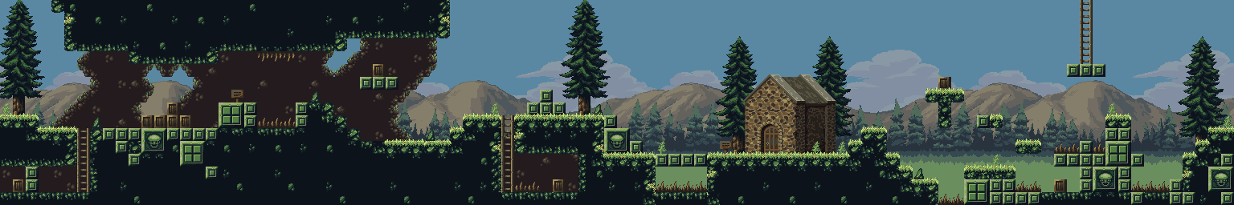

**Licencing information**

1. Tileset -

Taiga Tileset <https://vnitti.itch.io/taiga-asset-pack>

1. Sword hero

RVROS

<https://rvros.itch.io/animated-pixel-hero>

1. Archer hero

RVROS

<https://rvros.itch.io/animated-pixel-hero>