Project Milestone 4
Project title: Automated Consumer Complaint Triage: Predicting the Product of a CFPB Complaint from Its Narrative
Team / Author(s): Team 32 (KASS Tech), CSCI 3052: Kevin Thomas, Alex Facey, Subangan Sundaralingam, Sayon Kirubaharan. Date: October 30, 2026. Repository: github.com/KevinThomasOTU/MachineLearningProject (M4 code in m4_deliverables/code/).
All scores below are on the validation split (n = 14,649). The test split is sealed until M5. Results marked [highlighted] are items the team must confirm or fill in before submission.

1. Current Methods and Approaches

1.1 Data
Item | Details
Source(s) | CFPB Consumer Complaint Database, narratives archive file for April to July 2024 (839,903 raw rows; downloaded 2026-09-30). Public federal data, "freely available for anyone to use, analyze, and build on"; no formal licence text, CFPB is attributed. CFPB stopped publishing narratives on Aug 14, 2026, so the file is a frozen snapshot.
Size | 276,275 cleaned narratives, reduced to 97,655 distinct complaints (one row per exact or near-duplicate group). Input: one text field. Label: Product, 11 classes. Features: 10,000 TF-IDF terms (1 to 2-grams).
Split strategy | 70/15/15 stratified and group-aware (StratifiedGroupKFold, 20 folds, seed 42): train 68,357 / validation 14,649 / test 14,649. No duplicate group appears in two splits (12 leakage tests pass).
Class balance | Severe: credit reporting is 51.3% of rows and the smallest class (Debt or credit management) is 0.46%, a 111:1 ratio. Stratified Random scores accuracy 0.31 but Macro F1 only 0.092 (about 1/11).
Known quality issues | 50.6% of narratives were exact copies (template letters); 345 identical texts carry more than one product (label noise, majority label kept); 5.4% of narratives are under 20 tokens; only 32.9% of complaints have a narrative (opt-in bias); 22.9% of validation complaints still have a training near-copy at cosine 0.8 or more; 11 training rows (0.02%) have an all-zero TF-IDF vector (see Section 3.4).
Preprocessing and feature engineering: Narratives are lower-cased, masked tokens such as XXXX and XX/XX/2024 are removed, whitespace is collapsed, and exact and near-duplicate narratives are grouped (same date, state, ZIP and issue block, plus identical first 200 characters or TF-IDF cosine of 0.80 or more). Features are TF-IDF with sublinear term frequency, 1 to 2-grams, no stop-word removal, 10,000 features. The TF-IDF vocabulary and IDF weights are fit on the training split only; validation text is only transformed. Class priors, model weights and the k-NN reference set also come from train only. The M5 ablation will vary stop words {none, English}, n-grams {(1,1), (1,2)} and vocabulary {1,000, 5,000, 10,000}.

1.2 Models
Stage | Model | Purpose | Key hyperparameters
Baseline | Stratified Random and Majority Class; Multinomial Naive Bayes (M3) | Lower bound and course-level baseline | NB: Laplace/Lidstone alpha = 0.03, chosen from {0.001 to 1} on validation; class priors from train
Intermediate | k-NN, brute force, distance-weighted votes | Non-parametric benchmark, tests the cosine vs Euclidean question | k in {1, 5, 15, 31}; cosine and Euclidean; best: cosine, k = 15
Main | L2-regularised multinomial Logistic Regression | Primary candidate | lbfgs, max_iter 1000, C in {0.1, 1, 10, 100}, class_weight in {none, balanced}; best: C = 10, none (C = 1 is tied)

1.3 Training and Evaluation Setup
- Framework and tooling: Python 3.14.5, scikit-learn 1.9.1, pandas, SciPy, matplotlib; pinned in requirements.txt. Git with one reviewed pull request per person per milestone; AI use is logged in AI_USE.md.
- Hardware: laptop CPU (Intel Core Ultra 5 125U, 15 GB RAM), no GPU. Measured per run: TF-IDF about 16 s, NB 0.2 s, LR 21 to 36 s (C = 1 to 10), k-NN prediction about 27 s per validation pass.
- Loss function and optimiser: NB has closed-form estimates (no optimiser). LR minimises multinomial cross-entropy plus an L2 penalty with the deterministic lbfgs quasi-Newton solver. k-NN is lazy (no training).
- Regularisation: L2 penalty strength 1/C for LR, Laplace smoothing alpha for NB, and k (plus distance weighting) for k-NN. No early stopping or augmentation.
- Hyperparameter search: small grids on validation Macro F1 (NB alpha 6 values, LR 8 settings, k-NN 8 settings). Because tuning and scoring both use validation, scores are slightly optimistic until the single test pass in M5.
- Evaluation metrics: primary Macro F1 (each product counts equally, so the 51% class cannot hide failures on rare ones); secondary accuracy, weighted F1, macro precision and recall, per-class recall and F1, confusion matrix, paired bootstrap 95% CIs (1,000 resamples).
- Reproducibility: seed 42 everywhere, configs/config.yaml, pinned environment, split files fixed, scripts/08_check_reproducible.py (M3) and the new M4 scripts, which write only to m4_deliverables/results/. Release tag v0.3-m3; an M4 tag is planned.

2. Theoretical Justification for Chosen Methods

2.1 Choice of Model Family
Claim: linear models on sparse TF-IDF features are the right family for this data, and the three we compare span the generative, discriminative and non-parametric views of the same representation. Reasoning: narratives are long, high-dimensional and sparse (10,000 features, a median of 119 tokens), and product is largely signalled by a few topical words ("mortgage", "payday", "prepaid"). Text classes are close to linearly separable in this space, which is why linear classifiers are strong text baselines (Joachims, 1998; Manning et al., 2008). Naive Bayes models P(c | x) proportional to P(c) times the product of P(w | c)^x_w with smoothed estimates theta_cw = (N_cw + alpha) / (N_c + alpha |V|). Its conditional-independence assumption is false, but it needs one pass over the data and estimates well from few examples; applying it to fractional TF-IDF weights is a known heuristic that works well in practice (Rennie et al., 2003). Logistic regression models the class posterior directly with a softmax, so it does not need the independence assumption and can weight correlated words jointly; Ng and Jordan (2002) show the discriminative model has the lower asymptotic error while the generative one converges faster, which is the pattern we measure (Section 3.3). k-NN makes no model assumption and converges to at most twice the Bayes error as n grows (Cover and Hart, 1967); on sparse text, similarity is meaningful only through shared terms, so it tests whether local lexical overlap is enough. Evidence: LR beats NB by +0.058 Macro F1 (paired bootstrap 95% CI +0.044 to +0.072); k-NN is statistically indistinguishable from NB (-0.002, CI -0.014 to +0.010).

2.2 Choice of Loss Function and Optimisation
Multinomial cross-entropy is the negative log-likelihood of a categorical model, a proper scoring rule that yields calibrated class probabilities. Adding an L2 penalty equals a Gaussian prior on the weights (MAP estimation), which is essential when features (10,000) are numerous relative to the rarest class (451 rows overall). The objective is convex, so lbfgs reaches the single global optimum and results are deterministic, which suits our reproducibility rule better than stochastic Adam or SGD, and a 68k by 10k sparse problem is small enough for a second-order method. The loss optimises likelihood, not Macro F1, so under imbalance the model drifts toward large classes. We tested the standard remedy, class weights inversely proportional to class frequency: it raised macro recall (0.650 to 0.698 at C = 10) but lowered precision more (0.753 to 0.655), so Macro F1 fell from 0.682 to 0.674. For NB, removing the class prior (fit_prior=False) behaved the same way (recall up, precision down, F1 0.623 to 0.604). Reweighting therefore trades precision for recall; it did not fix the rare-class problem, and thresholding or re-sampling is a candidate for M5.

2.3 Bias-Variance and Generalisation
Model capacity was balanced through the regularisation strength. At C = 0.1 LR under-fits (train 0.574, validation 0.568). At C = 100 it over-fits (train 0.990, validation 0.656). C = 1 and C = 10 tie on validation (0.681 and 0.682), but C = 10 has a train-validation gap of 0.243 against 0.076 for C = 1, so C = 1 is the lower-variance choice and both are carried into M5, where bootstrap intervals decide. NB shows a gap of 0.081 (train 0.705, validation 0.623). The learning curve (Figure 1) shows validation Macro F1 still rising for both models at 68,357 rows with a persistent train-validation gap for LR, evidence that more data or stronger regularisation would help more than more model capacity.

2.4 Evaluation Methodology
With 51% of rows in one class, accuracy rewards predicting the majority (Majority Class gets 0.513 accuracy but 0.062 Macro F1), so Macro F1 is primary, with closed-form chance level 1/K = 0.091 as a floor that our naive benchmarks matched in M3. The group-aware stratified split prevents the main leakage risk (template letters and three-bureau filings appearing in both train and evaluation), and fitting TF-IDF on train only prevents vocabulary leakage. Because validation is used for tuning, we report paired bootstrap confidence intervals now and make the final claims from one pass over the sealed test split. We also keep group_size so the score can be reweighted to the live mix, where templates repeat (M3: 0.623 falls to 0.587 under that weighting).

2.5 Alternatives Considered
Alternative | Why it was not chosen
Transformer fine-tuning (BERT-style) | No GPU; 97k narratives at median 119 tokens would take far longer than our CPU budget; the project question is about classical TF-IDF models, stop words, n-grams and vocabulary size.
Linear SVM | Closest competitor to LR on text and a good M5 extension; not in the proposed model set, and LR gives calibrated probabilities for per-class analysis.
Random forest / gradient boosting | Tree ensembles on 10,000 sparse TF-IDF columns are slow and rarely competitive with linear models on text.
Euclidean k-NN as a separate method | On unit-length TF-IDF it is equivalent to cosine k-NN (Section 3.4); we keep it only as a check.
SMOTE / oversampling | Interpolating sparse text vectors yields unrealistic documents; class weights tested instead (Section 2.2).

3. Preliminary Results and Findings

3.1 Quantitative Results
Model | Train Macro F1 | Val Macro F1 (95% CI) | Val acc. | Val macro R | Time
Stratified Random (3 seeds) | n/a | 0.092 ± 0.002 | 0.306 | 0.092 | 0.05 s fit
Majority class | n/a | 0.062 | 0.513 | 0.091 | 0.06 s fit
Baseline: Multinomial NB, alpha = 0.03 | 0.705 | 0.623 (0.611 to 0.637) | 0.787 | 0.602 | 0.2 s fit
Intermediate: k-NN cosine, k = 15 | n/a | 0.622 (0.608 to 0.637) | 0.802 | 0.582 | 27 s predict
Main: LR, C = 10 | 0.925 | 0.682 (0.667 to 0.697) | 0.831 | 0.650 | 36 s fit
LR, C = 1 | 0.757 | 0.681 (0.668 to 0.694) | 0.844 | 0.641 | 21 s fit
LR, C = 10, class-balanced | 0.917 | 0.674 (0.660 to 0.687) | 0.815 | 0.698 | 30 s fit
k-NN Euclidean, k = 15 (as first run) | n/a | 0.099 | 0.527 | 0.110 | 27 s predict
_Stratified Random is mean ± std over seeds 42 to 44. NB, LR and k-NN are deterministic, so their uncertainty is the paired bootstrap interval (1,000 resamples, seed 42) rather than seed variance. The k-NN train score is not reported because each training row is its own nearest neighbour. Source: m4_deliverables/results/tables/._

3.2 Visualisations
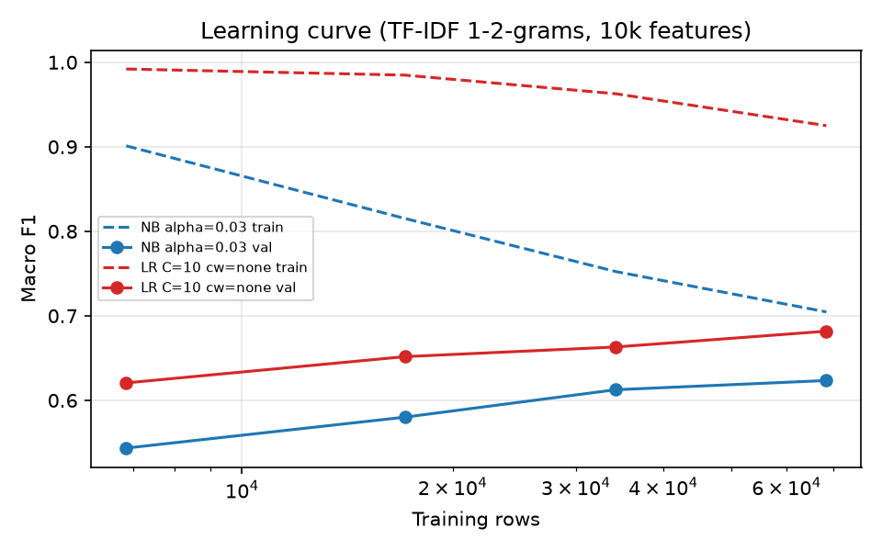
Figure 1: Training and validation Macro F1 versus training-set size for NB and LR (stratified subsamples, validation split).
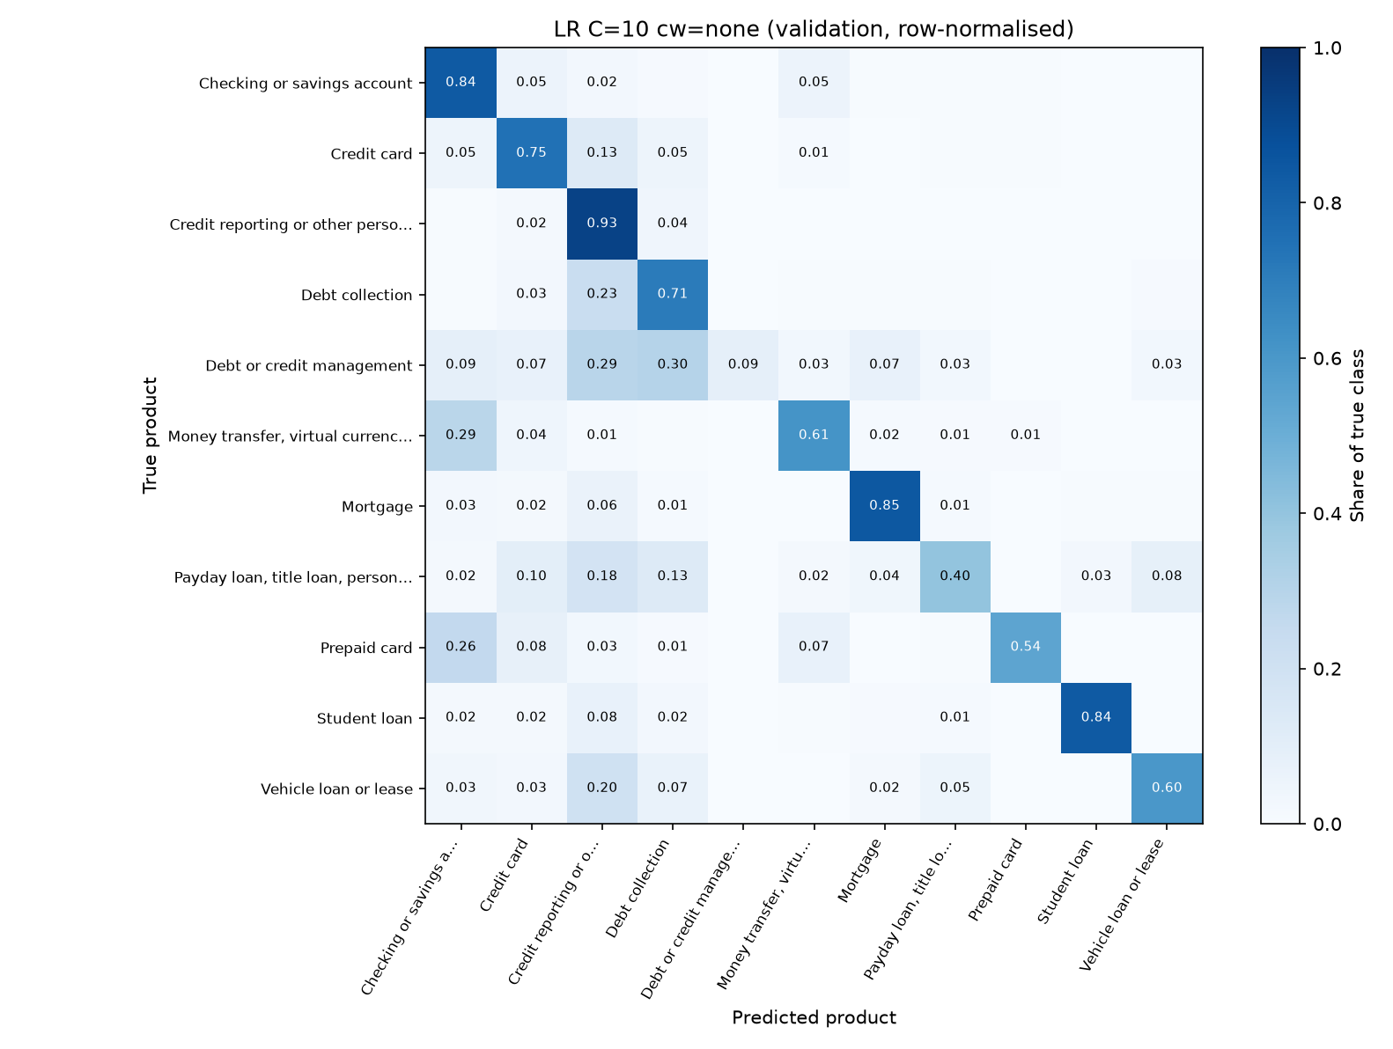
Figure 2: Row-normalised confusion matrix of the main model (LR, C = 10) on validation; the diagonal is per-class recall.

3.3 Key Findings
- LR is the strongest model so far, and the gain is real. Macro F1 0.682 versus 0.623 for the NB baseline: +0.058 (paired bootstrap 95% CI +0.044 to +0.072), and accuracy rises from 0.787 to 0.831. This is 0.590 above Stratified Random. k-NN with cosine similarity (0.622) is statistically tied with NB (difference -0.002, CI -0.014 to +0.010) but over 1,000 times slower at prediction (27 s versus 0.02 s).
- Rare classes remain the bottleneck. Recall for Debt or credit management (69 validation rows) is 0.03 for NB, 0.09 for LR and 0.06 for k-NN (LR F1 0.15). Payday loan recall is 0.28 (NB), 0.40 (LR) and 0.18 (k-NN). LR's biggest per-class gain over NB is Money transfer (recall 0.40 to 0.61, F1 0.55 to 0.65).
- Euclidean k-NN collapsed (Macro F1 0.099), and the cause was 11 empty training vectors, not the metric. On L2-normalised TF-IDF, squared Euclidean distance is 2 - 2cos, so both metrics must rank neighbours identically. An all-zero vector is at distance exactly 1 from every unit vector, so for any query whose best real neighbour has cosine below 0.5 the empty rows become the nearest neighbours. Removing the 11 empty training rows (0.02% of train) lifts Euclidean Macro F1 from 0.099 to 0.621, and its predictions then agree with cosine on 99.6% of validation rows. Cosine is robust because it ignores vector length.
- Regularisation matters more than reweighting. LR Macro F1 moves from 0.568 (C = 0.1) to 0.682 (C = 10) to 0.656 (C = 100), while class weights change it by under 0.01 and trade precision for recall.

3.4 Error Analysis
LR makes 2,478 errors on 14,649 validation rows (accuracy 0.831). The largest confusion blocks are Debt collection predicted as Credit reporting (444 rows) and the reverse (316), Credit card as Credit reporting (197), and Money transfer as Checking or savings (132). These pairs share vocabulary: credit-reporting complaints about debts, and card or transfer problems that happen through a bank account. The worst-served classes (Debt or credit management, Payday loan, Prepaid card, Vehicle loan) are small, have few distinct training documents, and their words overlap with larger neighbours (for example credit-counselling complaints read like debt collection). Label noise adds an error floor: 345 identical texts carry more than one product. Still to do for M5: read 20 sampled errors per weak class to confirm these hypotheses, and inspect the 22.9% of validation complaints with a training near-copy.

3.5 Limitations of Current Results
- One fixed TF-IDF setting; the 12-setting ablation is M5 work, so the model ranking could change with other stop-word, n-gram or vocabulary choices.
- Hyperparameters were tuned on the same validation split used for scoring, so all numbers are slightly optimistic (M3 showed tuning alpha added +0.107 over default for NB); the sealed test split is used once, in M5.
- LR and k-NN are deterministic, so there is no seed variance to report; the uncertainty shown is sampling uncertainty of the validation set only, not variation across different splits.
- Scores describe distinct complaints. Template letters are collapsed, and weighting by duplicate-group size lowers NB Macro F1 from 0.623 to 0.587 (M3); the same check is not yet run for LR.
- 22.9% of validation complaints have a training near-copy (cosine 0.8 or more), which makes the task somewhat easier than for entirely new complaints (M3: +0.03 Macro F1).

4. Deviations from the Original Plan
Planned | What actually happened | Reason | Impact
M1: use the CFPB complaint database, label product or issue | Narratives archive (Apr to Jul 2024), label fixed to Product, 11 classes (done in M2) | CFPB stopped publishing narratives on Aug 14, 2026; narratives are needed for text models | None now; frozen dataset, no refresh possible
M1: one row per complaint, strict stratified split | One row per duplicate group (276,275 to 97,655), stratified and group-aware split (M2) | 50.6% exact copies would leak across splits | Results describe distinct complaints, reported as a limitation
M2 compute plan: NB fit 1.30 s, k-NN (both metrics) about 85 s, LR about 16 s per run | NB 0.17 s, k-NN 27 s per metric (55 s for both), LR 21 to 36 s at C = 1 to 10 (up to 55 s at C = 100) | Subsample timings include fixed overhead and do not scale linearly | Full ablation grid still about 15 to 20 minutes per pass; no sampling needed
M4: theory write-up, video, initial validation results (NB baseline) | Also ran LR and k-NN with small sweeps, class-weighting, and a k-NN diagnosis | M3 Start list asked for LR and k-NN early, and NB results alone are thin | Pulls part of M5 forward; M5 keeps the ablation and test pass
src/ modules for LR, k-NN and ablation (stubs) | M4 code lives in standalone scripts in m4_deliverables/code/ | Avoided editing shared files the night before the deadline | Move into src/cfpb_triage/models/ and experiments/ in M5 (about half a day)
Seed-averaged results for every model | Seeds only matter for Stratified Random; others are deterministic | NB, LR (lbfgs) and k-NN have no random component | Use bootstrap CIs; use seeds only in M5 for the benchmark and any subsampling
No change was made to the research question, the metric, the split, or the model set.

5. Current Blockers and Challenges
Challenge | Severity | Effect on project | Mitigation / support needed | Owner
Rare-class recall (Debt or credit management recall 0.09; Payday loan 0.40) | High | Caps Macro F1, since the rare classes weigh as much as the largest | Error reading per class; compare class weights, probability thresholds, and cleaner features (stop words, bigrams) in the M5 ablation | Alex
Hyperparameters tuned on the validation split | Medium | Reported scores are slightly optimistic | Freeze choices; one test-split pass in M5; bootstrap CIs; consider 5-fold CV on train for C | Subangan
k-NN prediction cost (27 s per validation pass, grows with n_train x n_val) | Low | Slows the 12-setting grid | Cosine only (Euclidean is equivalent); run k-NN last; cache sparse matrices | Sayon
Near-copy leakage across splits (22.9% of validation) and template collapsing | Medium | May overstate performance on new complaints | Report near-copy and group_size-weighted scores for LR and k-NN too | Kevin
Peer and instructor feedback not yet logged in the repository | Low | Section 7 and Section 8 depend on it | Record feedback in docs/FEEDBACK_LOG.md as it arrives | Kevin
Help requested from supervisor or peers: (1) guidance on whether a linear SVM may be added to the model set as a fourth model; (2) whether a 5-fold cross-validation on train (instead of the single validation split) is preferred for tuning; (3) a quick sanity check of our claim that Euclidean and cosine k-NN agree on normalised TF-IDF once empty rows are handled.

6. Revised Timeline and Next Steps

6.1 Revised Timeline
Phase | Tasks | Original date | Revised date | Status
Data collection and cleaning | Data card, dedupe, group-aware split, leakage tests | Oct 2 | Oct 2 | Complete
Baseline and initial models | Benchmarks, NB baseline (M3); LR and k-NN first results (M4) | Oct 19 / Oct 30 | Oct 19 / Oct 30 | Complete
Model improvement and tuning (internal target, feeds M5) | 12-setting TF-IDF ablation for NB, LR, k-NN; tuning procedure; rare-class remedies | Nov 20 (M5) | Nov 13 | In progress
Ablations and robustness testing (internal target, feeds M5) | Uncertainty (bootstrap CIs), sensitivity checks: group_size weighting, near-copy check, temporal check (train Apr to Jun, test Jul); error analysis | Nov 20 (M5) | Nov 18 | Not started
M5 Final Experiments and Analysis (Fri Nov 20) | One pass over sealed test split with frozen choices; results package, experiment log, main table/figure, limitations, draft Results section | Nov 20 | Nov 20 | Not started
M6 Final Report, Repository, Demonstration (Fri Dec 4) | 8 to 10 minute presentation/demo (slides/video), 6 to 8 page PDF report, reproducible repository release, contribution and AI-use statements, 1-page revision response | Dec 4 | Dec 4 | Not started
M7 Individual Reflection and Oral Defence (Mon Dec 7) | Individual 1 to 2 page reflection and 5-minute oral or code walkthrough (not collaborative) | Dec 7 | Dec 7 | Not started

6.2 Prioritised Next Steps
- [Highest priority]: Move LR and k-NN into src/cfpb_triage/models/ and build the config-driven ablation runner (experiments/ablation.py, scripts/05_run_ablations.py). Owner: Alex with Sayon. Due: Nov 6. Outcome: all 12 settings x 3 models reproduced by one command, logged to results/.
- [Second priority]: Rare-class study: per-class error reading, class weights versus thresholds versus bigrams, plus group_size-weighted and near-copy scores for all models. Owner: Subangan. Due: Nov 13. Outcome: a defensible answer to why rare classes fail and which remedy helps.
- [Third priority]: Reproducibility and test-pass protocol: extend 08_check_reproducible.py to LR and k-NN, add tests for the empty-vector guard, freeze configs, tag v0.4-m4 and v0.5-m5, run the sealed test split once. Owner: Sayon with Kevin. Due: Nov 18 to Nov 20. Outcome: final numbers that match a re-run exactly.

6.3 Risks to the Revised Plan and Contingencies
- If the full ablation is too slow on laptops: run k-NN only at the best two TF-IDF settings and document the reduced grid; each full pass is estimated at 15 to 20 minutes, so this is unlikely.
- If rare-class recall cannot be improved: report it as a documented limitation with per-class numbers and the strongest remedy tried, and keep Macro F1 as the headline metric.
- If tuning on validation looks too optimistic against the test split: report the gap openly and refit C with cross-validation on train for the final table.
- If a teammate is unavailable: the two highest-priority tasks each have two owners (Section 6.2), and pull requests plus AI_USE.md keep work reviewable by anyone.

7. Responses to Feedback Received So Far
The table lists the feedback the repository records. Rows highlighted in yellow need the team to paste the actual M2 and M3 instructor or TA comments before submission; we have not invented any.
Feedback (source, date) | Our response | Action taken | Status
[TEAM: paste instructor/TA feedback on the M2 approval memo] | [response] | [action] | [status]
[TEAM: paste instructor/TA feedback on the M3 memo] | [response] | [action] | [status]
Our own M3 reflection: "Run L2 Logistic Regression and k-NN through the same pipeline and table" (team, Oct 19) | Agreed; needed to answer the research question | LR and k-NN run on the same TF-IDF and metrics, reported in Section 3 | Done
M3: "Stop treating the tuning score as final; final numbers from one pass over the sealed test split" (team, Oct 19) | Agreed | Test split not loaded for scoring; bootstrap CIs added; optimism noted | Done, test pass in M5
M3: "Test fit_prior=False in Naive Bayes to target the rare-class recall gap" (team, Oct 19) | Agreed | Tested: recall up, precision down, Macro F1 0.623 to 0.604 | Done; not adopted
M3: "Budget compute from measured full-size times, not 10,000-row extrapolations" (team, Oct 19) | Agreed | Section 4 compares estimates with measured times; M5 budget uses measured times | Done
Where feedback was not adopted, the reason is given in the table (fit_prior=False lowered Macro F1). This log will be reused for the 1-page revision response required with the M6 final report.

8. Midpoint Peer Check-In
Peer / group consulted: [TEAM: names of the peer team(s)] Date and format: [TEAM: date; meeting, written review or presentation]
Fill in this section after the check-in. The talking points below come from this report so the discussion is quick.

8.1 What We Shared
The 5-minute progress presentation and this report: the 11-class complaint-triage task, the group-aware split, the NB baseline (Macro F1 0.623), and the first LR (0.682) and k-NN (0.622) results, including the empty-vector finding. [TEAM: add anything else shown]

8.2 Feedback Received from Peers
- Strengths noted: [TEAM]
- Concerns or questions raised: [TEAM]. Questions we expect: why Macro F1, why collapse duplicates, is tuning on validation optimistic?
- Suggestions: [TEAM]

8.3 Feedback We Gave to Peers
- Peer project: [TEAM: title]
- Observations: [TEAM: strengths, gaps, constructive suggestions you offered]

8.4 Changes Resulting from the Check-In
[TEAM: list specific changes to methods, timeline or scope that came out of the discussion, or state that none were needed]

9. Conclusion
We have moved from the NB baseline (Macro F1 0.623) to a statistically better main model, L2 Logistic Regression (0.682, +0.058 with a 95% interval that excludes zero), and shown that cosine k-NN only ties the baseline while costing far more at prediction time. The top risk is weak recall on the smallest product classes, which M5's ablation and error study target directly. The pipeline is reproducible, the test split is still sealed, compute is well within budget, and we are confident of delivering the final experiments on Nov 20.

References
- Consumer Financial Protection Bureau. 2026. Consumer Complaint Database and How we share complaint data. consumerfinance.gov/data-research/consumer-complaints/.
- Manning, C. D., Raghavan, P., and Schütze, H. 2008. Introduction to Information Retrieval. Cambridge University Press.
- Joachims, T. 1998. Text categorization with support vector machines: learning with many relevant features. Proc. ECML, pp. 137 to 142.
- Rennie, J. D. M., Shih, L., Teevan, J., and Karger, D. R. 2003. Tackling the poor assumptions of naive Bayes text classifiers. Proc. ICML, pp. 616 to 623.
- Ng, A. Y., and Jordan, M. I. 2002. On discriminative vs. generative classifiers: a comparison of logistic regression and naive Bayes. Advances in NIPS 14.
- Cover, T. M., and Hart, P. E. 1967. Nearest neighbor pattern classification. IEEE Transactions on Information Theory, 13(1), 21 to 27.
- Pedregosa, F., et al. 2011. Scikit-learn: machine learning in Python. JMLR, 12, 2825 to 2830.

