**Section 10.1**

**1)** Describe the diﬀerence between sexual reproduction in diploid organisms, binary ﬁssion in haploid organisms, and fusion in haploid organisms.

In diploid organisms, each parent produces a haploid gamete, and the two gametes unite to produce a diploid zygote, which then grows into an adult. The zygote has half of the genome from each parent.

Some haploid organisms (unicellular) reproduce through fusion: two parent cells combine to produce a transient meiocyte (diploid), which then undergoes meiosis, producing four haploid descendant cells. Each descendant has a mixture of genes from each parent, which makes this type of reproduction sexual.

Most haploid organisms reproduce asexually, through fusion: one parent cell splits into two copies with identical genomes.

2) Suppose a diploid organism has 10 chromosomes in one of its genomes.

(a) How many chromosomes are in each of its somatic cells?

Somatic cells are diploid, therefore they have two genomes, or 20 chromosomes.

(b) How many chromosomes are in each of its gametes?

Gametes are haploid, therefore they have only one genome, or 10 chromosomes.

3. Suppose two adult haploid organisms reproduce by fusion.

(a) How many children will be produced?

Four.

(b) Will the genetic content of the children all be the same?

No, in general each of the four children is genetically distinct (each inherits differnet combinations of genes from each parent).

4. Consider the eye color of a human being as determined by the bey2 gene. Recall that the allele for brown eyes is dominant. For each of the following parent allele combinations, determine the eye color of the individual.

|  |  |  |
| --- | --- | --- |
| Father | Mother | Child |
| BLUE | BLUE | BLUE |
| BLUE | BROWN | BROWN |
| BROWN | BLUE | BROWN |
| BROWN | BROWN | BROWN |

**Section 10.2**

**5)** Consider Table 10.1. Suppose the ﬁtnesses of the 8 individuals are .61, .23, .85, .11, .27, .36, .55, and .44. Compute the normed ﬁtnesses and the cumulative normed ﬁtnesses.

|  |  |  |
| --- | --- | --- |
| Fitness | Normed fitness | Cumulative normed fitness |
| .61 | .178 | .178 |
| .23 | .067 | .245 |
| .85 | .249 | .494 |
| .11 | .032 | .526 |
| .27 | .079 | .605 |
| .36 | .105 | .710 |
| .55 | .161 | .871 |
| .44 | .129 | 1.000 |

Sum 3.42

**6)** Suppose we perform basic crossover as illustrated in Table 10.3, the parents are 01101110 and 11010101, and the starting and ending points for crossover are 3 and 7. Show the two children produced.

We assume that the points for crossover are numbered from left to right, from 1 to 8.

The children are: 0101 0100

1110 1111

**7)** Implement the genetic algorithm for ﬁnding the value of x that maximizes

f(x) = sin(xπ/256), which is discussed in Section 10.2.2.

Implementations will vary, however, in C/C++ efficient mutation and crossover operations should take advantage of the bitwise operators. Below is a short example showing how the bit in position x can be swapped (crossover) between two 8-bit numbers a and b. The bit positions are 0 on the right and 7 on the left.

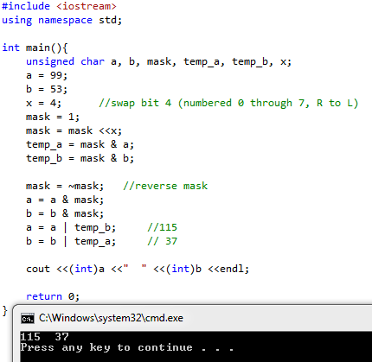

To swap an entire crossover sequence, a mask with consecutive ones should be constructed first, and then the process is similar.

**8)** Consider the instance of the TSP in Figure 10.12. Assume the weights in both directions on an edge are the same. Find the shortest tour.

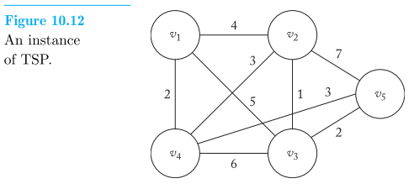

We use the implementation from Exercise 6-10, with a 5-by-5 matrix:

#include <iostream>

using namespace std;

#define n 5

int W[n+1][n+1] = { {0, 0, 0, 0, 0, 0},

{0, 0, 4, 5, 2, 0},

{0, 4, 0, 1, 3, 7},

{0, 5, 1, 0, 6, 2},

{0, 2, 3, 6, 0, 3},

{0, 0, 7, 2, 3, 0} };

int best_vindex[n] = {-1};

int vindex[n] = {-1};

int minimum = 1000;

bool promising(int i){

int j;

bool switchie;

if (i==n-1 && !W[vindex[n-1]][vindex[0]]) //No edge to close circuit

switchie = false;

else if (i>0 && !W[vindex[i-1]][vindex[i]]) //No edge to current node

switchie = false;

else{ //Check if vertex has already been selected

switchie = true;

j = 1;

while (j<i && switchie){

if (vindex[i] == vindex[j])

switchie = false;

j++;

}

}

return switchie;

}

int evaluate(int vindex[]){

int sum = 0;

for (int i=0; i<n-1 ;i++)

sum += W[vindex[i]][vindex[i+1]];

sum += W[vindex[n-1]][vindex[0]]; //closing the circuit

return sum;

}

void hamiltonian(int i) {

int j;

if(promising(i)) {

if (i == n-1){

int eva = evaluate(vindex);

if (eva <= minimum) {

minimum = eva;

cout <<"Found new minimum tour = " <<minimum <<" : ";

for (int k=0; k<n; k++){

cout << vindex[k] <<" ";

best_vindex[k] = vindex[k]; //update min. circuit

}

cout <<endl;

}

}

else

for(j=2; j<=n; j++) {

vindex[i+1] = j;

hamiltonian(i+1);

}

}

}

int main(){

vindex[0] = 1;

hamiltonian(0);



return 0;

}

As expected, there are two minimal tours, one being the reverse of the other, since all edges are bi-directional (undirected graph).

**9)** Suppose we perform order crossover, the parents are 3 5 2 1 4 6 8 7 9 and

5 3 2 6 9 1 8 7 4, and the starting and ending points for the pick are 4 and 7. Show the two children produced.

We assume that the points for crossover are numbered from left to right, from 1 to 8.

The children are: 9 7 5 1 4 6 8 3 2

4 7 3 6 9 1 8 5 2 The picks are shaded.

**10)** Consider the instance of the TSP in Figure 10.12. Apply the Nearest Neighbor Algorithm starting with each of the vertices. Do any of them yield the shortest tour?

The only two starting vertices that yield tours are v2 and v4:

v2 → v3 → v5 → v4 → v1 → v2 Length is 12

v4 → v1 → v2 → v3 → v5 → v4 Length is 12

They are both the same tour (after a circular permutation), namely the first shortest tour found in Exercise 8.

**11)** Form the union graph of the two tours shown in Figure 10.13, and apply the Nearest Neighbor Algorithm to the resultant graph starting at vertex v5.

1

The union graph is:

2

4

4

7

5

2

3

6

5

8

3

The sequence of nodes starting at v5 is: v5 → v6 → v2 → v4 → v3 → STOP, since there is no edge to the remaining node v1.

If, however, we start at v1, we obtain the tour v1 → v2 → v4 → v3 → v5 → v6 → v1, of cost 22.

**12)** Apply the Greedy Edge Algorithm to the instance of the TSP in Figure 10.12. Does it yield a shortest tour?

The first three shortest edges are 2-3 (cost 1), 1-4 (cost 2), and 3-5 (cost 2). They can all be added without violating the conditions for a tour. The next two edges are 2-4 and 4-5, both of cost 3, but they cannot be both added, because this would create a cycle composed of only the nodes 2 → 3→ 5 → 4. If we try to add 2-4, no tour can be found, but if we add 4-5, we obtain a tour after the addition of the next edge, 1-2 (cost 4).

The final tour is 1 → 2 → 3 → 5 → 4 → 1, of cost 12.

**Section 10.3**

**13)** Consider the two trees in Figure 10.8. Show the new trees that would be obtained if we exchanged the subtree starting with the “4” in the left tree with the subtree starting with the “+” in the right tree.

**14)** Consider the individual (program) in Figure 10.10. Show the moves produced by that program when negotiating the Santa Fe trail for the ﬁrst 10 time steps.

|  |  |  |
| --- | --- | --- |
| **Step nr.** | **Actions** | **End position and orientation** |
| **1** | **Move (and eat)** | **(1,2)→** |
| **2** | **Move (and eat)** | **(1,3)→** |
| **3** | **Move (and eat)** | **(1,4)→** |
| **4** | **L, R, R, L, R, move (and eat), move (and eat)** | **(3,4)↓** |
| **5** | **Move (and eat)** | **(4,4)↓** |
| **6** | **Move (and eat)** | **(5,4)↓** |
| **7** | **Move (and eat)** | **(6,4)↓** |
| **8** | **L, move (and eat), R, L, R, L, move (and eat)** | **(6,6)→** |
| **9** | **Move (and eat)** | **(6,7)→** |
| **10** | **L, R, R, L, R, L, move (not eat)** | **(6,8)→** |

**15)** Implement the genetic programming algorithm for the Santa Fe trail discussed in Section 10.3.2.

Implementations will vary.