新增資料夾

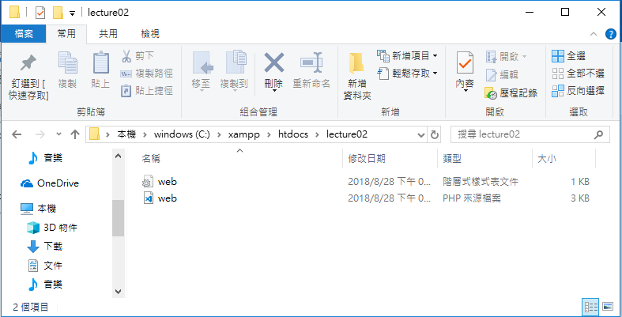

web.php

<!DOCTYPE html>

<html lang="en">

<head>

<meta charset="UTF-8">

<meta name="viewport" content="width=device-width, initial-scale=1.0">

<meta http-equiv="X-UA-Compatible" content="ie=edge">

<title>Document</title>

<link rel="stylesheet" href="./web.css">

</head>

<body>

<form action="" method="post">

<p>

<label for="user-name">姓名：</label>

<input type="text" name="user-name" required placeholder="請輸入中文名字">

</p>

<p>

<label for="user-email">信箱</label>

<input type="email" name="user-email" required>

</p>

<p>

<label for="password">密碼</label>

<input type="password" name="password" required>

</p>

<p>

<label for="gender">性別</label>

<input type="radio" name="gender" value="male" checked>男性

<input type="radio" name="gender" value="female">女性

</p>

<p>

<label for="food">想吃什麼</label>

<input type="checkbox" name="food" value="sushi">壽司

<input type="checkbox" name="food" value="hotpot">火鍋

<input type="checkbox" name="food" value="bbq">燒烤

<input type="checkbox" name="food" value="pizza">披薩

</p>

<p>

<select name="sport" multiple>

<option value="" disabled selected>--請選擇一項運動--</option>

<option value="volleyball">排球</option>

<option value="basketball">籃球</option>

<option value="baseball"">棒球</option>

</select>

</p>

<p>

<label for="message">留言</label>

<br>

<textarea name="message" cols="50" rows="10" placeholder="想說什麼.."></textarea>

</p>

<input type="submit" value="送出">

</form>

<h3>囚犯賽局</h3>

<table>

<tr>

<td colspan="2" rowspan="2">囚犯賽局</td>

<td colspan="2">犯人A</td>

</tr>

<tr>

<td>招供</td>

<td>不招</td>

</tr>

<tr>

<td rowspan="2">犯人B</td>

<td>招供</td>

<td>各5年</td>

<td>A:10年;B:1年</td>

</tr>

<tr>

<td>不招</td>

<td>A:1年;B:10年</td>

<td>各3年</td>

</tr>

</table>

</body>

</html>

web.css

table,

td {

border: 1px solid;

}

http://localhost/lecture02/web.php

