Kevin Vincent Loachamin Almeida A00392106

test-with-actions

**Step 1: Add a test workflow**

*Welcome to "GitHub Actions: Continuous Integration"! 👋*

**What is *continuous integration*?**: [Continuous integration](https://en.wikipedia.org/wiki/Continuous_integration) can help you stick to your team’s quality standards by running tests and reporting the results on GitHub. CI tools run builds and tests, triggered by commits. The quality results post back to GitHub in the pull request. The goal is fewer issues in main and faster feedback as you work.

[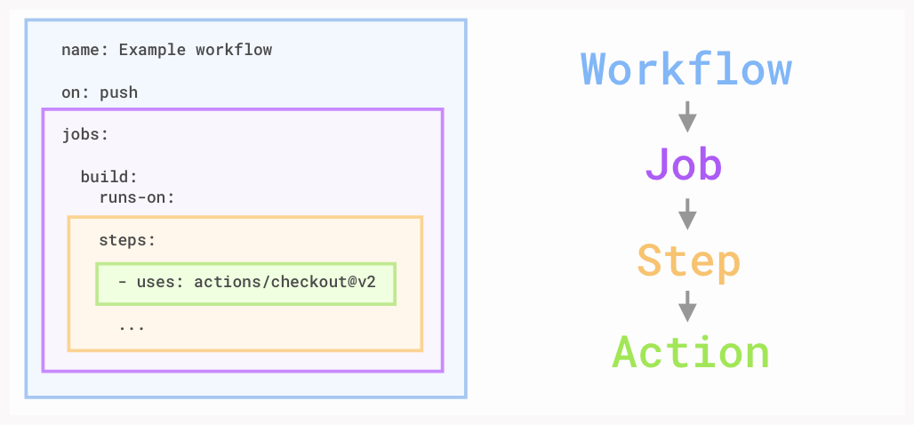](https://user-images.githubusercontent.com/6351798/88589835-f5ce0900-d016-11ea-8c8a-0e7d7907c713.png)

* **Workflow**: A workflow is a unit of automation from its start to finish, including the definition of what triggers the automation, what environment or other aspects should be taken into account during the automation, and what should happen as a result of the trigger.
* **Job**: A job is a section of the workflow, and is made up of one or more steps. In this section of our workflow, the template defines the steps that make up the build job.
* **Step**: A step represents one *effect* of the automation. A step could be defined as a GitHub Action, or another unit, like printing something to the console.
* **Action**: An action is a piece of automation written in a way that is compatible with workflows. Actions can be written by GitHub, by the open source community, or you can write them yourself!

To learn more, check out [Workflow syntax for GitHub Actions](https://docs.github.com/actions/using-workflows/workflow-syntax-for-github-actions) in the GitHub Docs.

First, let's add a workflow to lint (clean, like a lint roller) our Markdown files in this repository.

**⌨️ Activity: Add a test workflow**

1. Open a new browser tab, and work through the following steps in that tab while you read the instructions in this tab.
2. Go to the **Actions tab**.
3. Click **New workflow**.
4. Search for "Simple workflow" and click **Configure**.
5. Name your workflow ci.yml.
6. Update the workflow by deleting the last two steps.
7. Add the following step at the end of your workflow:
8. - name: Run markdown lint
9. run: |
10. npm install remark-cli remark-preset-lint-consistent

npx remark . --use remark-preset-lint-consistent –frail

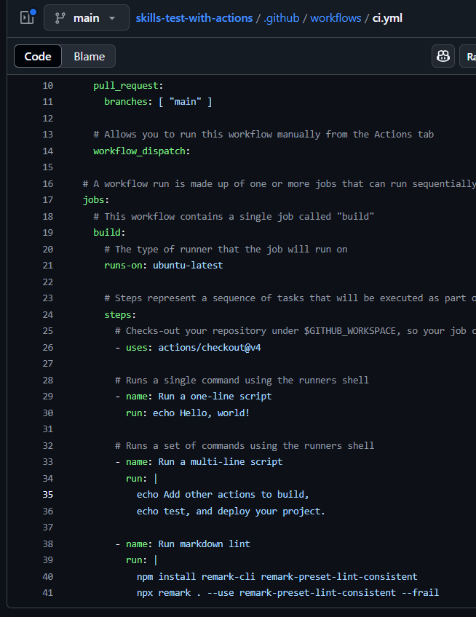

Even after the code is indented properly in ci.yml, you will see a build error in GitHub Actions. We'll fix this in the next step.

1. Click **Commit changes...**, and choose to make a new branch named ci.
2. Click **Propose changes**.
3. Click **Create pull request**.

Step 2

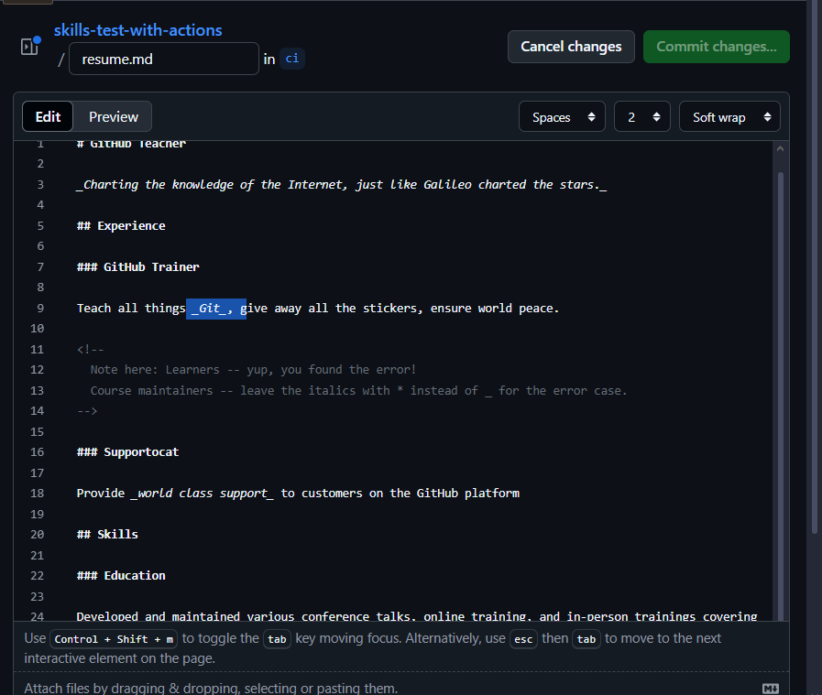

Step 3

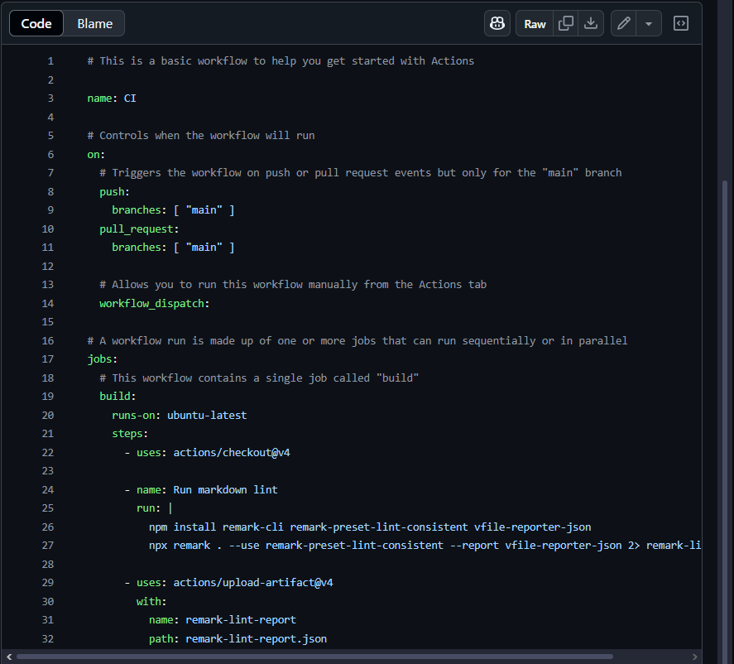

**Step 4: Add branch protections**

*Great job uploading test reports! 🥳*

Take a look at the merge box, you'll notice you can merge this even though the review process hasn't been met.

Protected branches ensure that collaborators on your repository cannot make irrevocable changes to branches. Enabling protected branches also allows you to enable other optional checks and requirements, like required status checks and required reviews.

**⌨️ Activity: Add branch protections**

1. Go to **Branches** settings. You can navigate to that page manually by selecting the right-most tab in the top of the repository called **Settings** and then clicking **Branches**.
2. Click **Add classic branch protection rule** under "Branch protection rules".
3. Type main in **Branch name pattern**.
4. Check **Require a pull request before merging**.
5. Uncheck **Require approvals**.
6. Check **Require status checks to pass before merging**.
7. Check all build and test jobs that you'd like to see in the newly visible gray box.
8. Click **Create**.

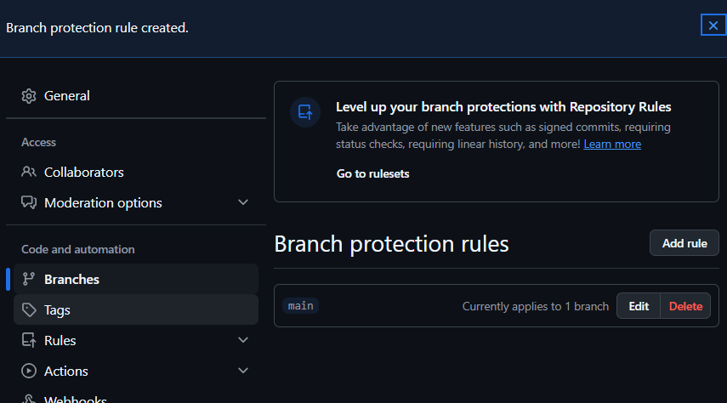

**Step 5: Merge your pull request**

*Almost there! ❤️*

You can now [merge](https://docs.github.com/get-started/quickstart/github-glossary#merge) your pull request!

**⌨️ Activity: Merge your pull request**

1. Go to the **Pull requests** tab.
2. Click **Merge pull request**.
3. *Once you turn on branch protection, Actions can no longer push directly to the main branch. Make sure that you're on the ci branch in the page you're following instructions from.* Wait about 20 seconds and then refresh the page. [GitHub Actions](https://docs.github.com/actions) will automatically update to the next step.

