SODV 1202
Object-Oriented Programming - Term Project

SODV 1202 – Connect Four Project

Name: Kevin Souza

Student Number: 481236

E-mail: k.souza236@mybvc.ca

GitHub Repo:
https://github.com/KevinWGS/ConnectFour-SODV1202

Project
Connect Four

SODV 1202: Object-Oriented Programming

Term Project: Connect Four

1. Project Overview
Connect Four is a classic two-player strategy game. Players select a symbol (e.g., 'X' and 'O') and take turns dropping discs into a vertically suspended grid consisting of seven columns and six rows. Discs occupy the lowest available space within a chosen column.
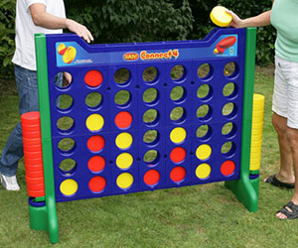
Figure: Connect Four.

Objective: Be the first player to form a horizontal, vertical, or diagonal line of four consecutive symbols.

2. Project Milestones & Deadlines
To ensure timely progress, the project is divided into the following milestones:
Milestone 1: Team Formation & Research
- Form a team (maximum 2 members) or work individually.
- Define a team name and research game rules and strategies.
Milestone 2: Skeleton Development
- Draft the initial Object-Oriented (OO) structure and program flow.
Milestone 3: Git Repository Setup (Deadline: February 27, 2026)
- Create a public GitHub repository.
- Submit the repository link to your instructor via D2L (copied in a Word file).
- Distribute tasks among team members and make frequent commits to document contributions.
Milestone 4: Core Class Implementation
- Design at least four classes or more, such as:
  - Controller: Manages game flow.
  - Model: Handles game logic and data storage.
  - Player (Abstract class/Interface): Base class for player types.
  - Human/Computer Players: Subclasses implementing the Player class/interface.
  - View/UI: Manages console input and output.
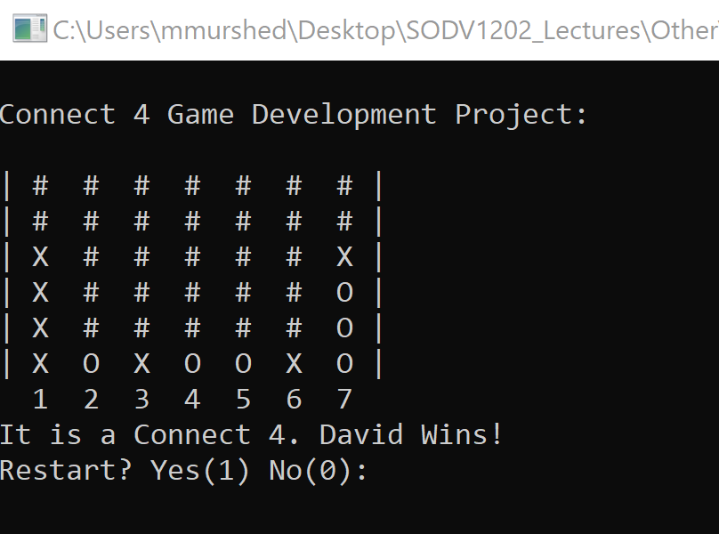
Snapshot of a console Connect Four Board.
Milestone 5: Two-Player Functionality
- Implement the main engine for two human players interacting through the console.
Milestone 6: Advanced Logic & AI (Optional)
- Implement a rule-based AI or algorithm for Human vs. Computer mode.
Milestone 7: Final Code Submission & Presentation (Deadline: April 20, 2027)
- Submit the final code and GitHub repository link (if different from proposal).
- Upload a demonstration video with active participation from all team members.

3. Technical Requirements & Rules
- Board Dimensions: 7 columns x 6 rows.
- Input Handling: Players select columns by entering numbers (1–7).
- Validation: The program must handle full columns gracefully without crashing.
- Game Loop: Alternate turns, check for win/draw conditions after each move, and display the winner or draw message.
- State Management: After a game ends, return to a start screen for a new game.
- OOP Principles: Evaluation focuses on the correct application of Abstraction, Encapsulation, Inheritance, and Polymorphism.

4. Implementation Methodology
- The project follows a progressive implementation model. As the course introduces advanced OOP concepts, students must integrate these principles into the game's ongoing development.
- All updates must be documented through structured commits in the public GitHub repository. This ensures the project evolves dynamically and aligns with technical and pedagogical objectives.

5. Assessment Rubric (Total: 30 Marks)

A. Design (10 Marks)
- Design facilitates ease of development, scalability, and maintenance.
- Classes and methods are logically organized.
- Demonstrates strong object-oriented principles: abstraction, encapsulation, inheritance, polymorphism, and well-structured design.

B. Effort (15 Marks)
- All project milestones are completed.
- GitHub repository link and team information have been submitted (Deadline: February 27, 2026).
- Repository shows regular and meaningful commits.
- The project is completed independently or with equal contribution from all team members.
- Each member’s contributions are visible in GitHub commits.
- Code follows a consistent and professional style.
- Necessary documentation and comments are included.
- Initial proposal and final submission meet deadlines.
- A final demonstration video is submitted, with all team members participating.
- Overall: milestones completed, consistent GitHub activity, fair contribution, proper documentation, and video demonstration provided.

C. Functionality (5 Marks)
- Demonstrates a planned and properly implemented strategy.
- Includes meaningful and non-trivial functionality.
- Program runs successfully without crashes.
Total Marks: 30

6. Developer Tips
- Prioritize OOP: Focus on clean architecture using abstraction, encapsulation, inheritance, interfaces, method overriding, and overloading rather than a complex AI with poor structure.
- Maintain Clean Code: Use consistent naming conventions and include relevant comments.
- Educational Resources:
  - How to Play: Watch Tutorial
  - Game Strategy: Watch Strategies

