February 24

Motion Planning in Rviz

*** MAKE SURE YOU HAVE ros-melodic-ros-controllers installed
sudo apt install ros-melodic-ros-controllers

change controllers.yaml to

controller_list:
- name: /vel_based_pos_traj_controller #or /pos_based_pos_traj_controller
action_ns: follow_joint_trajectory
type: FollowJointTrajectory
default: true
joints:
- shoulder_pan_joint
- shoulder_lift_joint
- elbow_joint
- wrist_1_joint
- wrist_2_joint
- wrist_3_joint

Terminal for robot movement

$ cd catkin_cb2
$ source devel/setup.bash
$ roslaunch ur_modern_driver ur5_ros_control.launch robot_ip:=172.22.22.2
$ roslaunch ur5_moveit_config ur5_moveit_planning_execution.launch
$ roslaunch ur5_moveit_config moveit_rviz.launch config:=true

updated March 13, all in one script
$ roslaunch ur_modern_driver ur5_ros_control_moveit_rviz.launch robot_ip:=172.22.22.2

March 1
Dependencies:
- ros-melodic-ros-controllers
- ros-melodic-rosbash

March 3

Packages added to workspace:
- robot_state_publisher
- urdf
To get transformation btwn base and controller: rosrun tf tf_echo base_link tool0_controller

March 13
Importing camera calibration files

import <Generated File Name>.yaml and rename to 0.yaml
cd /home/<username>/.ros
mkdir camera_info
cd directory with 0.yaml
cp 0.yaml /home/<username>/.ros/camera_info

March 29

Tutorial launch file
<launch>

<node name="move_group_interface_tutorial" pkg="moveit_tutorials" type="move_group_interface_tutorial" respawn="false" output="screen">
</node>

</launch>

node name: node name – can be anything
pkg: package where node is located
type: node type – must be corresponding executable with same name

here the executable is move_group_interface_tutorial.cpp - for c++ files, the .cpp doesnt seem to need to be added. .py needs to be added if using a python executable
^ this is actually due to a line in the Cmakelists file: add_executable(move_group_interface_tutorial src/move_group_interface_tutorial.cpp)

respawn: if true restart node automatically if it quits
output: log or screen

Desired graph
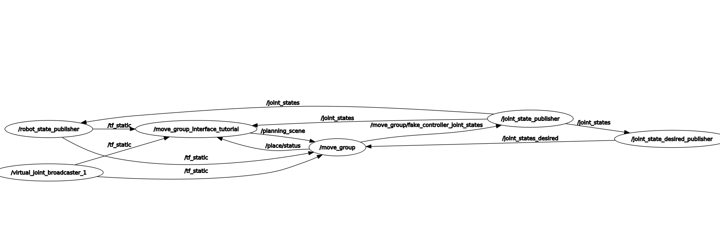
Created motion_planning package
- roslaunch motion_planning basic_movement.launch
- using basic_movement.launch to test basic movements of robot controlled using c++

Modify move_group_interface_tutorial.cpp to interface with ur5 robot

Problem 1: Change panda_arm to ur5
- current planning group is panda_arm which is defined in the rviz launch.
- panda_arm is defined in panda_arm.xacro
- panda_arm.xacro is used to load URDF (universal robot description format) in planning_context.launch
- planning_context.launch is run by the demo.launch file used to launch the robot in move_group_interface tutorial
- Current launch file for motion_planning loads hardware interface through ur_modern_driver package with ur_driver executable that runs ros_main.cpp
- planning group name for ur5 determined to be “manipulator” as defined in catkin_cb2/src/universal_robot/ur5_moveit_config/config/ur5.srdf
- static const std::string PLANNING_GROUP = "manipulator";
- ^ allows for planning group to be changed to our ur5 robot
- solved

Problem 2: Topic '/rviz_visual_tools' unable to connect to any subscribers within 0.5 sec
- You need to add the rviz display plugin "Markers" to rviz and set it to "/rviz_visual_tools". that warning is to let you know you haven't connected the output to anything.
  - https://github.com/davetcoleman/moveit_simple_grasps/issues/17
- tutorial initializes a marker array subscribed to /rviz_visual_tools

Days Progress
- Successfully moved physical robot using coordinates inputted into c++ script.

Next Steps
- Program talker and listener into robot motion script so that talker gives coordinate information to listener which moves robot to that point.

March 31

Combing ArucoROS TFs with UR5
- Tried manually multiplying matrices but tf::StampedTransform and tf::Transform dont multiply
- Going to make broadcaster to find transformation between target and base
  - need to put arucoros frames into same tree as ur5 frames
- Added broadcaster to basic_movement.cpp
- Now in rviz can see the marker frame
  - Need to add arucoros image – added manually to rviz and saved rviz configuration in moveit.rviz
basic movement now moves to arucoROS marker

April 5

Combined camera launch and ArucoROS into one launch file
- roslaunch motion_planning robot_camera.launch

Added Translational Wobble
- roslaunch motion_planning translational_wobble.launch
- “Wobbles” in x-y plane, and returns to higher position
April 8

Notes when running movement launches
- make sure planning group is manipulator
- load obstacles
- set planning algorithm to PRM

April 14

Real Time Planning
- while loop continuously updating tag position
- working, but tag not always in camera FOV
Rotational Wobble
- Added new joint for probe
- New ur5_robot.urdf.xacro
<?xml version="1.0"?>
<robot xmlns:xacro="http://wiki.ros.org/xacro"
name="ur5" >

<xacro:arg name="transmission_hw_interface" default="hardware_interface/PositionJointInterface"/>

<!-- common stuff -->
<xacro:include filename="$(find ur_description)/urdf/common.gazebo.xacro" />

<!-- ur5 -->
<xacro:include filename="$(find ur_description)/urdf/ur5.urdf.xacro" />

<!-- arm -->
<xacro:ur5_robot prefix="" joint_limited="false"
transmission_hw_interface="$(arg transmission_hw_interface)"
/>

<link name="world" />

<joint name="world_joint" type="fixed">
<parent link="world" />
<child link = "base_link" />
<origin xyz="0.0 0.0 0.72" rpy="2.35 0.0 3.14" />
</joint>

<link name="probe"/>
<joint name="probe_joint" type="fixed">
<parent link="ee_link" />
<child link = "probe" />
<origin xyz="0.26 0.0 0.0" rpy="0.0 0.0 0.0" />
</joint>

</robot>

April 19 2021

Implemented Rotational Wobble
- rotational_wobble.launch
- rotaitonal_wobble.cpp
- rotates by 30 degrees and -30 degrees about the z axis
- uses Eigen library to calculate rotations
- changed probe orientation in ur5_robot.urdf.xacro to match ultrasound probe configuration
  - <link name="probe"/>
  - <joint name="probe_joint" type="fixed">
  - <parent link="ee_link" />
  - <child link = "probe" />
  - <origin xyz="0.26 0.0 0.0" rpy="0.52359877559 0.0 0.0" />
  - </joint>

April 21, 2022

Initial Position
FOV: 30x25cm
Probe Position
X: 0.191656
Y: 0.742496
Z: 0.579901
Probe Orientation
X: 0.219516
Y: 0.718178
Z: -0.192821
W: 0.631548

Conducted US Calibration
- Save png files and updated matlab code to read quaternions
- results were very close to our manual calibration
- 10 train, 5 test

Connecting to Ultrasonix
- change ip address on Ultrasonix to 172.22.22.3 to connect with laptop (172.22.22.1)
- Next steps is to set up Ulterius and capture US data
<origin xyz="0.262 0.0 0.0" rpy="0.52359877559 0.0 0.0" />

April 26

Ultrasound Calibration
Collected 50 additional poses for ultrasound calibration

Force Torque Based Movement
- moves until a certain force is exerted upon patient
- force_sensor_integration.launch
- uses robotiq_ft_sensor library
- install
  - git clone https://github.com/ros-industrial/robotiq.git
  - remove all folders except robotiq_ft_sensor
  - sudo usermod -a -G dialout <USERNAME>
  - restart computer
  - roscore
  - rosrun robotiq_ft_sensor rq_sensor
  - roslaunch force_sensor_integration.launch

Stable Wobble
- initial wobble has a dip in z due to only start and end positions inputted
- fixed this by incrementally wobbling to 30 degrees by increments of 3 degrees
- future work could implement this as a path constraint for smoother wobble

