**Report** **107062546 楊仲愷**

**Java File, Class Name: PageRank01, PageRank**

**PageRank02, PageRank**

**PageRank03, PageRank**

First, I deal with the data into websites, rank, and links. Therefore, type this command and the input path is Input, output path is Output1.



Then, we will see the data like this.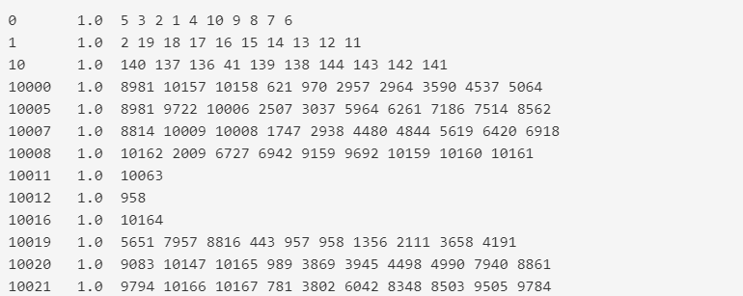



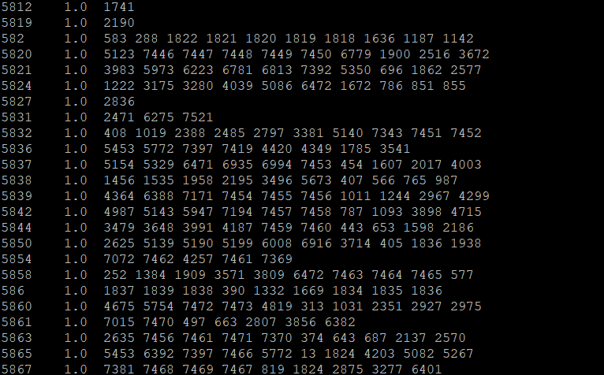

Here is the map. I process the original string to a website and its out links. Therefore, I set the website to key, and out links to value.

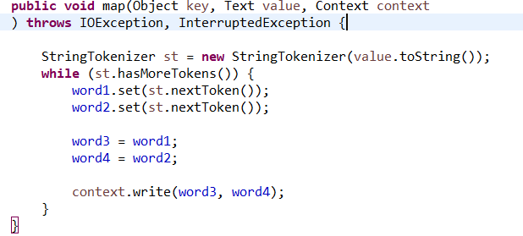

Consequently, I reduce the website and its out links, and add the rank into the line. Then, we can get the line like “website rank out links“.

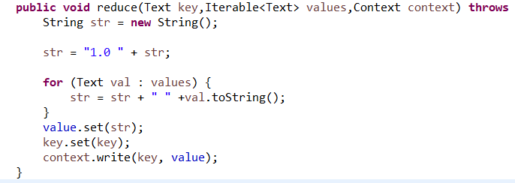

Secondly, let’s process the data with the function for twenty times.



And we will see there are twenty directories from Output2-0 to Output2-19. They represent which times they process. We open Output2-19 which means the twenty times processed data and will see results below.

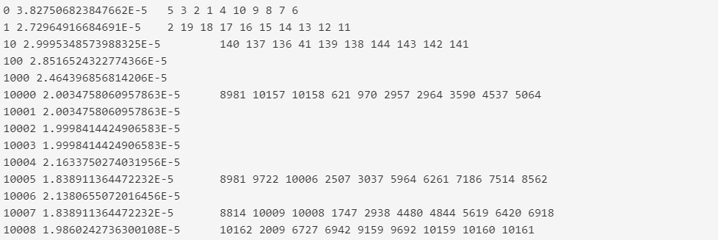



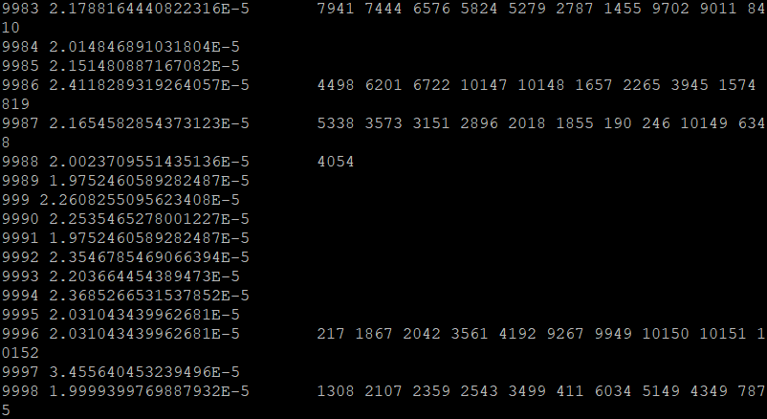

I set out links and their rank to keys and values, and then set from links and out links to another keys and values. Specially, I add ‘t’ and ‘r’ to represent to and out.

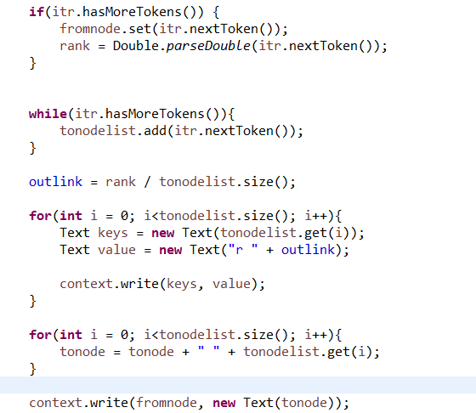

Here, we can see I take advantage of the string to determine whether it is out or to. Then, let’s put data into the formulation 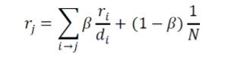. And we will get the processed rank. Data are like “website rank out links”.

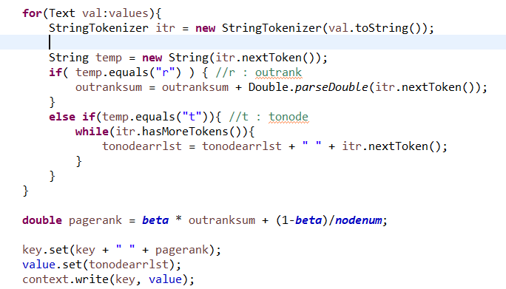

Finally, we got the processed data from PageRank02, and we can sort the results with descending because we can see the top ten websites from this.



And we can the results like this which is sorted with descending.

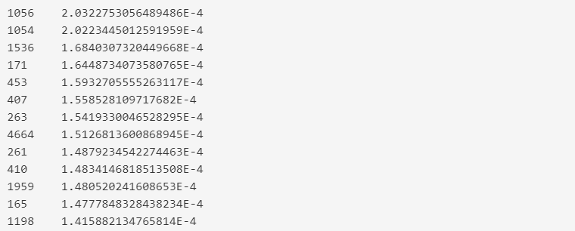



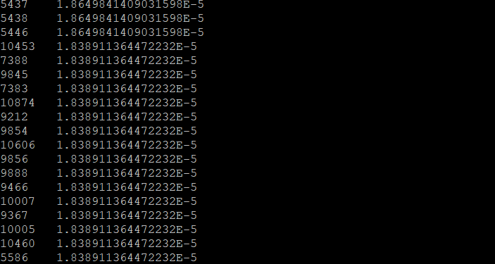

As a result, we can see the top ten websites from the results. They are separately 1056, 1054, 1536, 171, 453, 407, 263, 4664, 261, 410.

I set the rank and the website to separately key and value because when this reduce it will be sorted. However, output list will be ascending, but I want list which is descending. Thus, I multiple all the rank negative one, and the rank will be totally opposite.

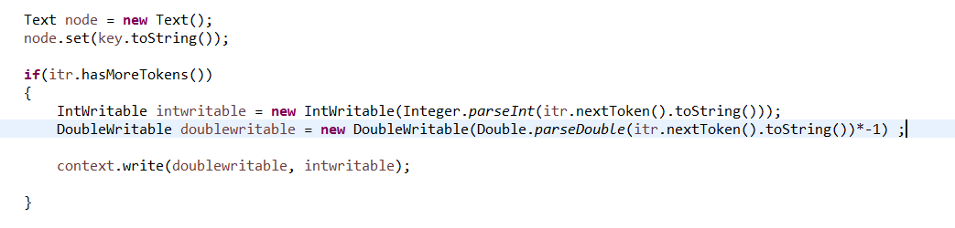

I multiple rank negative again and set website and link to key and value for correct output, and the rank will be not only original but also descending.

