|  |
| --- |
| Principles and Applications of Digital Image Processing |

【Fall, 2016】

Homework 6

**Part 1: (50%) Geometric Transformation**

Design a computer program for geometric transformation of an image. Try to find the optimal geometric transformation to obtain the warped images shown below. Describe your approach as clearly as possible and show the resulting images. You may also challenge yourself by designing an interactive interface for more flexible geometric transformation.

|  |  |
| --- | --- |
| 描述: D:\課程資料\C1-影像處理原理與應用\影像處理原理與應用影像\IP_dog.bmp | 描述: D:\課程資料\C1-影像處理原理與應用\影像處理原理與應用影像\IP_dog1.bmp |
| Original Image | Trapezoidal Transformation |
| 描述: D:\課程資料\C1-影像處理原理與應用\影像處理原理與應用影像\IP_dog3.bmp | 描述: D:\課程資料\C1-影像處理原理與應用\影像處理原理與應用影像\IP_dog2.bmp |
| Wavy Transformation | Circular Transformation |

**Part 2: (50%) Hough Transform**

Apply Hough transform method described in 10.2 of our textbook to find the sides of the two rectangular papers in the image RECTS.BMP (available from the CEIBA course website). Determine the areas and perimeters of the two rectangular papers assuming the scale factor is 0.5 mm/pixel in both horizontal and vertical directions.

Try your Hough transform program for other images containing multiple lines. What are the major factors affecting the performance of your Hough transform program. Discuss and report your results in details.

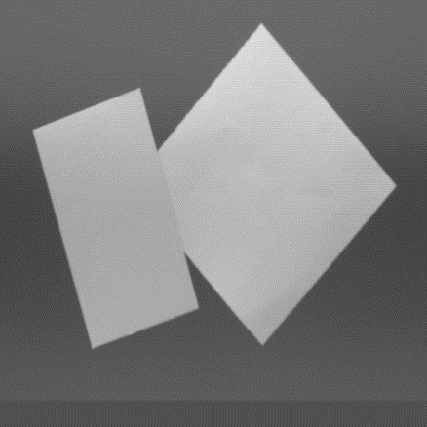

**Notes:**

1. Please submit your programs and report to the CEIBA course website before **Dec. 23**. Hand in the hardcopies of your report in the class of **Dec. 23 (2:20PM)**.
2. Late submission will have a penalty of 10% discount per day of your grade toward a minimum score of 60. No late submission over a week will be accepted.