**Deliverable 0: System Overview and Team Members**

System Description

**Web Application Name:** TimeTurner

The general web-based scheduler system, which we have named TimeTurner, is a student scheduling system. Users, which can be administrators or students, may log into the TimeTurner system using their username and password. Once logged in, users will have the option to check their sequence, which lists the classes they must register for, the order in which they must register for them, and the semester in which each course should be taken. Based on their sequence, students have many options for generating a class schedule. They may input their preferences into the system, which will modify their course sequence based on these preferences, and will then suggest a schedule for them based on the chosen semester which fits these preferences. Students may also choose classes and class sections and add each class and section to their schedule individually. Once a student has finalized their schedule, they may view it from the TimeTurner application. Administrators may manage their respective course sections with regards to capacity and time.

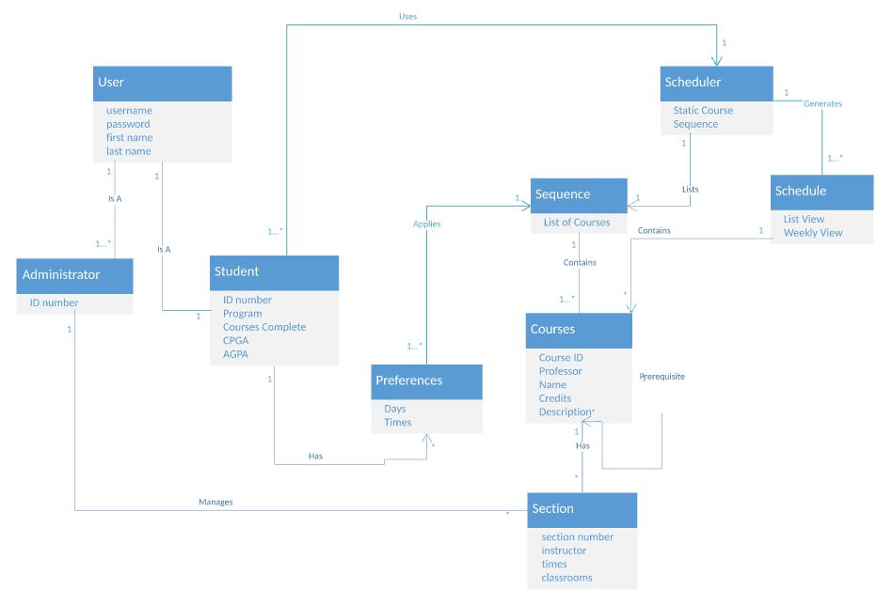

DLO 1: **User**: The user is an entity which will be making use of the Scheduler web application. The user can be a Student or an Administrator. The User will log into the Scheduler app using a username and password. A User will not be logged in if they enter the wrong username and password, or an invalid username and/or password.

DLO 2: **Administrator**: The administrator is one of the two types of users of the Scheduler application. The administrator is a privileged user as they will have higher access rights than the other type of user, which is the student. The administrator will have the rights to set/edit the capacity of a course section, to empty a course section, and in general manages a course section. The administrator is typically expected to be a course advisor or program coordinator of sorts. A single administrator has rights to as many sections as they want. This object has an ID number as an attribute, which serves as a unique identifier of the Administrator.

DLO 3: **Student**: The student is the second type of user that will access the Scheduler application. The student is not a privileged user like the admin because they have limited access rights to the Scheduler. The student has preferences which will be what the user prefers their schedule to look like, and has access to the Scheduler object. The student has no direct access to the course sections. This object has the attributes of an ID number which is the Student’s unique identifier, a Program which is expected to be Software Engineering or Computer Science, Courses Complete which is the courses that the individual Student has completed, a CGPA which is the cumulative GPA from the start of the Student’s studies, and a AGPA which is the Student’s total GPA from the latest year.

DLO 4: **Scheduler**: The Scheduler is the entity encapsulating the entire Web application. This will be the center of the user’s schedule building process. Once logged in, the user will be able to choose their own courses and sections, view and modify their schedule, and input their preferences in order to build a schedule based on those preferences. The user will also be able to view their course sequence suggested by their program, and will be able to view their student record to view the courses that they have already taken.

DLO 5: **Courses**:

DLO 6: **Section**: The section of a course, managed by an administrator, is an entity representing a time slot at which students can attend a course given by an instructor in a certain classroom. There can therefore be multiple sections for the same course. A section holds as information its section number, the full name of the instructor teaching the course, the times and the classroom numbers at which the lectures, laboratories and tutorials are held.

DLO 7: **Preferences**: The preferences of a student are filters to be applied when the course sequence of that student is generated. Those preferences include the times in a day at which the student prefers to have classes and a set of days on which the student wishes to have less classes. At least one preference is to be applied when the sequence is generated.

DLO 8: **Sequence**: The sequence is the list of courses that the student must take. The sequence may either be the static sequence that every SOEN student takes, or an adapted sequence in case the student deviates from the original sequence. The sequence is generated by the scheduler based on the preferences that are set by the student.

DLO 9: **Schedule**: The schedule is generated by the scheduler. It is comprised of several courses throughout the week. It can be viewed by a list view where all courses are shown one after another, or it can be shown on a weekly basis where the times of each class are represented visually on a table.

Team Members

**Team name: YAWD**

**Scheduler application name: Time Turner**

**Git Repository:** [**https://github.com/dtopaloglou/ConUScheduler**](https://github.com/dtopaloglou/ConUScheduler)

Team Leader: Daniel Di Corpo

**Coding team:**

1. Dimitri Topaloglou (leader)

2. Bryce Drewery Schoeler

3. Lori Dalkin (secretary)

4. Ideawin Koun

5. Marc Leclair

6. Erin Benderoff (secretary)

**Documentation team:**

1. Claudia Della Serra (leader)

2. Ryan Lee

3. Aline Koftikian (secretary)

4. Philip Lim

5. Kevin Yasmine