6.1 Architecture

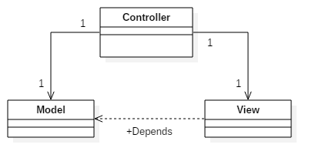

Time Turner’s architecture will follow a Model-View-Controller architecture (MVC). This MVC architecture is best suited for this project because it isolates our application to 3 different layers, data, logic and presentation. With these clear separation of concerns, changing any of these components might not affect the other two components. This is a preferred for team based environments since all 3 components can be coded at the same time.

We have chosen to use the Yii Framework for its ease of use, modular components and its exceptional handling of applications with big traffic flow such as portals and content management systems. We have chosen this framework for its high speed of development and work, integration with Javascript, can handle multiple types of databases and convenient and flexible caching system which will help for caching validation.

These are the 3 main components:

**Controller**

This is the data of the MVC. With a web application, the user will make a request for a web page which will be handled by the controller. The controller will evaluate the request, sending any logic operations to the model component. Once the controller has collected all of the necessary information, it will send all its data to the view component, which will generate an HTML output to the user.

**Model**

This is the logic of the MVC. With the user information given from the controller, and with the use of the underlying logical data structure, such as our domain model, processes such as, generate sequence, can be utilized and sent back to the controller. One controller does not have exclusivity over the model component, since multiple pages may need the same information, many controllers can access the model component.

**View**

This is the presentation of the MVC. With the proper session handling from the controller and relevant data from the modeller, the viewer can generate an HTML output with CSS and Javascript, which will, in-turn, be viewed on the user’s web browser.

A general work flow starts off with a user request. This is handles by the controller, which will separate what needs to be sent to the model component and the view component. Anything that needs data retrieval or sequence generation, will be sent to the model component, which is in conjunction with our domain model. Once the data has been retrieved, it is sent back to the controller to be packaged and sent to the viewer. Once the view component has all the information, it will generate, what will be, in the end, the display on the user’s web browser. Then, once a new request is sent, the process will start over again.