**3.2.1 IUserInteraction**

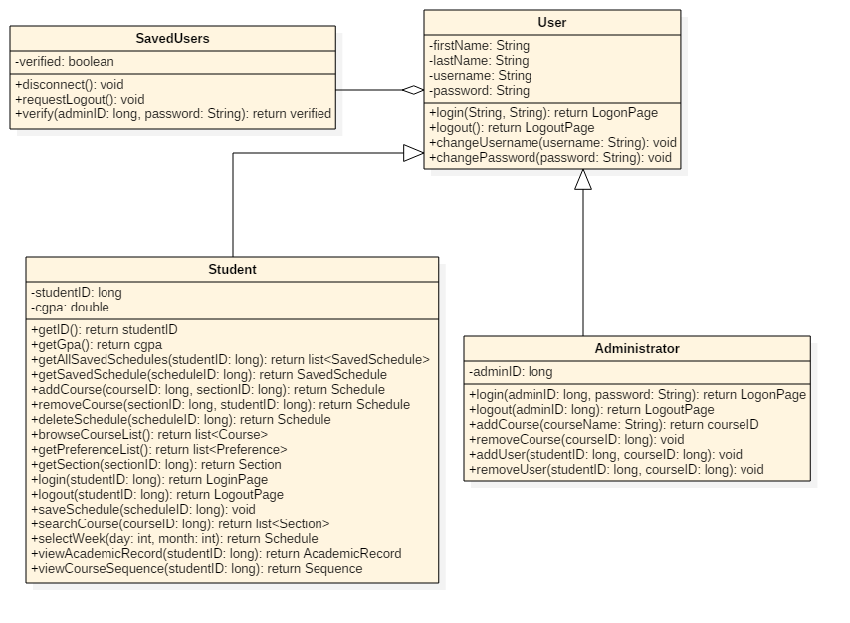

**3.2.2 IScheduleManagement**

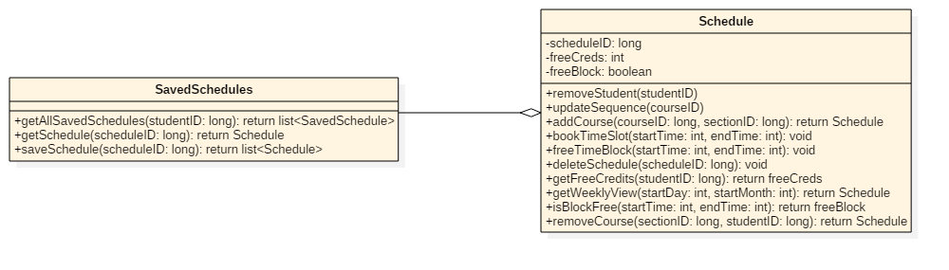

**3.2.3 ICourseManagement**

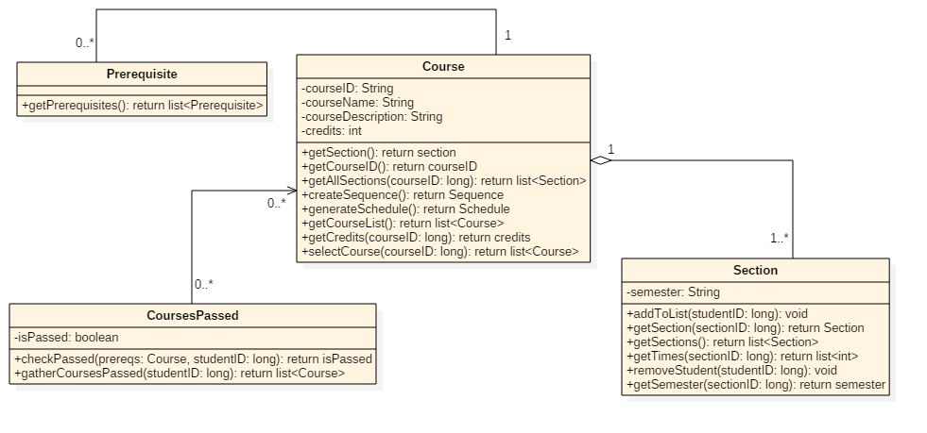

**3.2.4 IPreferenceManagement**

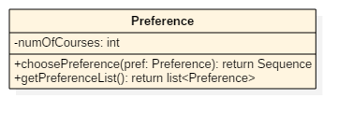

**3.2.5 ISequenceManagement**

