Installation Manual

Description

With this product, provided to clients as an archived or zipped folder, only a few simple steps are needed to install this on a client's server. The zip folder includes the root folder of the web application, the database file and Xampp program.

System requirements

Minimum 2gb of ram

WIndows Vista or newer

Database included with Xampp,.db file included in zipped folder

Installation steps

Step 1: Extract the timeturner.zip folder to your preferred location.

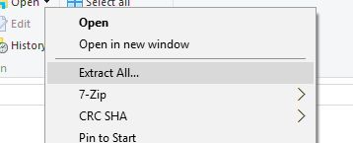

Step 2: Locate the ‘Xampp’ executable and install the program to your preferred location. No special changes made when installing, follow the installation steps

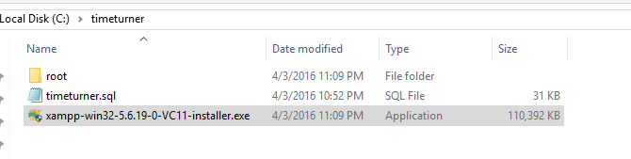

Step 3: Setup the Virtual Server

Step 3.1: Go to the installed ‘Xampp’ folder

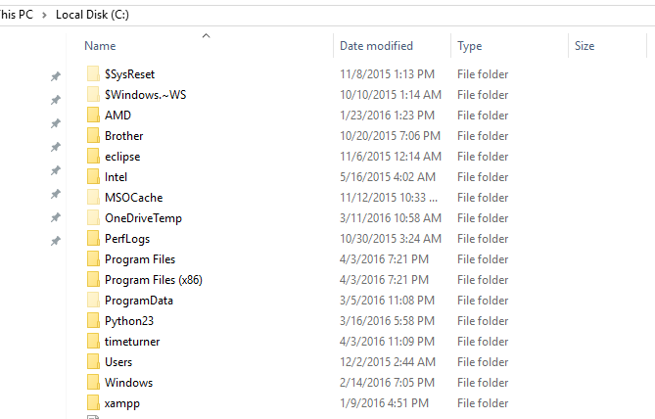

Step 3.2: Go to the Apache folder

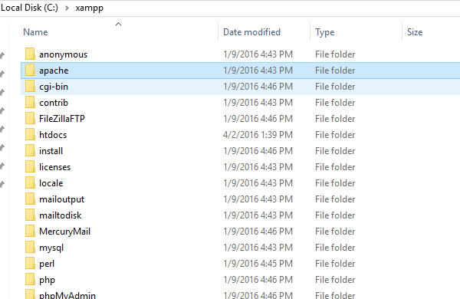

Step 3.3: Locate conf folder in apache

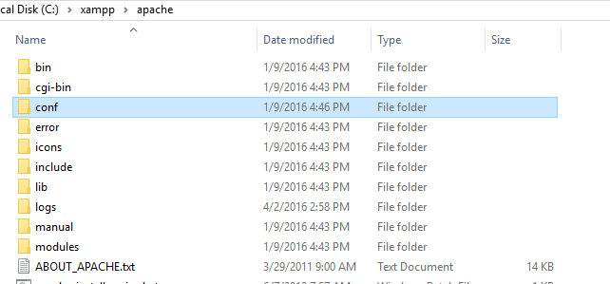

Step 3.4: Go to extra

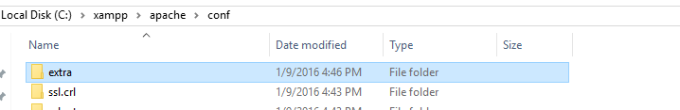

Step 3.5: Open the httpd-vhost.conf file

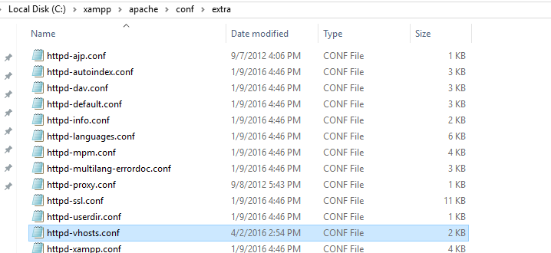

Step 3.6: Set up virtual server by including the appropriate lines of code provided and visualized in the next screen capture:

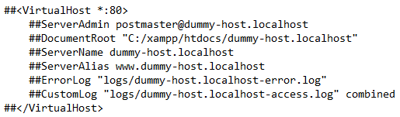

*Remove the hashtags from all the lines. The ServerName should be the name of the domain that will be used to access the application via URL. The ServerAlias allows to access the domain through a ‘www’ protocol. For example, if the preferred domain is ‘*[*www.mytimeturner.com*](http://www.mytimeturner.com)*’ the ServerName would be* ***mytimeturner*** *and the ServerAlias would be ‘*[*www.mytimeturner.com*](http://www.mytimeturner.com)*’. The DocumentRoot is the location of the web application root folder, which is provided in the zip folder of the application. The* ***root*** *folder provided in the zip file, should be extracted in the same location as the DocumentRoot location. Once provided with valid DocumentRoot location folder, extract the ‘root’ folder in that location.*

Step 4: Redirecting windows hosts

Step 4.1: Once the virtual host is setup, the new domain name that was provided in the ServerAlias must be also setup in the Windows host file. To locate the Windows host file:

C:\Windows\System32\Drivers\etc\host.file

Step 4.2: Open the file and append the following lines:

127.0.0.1 [www.mytimeturner.com](http://www.mytimeturner.com)

*This simply tells the operating system to resolve the domain as the local machine. Of course,* [*www.mytimeturner.com*](http://www.mytimeturner.com) *should match exactly what was setup in the Virtual Host setup ServerAlias name. Save the file.*

**Installation continued after short installation testing in the next section**

Virtual Server Installation Testing

In order to test if the virtual server was setup properly, locate the ‘XAMPP’ installation folder and locate the xampp-control.exe file:

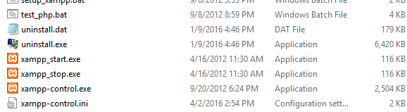

Once XAMPP runs, click on ‘Start’ on the Apache line. If the server was setup properly, the following should appear:

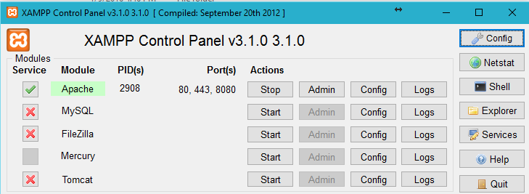

A green indicator should appear on Apache.

Virtual Server Installation Testing (Continued)

Once the Apache server is setup, click on ‘Start’ for the MySQL line. Again, a green indicator light should highlight the MySQL. If the green light appears, click on ‘Admin’. This will open up phpmyadmin, a GUI provided by XAMPP for the MySQL database.

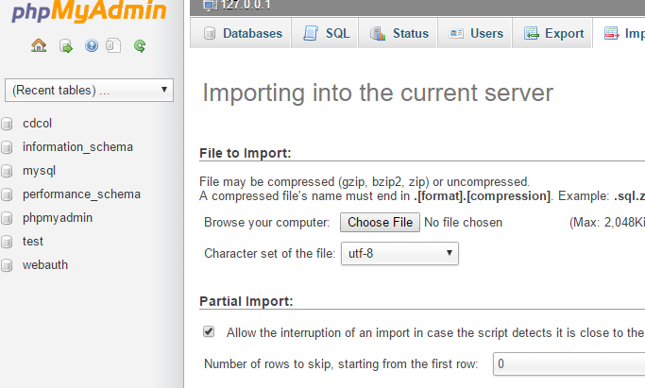

Continued Installation

Step 5: Database Installation

Step 5.1: To install the database, a database file is provided in the ZIP folder called ‘timeturner.db.’ This file is to be extracted in phpmyadmin.

Step 5.2: At this point, we need to create a database in order to import the existing database file. Click on database, and create a database under the name: ‘timeturner’

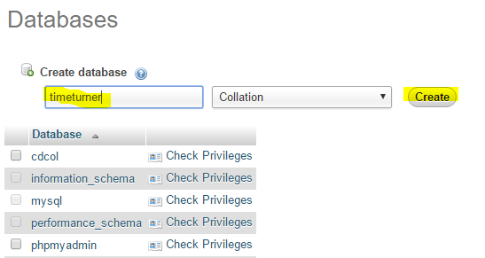

Step 5.3: Click on ‘Create’. This will create a new database that will appear on the left hand column where the rest of the databases are located. From here, the actual database needs to be imported in order for the application to run.

Step 6: Database Extraction

Step 6.1: To extract the database, click on the database name ‘timeturner’ on the left and then click on

import.

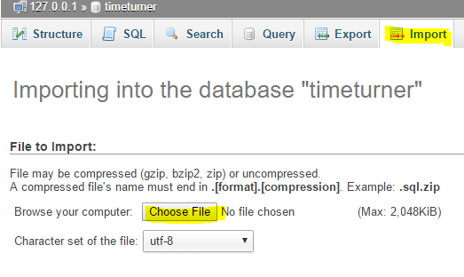

Step 6.2: Upload the ‘timeturner.sql’ file provided and then click on ‘Go’. At this point, all the data tables should appear in the timeturner database:

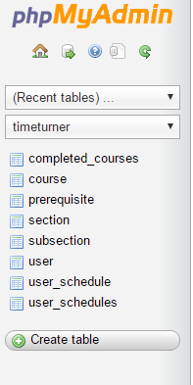

Final Installation Testing

To run the application, open a web browser and type in the domain name provided earlier through ServerAlias, which in this case would be ‘[www.timeturner.com](http://www.timeturner.com)’

