Upon logging in the student can access schedule planner tab.

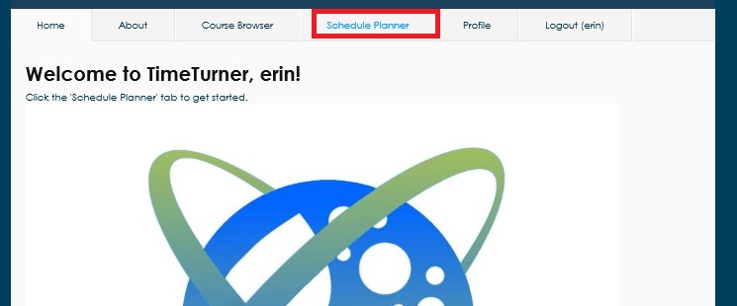

In this tab, one can generate a schedule that adheres to the specifications requested in the preferences list. After having generating the schedule for a specific year and selecting the section of choice, the schedule can be saved with the save schedule button.

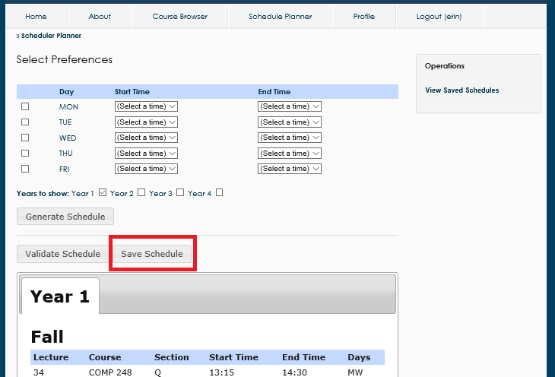

This will return a pop-up indicating confirmation that the schedule has been saved.

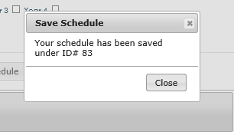

|  |  |  |  |  |  |
| --- | --- | --- | --- | --- | --- |
| **UC11** | | **Save Generated Schedules** | | | |
| Test ID | Description | | Expected Output | Actual Output | Result |
| 11.1 | Student chooses to save a generated schedule | | Saved schedule confirmation is displayed | Saved schedule confirmation is displayed | Pass |
| 11.2 | Student chooses to save a schedule in a semester that already has a saved schedule | | Error message indicating the semester already has a schedule saved | Saved schedule confirmation is displayed | Fail |

Upon logging in the student can access the scheduler planner tab.



In the operations on the sidebar, there is a view saved schedules option.

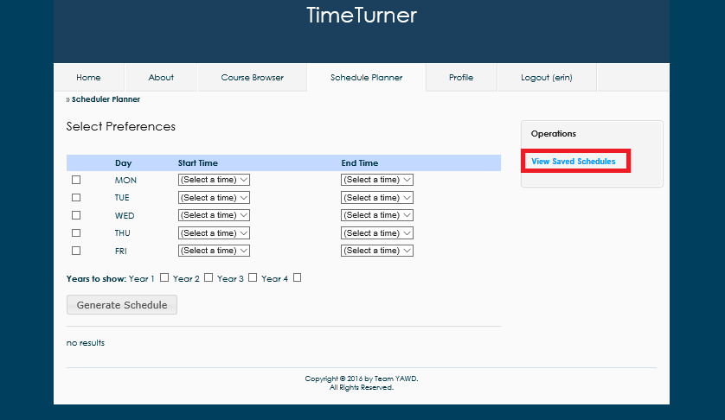

Upon clicking this option, a list of all saved schedules will be presented to the student. At this point they can view or delete a schedule.

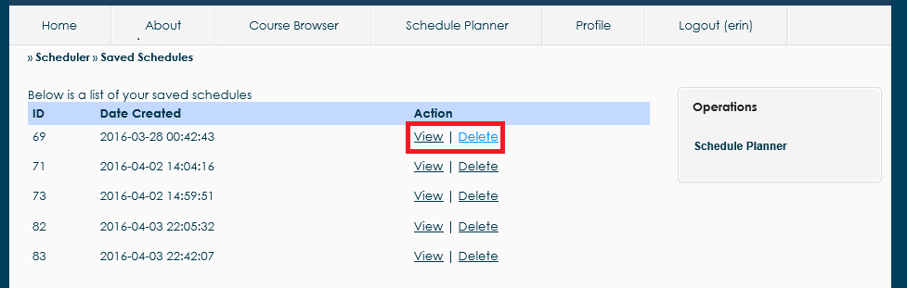

By viewing it, it returns the schedule for the given semester and by deleting it, it asks for confirmation then is removed the schedule from the list of saved schedules.

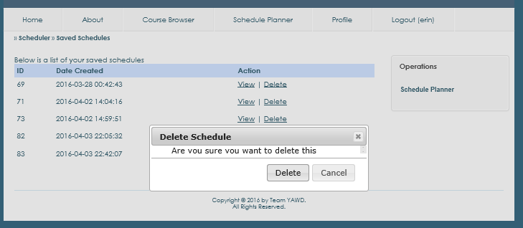

|  |  |  |  |  |  |
| --- | --- | --- | --- | --- | --- |
| **UC7** | | **View Saved Schedules** | | | |
| Test ID | Description | | Expected Output | Actual Output | Result |
| 7.1 | Student chooses to view saved schedules | | List of saved schedules is displayed | List of saved schedules is displayed | Pass |
| 11.2 | Student chooses to view a specific saved schedule | | Saved schedule is displayed | Saved schedule is displayed | Pass |
| 14.3 | Student chooses to delete a saved schedule | | A prompt to confirm deletion is given, then after confirmation the saved schedule is removed | A prompt to confirm deletion is given, then after confirmation the saved schedule is removed | Pass |

Intro

The following section covers the testing involved in the system. A full breakdown of each test case is provided, accompanied by the results. This is useful information in the installation procedure of this software for any users, which is shown alongside the user manual of this section. The types of testing includes unit testing, requirement testing and stress testing. The final topic included is the final cost estimation of the entire project.