|  |  |  |  |  |  |
| --- | --- | --- | --- | --- | --- |
| **UC18** | | **Browse Users** | | | |
| Test ID | Description | | Expected Output | Actual Output | Result |
| 18.1 | Admin selects user’s tab and is populated with all the users | | List of users are displayed on screen | List of users are displayed on screen | Pass |

Viewing Users (as Administrator)

An administrator can view all users currently in the database. To do so, he/she can select the user’s tab from the home page, once they have logged in (shown in Figure 1).

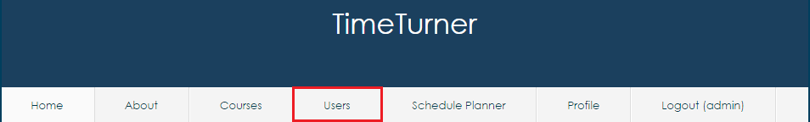

*Figure 1: Accessibility to the ‘User’ tab from the home screen*

Once the tab has been selected, all the users will be displayed on screen. The users are sorted by ID and displayed are each user’s specific credentials, such as, first and last name and their net names (shown in figure 2).

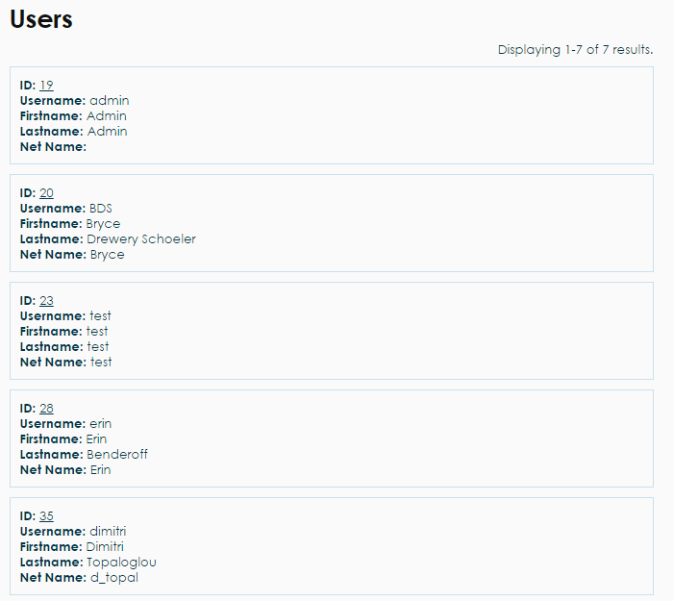

*Figure 2: All users displayed on the ‘User’ tab*